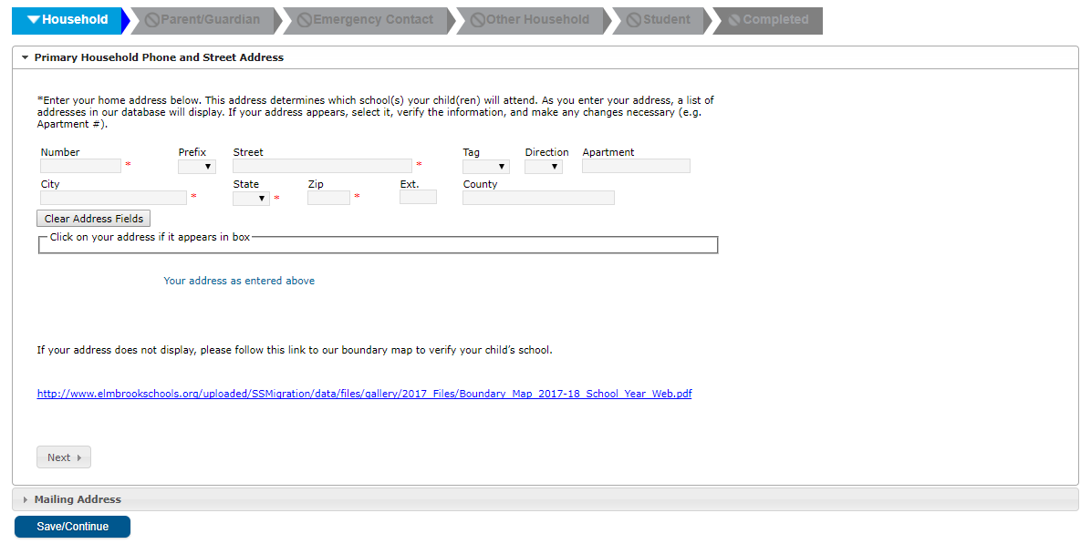


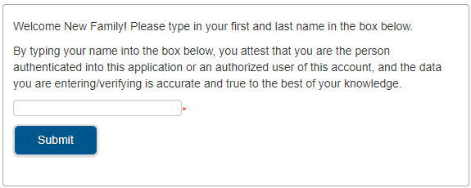
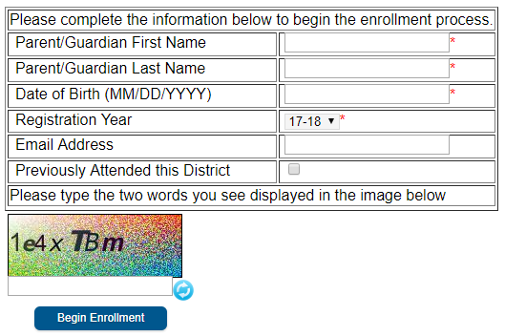
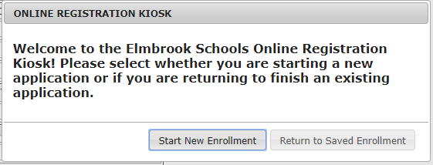

Hello Private and Parochial School Families,

Thank you for your interest in Elmbrook Schools Summer School Program! In order to participate in course selection you will need to complete online enrollment by February 27. This is required for all new and returning students.

NEW Summer School Students
- When completing the online enrollment you will need to upload your child’s birth certificate and proof of residency documents.
- After the district verifies your documents and processes your child’s enrollment, you will receive a confirmation email. Then you will be able to complete course selection March 4 noon - March 11 noon.

RETURNING Summer School Students
- Your submission of the online enrollment ensures that we have the most up-to-date information on file for your child (emergency contacts, medical updates, parent/guardian contact information, etc.).
- You are NOT required to provide any verification documents.
- After the district processes your child’s enrollment, you will be able to complete course selection March 4 noon - March 11 noon.
3

Online Enrollment Instructions
To complete your Online Enrollment form, please visit Elmbrookschools.org and select New Student Enrollment.
STEP 1: Confirm you wish to “Start a New Enrollment”
STEP 2: Complete all the information in the table
  - For Summer School enrollment, choose 25-26 for Registration Year
  - Click “Begin Enrollment” to continue
  - You will receive an email message shortly containing a link to the enrollment form, should you need to exit the application and return later
STEP 3: Confirm your authentication by entering your first and last name. Click “Submit” to continue.
STEP 4: Enter and Verify Information
  - For each of the six TABS (e.g. Household) follow the on-screen prompts
  - Move to the next page by clicking Next
  - A red * indicates a required field
  - Yellow highlights indicate missing information
  - When all pages are complete, move to the next tab by clicking Save/ Continue
  - In the Student tab section select Summer School K-8 or Summer School High School based on your child’s grade level during the 25-26 school year.

STEP 5: Review and Submit. When you reach the 6th (Completed) tab, be sure to review and submit your online enrollment. You will have an opportunity to print your registration, and you will also receive a confirmation email.

4
1
2

