DRDP Assessment Instructions

Step 1-“Who is given the DRDP?”:
Students in special education, ages infant/toddler through preschool, meeting the additional criteria below, are required to complete DRDP process. Identified case manager in SEIS is responsible for completing the assessment or accounting for every student not meeting criteria.
- Students must have been enrolled and have started RECEIVING services before target dates below:
  - November 1 for inclusion in the fall assessment
  - April 1 for inclusion in the spring assessment
- Students ages 0-5 years that started receiving SPED services before above dates must have a DRDP completed. If the student transferred into or enrolled in your district after target dates above, it is not required to complete a DRDP for that student.
- If a student started on or after target dates, do not complete the DRDP on that student. This includes any students who were supposed to have started but for some reason did not. If a student came once and then never again, you must complete a DRDP unless parent agrees to revoke services. Contact parent for assistance in completion as needed.
- Starting in the 2024-25 school year, children 3, 4, or 5-years old with an IEP in Transitional Kindergarten and Kindergarten will be assessed with the DRDP.
- If the child turns 6 at any point during the school year (prior to 6/30), the DRDP is not required. For example, if a child turns 6 in October or March, a DRDP is NOT required.
- Please email Staci Johnson sjohnson@sjcoe.net with names of any students starting on or after November 1 or April 1.

Step 2-“Access account and complete required courses”:
- New users must create an account or previous users can check account status at https://www.draccesslearn.org/index
- If logging in for the first time this year, your temporary password is the email address which you used to create your DRDP account. Contact (800) 673-9220 or email info@draccess.org for account assistance.
- Forgot your password?? Go to DRAccessReports.org and click on “Forgot Password” to check if you have an account or reset your password. Be sure to note your account email and password in a secure location for future reference. Your name and email used for account must be entered on DRDP reporting form:

- There are now three courses required for all assessors giving the DRDP: “Using the DRDP (2015) for Special Education”, “Benny Having a Snack” and “Using DR Access Reports”. These are short courses and should be completed in one sitting and must be completed in order. You can also leave the courses and come back to where you left off if needed.
- You are still required to complete DRDP on applicable students regardless of course completion.
- Access courses at www.draccesslearn.org

Step 3-Give the assessment and “what forms do I use?”:
- Complete the DRDP assessment on every eligible birth through Kinder aged student assigned to you. You complete one information page and one assessment form for each student, either infant/toddler assessment form or preschool assessment form. Most of you will use the preschool form.
Enter all final assessment information in SEIS, clicking on the “pencil” under DRDP tab. Add a new DRDP form and enter information. Don’t forget to affirm information at bottom of the assessment page.
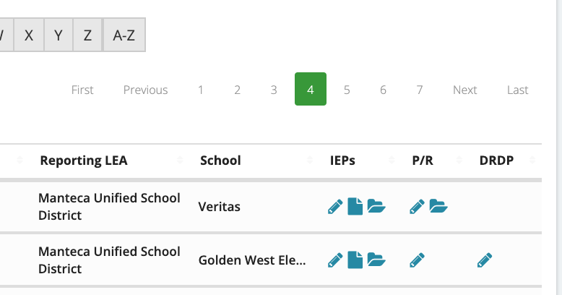
- You must answer question #9 on the information page in SEIS before the correct assessment form (Infant-Toddler or Preschool) will show up.
- You must complete ALL the questions on the DRDP. The ONLY optional section is English Language Development (ELD). This section is only completed if a language other than English is spoken in the home. This is determined by answering question #12 on the information page and must match what is noted on the IEP. Please check this to avoid an error which will require you to re-do the entire assessment again.
- Every student must have a district ID number and SSID number on DRDP assessment form. Get these numbers from your district Sped data coordinator.

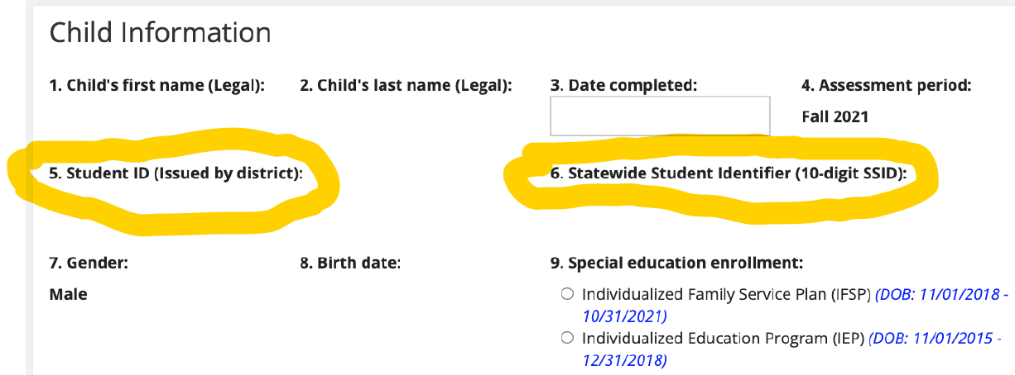

Step 4-“When is the assessment period?”:
The DRDP assessment should be initiated within the first 60 days of services.
All completed assessment data must be entered and affirmed in SEIS no later than early December and May. Exact dates will be provided by SELPA.

Step 5-“Common errors”:
- CDE requires you to complete the DRDP for every student once they have begun receiving services. There is no opt out. This applies even if student was seen only once or if you don’t know all the information to complete the assessment. Contact family to gather information required.
- “Unable to Rate” should ONLY be used in rare and extreme cases when you have exhausted every means of gathering information. Contact family to gather information required.
- Only open ONE DRDP for each student. Delete any accidentally open/unused forms.
- Affirm every DRDP at the bottom of the assessment form.
- Ensure your name and DR access account email (#18), district ID (#5) student SSID (#6) is entered on every assessment form before affirming.
- Be sure you answer questions #9 and #12 to make sure you are completing the correct form/questions.
- Ensure accommodations on IEP-State Assessment section are accurate. All changes must be made on IEP State Assessment page. They cannot be made on the DRDP form.

Step 6-“Where do I go for more information?”:
- The main site is excellent! It has all forms, written instructions and videos https://draccess.org/
- You may also review the DRDP assessment manual https://draccess.org/DRDP2015PSF.html#ATL-Reg1

Understanding the Measures of the DRDP (2015)
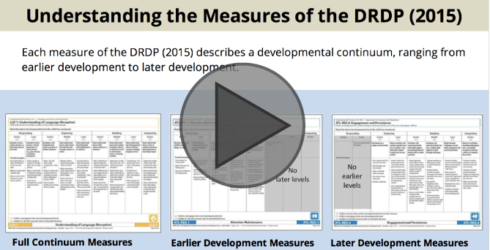

DRDP (2015) Special Education Information Page Tutorial
