SLPs servicing Private School Students
Individualized Service Plan (ISP)

This may serve as a template that you can personalize for your upcoming ISP meetings.

You will click the pencil on the FUTURE IEP page.

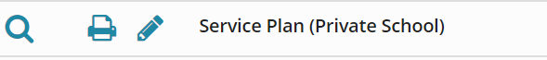

You will then fill out the top part of the ISP:
- Date – Date of ISP – do not change any other dates
- You will input the information for the private school and the school district:
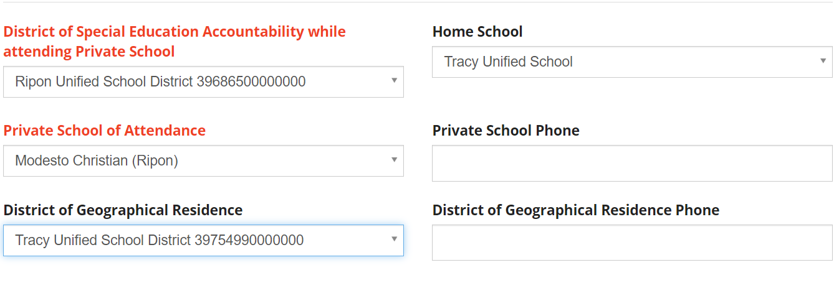
You will then complete the following:
- Change Program Setting Code to 403 – Parentally Placed in Private School
- Add Services at the bottom of the page – 30 minutes of monthly virtual speech and language consultative services. Consultative services are offered to the general education teacher and school staff.
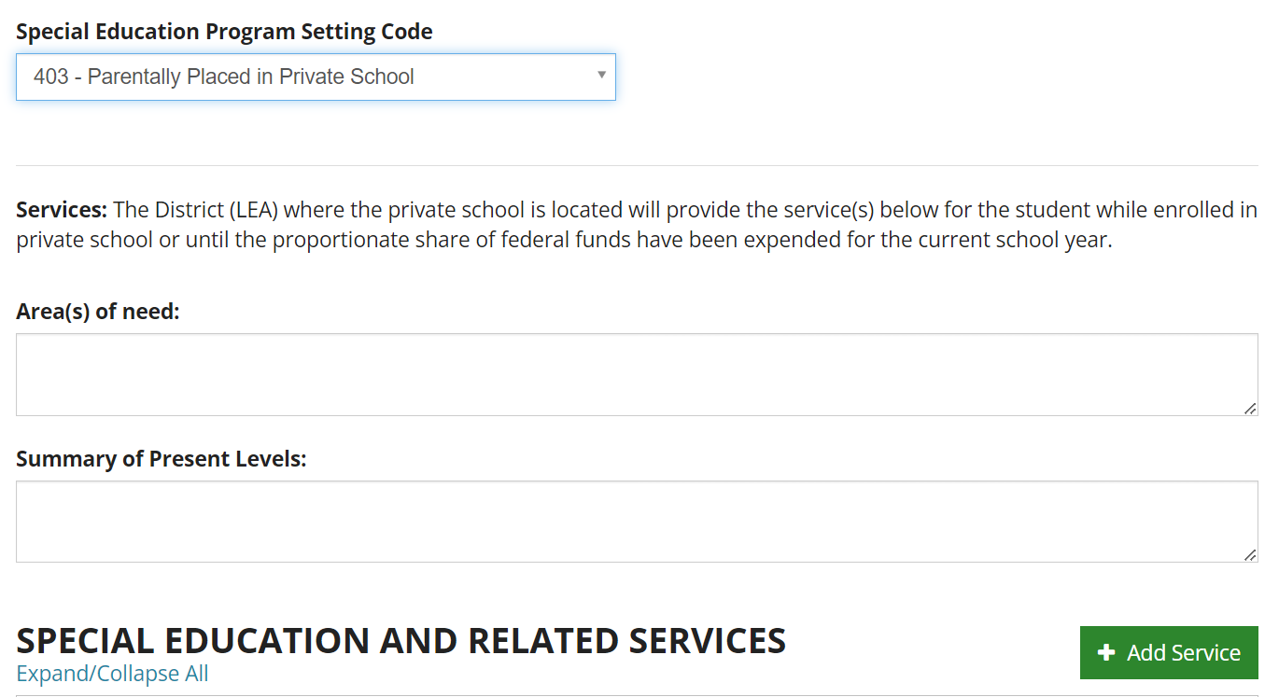

Please Remember:
- We do not propose goals for RSP. We only offer goals for Speech
- We do not offer direct services
- We do not offer ESY
- We do not offer transportation services
- We do not offer transition services

