Kamiakin Middle School 5th Grade Family Information Night
6th Grade Elective Selection Survey: Final Submission DUE Wednesday, February 11th

Students without a form submitted will be defaulted to the Elective Wheel. If the form is completed multiple times, the last entry will be the final entry. https://forms.office.com/r/ZV6kYCzD8Z

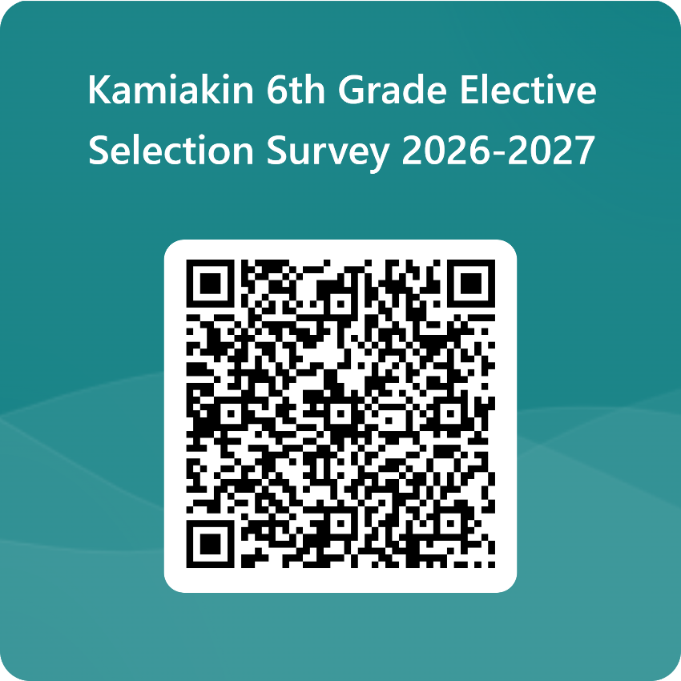
Required Classes:
Year-long
- Math
- Science
- Language Arts
- Social Studies
Semester
- PE
- Computer Literacy

Electives Options:
Year-long
- Music
  - Band
  - Orchestra
  - Choir
Quarter
- Elective Wheel
  - Art
  - Science, Technology, Engineering, and Math (STEM)
  - Foods
  - Music

Questions? Please contact your child’s school counselor.

Students last names A – L  Melissa Pierson  mpierson@lwsd.org | Students last names M – Z  Liz Biell  ebiell@lwsd.org

Explore our website and Instagram: https://kams.lwsd.org/about-us and https://linktr.ee/kamiakin_asb/
Join the Kamiakin PTA -https://kamspta.givebacks.com
- Officers needed.
- Volunteers
- Example of PTA in action: Kamiakin Drama Production
Kamiakin – Our Motto: We Come Here to Grow
Elementary to Middle School Transition Plan
- Counselor visits to each elementary
- 5th Grade Family Night Meeting – January 27th
- Elementary students visit KaMS – Purpose is to allow students to see their new school and reduce anxiety of the unknown. Let by 7th and 8th grade Pride Leaders and staff.
  - June 9 = Frost & Keller (we bus them from school to KaMS)
  - June 9 in the evening for other students
  - June 11 = Franklin, Lakeview, Thoreau & Muir (we bus them or they walk from school to KaMS)
- Back To Business Day – Photos, IDs, Sports Registration, Family support- Last week in August
- First day – orientation activities at the start of the day in Cougar Time
  - End of Day bus support for first week
  - If your child rides the bus – please have them ride the first day.
- During the school year on-going orientation in Cougar Time Activities
LAPTOPS
- Each student will check-out a laptop and charger
- Checked out at the start of the year.
- Checked in at the end of their time at Kamiakin
- The same laptop will be theirs for 6th through 8th grade.
- Filters are in place even when at home.
- Students can defeat the filter process.
- Suggestion: Set the expectations for computer use around academic use, AND what likely consequences might be for misuse. It is not uncommon for internet games to be a significant distraction. Discuss this before your child has their computer.
Student Government is known as ASB (Associated Student Body)
- All Students join ASB at the start of the year- This allows participation in ASB sponsored events
- Students elect their representatives.
- ASB funds are generated by students for students – fundraisers.
Athletics- Registration opens the last week in August.
- Intramural – Students compete with other students within Kamiakin
  - Much more casual and low-key – opportunity to try something new for a couple weeks
  - November to Mid-January
  - Mid-March to Mid-April
  - Fee waivers and scholarships available if needed (see school counselor)
Athletics Continued…
- Students compete with students from other schools – competitive, fun
  - 3 seasons, 8 weeks each, 6 games vs. other LWSD middle schools- these are from last year, are subject to change
  - Fall
    - Cross Country – no cut- open to all
    - Tryout- Girls Tennis, Boys Soccer. Boys and Girls Basketball
  - Winter
    - Wrestling – no cut, both boys and girls together
    - Tryout- Boys and Girls Badminton
  - Spring
    - Track – no cut, both boys and girls
    - Tryout sports: Girls Soccer, Boys Tennis, Girls Volleyball
- Students must have clearance to play from a doctor. – Get this early. It becomes very difficult to get this sign-off in August.
6th Grade Growth
- Organization
  - Multiple Teachers – Students will meet with 6 to 7 teachers each day.
  - Mobile Student – Students move between classrooms each period.
  - Backpacks (lightweight) – 6th graders generally want to put everything in their bag. PACK LIGHT.
  - Laptops and chargers – Students
  - ASB card (used to pay for lunch)
  - School Supplies – list comes to you in August
- Responsibility shifting from parent to student.
  - Organizational habits
  - Students step forward while adults support and monitor.
  - Your child still needs your support, and encouragement to empower themselves.
Daily Bell Schedule – Students move to new teacher after each period
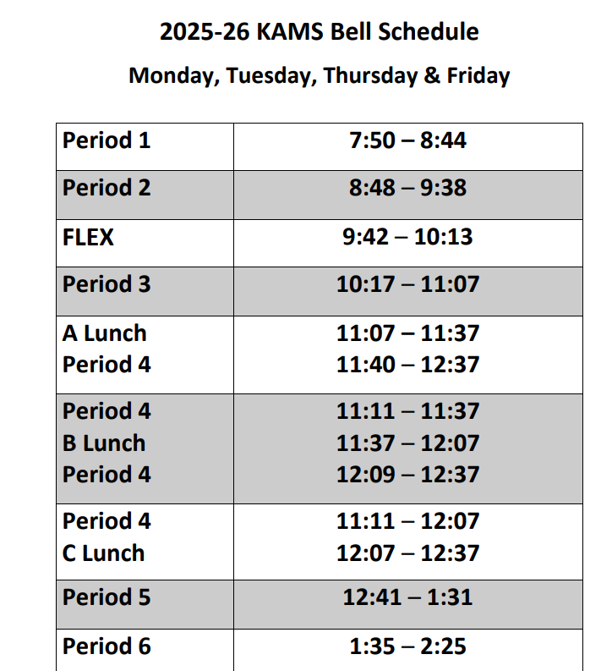 | 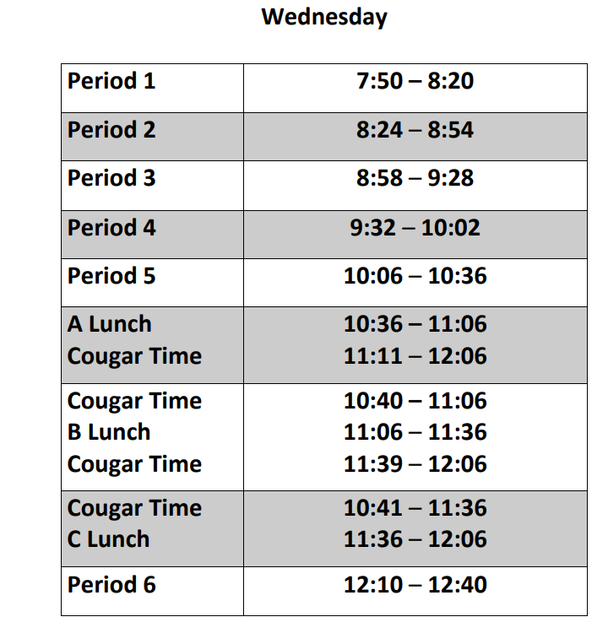 | Example student schedule:  1 – 6+ Math  2- English Language Arts  3- PE  4 – Social Studies  5 – Elective  6 – Science  Flex – Academic Intervention Period

