

Secondary eLearning
General Tips for Planning

When a day has been designated as an eLearning day, teachers will provide both synchronous instruction during school hours but may also assign asynchronous activities at various points during the lesson to balance screen and non-screen time. While daily schedules may vary, please keep in mind the following reminders when planning:

- Students will take home the district-issued devices to ensure access to instruction/daily activities. If the situation allows, students should restart their devices while on the school network prior to the eLearning day to ensure any necessary updates or configurations are downloaded (if a student device is broken or unavailable, schools will provide an alternative plan for that student[s]).
- The instructional day should follow the normal school start and end times.
- Teachers should provide synchronous, live instruction throughout the school day; however, teachers may also assign some asynchronous learning activities (i.e. Edgenuity modules, Newsela, etc.).
Planning for Instruction  - Prepare simple, targeted lessons.  - Review the schedule, resources, and passwords with students prior to the eLearning day if time allows.  - Use both synchronous and asynchronous learning to keep students engaged and balance screen and non-screen time.  - Ensure students have access to all materials needed to participate in instruction. | Planning for Students without Internet Access or Power  - Provide students with a phone number (consider a Google number) or email to report outages.  - Provide ample asynchronous assignments.  - Have students download assignments/resources onto the laptop before leaving (when the situation allows).  - Provide hotspots, if available.  - Utilize pre-recorded lessons that can be downloaded to devices in advance of the eLearning day (when the situation allows).
Guidance for Students and Families  - Stay engaged. An eLearning day should be a regular school day full of learning experiences.  - Select a workspace for your child that is conducive to learning.  - Ensure that your child charges their device.  - Gather and set up supplies the day before eLearning.  - Be ready for school to begin and end on time.  - Utilize headphones when available to minimize background noise and distractions.  - If your child’s laptop is not functioning properly, please reach out to your child’s school. | Digital Resources  - ALEKS  - Delta Math  - Discovery Education  - IXL ELA  - MasteryConnect  - Newsela  - Progress Learning  - Schoology


 | Sample Secondary Synchronous/Asynchronous Schedule
 | 1st Period | 8:00-8:50 | Synchronous/Asynchronous Class Meeting
 | 1st Period | 8:50-9:15 | Asynchronous Assignments
 | 1st Period | 9:15-9:30 | Brain Break
 | 2nd Period | 9:30-10:20 | Synchronous/Asynchronous Class Meeting
 | 2nd Period | 10:20-10:45 | Asynchronous Assignments
 | 2nd Period | 10:45-11:00 | Brain Break
 | 3rd Period | 11:00-11:50 | Synchronous/Asynchronous Class Meeting
 | 3rd Period | 11:50-12:15 | Asynchronous Assignments
 | 3rd Period | 12:15-1:15 | Brain Break/Lunch
 | 4th Period | 1:15-2:05 | Synchronous/Asynchronous Class Meeting
 | 4th Period | 2:05-2:30 | Asynchronous Assignments
 | 4th Period | 2:30-2:45 | Brain Break
 | 4th Period | 2:45-3:15 | Asynchronous Assignments (Any Incomplete Classwork/Homework)
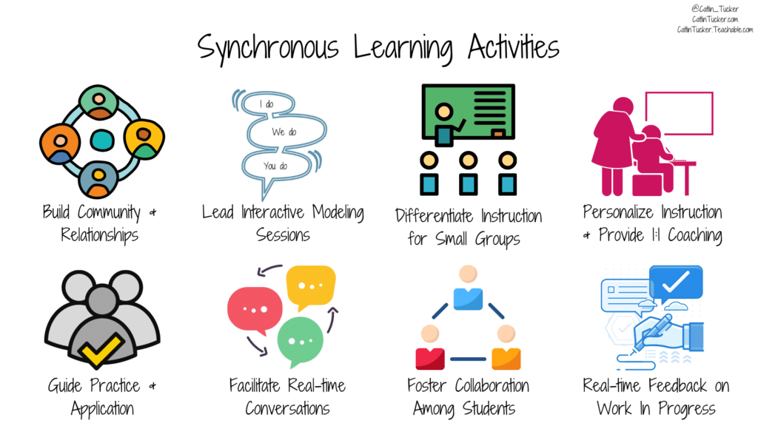 |  |  |  | 