Mackay School District No. 182
NONINSTRUCTIONAL OPERATIONS 8110-F(1)
Safety Busing – Safety Busing Measuring and Scoring Instrument

The following form can be found at the Idaho State Department of Education website under Student Transportation and Safety Busing.

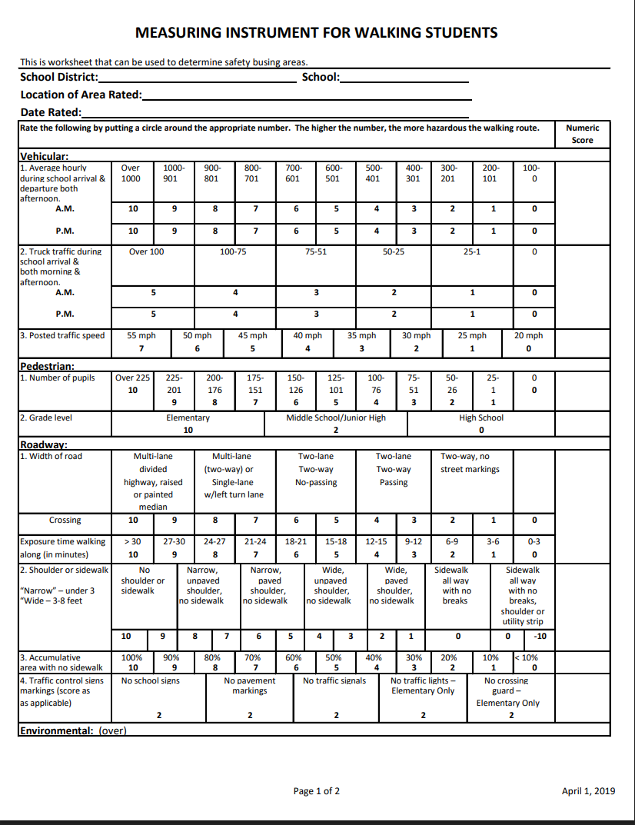

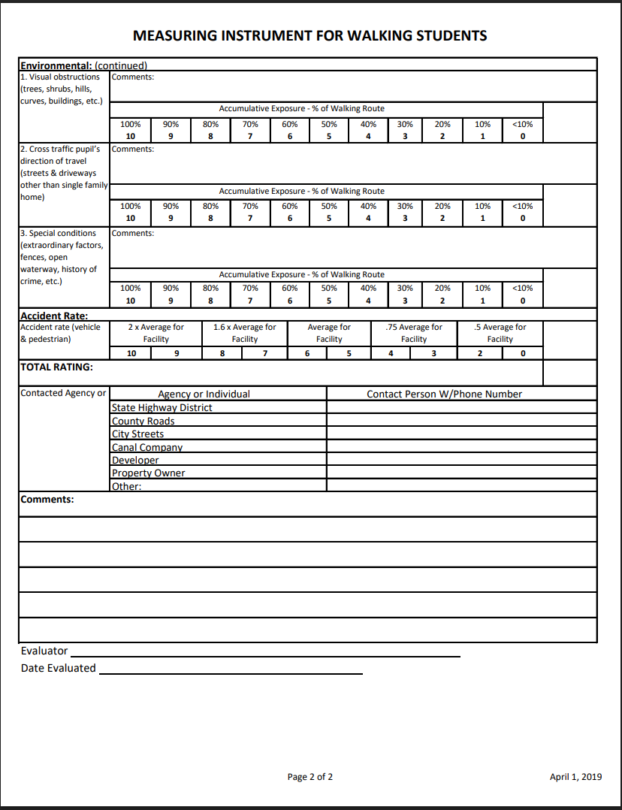

Legal References
IC § 33-1501
IC § 33-1506
IC § 33-1509
IC 33-1006
IC 33-1504
IC 33-1515
Other References
Idaho State Department of Education
ISBA Policy Services
Cross References
Code | Description
8100 | Transportation
8120 | Bus Routes, Stops, and Non-Transportation Zones

Adopted: January 12 2026

