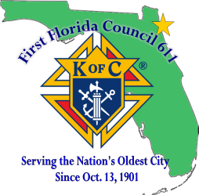
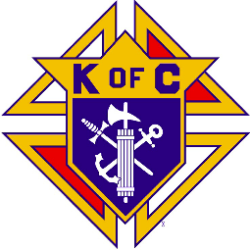
Knights of Columbus

FIRST FLORIDA COUNCIL, NO. 611
P.O. Box 0611
St. Augustine, FL 32085

2026/2027 St Joseph Academy $1,000 Scholarship

The Knights of Columbus Council 611 from the Cathedral Basilica of St Augustine are sponsoring a $1,000 merit scholarship for St Joseph’s Academy students.

Eligible candidates for the scholarship shall meet the following criteria:

- Candidates must be enrolled in St Joseph Academy.

- Candidates must include examples of their service to the community.

- Candidates must demonstrate Christian values through charity.

- Candidates must submit a, separately attached, no more than 300-word, typed essay explaining their faith journey and their need for the scholarship. The essay must accompany the application form.

- Essay content shall include:
  - A clear statement of why the candidate should receive the scholarship.
  - An example of how the candidate has experienced their faith.
  - A clear conclusion.
  - Proper grammar, spelling and mechanics.

- Candidates must complete the application and submit it to the Knights of Columbus, Council 611 by the application deadline of July 1st 2026.

- Once the winning candidate is selected by the Council 611 Scholarship Committee, the scholarship will be applied to the winner’s 2026-2027 tuition.

Send applications to:
First Florida Council 611 Knights of Columbus
Attn: Scholarship Committee
P.O. Box 0611
St. Augustine, FL 32085

Or email applications to: ProgramDirector@kofc611.org

Knights of Columbus

FIRST FLORIDA COUNCIL, NO. 611
P.O. Box 0611
St. Augustine, FL 32085

Application Format

Name: Age: Grade:

Do you have brothers/sisters attending CPS/St Joseph Academy? Yes No
If yes, how many and which school?

Your address:

Where do you attend your faith services?

Examples of your community services:
_____

Please attach the essay on a separate page:

