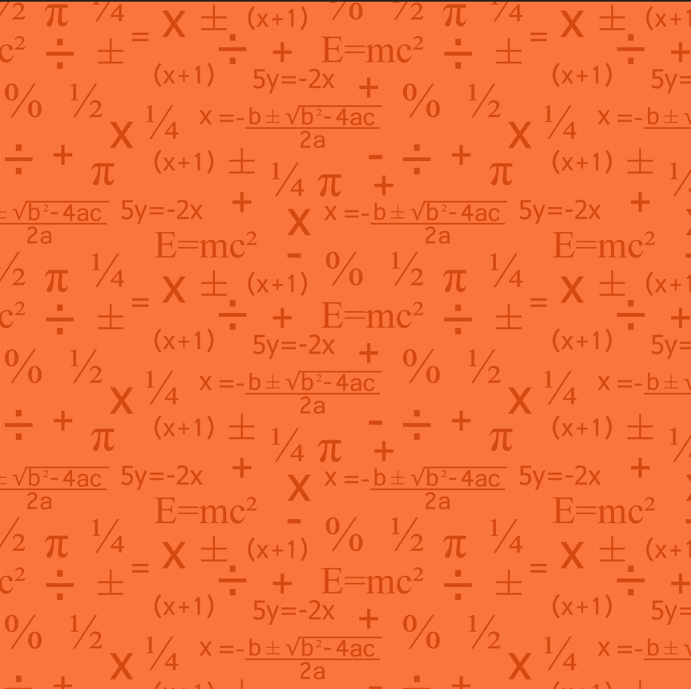
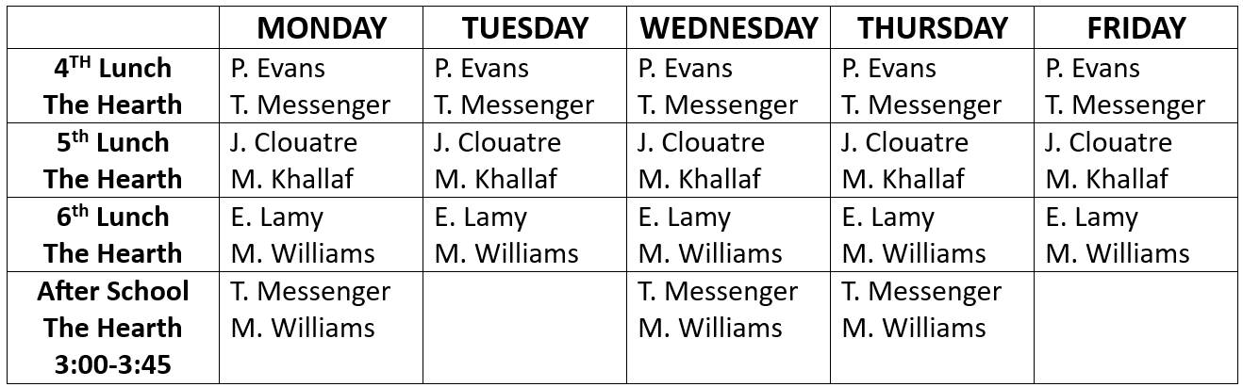
2025-2026 Math Lab Schedule

