How to Run a Report in Accudemia
- Go to Data Analytics and select Reports
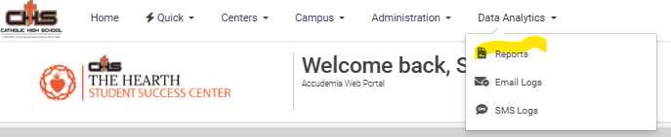
- Click on My Reports and Activity of my Students
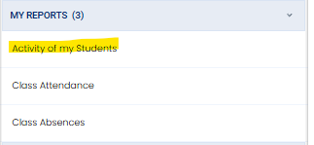
- There is a lot going on HERE! (I would recommend you focus on what I have highlighted in Yellow)
  - Date Range – Select Spring of 2026 or select specific date
  - Student – Select the student(s)
  - Run – Run the report
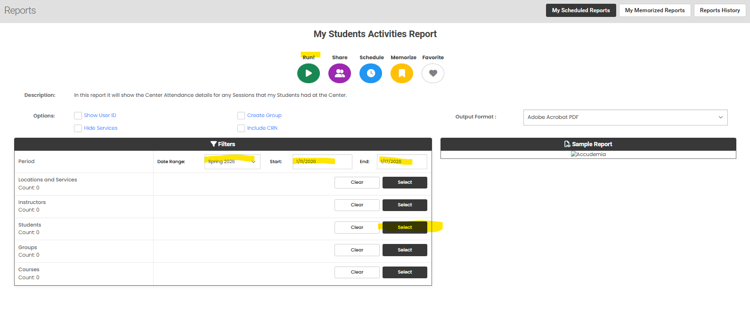
- For a more in-depth explanation on report running in Accudemia come chat with Tracy or myself. You can also just click around and try running different reports.

