How to Schedule a Make-Up Assessment
Steps:
- Go to Accudemia

- Click on Quick

- Select New Appointment
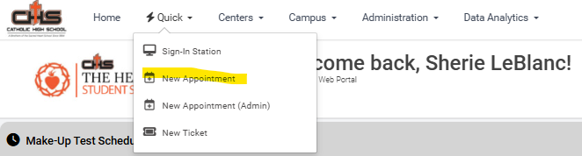

- Search for your student then click the arrow
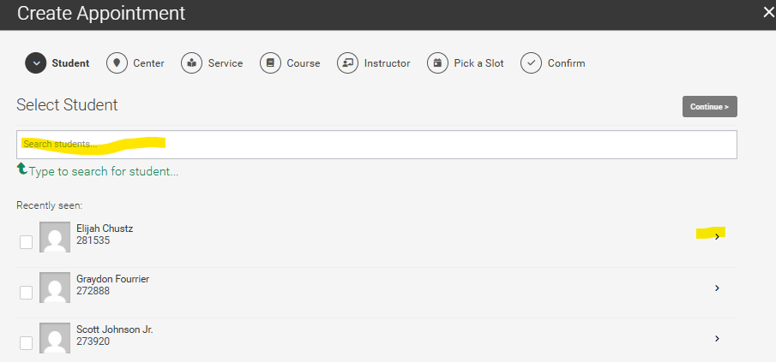
- Select The Hearth as your Center then click the arrow
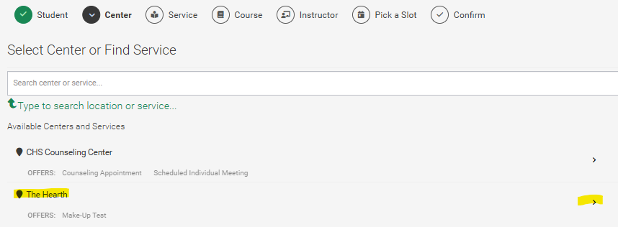

- Pick your course from the students list of courses then click the arrow
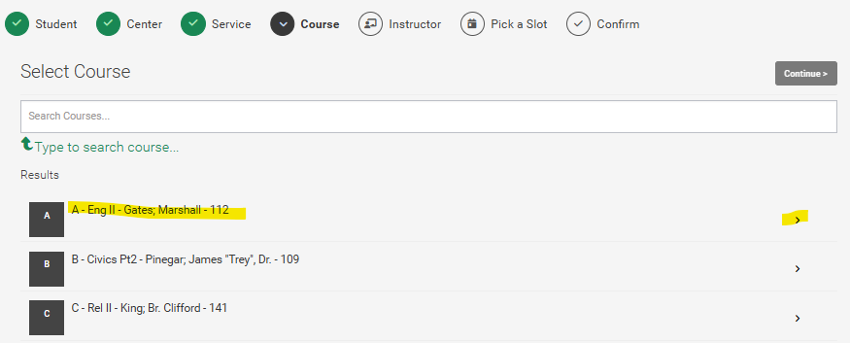

- Pick The Time and Date of when you would like your student to take the make-up
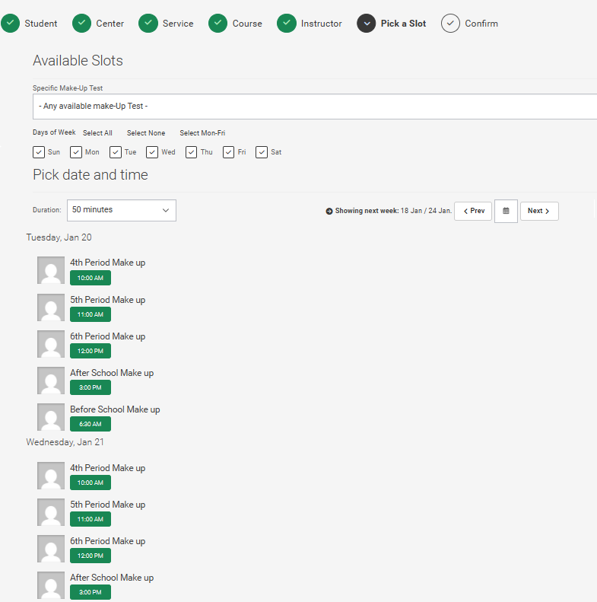

- Add any notes that we or the student may need to take the assessment.
(Students cannot see those notes until they come to the make-up)
If all is correct click confirm.
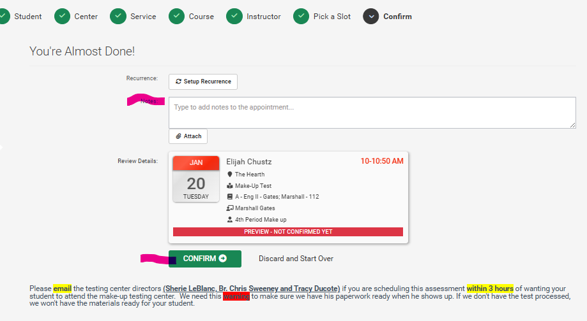

- Immediately after hitting confirm the following will happen:
  - The Student and Br. Chris will receive an email about the make-up.
  - The Student will also be sent reminder emails about the make-up.

- In Accudemia YOU CAN ALSO: (Come by for a tutorial on this at any time)
  - Make-Up Test Schedule - See all the make-up tests we have scheduled
  - Manage Center - See who has signed in and out of The Hearth
  - Upcoming Appointments – You can view all upcoming appointments
    - You can edit an appointment you have scheduled
    - You can cancel an appointment you have scheduled
    - You can see if a student has signed in for an appointment that was scheduled
  - Center News – This is where we post The Hearth Happenings for the Month

