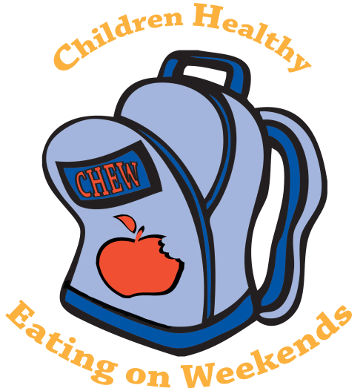
Free Weekend Food Available through
CHEW! (Children Healthy Eating on Weekends!)

CHEW! is offering a weekend supply of nutritious meals and snacks for children, free of charge. Backpacks with food will be discreetly put on the bus or given to students on the last school day before the weekend.

If you would like your child(ren) attending Northwoods Elementary school to be a part of this program, please complete the information below and return it to your child’s school Monday morning. Only one form is needed for all children in your family attending the above referenced school. Please note that not all Onslow County Schools have a CHEW! Program at this time.

Identifying information is kept confidential between CHEW! and Northwoods Elementary School. Demographic information provided in the box marked “Student Statistical Data” on the attached page will be forwarded to United Way of Onslow County for statistical data reporting purposes. The statistical data you provide may aid in acquisition of additional funding which could help ensure the sustainability of this program and help more children in need.

Once your child(ren) are signed up, they will receive a bag of food each week for the remainder of this school year, or until you no longer wish to participate. We encourage you to take advantage of this program.

If you have any questions or concerns, please contact Shayla Delekta
910-358-0803 or Shayla.delekta@onslow.k12.nc.us

Please sign my child up for CHEW! I understand he/she will receive a backpack of food at the end of each week for his/her use over the weekend. I agree to return the empty backpack the day he/she returns to school.

Child’s Name: _______________________________________________ Teacher/Grade: ________________
Special dietary needs? (Diabetic, food allergy, kosher, etc.) _______________________________________

Child’s Name: _______________________________________________ Teacher/Grade: ________________
Special dietary needs? (Diabetic, food allergy, kosher, etc.) _______________________________________

Child’s Name: _______________________________________________ Teacher/Grade: ________________
Special dietary needs? (Diabetic, food allergy, kosher, etc.) _______________________________________

Child’s Name: _______________________________________________ Teacher/Grade: ________________
Special dietary needs? (Diabetic, food allergy, kosher, etc.) _______________________________________

Do you have the following? (yes/no) Refrigerator_____, Microwave_____, Stove Top_____, Oven_____

Please Note: We do our best to strive to follow all dietary restrictions but ultimately it is the Parent’s responsibility to make sure their children do not eat the food in the bag that they are allergic to.

Parent/Guardian Name/Signature: _______________________________________________________
Telephone Number: _____________________________________
Email Address: _________________________________________

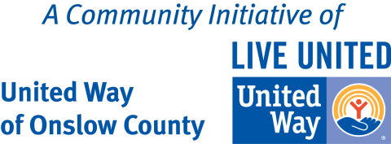

Student Statistical Data

CHEW! School Site: ________________________________________________
Number of people in your household: _________
Number of children in your household not attending this school: __________

Military Affiliation
Parent/Guardian is: Active Duty Retired/Veteran Non-Military

Student’s Age & Gender
Please select for student 1: 0-5 years 6-10 years 11-17 years Male Female
Please select for student 2: 0-5 years 6-10 years 11-17 years Male Female
Please select for student 3: 0-5 years 6-10 years 11-17 years Male Female
Please select for student 4: 0-5 years 6-10 years 11-17 years Male Female
Student’s Ethnicity
Please select for student 1: African American White Hispanic or Latino Asian Multi-Racial Other
Please select for student 2: African American White Hispanic or Latino Asian Multi-Racial Other
Please select for student 3: African American White Hispanic or Latino Asian Multi-Racial Other
Please select for student 4: African American White Hispanic or Latino Asian Multi-Racial Other

