LAGRANGE ELEMENTARY SCHOOL
SBDM Meeting
January 26, 2026| 2:40 p.m.| SBDM Council
______________________________________________________________________________

Council Members
Heather Thomas, Chair| Melinda Hadley, Teacher| Brittany Stephens, Teacher| Jamie Parker, Teacher| Danielle Barnes, Parent| Kiley Walker, Parent|
______________________________________________________________________________
Agenda Item Lead
______________________________________________________________________________

Welcome, Review Norms & Roll Call H. Thomas
- Council discussions stay within the group until the action item has been approved by the Council
- Start on time and end on time
- Maintain a focus on ensuring the learning of all students
- Be willing to share ideas and open to new learning
Approval of Agenda H. Thomas

Approval of Minutes from — Meeting H. Thomas

Council Action Items
- Policy Review of 3001, 4012 and 4008 (Enclosure A)
- Family Resource Bi-Annual SBDM/Principal Agreement (Enclosure B)

Comprehensive School Improvement Plan (CSIP) Update

Public Comment

Principal’s Report
- Math adoption T. Clark
- Budget Review H Thomas

Adjournment H Thomas

La Grange Elementary
School-Based Decision-Making Council
November 17, 2025
The La Grange Elementary School Site Based Decision Making Council met at LaGrange Elementary for the regularly scheduled SBDM meeting with the following members in attendance: Kiley Walker – Parent Rep, Danielle Barnes – Parent Rep, Jamie Parker – Teacher Rep, Melinda Hadley – Teacher Rep, Brittney Stephens – Teacher Rep and Heather Thomas - Chair. Brooke Ferris, 1st Grade teacher, also joined the meeting.
Mrs. Thomas called the meeting to order at 2:40 pm.
1) A motion was made by Melinda Hadley and seconded by Brittney Stephens to accept the agenda with the following change: Brittney Stephens’ name was inadvertently left off Council Members. The motion was approved with no opposition. A motion was made by Jamie Parker and seconded by Melinda Hadley to accept minutes from the previous meeting with a minor correction. Peggy Brissette’s name was misspelled in #2 of the minutes. Under #9, it should have read as follows: “She also discussed the KSA data that is in the assessment and that KSA scores have not been made available to the public yet. The corrections were made, and the motion was approved with no opposition.
2) Mrs. Thomas reviewed SBDM Policy 1003 – Staff Time. Under the category Procedure, the following changes were recommended: the 3rd paragraph should read:
a) Each certified specialist area teacher shall maintain a daily schedule built with a focus on student achievement. Special education teachers will maintain a classroom schedule with pull-out services kept to a minimum and only where specified by a student’s individual education plan (IEP) or program services plan (PSP…
A motion was made by Brittney Stephens to approve the policy with the change. The motion was seconded by Kiley Walker and passed unanimously.
3) Mrs. Thomas reviewed SBDM Policy 1007 – Determination of Use of School Space During the School Day. Minor changes were made in Section A. The words “determined by the district” were removed. In Section D the words “with assistance from the School Climate committee” were removed. A motion was made by Jamie Parker to accept the policy with the changes. The motion was seconded by Danielle Barnes and passed unanimously.
4) Mrs. Thomas reviewed the CSIP with the Council. She explained that KSA scores are still embargoed at the time of Council’s meeting. As soon as the embargo is lifted, she will share KSA data results. A motion was made by Jamie Parker to approve the 2025-2026 CSIP plan for LaGrange Elementary. The motion was seconded by Kiley Walker and passed unanimously.
5) Mrs. Ferris exited the meeting at 3:23 pm
6) The Council entered Closed Session to discuss Certified Personnel Selection per KRS 61.801 (1) (f) for discussions that might lead to the appointment of an individual employee at 3:23 pm. The Council exited the Closed Session at 3:25 pm.
7) With no further business to discuss, a motion was made by Kiley Walker to adjourn. The motion was seconded by Jamie Parker. The meeting adjourned at 3:27 pm.

December 8, 2025
The La Grange Elementary School Council met in a special-called session with the following members in attendance: Jamie Parker (teacher), Kiley Walker (parent), Danielle Barnes (parent) and Heather Thomas (chair), called the meeting to order.
1. The meeting was called to order at 7:11 AM
2. The Council reviewed and approved the agenda.
3. The Council entered a closed session to discuss certified personnel selection as
provided by KRS 61.810 (1)(f) at 7:15 AM.
4. The Council resumed open session at 7:16 AM.
5. With no further business, the Council adjourned.

December 12, 2025
The La Grange Elementary School Council met in a special-called session with the following members in attendance: Melinda Hadley (teacher), Jamie Parker (teacher), Brittany Stephens (teacher) and Heather Thomas (chair), called the meeting to order.
1. The meeting was called to order at 10:00 AM
2. The Council reviewed and approved the agenda.
3. The Council entered a closed session to discuss certified personnel selection as
provided by KRS 61.810 (1)(f) at 10:03 AM.
4. The Council resumed open session at 10:10 AM.
5. With no further business, the Council adjourned.

January 26, 2026
Enclosure A

La Grange Elementary School Council
Oldham County Schools

CONCERN:

The phrase council policies refer to what the school council develops and adopts concerning how the school operates. This includes such items as curriculum development, determining school schedules and technology use in schools. Policies are the rules, guidelines and procedures for school operations.

DISCUSSION:

School council policies need to contribute to raising student performance and keep a focus on achieving our mission and goals. As our goals and procedures evolve, the council needs to review our policies to determine if and how they need to be revised.
In regards to policy 3001 with minor suggestions (see highlights and additions in red font) for clarification, Policy 4012 Attendance with changes regarding parent notes, and 4008 School Wellness with changes regarding parent notes. Policy 4008 Wellness Policy with one addition in red.

RECOMMENDATION:

Discuss council policy 3001, 4012 and 4008 to make revisions, ask questions and seek additional information if needed. Pending no additional questions, approve policy revision as presented.

SCHOOL BUDGET 3001
TOPICS | STATEMENTS
a. Budgeting Process | In compliance with KRS 160.345(3), a school budget shall be prepared annually based on the allocation from the Board. All funds received by the school from the Board shall be included in the budget. The budget shall include a complete financial forecast of both anticipated receipts and the expenditures for the school year, including staffing, and shall be prepared on forms approved by the Superintendent  Prior to the end of the school year, each staff group within which will be involved in a particular activity account shall be required to develop a working budget and an explanation of expenditures. This budget shall be the work of the members of the group.
b. Council Approval | The Principal, with assistance from the Team Leaders if there are changes in the budget according to SBDM approved per grade amounts, shall submit and recommend a draft budget within the allocation level approved by the Board for the Council's consideration. The principal shall recommend approval of the annual school budget by the Council for the preceding year or no later than three weeks after receipt of notice of final allocation of funding from the Board.
c. Expenditures | Expenditures of funds allocated to the school shall be pursuant to all fiscal policies of the Board. Funds may be moved from one activity account to another only with the approval of the principal. The principal shall approve each expenditure. Expenditures shall not exceed appropriations.
d. Audit | Accounting for funds shall be pursuant to all fiscal and audit policies of the Board. The audit shall be reported to the Council.

STUDENT ATTENDANCE POLICY 4012

Topics | Statement
Purpose | The purpose of the La Grange Elementary School Attendance Policy is to foster the understanding and emphasize the importance of regular school attendance. Students are expected to be in attendance each day for the full instructional period from 7:40 a.m. to 2:20 p.m. Research shows that there is a far greater risk of academic failure and an increased dropout rate for students who do not attend regularly. We are striving to create an atmosphere conducive to learning, creativity, and character growth that encourages students to attend.
Commitment | The faculty and staff of La Grange Elementary School will work to help each child internalize the expectation that attendance is important so he/she can experience the feeling of pride and belonging that comes from being a regular part of our school community. Students and classes with outstanding attendance will be recognized. It is our hope that this plan will lead to increased attendance.
Excused | Excused absences shall include 8 parent notes illness of the student, serious illness in the immediate family, medical appointments, funerals, acknowledged religious holidays, or military deployment of an immediate family member, educational enhancement opportunities and court proceedings per the state statute. Parents are encouraged to make after-school or weekend doctor appointments. Upon returning to school following an absence, a child is required to bring a note from his/her parent/guardian, doctor or dentist stating the reason for the absence. This note should be given to the student’s homeroom teacher within 5 days of an absence or tardy. After the fifth day, the note can no longer excuse an absence or tardy. Eight parent notes, for either tardies or absences, are permitted as an excused absence if the absence aligns with the acceptable reasons listed above. Family trips or any other reason not listed above will be unexcused.  A doctor’s authorization must be provided for an absence to be excused if a student is absent on the day prior to a scheduled break as well as the day immediately following a scheduled break in accordance with the approved school calendar.  Tardies are recorded, including early dismissals and may accumulate to become half or full day absences.
Unexcused | After three unexcused events the 1st letter is sent and after six unexcused absences the 2nd letter is automatically generated by the Board of Education and mailed to the guardian. If school personnel are unsuccessful in improving the attendance of the child, the Director of Pupil Personnel will be contacted for further inquiry. Per district policy, when a student accumulates a total of eight full-day absences, a doctor's authorization is required for subsequent absences. If irregular attendance still persists after the parent/guardians have been contacted by the school personnel and the Director of Pupil Personnel concerning the importance of regular attendance and the legal responsibilities of the parents/guardians, the Director of Pupil Personnel, upon the ninth unexcused absence, will then request a juvenile court appearance.  Kentucky’s Compulsory Attendance Law KRS 159.150 states “Any child who has been absent from school without a valid excuse for three or more days, or tardy without a valid excuse on three or more days is a truant. Any student who has been reported as truant two or more times is a habitual truant.”
House Bill 6011 | Kentucky's new student attendance law, House Bill 611, requires schools to report students with 15 or more unexcused events to the local county attorney's office. The law went into effect this school year to address the increase in truancy in the state
Celebrations | Students with perfect attendance will be recognized at the end of the school year. Monthly and daily school attendance celebrations will be used to encourage and reward students’ attendance.

SCHOOL WELLNESS POLICY 4008
Topics | Statement
- Nutrition Education | In compliance with KRS 160.345 (11), all students will be provided nutrition education that will encourage and support healthy eating. The curriculum  - Is designed to provide students with the knowledge and skills necessary to promote and protect their health;  - Is integrated, to the extent practicable, into other classroom instruction through subjects such as math, science, language arts, social sciences and elective subjects  - May include enjoyable, developmentally-appropriate, culturally-relevant and participatory activities, such as cooking demonstrations or lessons, promotions, taste-testing, and farm visits.  - Promotes fruits, vegetables, whole-grain products, low-fat and fat-free dairy products and healthy food preparation methods;  - Emphasizes caloric balance between food intake and energy expenditure (promotes physical activity/exercise);  - Links with school meal programs, cafeteria nutrition promotion activities, Farm to School programs, other school foods and nutrition-related community services;  - Teaches media literacy with an emphasis on food and beverage marketing;  - Assesses social influences on healthy eating, including media, family, peers and culture  - Encourages looking for valid information or services related to nutrition and dietary behavior  - Emphasizes tracking progress toward achieving a personal goal to eat healthfully  - Encourages resisting peer pressure related to unhealthy dietary behavior  - Influences supporting or advocating for others’ healthy dietary behavior
- School Meals | We will encourage healthy meal choices among students by using the following methods:  - The school shall make every effort to encourage students to participate in the school breakfast and lunch programs, and possible snack provided through a federal grant and distributed through the school food service program, by working with district staff to appeal to the students’ taste preferences (i.e. food promotions, grab-and-go options, smoothies, student input on menu items, etc.)  - After obtaining food, students will have 25 minutes to eat lunch in a clean, pleasant environment with appropriate supervision.  - All school meals will meet current USDA nutrition standards which can be found at the USDA website: https://www.usda.gov/wps/portal/usda/usdahome  - Nutrition information for meals will be made available in the cafeteria.  - The healthiest choices at each meal, such as salads and fruit, will be prominently displayed in the cafeteria.  - Students will be made aware that free, safe, unflavored drinking water is available throughout the school day, including mealtimes.  - Parents are encouraged to consider healthy options if bringing food in during the lunch period.  La Grange received a grant allowing all students to receive free lunch.
- Competitive Foods and Beverages | To support children’s health and school nutrition-education efforts, only Smart Snacks and beverages are served or sold during the official school day or including after-school Leopard Spot program. View Smart Snacks Standards here: https://www.fns.usda.gov/healthierschoolday/tools-schools-focusing-smart-snacks
- Physical Education and Physical Activity | We will encourage physical activity among students using the following methods:  - The physical education curriculum will be aligned with established state and national physical education standards and teacher-student ratios are equivalent to the other class sizes within the building.  - The physical education curriculum will promote the benefits of a physically-active and healthy-eating lifestyle and will help students develop skills to engage in lifelong healthy habits  - All students will receive at least 60 minutes per week of physical activity throughout the school year.  - All students will be provided equal opportunity to participate in physical education classes. Appropriate accommodations will be made to allow for equitable participation for all students and we will adapt physical education classes and equipment as necessary.  - Physical education will be taught by a certified teacher who is endorsed to teach physical education.  - The physical education teacher will participate in annual professional development opportunities that are focused on physical education topics and competencies specifically for physical education teachers.  - The school will develop and implement a comprehensive school physical activity program that provides 20 minutes of movement throughout each school day for all students. Physical activity shall not be used as punishment or shall not be withheld as punishment.  - All students will be offered periodic opportunities to be active or to stretch throughout the day.  - The physical education program will promote student physical fitness through individualized instruction.
- Wellness Promotion and Marketing | The School Wellness Committee and the School Wellness Coordinator will develop, promote and oversee a multifaceted plan to promote health and wellness and ensure the following:  - LaGrange will remain a food free school with the exception of Principal approved, PTA sponsored events that will include an entire class, grade and/or school wide.  - Physical activity shall be used as a reward when feasible  - Walking/biking to school is encouraged with parent permission.  - Nutrition and physical activity will be incorporated into family events provided throughout the school year.  - Any foods/beverages marketed or promoted to students on the school campus during the school day will meet or exceed the USDA Smart Snacks standards.

January 26, 2026
Enclosure B

La Grange Elementary School Council
Oldham County Schools

CONCERN:

La Grange Elementary, based on our percentage of free and reduced lunch numbers, is designated as a Family Resource Center School. If the FRYSC is assigned to serve one School Based Decision Making (SBDM) school, the authority of the SBDM Council, as defined in KRS 160.345, applies to the FRYSC. The SBDM Council has the authority to determine which “school-based student support services” shall be available at the school. A school, which makes an application for center funding, must receive a review and approval by the SBDM Council as to the proposal for services, which the school has submitted. The proposal is to include, pursuant to KRS 156.4977 (4) (f) “[a] description of the development, composition, and role of the local advisory council.” The SBDM/Principal Agreement that is part of the FRYSC New or Continuation Program Plan verifies the review every two years.

DISCUSSION:

Our Family Resource Center has the primary goal of removing non-academic barriers to learning as a means to enhance student academic success. In reviewing our FRC Continuation Program Plan, we must ask ourselves if the program and services suggested meet the needs of our population.

RECOMMENDATION:

Review and certify that our school policies are consistent with FRYSC-related statutes by approving the FRC Continuation Program Plan as presented.

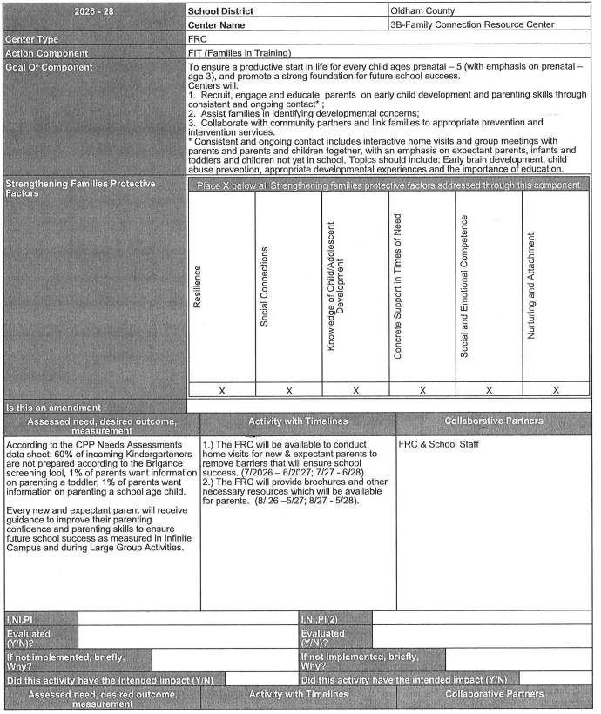
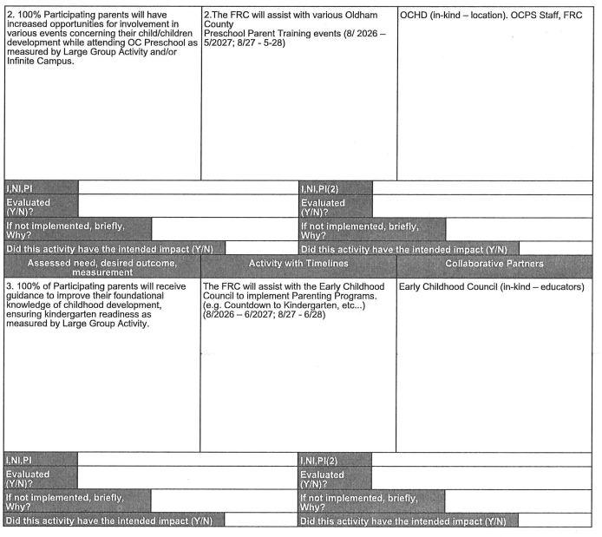
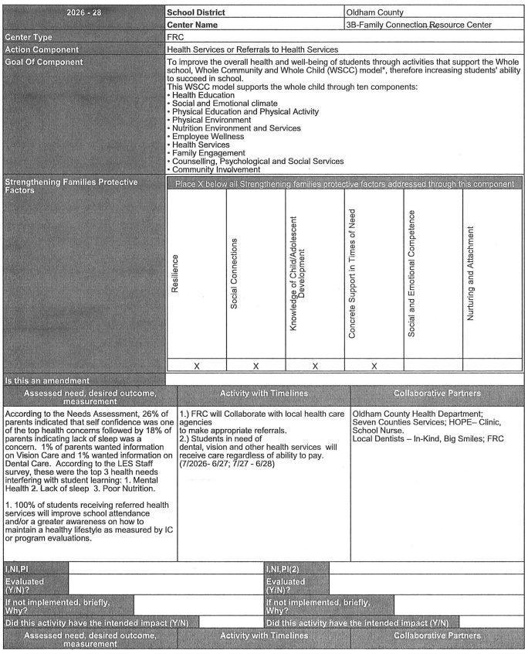
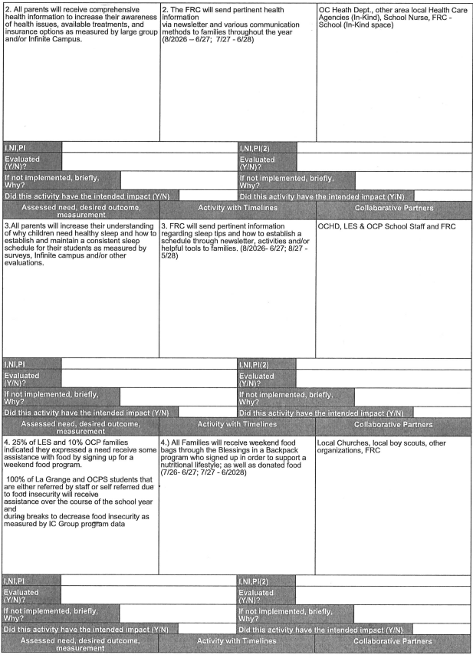
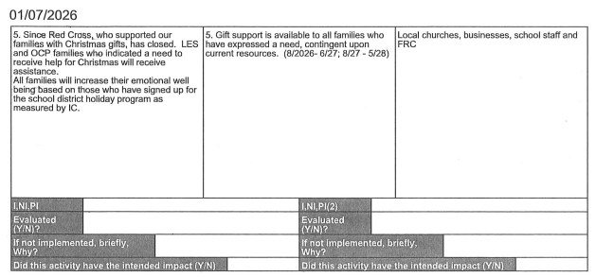
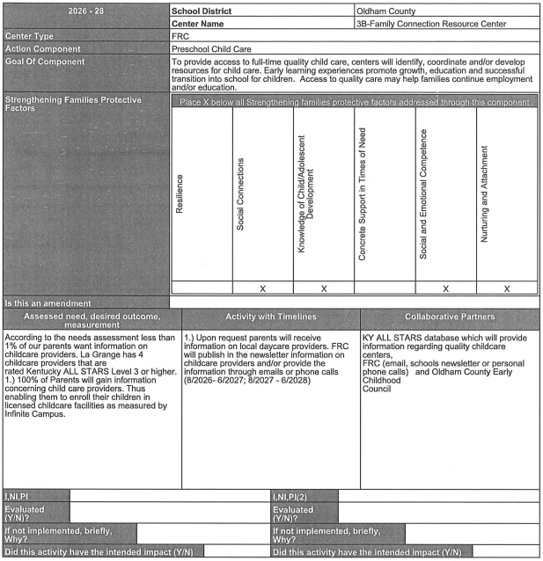
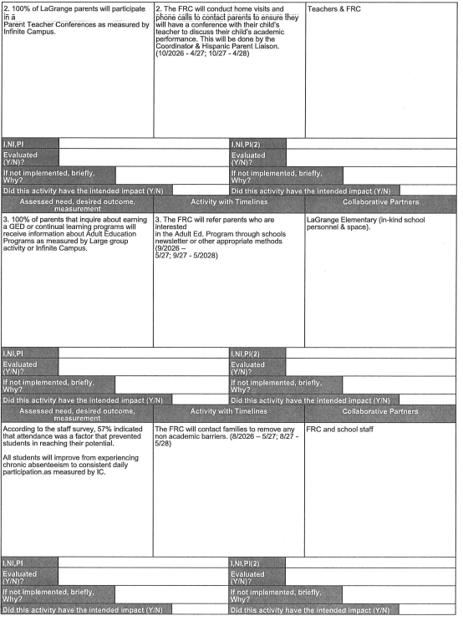
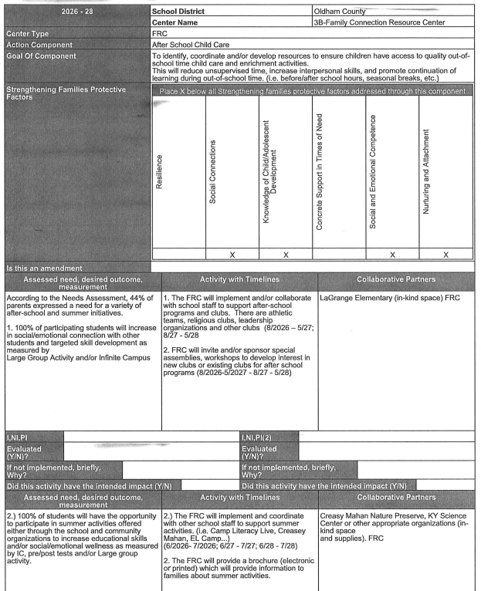
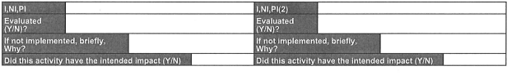

Principal Report
Math Curriculum Adoption T. Clark
Budget Review
Our school-based decision making (SBDM) council is responsible for reviewing and approving the school's annual budget. The budget covers allocations for staffing, operational costs, and other school-specific funds. Annual budgets are reviewed in the spring, however, it’s important to review our finances on a regular basis throughout the year.
La Grange has five categories of funding which include Fund 21, Leopard Spot, Discretionary, Section 6 and Family Resource. A short description of each category and current balance are listed below.

Category | Description | Oct | Jan | March | Usable Funds
Fund 21 | Student fees, building projects and donations.The school can access Basic fees, General and Interest/Copies | $57,700 | $58,000 |  | $14179 can be used for general purposes
Leopard Spot | A minimum of three months expenses need to remain in the account | $212,831 | $147,000 |  | Withholding $60,000 for contingency
Discretionary | Funds moved from Leopard Spot and 20% Section 6 can be rolled over at the end of the year | $104,932 | $ 75, 049 |  | Funds to be used for extra payroll expenses, PD, and workbooks
Section 6 | This is the money given by the state, based on the per child amount. This can be used for staffing and grade-level/department funds. | $41,130 | $34,040 |  | $12572 can be rolled  $21, 540 available funds
Family Resource | Funds cover the salary for our FRC and remaining funds are divided into multiple categories to support La Grange and the Preschool | $51,354 | $30,800 |  | Remaining funds will cover payroll

