Scholarships – Scholarship Workshops – Scholarship Resources
Marianne Ragins, Northeast High School Graduate
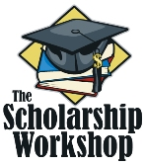




  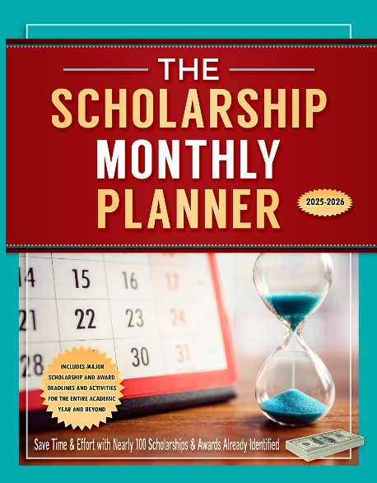
Dear Students, Advisors & Families,

It’s January of a New Year! 🎊

While many students are still easing into the year, those who take action now can find and apply for major opportunities to reduce college costs. It’s important to get started now, before this month ends, because as spring approaches, high-value scholarship opportunities will begin to decrease. Smaller local opportunities will still be available, but there will be fewer large-award options.

Use this January Scholarship Checklist to start strong and stay ahead.

🎯 Set Your Scholarship Goals for the New Year

A clear plan turns resolutions into results.
- Review scholarship deadlines for January–March. See The Scholarship Monthly Planner to help.
- Break big goals into weekly action steps
- Commit to consistent scholarship time each week
- See Winning Scholarships for College for help with your plan.

✍️ Refresh & Finalize Your Essays

New year, stronger stories.
- Update your scholarship and college essay with recent achievements
- If possible, refine essays to include:
- Leadership and service
- Academic growth or challenges overcome
- Community service
- Career and college goals

- Tailor essays for each scholarship—small tweaks make a big difference.
- See Winning Scholarships for College and The Scholarship and College Essay Planning Kit for help.
- Attend The Scholarship & College Essay Writing Boot Camp for specific guidance

🔍 Apply for January Scholarships
January is packed with deadlines. The Scholarship Monthly Planner can help.
Focus on:
- Local and community scholarships
- Scholarships with January–February deadlines
- Major- and career-specific awards

💡 Don’t skip smaller scholarships—less competition can add up to big savings. Review “The Local Scholarship Search: Finding Scholarships in Your Backyard” in Winning Scholarships for College.

🤝 Secure Recommendation Letters
Start early and stay organized.
- Create a recommendation chart
- Provide each recommender with:
- An updated résumé or list of extracurricular activities
- Specific information and a link for each scholarship you are requesting a recommendation
- Send polite reminders 2–3 weeks before deadlines
- Refer to this chapter “The Art of Getting Good Recommendations and Requesting Nominations” in Winning Scholarships for College for additional help.

🗂️ Get Organized for Scholarship Success
Strong systems = less stress.
- Update your scholarship tracker or spreadsheet
- Organize key documents:
- Essays
- Transcripts and test scores
- List of extracurricular activities
- Recommendation request charts
- Check email daily (including spam folders!) for opportunities and updates
See the chapter, “Getting Organized” in Winning Scholarships for College for more information.

🌟 Build Your 2026 and Beyond Scholarship Profile
Everything you do this year can help you win money.
- Start or continue volunteering
- Take on leadership roles at school or in your community
- Get a job, internship, or research experience
- Plan a service or passion project you can grow all year

If you’re a parent or student who wants to start the scholarship process early or learn more with step-by-step guidance from Marianne Ragins, consider attending The Scholarship Boot Camp tomorrow. Or check out our other resources in our bookstore, www.scholarshipworkshop.com/bookstore.

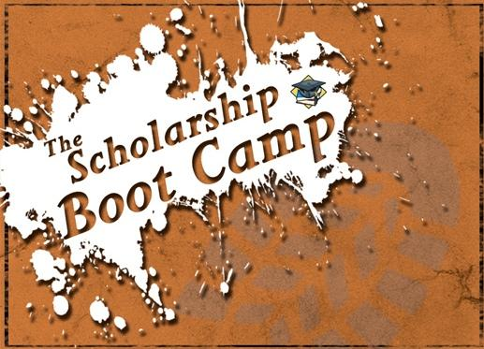

Upcoming Virtual Scholarship Boot Camp + Other Virtual Sessions
﻿
THE SCHOLARSHIP BOOT CAMP *
- A LIVE Virtual Boot Camp
February 22, 2026 - 2:00 pm to 5:15 pm ET
If you can't attend, consider The Scholarship Success Toolkit.

THE SCHOLARSHIP CLASS FOR HIGH SCHOOL STUDENTS AND THEIR PARENTS* - A LIVE Virtual Session
January 27, 2026 - 8:00 pm to 9:30 pm ET

SCHOLARSHIP, FELLOWSHIP & GRANT INFORMATION SESSION FOR STUDENTS ALREADY IN COLLEGE, RETURNING TO COLLEGE, AND PURSUING GRADUATE SCHOOL* - A LIVE Virtual Session
February 22, 2026 - 12:00 pm to 1:30 pm ET

THE SCHOLARSHIP & COLLEGE ESSAY WRITING BOOT CAMP * - A LIVE Virtual Session
January 28, 2026 - 8:00 pm to 9:30 pm ET.
﻿
* Virtual class attendees become eligible for the Ragins/Braswell National Scholarship.



THURSDAY, FEBRUARY 5
6:30 PM to 8:30 PM ET

Learn early steps to accumulate and manage money as a student, including how you can earn scholarships as young as age 6 to pay for your dream college or university.

sponsored by Reston Community Center in Reston, Virginia

Attend Money Matters (a virtual session) with
Marianne Ragins, $400,000 scholarship winner and learn her strategies.
THIS SESSION IS OPEN TO THE PUBLIC.
YOU DO NOT NEED TO LIVE IN RESTON, VIRGINIA TO ATTEND.

Marianne Ragins, $400,000 scholarship winner and author of Winning Scholarships for College and Senior Year Head Start, will help students of all ages, including middle school and high school students, understand how to manage money. Marianne will discuss savings, credit cards, budgeting, identifying needs versus wants, simple investing tactics, and ways to tackle college costs early to minimize student loans. Parents are encouraged to attend with their students.

See scholarshipworkshop.com/rccmoneymatters for more information
and to register to attend.

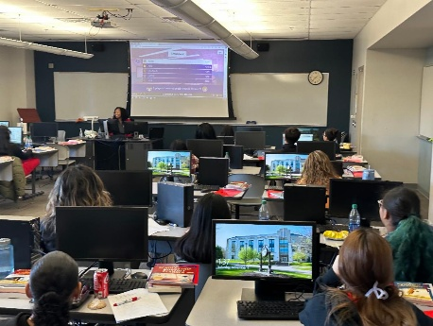

SCHEDULE A SESSION FOR YOUR STUDENT OR PARENT GROUP!

﻿Marianne has specialized virtual and in-person workshops and boot camps for high school and middle school students, current college students, and graduate students. Marianne frequently works with TRIO and other student focused programs.

﻿
﻿See this page to schedule a workshop for your group TODAY!

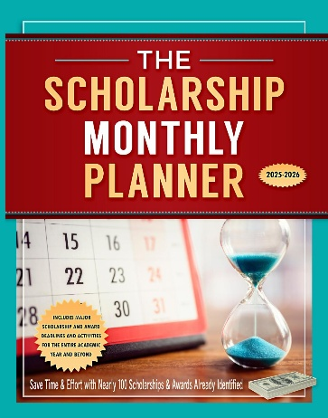

Upcoming Scholarship Deadlines

FOR CURRENT COLLEGE, HIGH SCHOOL AND IN SOME CASES, YOUNGER STUDENTS (ELEMENTARY AND MIDDLE)

January 20 - C-Span Student Cam competition- open to students in grades 6-12 who create a short 5 to 6 minute video documentary on a topic that relates to the competition theme. Prizes up to $5,000 available.

January 30 - Technology Addiction Awareness Scholarship - $1,000 scholarship open to high school students, undergraduate, and graduate students. This scholarship is also open to older students.

January 31 - I Have a Dream Scholarship - up to $1,500 for students 13 years of age or older, including current college students.

January 31 - Flavorful Future Scholarship - $5,000 scholarships available to high school seniors
﻿

To get more upcoming deadlines and learn about them months in advance, see The Scholarship Monthly Planner.

Scholarship eBooks are Available

  
  ﻿If you love the convenience of digital information, many of our resources are available for immediate download on Kindle, Nook, and other e-readers. See this page for more information.

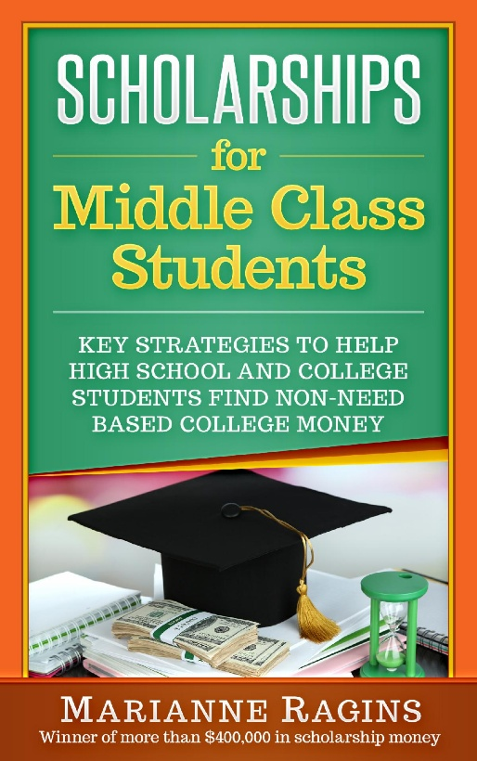

Do You Need More Information?
Get One of Our Popular Student Resources
on Amazon, Barnes & Noble or Our Bookstore

- Winning Scholarships for College - Everything you need to know about winning NOT just finding scholarships.
- The Scholarship Monthly Planner 2025-2026 - Helps students get organized to find scholarships and stay on track to apply for scholarships.
- The Scholarship and College Essay Planning Kit - Helps slow starters get their essays started AND finished.
- Senior Year Head Start - Get started BEFORE senior year winning scholarships and awards.
- Last Minute College Financing Guide - Helps you find college money late in your high school senior year and beyond.
- College Survival & Success Skills 101 - Helps students get off to a fast start in college, avoid pitfalls, and do well the 1st year and beyond.
- Scholarships for Middle Class Students - Helps middle class students and families find college money.
- Scholarships for College Students - Helps students who have already started college find and win money to continue.
- Scholarships for Average Students - Students without the highest grades and test scores can discover scholarship options that work for them.
Our resources are also available in the bookstore on our website. See www.scholarshipworkshop.com/bookstore.
*Note: We participate in Amazon Associates and earn a small commission from your Amazon purchases.

 | Share This Email

 | Share This Email

 | Share This Email

The Scholarship Workshop from Marianne Ragins, $400,000 Scholarship Winner & Author | P. O. Box 176 | Centreville, VA 20122 US

Unsubscribe | Update Profile | Constant Contact Data Notice



