Project Checklists

Poem/Song Lyrics Performance Project Checklist

✅ Project Focus (Choose 1+ to Include)
My original poem/lyrics reflects at least one or more of the following:
- Characters/Persons – highlights personalities, challenges, and journeys
- Setting – explores how the setting impacts the plot
- Theme – communicates the core message/ideas in the book
- Major Conflict – showcases major struggles or turning points
- Symbols – explores a key object/image/idea central to the story/theme
✅ Requirements Checklist

Original Work
- My poem/lyrics is 100% my original work.
- My poem/lyrics clearly connects to the book through at least one focus area listed above.
- My poem/lyrics is appropriate for school (clean language and appropriate content).

Printed Copy Submission
- I will submit a printed copy of my poem/lyrics on the day of the competition.
- My printed copy includes all required information:
  - Book Title
  - Book Author
  - Title of Poem/Song
  - Student Name
  - (If partners) Partner Name(s): ________________________________

✅ Presentation Checklist

Time Limit
- My performance is 3 minutes or less.

Introduction (Must Include All)
Before performing, I will introduce:
- My name (and partner name if applicable)
- The book title
- The author
- The title of my original poem/song
- What interested me about the character/person/symbol/theme/etc.
- Why the story/message is meaningful to me

Performance
- I am prepared to perform for a panel of judges.
- My performance style matches expectations:
  - Poetry reading style (spoken)
  - OR lyrics may be sung
- I will express the emotion and meaning of my work through my voice and delivery.

✅ Rules
- No AI was used at any stage in creating this poem/lyrics.
- I worked:
  - Individually
  - With a partner

✅ Tips for Success Checklist
- I chose a book I genuinely connect with.
- I used creative techniques (metaphor, simile, imagery, repetition, etc.).
- I included key moments/objects/themes that show deeper meaning.
- If working with a partner, we divided tasks based on strengths:
  - Writer focus
  - Performer focus
  - Shared roles
- We practiced together to make the performance smooth and coordinated.
- I rehearsed multiple times to build confidence.
- I will engage the judges/audience by:
  - Making eye contact
  - Using appropriate gestures
  - Speaking/singing clearly and confidently
  - Performing with meaning and passion

Diorama Drama: Bringing Books to Life ✅ Checklist

✅ Competition Goal
- I created an original 3D diorama that shows a scene from a book I read.
- My book is:
  - Fiction
  - Nonfiction

✅ Diorama Focus (Choose 1+ to Highlight)
My diorama clearly shows one or more of the following:
- Characters/Persons – personalities, challenges, journeys
- Setting – how the setting impacts the plot
- Theme – the big message/lesson of the book
- Major Conflict – key struggle/turning point that drives the story
- Symbols – an important object/image/idea in the story

✅ Requirements Checklist

Original Work
- My diorama is my own original creation based on my interpretation of the book.
- No AI was used in creating this project.

Size & Materials
- My diorama is no larger than: 12” × 12” × 24” (L × W × H)
- I used school-appropriate materials only.
- My diorama is transportable (easy to carry safely).
- At least 60% of my project is handmade.
Materials used (optional checklist):
- Fabric
- Paper
- Paint
- Clay
Other: __________________________

Label
- My diorama has a label that includes:
  - Book Title
  - Author
  - Chapter OR scene name/description

✅ Display & Presentation Checklist

Presentation Expectations
- My diorama is ready to be displayed for judges.
- I am prepared to present and answer questions about my project.
- My presentation stays within the 3-minute time limit.

What I Must Say to the Judges
Introduction
- I introduced myself.
- I stated the book title and author.
- I explained why I chose this book.
Diorama Overview (Explain using my focus areas)
I am ready to explain key story elements, such as:
- Characters: personalities, challenges, relationships
- Theme: main message and how it shows up in the story
- Major conflict/events: turning points and how they affect the story
Setting: how the location/time affects events
- Symbols: key object/image/idea and meaning
Student Connection
- I explained what interested me about the book.
- I explained why the story is meaningful to me.

✅ Tips for Success Checklist
- I chose a scene that has strong visual details and is important to the story.
- I sketched/planned my layout before building.
- My characters/props are arranged clearly to show what’s happening.
- I used creative materials/textures to make it stand out.
- My diorama is sturdy and all parts are securely attached.
- I practiced explaining my diorama clearly and confidently.

“Read & Reel: Video Promotion ✅ Checklist

✅ Step 1: Choose Your Focus (Pick 1 or More)
My video highlights at least one of these book elements:
- Characters/Persons – personalities, challenges, and journeys
- Setting – how the setting impacts the story
- Theme – the core message/idea of the book
- Major Conflict – key struggles/turning points
- Symbols – an important object/image/idea

✅ Step 2: Video Requirements

Original Work
- My video is my original work and reflects my interpretation of the book.
- My video clearly connects to at least one focus area from Step 1.

Time Limit
- My video is 3 minutes or less.

Video Style Options
- My video format is one of the following:
  - Live action
  - Stop motion
  - Animation

File Format + Submission
- My video file is in an acceptable format:
  - MP4
  - MOV
  - Other: ____________________
- I uploaded my video to Google Drive.
- I created a viewable share link (anyone with the link can view).
- I tested the link to make sure it works.

✅ Step 3: Copyright + Credits Requirements
- All music, visuals, and video are original OR used with permission.
- My video includes credits at the end listing any sources/materials used.
- I understand that by submitting, I give permission for the video to be shared in the competition.

✅ Step 4: Presentation Requirements

Introduction (Must Say All of These)
Before the video plays, I will introduce:
- My name (and group members if applicable)
- Book title
- Author
- Title of my video
- What interested me about the character/theme/conflict/setting/symbol, I highlighted
- Why the story or message is meaningful to me

Opening Credits (In the Video)
My video begins with opening credits that include:
- Book title
- Author
- Chapter or scene represented
- Director: student name(s)

✅ Rules
- No AI was used in creating the video.
I worked:
  - Individually
  - In a small group (up to 4 students)
Group members (if applicable):

✅ Tips for Success Checklist
- I chose a book I connect with and can promote confidently.
- I created a storyboard (plan) before filming.
- I included clear scenes/visuals/text/voiceovers to make the trailer flow smoothly.
- I used music/sound effects thoughtfully (and legally).
- I practiced my introduction for the judges.
- I stayed within the 3-minute time limit.
- I tested the file and Google Drive link before submitting.

🎬 Digital Tools You May Use
- iMovie
- Canva
- Adobe Spark

Project Descriptions/ Rubrics

Middle School Project #1

“Lyric Lab: A Celebration of Books in Verse”

Competition Overview

You will create an original piece of poetry or lyrics that showcase a book you’ve read. You may choose fiction or nonfiction; however, the poem or song lyrics should focus on at least one or more of the following aspects:

- Characters/Persons – Highlight the personalities, challenges, and journeys of the characters/persons.
- Setting - Explore the impact of the setting on the plot.
- Theme – Explore the core message or ideas presented in the book.
- Major Conflict – Showcase the key struggles or turning points that drive the story.
- Symbols - Explore a key object/image/idea central to the book’s story or theme.

Requirements

- Original Work: Your poem or lyrics must be your own original work and should reflect at least one or more of the following aspects:
  - Characters/Persons – Highlight the personalities, challenges, and journeys of the characters/persons.
  - Setting - Explore the impact of the setting on the plot.
  - Theme – Explore the core message or ideas presented in the book.
  - Major Conflict – Showcase the key struggles or turning points that drive the story.
  - Symbols - Explore a key object/image/idea central to the book’s story or theme.
- Printed Copy: Submit a printed copy of your poem or lyrics on the day of the competition. The printed copy should have the book title, the author of the book, as well as the title of the poem, and the student's name.
- Presentation:
  - Time Limit: Each performance should be no longer than 3 minutes.
  - Introduction to Performance: Students must introduce themselves, provide the title of the book, name the author, and the title of the original poem/song. Explain what interested you about this character/person/symbol and why you find their story meaningful.
  - Performance: You will perform your poem or lyrics for a panel of judges. Be ready to express the emotions and message of your piece through your performance. Performance should be conducted in “poetry reading” style or lyrics may be sung.
- No use of AI in the creation of the project.
- Students may work in pairs or individually.

Tips for Success
- Choose a Book You Connect With: Pick a book that deeply resonated with you or one you are passionate about
- Be Creative with Your Interpretation: Think outside the box—explore metaphors, similes, and other literary devices to convey your message. Highlight moments or objects that reflect the deeper meaning of your chosen aspect.
- If working in pairs: Divide tasks based on each person’s strengths—one can write while the other focuses on performance. Practice together to ensure a seamless presentation.
- Practice Your Performance: Rehearse multiple times to feel confident about your delivery.
- Engage with the Judges and Audience: Make eye contact, use gestures, and focus on delivering your words with meaning. Speak or sing with confidence and passion to bring your words to life.
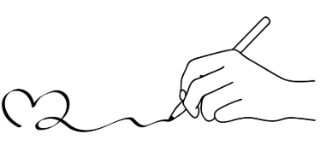

Lyric Lab: A Celebration of Books in Verse

Criteria | Descriptors | Max. Points | Points Awarded
Originality and Relevance of Content | - Demonstrates originality in crafting the poem/lyrics.  - Effectively reflects one or more aspects (Characters, Setting, Theme, Conflict, or Symbols) of the book.  - Connects ideas in a unique and meaningful way to the chosen book. | 10
Printed Submission Requirements | - Includes a printed copy of the poem/lyrics.  - Contains the title of the book, the author's name, title of the poem/song, and the student's name.  - Free from spelling and grammatical errors. | 10
Performance Quality | Introduction:  - Introduces themselves and their chosen book with enthusiasm.  - Clearly states the book title, author, and title of the poem/song.  - Provides a thoughtful explanation of why the aspect(s) chosen is meaningful.  Performance:  - Expresses the emotions and message of the piece through clear and engaging delivery.  - Demonstrates confidence and passion in performance.  - Uses gestures, eye contact, and tone to engage the audience and judges.  - Meets the 3-minute time limit for performance | 20
Creativity & Impact | - Demonstrates a unique and original perspective on the book.  - Uses vivid imagery and inventive language to bring the chosen aspect (Characters, Setting, Theme, Conflict, or Symbols) to life.  - Incorporates literary devices such as metaphors, similes, or symbolism to enhance depth and meaning.  - Showcases an imaginative interpretation that stands out and engages the audience. | 10
Total Points |  | 50

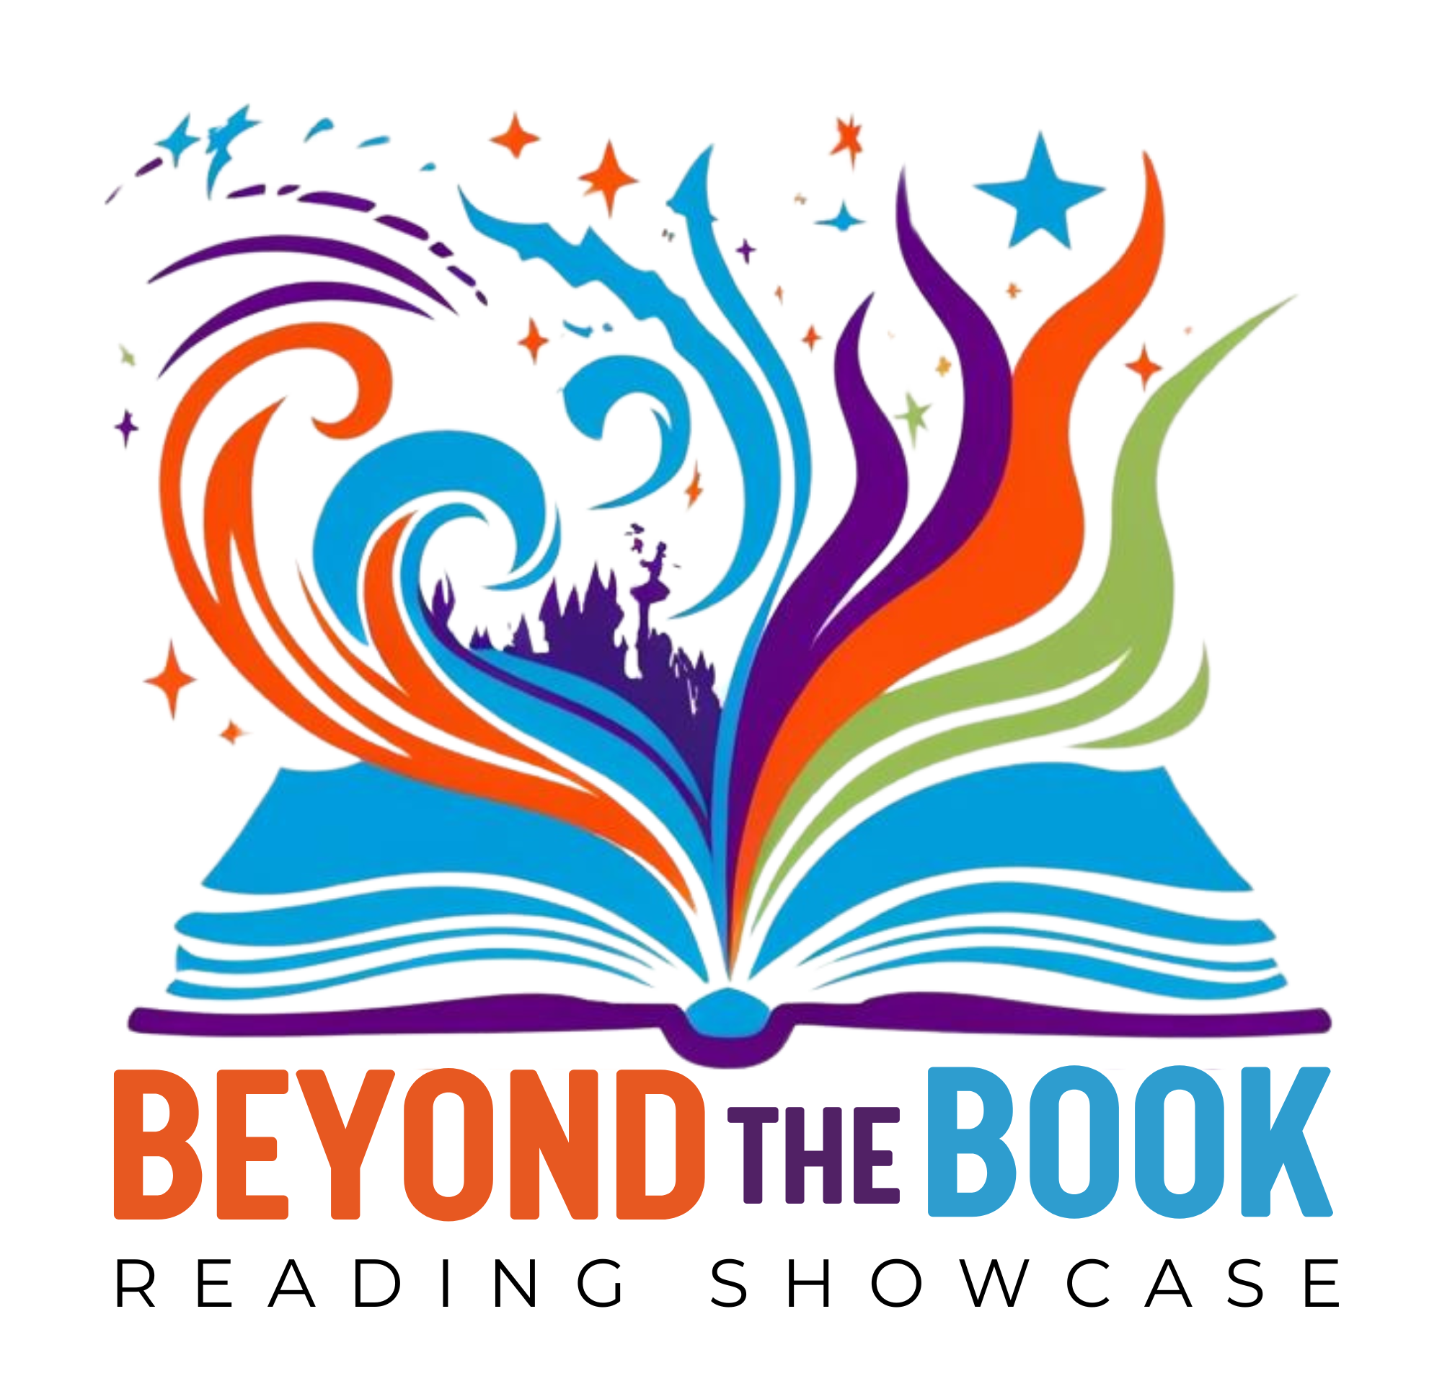

Middle School Project #2
“Read & Reel”
Competition Overview: Your task is to create an original video that captures the essence of a book you’ve read. The book can be fiction or nonfiction, but your video promotion should focus on at least one or more of the following:
- Characters/Persons – Highlight the personalities, challenges, and journeys of the characters/persons.
- Setting - Explore the impact of the setting on the plot.
- Theme – Explore the core message or ideas presented in the book.
- Major Conflict – Showcase the key struggles or turning points that drive the story.
- Symbols - Explore a key object/image/idea central to the book’s story or theme.

Requirements:
- Original Work: Your book video promotion must be original and should reflect your interpretation of the book and address at least one or more of the following:
  - Characters/Persons – Highlight the personalities, challenges, and journeys of the characters/persons.
  - Setting - Explore the impact of the setting on the plot.
  - Theme – Explore the core message or ideas presented in the book.
  - Major Conflict – Showcase the key struggles or turning points that drive the story.
  - Symbols - Explore a key object/image/idea central to the book’s story or theme.
- Length: The video should be no longer than 3 minutes long.
- Format: Video files must be uploaded to Google Drive and shared with a viewable link. MP4, MOV, etc. Video can be stop motion/live/animation.
- Copyright Statement:
  - By submitting a book trailer, you confirm that all content, including music, visuals, and video, is your original work or used with proper permission and that you grant permission for your trailer to be shared in the competition. Your book video promotion trailer should have the credits listed at the end of the video.
- Presentation: Your video will be displayed to a panel of judges, and be prepared to present your video promotion.
  - Introduction to Performance: Students must introduce themselves, provide the title of the book, name the author, and the title of the original video. Explain what interested you about this character/person/theme/conflict/setting/symbol and why you find their story meaningful.
  - Opening Credits: Title, Author, Chapter, or Scene from the book, Director should be the name of the student(s)
- No use of AI in the creation of the project.
- Students may work individually or in small groups of up to 4 students.

Tips for Success
- Choose a Book You Connect With: Pick a book you love or one that has a powerful story, character, theme, or symbol to highlight.
- Plan Your Storyboard: Before filming, outline each scene to create a clear, cohesive narrative. Outline key visuals, text, or voiceovers to help your video flow smoothly.
- Use Visual and Audio Elements Thoughtfully: Consider how visuals, sound effects, and music can enhance the mood and theme of your trailer. Ensure the music is original or used with proper permission to avoid copyright issues.
- Practice Your Presentation: Be prepared to confidently share your insights with the judges, explaining why you chose specific scenes or elements.
- Stay Within the Time Limit: Keep your video no longer than 3 minutes to meet competition requirements.
- Test Your Video File: Ensure your video file works and is compatible with the competition format (MP4, MOV, etc.). Upload it to Google Drive and check that the shared link is viewable.
- Digital tools that can be used: iMovie, Canva, Adobe Spark
Note to Students: Your book trailer should be an original, creative interpretation that captures the essence of the book you've chosen. Focus on telling a compelling story that will make your audience want to read the book!

Read & Reel

Criteria | Descriptors | Max. Points | Points Awarded
Originality and Relevance of Content | - Demonstrates originality and creativity in video production.  - Effectively reflects one or more aspects (Characters, Setting, Theme, Conflict, or Symbols) of the book.  - Shows a clear and meaningful connection to the chosen book. | 10
Video Quality and Technical Elements | - Video is clear and well-edited, with smooth transitions and appropriate pacing.  - Sound quality is clear, with well-balanced audio (voice, music, sound effects).  - Creative use of visuals, animations, or effects enhances the storytelling. | 15
Presentation and Introduction | - Introduction includes students’ names, book title, author, and title of the video.  - Explanation of the chosen aspect(s) is clear, personal, and meaningful.  - Demonstrates enthusiasm and confidence in presenting the video. | 10
Adherence to requirements | - Meets the 3-minute time limit.  - Video includes opening credits with book title, author, and director(s).  - Credits include copyright acknowledgment for all materials used (if applicable).  - Uploaded in the correct format (MP4, MOV, etc.) with a working, viewable link. | 5
Creativity and Engagement | - Highlights a fresh and imaginative perspective on the book.  - Engages the audience through compelling visuals, narrative, and storytelling.  - Stands out as a memorable and impactful video. | 10
Total Points |  | 50

Middle School Project #3

Diorama Drama: Bringing Books to Life

Competition Overview
Your task is to create an original 3D diorama that highlights a scene from a book you’ve read. The book can be fiction or nonfiction, and the diorama should reflect one or more of the following aspects:
- Characters/Persons – Highlight the personalities, challenges, and journeys of the characters/persons.
- Setting - Explore the impact of the setting on the plot.
- Theme – Explore the core message or ideas presented in the book.
- Major Conflict – Showcase the key struggles or turning points that drive the story.
- Symbols - Explore a key object/image/idea central to the book’s story or theme.

Requirements
- Original Work: Your diorama must be an original creation that reflects your own interpretation of the book.
- Size & Materials: Dioramas should be no larger than 12″ × 12″ × 24″ (L × W × H). You may use any materials, but keep them school-appropriate and transportable. Enhance your design with additional materials such as fabric, paper, paint, clay, or other school-appropriate decorations.
- Materials must be school-appropriate
- 60% of the project should be handmade
- Label: Title, Author, Chapter, or Scene from book
- Display & Presentation: Your diorama will be displayed for a panel of judges, and you will present and answer questions about your work.
  - Introduction: Introduce yourself, state the title and author, and explain why you chose this book.
  - Diorama Overview: Be prepared to use your diorama to explain the key elements to the judges. Provide the following information based on your diorama focus areas:
    - Characters: Explain their personalities, challenges, and relationships.
    - Theme: Describe the main message of the book and how it is conveyed in the story.
    - Major Conflict/Events: Explain the turning points and their impact on the story.
  - Student Connection: Explain what interested you about this book and why you find the story meaningful.
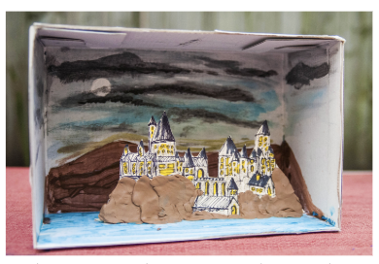
- Time Limit for Presentation: Be ready to present your diorama and discuss it in a 3-minute session with the judges.
- Students work individually.

Tips for Success
- Choose a Meaningful Scene: Select a scene that resonates with you or has a significant impact on the book’s story. Make sure the scene you choose has strong visual elements you can creatively represent.
- Plan Your Layout: Sketch out your diorama before building it. Include where each element will go and how they will interact to tell the story. Think about how best to arrange characters, props, and details in your diorama to bring the scene to life.
- Use Materials Imaginatively: Get creative with materials and textures to add depth and interest to your diorama. Combine different materials such as paper, fabric, clay, paint, and small objects to make your diorama stand out.
- Practice Your Presentation: Be prepared to confidently explain your choices, describing why you chose this scene and how you represented key elements.
- Test Its Stability: Make sure your diorama is sturdy and can be easily transported. Double-check that all pieces are securely attached before bringing it to the event.

Diorama Drama: Bringing Books to Life
Criteria | Descriptors | Max. Points | Points Awarded
Relevance to Book | - Diorama clearly represents one or more aspects (Characters, Setting, Theme, Conflict, Symbols) of the book.  - Accurately reflects the chosen scene, chapter, or moment from the book.  - Captures the tone and essence of the book through design. | 10
Craftsmanship and Visual Appeal | - Demonstrates originality and creativity in the construction of the diorama  - Neat and well-constructed with attention to detail.  - Effective use of materials to enhance the visual impact and storytelling - at least 60% of the project is handmade.  - Unique and imaginative interpretation of the book scene. | 15
Presentation - Introduction and Explanation | - Student introduces themselves, the book title, author, and the diorama’s scene or chapter.  - Provides a clear and thoughtful explanation of their choice and its significance.  - Explains the diorama’s focus on characters, theme, conflict, or symbols effectively. | 10
Connection and Engagement | - Demonstrates a personal connection to the book and its themes.  - Explains why the book and chosen scene are meaningful to them.  - Engages the judges with confidence, enthusiasm, and preparedness. | 10
Adherence to Requirements | - Diorama is within the size limits 12″ × 12″ × 24″ (L × W × H).  - Includes a visible label with the book’s title, author, and scene/chapter.  - Meets the presentation time limit of 3 minutes. | 5
Total Points |  | 50

