Project Checklist

Beyond the Book Showcase: Infographic
My infographic is my own work and shows my interpretation of the book.
My infographic covers at least ONE focus area (check all that apply):
- Characters – personalities, challenges, relationships
- Theme – main message or lesson of the book
- Major Conflict/Events – key turning points that drive the story

✅ FORMAT REQUIREMENTS
- My infographic is 8.5” x 14” (legal size paper).

✅ PRESENTATION CHECKLIST (3 Minutes or Less)

1) Introduction
- I introduced myself.
- I stated the book title and author.
- I explained why I chose this book

2) Infographic Overview
- I used my infographic to explain important parts of the book to the judges.
If my infographic focuses on CHARACTERS:
- I explained character personalities.
- I explained character challenges/problems.
- I explained character relationships.
If my infographic focuses on THEME:
- I described the main message/lesson.
- I explained how the story shows the theme.
If my infographic focuses on MAJOR CONFLICT/EVENTS:
- I explained the big turning points in the story.
- I explained how those events affected the story.

3) Student Connection
- I shared what interested me about this book.
- I explained why the story is meaningful to me.

✅ FINAL CHECK
- My presentation is 3 minutes or less.
- I practiced speaking clearly and confidently.
- I am ready to explain why I chose specific scenes or elements.

Beyond the Book Showcase: Wax Museum

✅ Speech Requirements (Your “Character Speech”)
- I can clearly say who my character/person is AND name the book title.
- I explain what we can learn from my character/person’s life or work.
- I share major accomplishments or important actions my character/person did.
- I explain why my character/person’s story is important.
- I describe the impact my character/person made (how they influenced others or changed something).
- I explain what interested me about this character/person and why their story matters to me.
- I have note cards OR I can recite from memory.

✅ Flyer Requirements (8.5” x 11”)
- My flyer is 8.5” x 11” (regular paper size).
- My flyer includes the book title.
My flyer includes the author name(s).
- My flyer is neat, clear, and ready to display in an acrylic stand (provided at district showcase).

✅ Props (Optional)
- I brought props only if I wanted to (props are welcome but NOT required).
- My props match my character/person (example: Babe Ruth = baseball).

✅ Presentation Rules
- My full presentation is 3 minutes or less.

⭐ Tips for Success (Student Checklist)
- I use creativity (voice, posture, gestures, facial expressions).
- I practiced my speech multiple times.
- I make eye contact, use gestures, and speak with meaning.

Beyond the Book Showcase: Recycled Art/ 2 Liter Bottle

✅ Project Requirements
Original Work
- I selected ONE of the following to represent:
  - Character (fictional character or real-life figure from the book)
  - Person (real individual featured in a nonfiction book)
  - Symbol (key object/concept/idea central to the theme or story)
Size & Materials
- I used a 2-liter bottle as the base.
- My design uses school-appropriate materials.
- My project is transportable (can be carried safely without falling apart).
- I enhanced my bottle using materials such as: fabric, paper, clay, paint, etc…
Flyer Requirement (8.5” x 11”)
- I created an 8.5” x 11” flyer.
- My flyer includes:
  - Book title
  - Author(s)
Display & Presentation
- My bottle is ready to be displayed for judges.
- I am prepared to present and answer questions clearly.

✅ Required Presentation Talking Points (Be Ready to Answer)
- Who/What is my character/person/symbol? (with reference to the book title)
- What can we learn from this character/person/symbol?
- Why is this character/person/symbol significant?
- What impact did this character/person/symbol make?
- What interested me about this character/person/symbol?
- Why is their story meaningful to me?
Tips for Success Checklist
- I planned my layout before building.
- I included details/props that help bring my idea to life.
- I used materials creatively to add depth, texture, and interest.
- I practiced my presentation so I can explain my choices confidently.

Project Directions

Elementary Project #1​​

"From Page to Stage: The Wax Museum Project"

Competition Overview
What is a Wax Museum?
Typically, a wax museum is a place where artists recreate historical, fictional, and famous people or characters using wax. Don’t worry, we won’t be sculpting wax!! Instead, your student will BECOME the character by dressing in costume and presenting information about the person/character. You’ll dress up like your character/person and will stand still like a wax figure, only “coming to life” when someone pushes your button.
Requirements
- Speech: Be prepared to deliver a speech about your character/person that will help the judges understand who you are portraying. Your speech should answer the following questions: (You may use notecards or recite from memory.)
  - Who is your character/person? (reference book title)
  - What can we learn from your character’s/person’s life and/or work?
  - What are your character’s/person’s significant accomplishments or notable actions?
  - Why is your character’s/person’s story important?
  - What impact did your character/person make?
  - Explain what interested you about this character and why you find their story meaningful.
- Flyer: Create an 8.5” x 11” flyer that must include the book title and author(s). Your flyer will be placed in an acrylic stand, which will be provided at the district-level showcase.
- Props are welcome but not required.
  - Examples: Babe Ruth, artifact-baseball or Matilda artifact-chocolate cake, newt, etc.
- The presentation should be no longer than 3 minutes.
- No AI should be used.
- The district will provide the “push” button for your station at the district-level showcase.
- The project must be completed individually.

Tips for Success
- Choose a Book You Connect With: Pick a character/person from a book that you feel strongly about. Your passion for the story will shine through in your work.
- Be Creative with Your Interpretation: Think outside the box– (ex. mimic gestures, voice changing, posture to match the character/person you are portraying).
- Practice Your Performance: Rehearse your piece several times to feel confident with your pacing, expression, stage presence, and staying within the time limits.
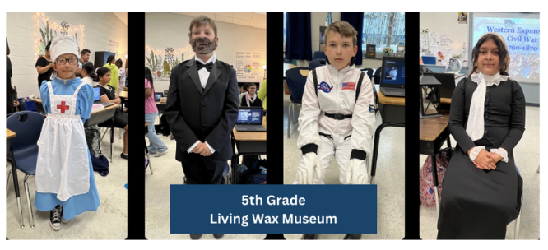
- Engage with the Judges and Audience: Make eye contact, use gestures, and focus on delivering your words with meaning.

From Page to Stage: The Wax Museum Project

Criteria | Descriptors | Max. Points | Points Awarded
Character Knowledge | Demonstrates deep understanding of personality, motivations, and role in the story. | 20
Oral Presentation | Speaks clearly, confidently, and in character; provides insightful information. | 20
Information Display | Informative, well-organized  display with engaging visuals and text. | 5
Creativity | Highly detailed, accurate, and creative representation of the character. It perfectly captures the character's posture, expression, and overall appearance. | 5
Total Points |  | 50

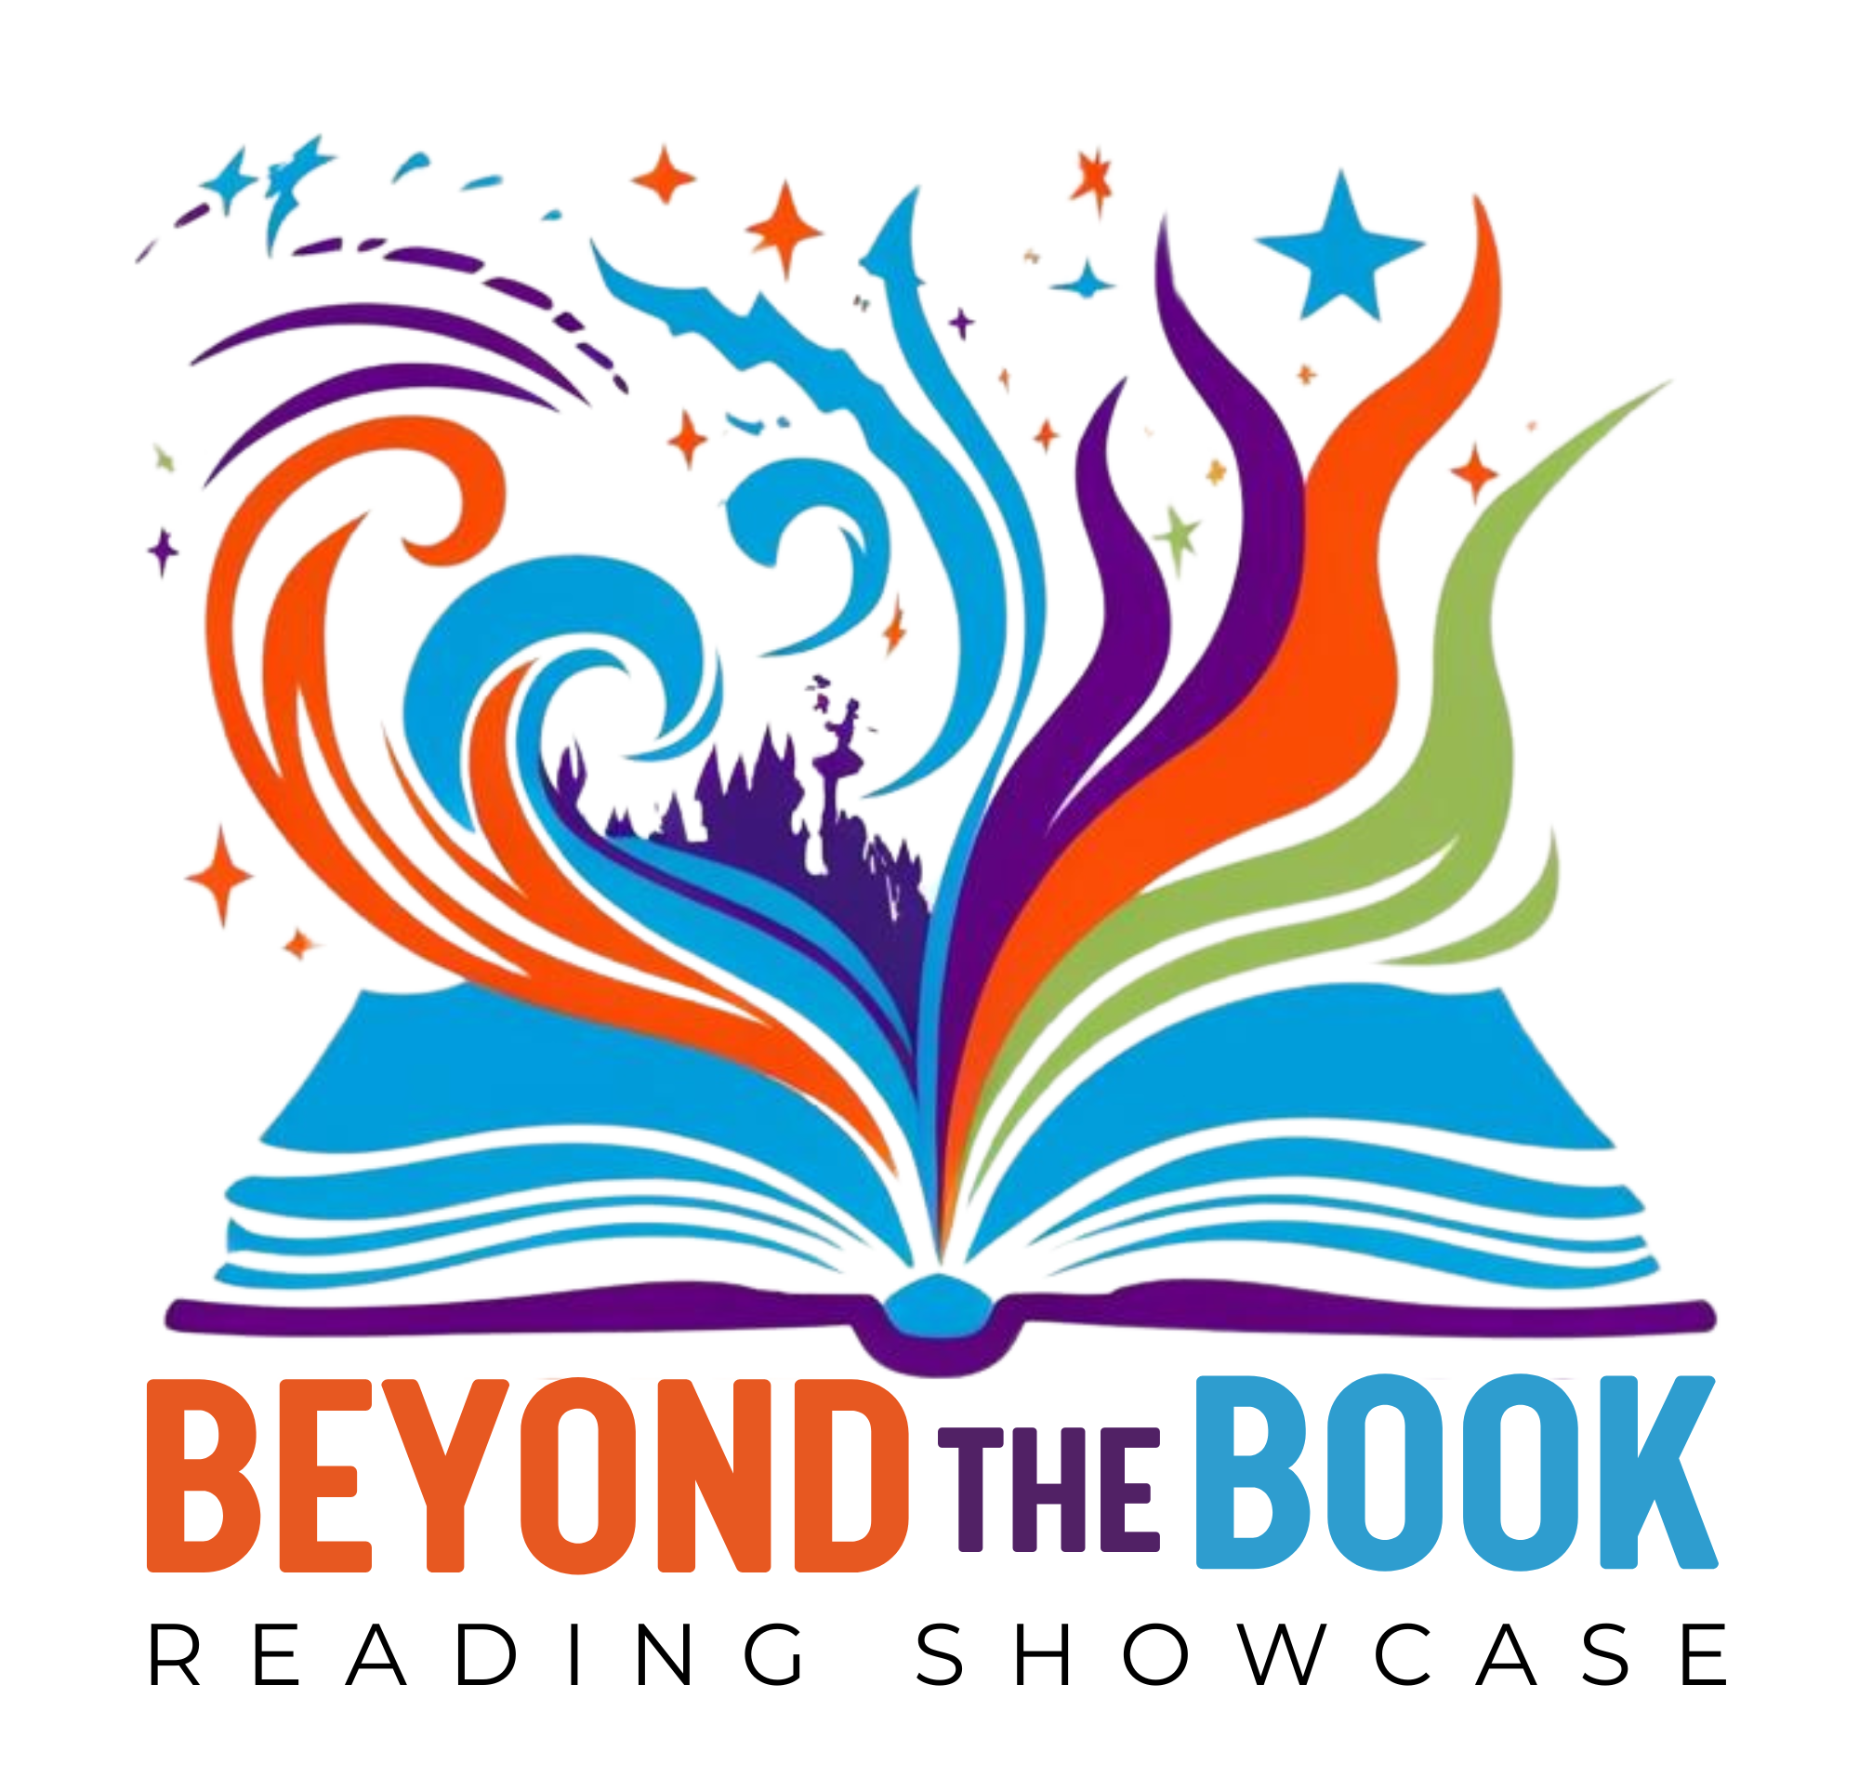

Elementary Project #2

“A Picture is Worth a Thousand Words”

Competition Overview
Your task is to create an original infographic that captures the essence of a book you’ve read. The book can be fiction or nonfiction, but your infographic should focus on one or more of the following:
- Characters – Highlight the personalities, challenges, and relationships of the characters.
- Theme – Explore the core message or ideas of the book.
- Major Conflict/Events – Showcase the key challenges or turning points that drive the story.
Requirements
- Original Work: Your infographic must be original and reflect your book interpretation. It must address one or more of the following:
  - Characters – Highlight the personalities, challenges, and relationships of the characters.
  - Theme – Explore the core message or ideas of the book.
  - Major Conflict/Events – Showcase the key challenges or turning points that drive the story.
- Format: 8.5” x 14” infographic. It may be created digitally or hand-drawn. If created digitally, it must be printed for display.
- Presentation:
  - Introduction: Introduce yourself, state the title and author, and explain why you chose this book.
  - Infographic Overview: Be prepared to use your infographic to explain the key elements to the judges. Provide the following information based on your infographic focus areas:
    - Characters: Explain their personalities, challenges, and relationships.
    - Theme: Describe the main message of the book and how it is conveyed in the story.
    - Major Conflict/Events: Explain the turning points and their impact on the story.
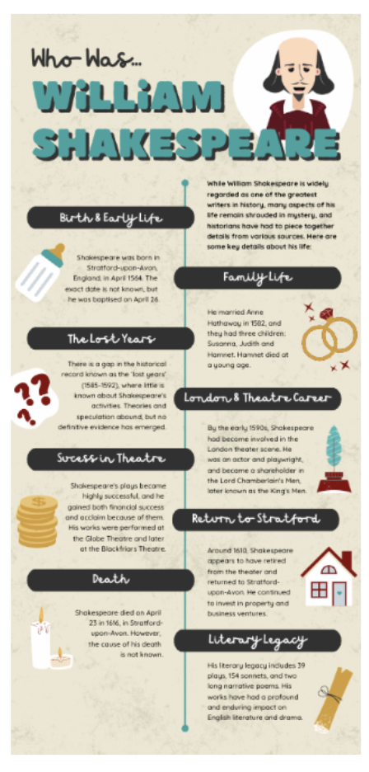
    - Student Connection: Explain what interested you about this book and why you find the story meaningful.
- The presentation should be no longer than 3 minutes.
- No AI should be used.
- The project must be completed individually

Tips for Success
- Choose a Book You Connect With: Select a book that resonates with you. Your passion for the story will be highlighted in your infographic.

- Practice Your Presentation: Be prepared to share your insights with the judges, explaining why you chose specific scenes or elements

T

A Picture is Worth a Thousand Words

Criteria | Descriptors | Max. Points | Points Awarded
Content Accuracy | All information is accurate and directly related to the book. Demonstrates deep understanding of the material. | 15
Key Elements Inclusion | Includes all key elements: title, author, main characters, major conflict/events, student connection, and theme/message. | 10
Oral Presentation | Speaks clearly, confidently, and in character; provides insightful information. | 10
Visual Appeal | Highly attractive layout with excellent use of color, fonts, and graphics that enhance understanding. | 5
Organization | The information is very well organized, easy to follow, and enhances understanding of the book. | 5
Creativity | Highly creative presentation of information with unique and engaging elements. | 5
Total Points |  | 50

Elementary Project #3

"Recycled Reads: Create a Character or Symbol from Your Favorite Book!"

Competition Overview
Your task is to use a recycled 2-liter bottle to create an original 3D character, person, or symbol highlighting a book you’ve read. The book can be fiction or nonfiction. It should be representative of one or more of the following:
- Characters/Person – Highlight the personalities, challenges, and relationships of the characters.
- Symbol: A key object, concept, or idea central to the book’s story or theme.
Requirements
- Original Work: Your 2-liter bottle should reflect your interpretation of one of the following:
- Character: A fictional character or real-life figure from the book.
- Person: A real individual featured in a nonfiction book.
- Symbol: A key object, concept, or idea central to the book’s story or theme.
- Size & Materials: 2-liter bottle. You may use any materials to enhance your bottle, but keep them school-appropriate and transportable.
  - Use a 2-liter bottle as the base for your creation.
  - Enhance your design with additional materials such as fabric, paper, paint, clay, or other school-appropriate decorations.
- Flyer: Create an 8.5” x 11” flyer that must include the book title and author(s). The flyer will be placed in an acrylic stand that will be provided at the district-level competition.
- Display & Presentation: Your 2-liter bottle will be displayed for a panel of judges, and you will present and answer questions about your work.
  - Who/What is your character/person/symbol? (reference book title)
  - What can we learn from your character/person/symbol?
  - What is significant about your character/person/symbol?
  - What impact did your character/person/symbol make?
  - Explain what interested you about this character/person/symbol and why you find their story meaningful.
- No AI should be used.
- The project must be completed individually.

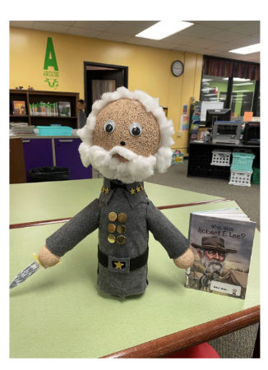
Tips for Success
- Choose a Meaningful Character, Person, or Symbol: Select a character/person/symbol that resonates with you or significantly impacts the book’s story.
- Plan Your Layout: Think about how best to create your chosen character/person/symbol --props, and details in your 2-liter bottle to bring the character/person to life.
- Use Materials Imaginatively: Get creative with materials and textures to add depth and interest to your display.
- Practice Your Presentation: Be prepared to confidently explain your choices, describing why you chose this scene and how you represented key elements.

Recycled Reads: Create a Character or Symbol from Your Favorite Book!

Criteria | Descriptors | Max. Points | Points Awarded
Character or Person Resemblance | The bottle character/person/symbol is instantly recognizable and closely resembles the book character. | 10
Oral Presentation | Student can confidently explain their character/person/symbol choice and design decisions, showing a deep understanding of the book. | 15
Craftsmanship | Excellent construction with neat, secure attachments and careful painting/coloring. | 10
Use of Materials | Innovative use of various materials beyond the bottle to enhance character/person features. | 5
Creativity and Originality | Highly creative use of materials and unique design elements that bring the bottle to life. | 10
Total Points |  | 50

