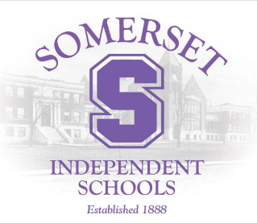
Somerset Independent Schools
2026-2027 Calendar

August 10 Workday for Teachers
August 11 Opening Day for Teachers
August 12 First Day for Students
September 7 Labor Day-school not in session
October 5-9 Fall Break-school not in session
November 3 Workday for Teachers- school not in session
November 23 Professional Development- school not in session
November 24-27 Thanksgiving Break-school not in session
December 21-January 1 Christmas Break-school not in session
January 18 Martin Luther King, Jr. Day-school not in session
February 15* Presidents’ Day-school not in session
March 19* Professional Development- school not in session
April 5-9 Spring Break-school not in session
May 25 Last Day for Students
May 26++ Make-up Days
After last day of instruction Closing Day for Teachers
*February 15 and March 19 may be used as make up days due to any school cancellations

BOE approved: 1/13/26

