Oak Park and River Forest High School
Food and Nutrition Services
Employee Handbook

2025-2026

Welcome to the OPRF Department of Food and Nutrition Services. Our mission is to provide safe, nutritious, and appetizing meals at a fair price to promote the proper growth and development of every student in OPRF. The School Nutrition Program is an integral part of the education process that assists with students being ready to learn. The Department of Food and Nutrition Services supports an environment that encourages students to make healthy food choices by offering a variety of items. Our goal is to provide quality meals in a positive atmosphere that encourages students to participate. We strive to make the OPRF Meal Program run as smoothly and efficiently as possible.
We encourage any feedback and questions you may have. Please keep this handbook readily available for quick reference.
201 N Scoville Avenue – Oak Park, IL 60302 – www.oprfhs.org

Table of Contents
Section 1 GENERAL INFORMATION 3
Primary Purpose of the Food and Nutrition Services Department 3
Goals of the Food and Nutrition Services Department 3
Employment 3
Employment of Temporary Personnel 3
Section II EMPLOYEE EXPECTATIONS 4
General Employee Responsibilities 4
Hours of Work 4
Attendance and Punctuality 4
Sanitation 5
5. Safety, Care and Use of Facilities 5
6. Progressive Discipline 5
7. Employee Evaluations 5
8. Institute Days 5
9. Staff Development Days 6
10. Injury on the Job 6
11. Resignation 6
12. Emergency Building Closings 6
Section III EMPLOYEE BENEFITS 7
Holidays and Breaks 7
Absence Due to Illness 7
Personal Leave 7
Bereavement Leave 7
Jury Duty 7
Retirement Fund and Disability Benefits 7
Insurance 7
Daily Meal Benefit 8
Section IV COMPENSATION 9
Compensation 9
Pay Periods 9
Deducted Time 9
Overtime Pay 9
Longevity Stipend 9
Attendance Incentive 9
Appendix A Employee Evaluation Template 10
Employee Acknowledgement 11

Section 1 GENERAL INFORMATION

Primary Purpose of the Food and Nutrition Services Department
The primary purpose of the Food and Nutrition Services Department is to provide meals of maximum nutritional value at minimum cost to students and staff, while providing nutrition education activities to improve the students’ eating habits, and to develop an understanding of the relationship between eating a balanced diet and good health. We offer students a range of healthy meal options, as well as their tried and true favorites, and we encourage them to make healthy, balanced choices.

Goals of the Food and Nutrition Services Department
  - Maintain efficient, well-organized cafeterias to produce meals that meet the needs and wants of students and staff.
  - Promote development of improved eating habits through the provision of nutritious, innovative meals and nutrition education activities.
  - Manage resources of the Food and Nutrition Services Department effectively to maintain minimal cost to students, while operating the program in a fiscally independent manner.
  - Maintain a productive staff by providing direction, training, and growth opportunities.
  - Increase student participation in the lunch program.
  - Operate within the guidelines of OPRF and applicable Federal, State, and local regulations.

Employment
Staffing and assignments of all employees is made by the Director of Food Services, who is responsible for the following:
- Screening and interviewing candidates;
- Placement of food services personnel;
- As permanent vacancies occur or new positions are created, positions shall be posted online so that all employees may know of the opening for five (5) work days. Employees interested in applying must apply online.
Prior to Hire: Human Resources
  - Physical exam – within 30 days physically fit for duty with no communicable diseases.
  - Fingerprinting and background check.
  - Completion of all required paperwork.
  - State-mandated trainings – The State requires a number of trainings as school district and food service employees, including Food Handler Training certification, as a condition of employment for all staff.

Employment of Temporary Personnel
Substitute/Temporary personnel may be utilized in the absence of regular cafeteria personnel.
Temporary food service workers are employed on a day-to-day basis as at-will employees of the District.

Section II EMPLOYEE EXPECTATIONS

General Employee Responsibilities
All employees are expected to observe the policies and procedures of the District and the Food and Nutrition Services Department, and to perform their assigned duties in a satisfactory manner.

Dress Code
  - Employees are required to wear a clean uniform consisting of an OPRF shirt, pants, apron, hairnet, and low-heeled, non-skid soles. Sandals and shorts are not permitted for safety reasons.
  - Shirts, aprons, and hairnets are provided to employees by the District.

Conduct at Work
- All employees must wash hands thoroughly when reporting for duty, returning from a work break or lunch, returning from the restroom, and after any action which may contaminate them, before handling any food product.
- Employees should report any infection which they may have to their manager.
- Plastic gloves must be used when serving food.
- Employees are prohibited from eating food and drinking beverages in the kitchen and serving area. These items should be consumed during break time in the break area. Food should be tasted as it is prepared by designated personnel in order to assure its quality.
- Chewing of gum or mints is not permitted while on the job.
- Cell phones must be silenced and kept in the locker. Cell phones are not to be used in the kitchen or on the serving lines.
- District issued photo ID must be worn at all times while on district property. An ID will be obtained from the attendance office at the time of hire. The food service secretary will arrange for a key fob for employees to gain access to the building.

Personal Care
- Every employee should practice good personal hygiene, which includes bathing regularly and using deodorant.
- Hair should be clean and neatly styled.
- Jewelry (other than engagement and wedding rings), nail polish, excessive makeup and perfume are not to be worn while employees are on duty. The wearing of decorative pins should be restricted to identification tags, professional pins, and those approved by the supervisor. All should have secure clasps.

Health Examinations
- Each employee new to the District must furnish the results of a physical examination and evidence to indicate the employee is physically fit for duty and free from communicable disease at the time of employment. The cost is paid by the employee.
- The district may require any employee to submit to a physical examination at any time after employment, to be paid by the district.

Hours of Work
  - The standard work year shall be determined by your employee calendar based on the school calendar established by hours as indicated by the job description.
  - Each employee working seven and one-half (7.5) continuous hours shall receive a fifteen (15) minute paid break and shall be provided a thirty (30) minute unpaid duty-free meal break. Those employees who work four (4) or more hours, but less than seven and one-half (7.5) hours, will be entitled to a fifteen (15) minute paid break at a time established by the supervisor. Lunch and break times must be approved by the supervisor and are to be taken during a mutually convenient time to support the operation of the program.
  - All cafeteria personnel shall observe regular working hours and utilize the District-approved time-keeping system to clock in and clock out. Employees are required to be in work uniform and prepared to begin their shift on time

Attendance and Punctuality
Regular attendance by all Food Service employees is expected. Time off requests should be submitted to the director for approval and entered in the District-approved time-keeping system (currently RedRover). If an employee is unable to report for work for a scheduled shift, the supervisor must be notified at least 3 hours prior to the start of their scheduled shift. Excessive absenteeism or frequent absence or tardiness may subject an employee to disciplinary action. Absence for three (3) consecutive days without notice to the Director will be considered as a resignation.

Sanitation
The following sanitation standards are the daily responsibility of the employee:
- According to the State of Illinois Food Code, all establishments that handle food must have at least one sanitation-certified person in their employ. Therefore, all food service employees are encouraged to obtain their valid Sanitation Certification. The Food Service department will pay the sanitation course fee (up to $175.00) upon successful completion of course and passage of exam. Employees must submit a copy of the invoice of course and exam fee and a copy of the sanitation license in order to be reimbursed. Employees must schedule these classes outside their regular shifts. If the employee lets the license expire, the class will be at the employee’s expense.
- The State requires a number of training as school district and food service employees, including Food Handler training certification, as a condition of employment for all staff.
- It is OPRF Food Service policy to adhere to all standards required by state and local health department guidelines to ensure that all foods are prepared and served in accordance with the highest standards. OPRF Food Services also reserves the right to implement additional sanitation policies.

5. Safety, Care and Use of Facilities
All employees are responsible for maintaining the cleanliness and orderliness of the work facilities and equipment. Employees should report any unsafe condition, malfunction or disrepair to their supervisor. Intentional damage or careless use of the District’s property may result in disciplinary action. Failure to follow safety rules and procedures may result in disciplinary action up to and including termination. Only authorized personnel will be allowed in the kitchen.

6. Progressive Discipline
- Philosophy of Corrective Discipline: The Board embraces the concept of progressive and corrective discipline for employees. Progressive discipline is a systematic approach to correct unwanted behavior and deter its occurrence by administering disciplinary actions based upon various factors, including but not limited to: (1) the seriousness of the offense; (2) the number of times it has occurred; (3) prior acts of misconduct; (4) the length of time between infractions (5) the employee’s length of service and record of performance; and (6) the totality of the circumstances. While the Board encourages the use of progressive discipline, circumstances dictate that it cannot be used for every act of misconduct.

- Disciplinary Procedure: The District supports a philosophy of corrective discipline that is built upon a process of progressive discipline. Toward that end, except in cases of gross misconduct such as, but not limited to, gross insubordination, theft, intoxication or being under the influence of non-prescribed controlled substances at work, or falsification of school records or other employment related records, employees covered by this agreement shall be subject to the following progressive discipline process:
      - Verbal Warning
      - Written Warning
      - Suspension
      - Termination of employment

7. Employee Evaluations
All Food Service employees will be evaluated annually utilizing the approved evaluation tool. The evaluation process identifies performance strengths, weaknesses, training needs, and future goals. The Evaluation tool is located in Appendix A.

8. Institute Days
Employees are expected to work as needed on Institute Days, as determined by the Director Food Service. These hours will be paid at the employee’s regular hourly rate.

9. Staff Development Days
Staff development days shall be part of the Food and Nutrition Services work calendars.

10. Injury on the Job
Workers’ Compensation will be provided to employees to protect against financial loss in the case of injury, certain types of illness or death arising out of and in the course of employment. Employees are required to report injuries immediately to their supervisor. If approved for Temporary Total Disability (TTD) under the Workers’ Compensation Act, employees would receive a portion of their lost wages. Employees with available sick days may elect to use available sick days to cover the portion of lost wages not covered by TTD.

11. Resignation
Employees who wish to resign are asked to give written notice of resignation to the Director of Food & Nutrition services at least ten (10) working days prior to the last day of work. The notice should include the date submitted, signature, reason for resignation, and effective date of resignation.

12. Emergency Building Closings
In the event of the school closing due to emergency circumstances, all employees will receive a call and/or text from the District. It is the employee’s responsibility to ensure contact information is up to date with HR. Cafeteria personnel may be excused from work for that day and paid for their assigned number of hours at their regular hourly rate.

Section III EMPLOYEE BENEFITS

Holidays and Breaks
- Employees will receive ten (10) paid holidays, which will be determined by the official school calendar.
- In order to be paid for a holiday, the employee must work the last full scheduled work day before and the first full scheduled work day after the holiday.
- Employees will also receive paid time off during winter and spring breaks.

Absence Due to Illness
  - Employees shall be granted ten (10) days paid sick leave per year. The sick days will be allocated annually at the beginning of the school year.
  - Sick leave shall be interpreted to mean personal illness, quarantine at home, or serious illness in the immediate family or household, as defined in the school code.
  - In case of absence due to illness, the Director or their designee should be notified at least 3 hours prior to the start of their shift.
    - A doctor’s note may be required as a basis for pay for an absence of three consecutive (3) days or more, or as deemed necessary
    - Once all sick and personal time have been exhausted, employees must provide a doctor's note for time off taken. If an employee exhausts all allotted sick or personal time, any absence without medical documentation will be subject to discipline.

Personal Leave
  - Subject to prior approval by the immediate supervisor, each employee is entitled to two (2) personal leave days per year for the purpose of attending to personal business.
  - Unused personal days will be converted to sick leave at the end of each fiscal year.
  - Any personal leave day taken beyond the entitlement will be considered unapproved and will result in a deduction of a day's pay.

Bereavement Leave
- Employees shall receive five (5) consecutive days of paid leave for absence due to the death of a spouse or child.
- Employees shall receive three (3) consecutive days of paid leave for absence due to a death in the immediate family.
- Immediate family is defined as father/guardian, stepfather, mother/guardian, stepmother, brother, stepbrother, sister, stepsister, grandparent, grandchild, any in-laws as stated, any relative living in the employee's house, or person for whom the employee serves as the legal guardian.

Jury Duty
- Employees will receive their regular rate of pay on required Jury Duty during the school year.
- Employees will not receive their daily rate of pay if called for Jury Duty during the summer; however, if that duty extends into the beginning of the school year, the employee would be paid their regular daily rate of pay for the days of jury service rendered after school begins.
- An employee must remit to the Business Office any juror compensation. Copies of the jury duty summons and pay stub should be submitted to the Food and Nutrition Services Office.

Retirement Fund and Disability Benefits
Employees who are expected to work 600 or more hours per year qualify to participate in the Illinois Municipal Retirement Fund (IMRF) as provided by statute.

Insurance
  - Employees in positions regularly scheduled for thirty (30) or more hours per week are eligible for insurance benefits from the District.
  - The details about benefits are contained in the OPRF Benefits Guide.

Daily Meal Benefit
Food service employees shall be provided one meal from the posted staff cafeteria menu without charge, which must be eaten in an employee break area. If the employee selects a la carte items in lieu of the meal from the posted menu, they must pay the regular price.

Section IV COMPENSATION

Compensation
The objective is to provide competitive compensation to attract, retain, and motivate employees. Annual increases will be determined by the Board of Education.

Pay Periods
  - OPRF employees receive their pay bi-weekly by regular check or through direct deposit.
  - Base salary is annualized and will be divided equally among the number of paychecks in the year. 10 and 11 month employees, prior to the start of each work year, shall make an election to be paid over 10-months/21-pay periods (during the work year) or 12-months/26 pay periods. No change can be made to an election for a given year once selected.
  - Hours worked outside of the employee’s regular schedule will be paid in arrears according to the payroll schedule.

Deducted Time
  - Employees are expected to be present for work when scheduled.
  - Employees may be granted time-off without pay for emergencies only, with the approval of the Director of Food & Nutrition Services.

Overtime Pay
All overtime pay must be authorized by the Director of Food and Nutrition Services or designee in advance. All time worked in excess of forty (40) hours in any week, and all non-scheduled time worked after 4:00 PM and on weekends, shall be paid at one and one-half (1.5) times the employee’s straight time rate. There shall be no pyramiding of overtime hours.

Longevity Stipend
Each employee who has completed their 20th year of service shall receive a longevity stipend as follows:
    - 21st through 24th Years of Service: $250
    - 25th and thereafter: $500
The longevity stipend shall be paid on the final scheduled paycheck in June.

Attendance Incentive
Employees who have perfect attendance throughout the school year will receive an incentive of $250 paid on final scheduled paycheck in June. Perfect attendance shall be defined as uninterrupted service with the exception of jury duty, bereavement leave, and worker’s compensation. The use of sick leave, personal leave, or unpaid absence will disqualify employees from being eligible for the perfect attendance incentive. An employee who uses up to three (3) sick/personal days in the course of the school year will be eligible for attendance incentive of $100 at the end of the year.

APPENDIX A

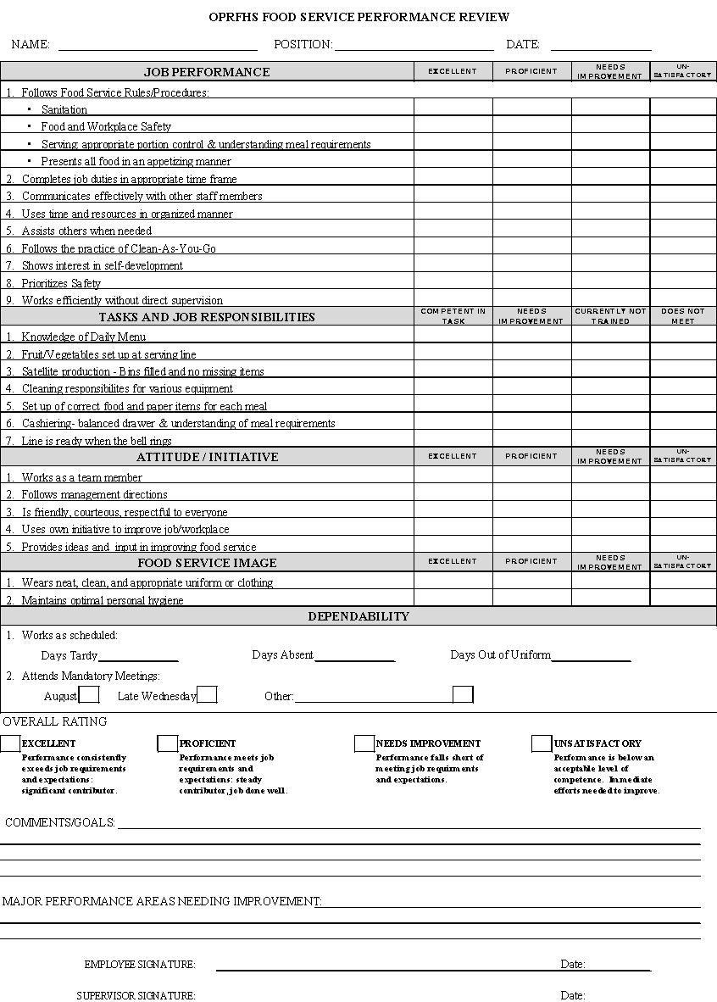

OPRF DEPARTMENT OF FOOD AND NUTRITION SERVICES
EMPLOYEE ACKNOWLEDGEMENT
2025-2026 School Year

My signature acknowledges that I have reviewed this handbook with a food service representative. I will read this handbook thoroughly and follow the aforementioned food service procedures. If anything is unclear or if I have further questions, I will contact the Food Service Department. I understand that this is a 10-month position and there is no work in the food service department during the summer. This also acknowledges that the state requires a number of training as school district and food service employees, including Food Handler training certification, as a condition of employment for all staff.

_________________________________________________________________________
Printed Name

_________________________________________________________________________
Signature

_______________________________
Date

