Guide to Entering Timesheets for Minnesota Paid Family Leave (PML) Top-Off
Employees on Paid Family Leave (PML) must continue submitting timesheets during their leave to ensure accurate payroll processing. You will enter sick or vacation time to supplement ("top off") your pay and unpaid time for wages covered by the State. The combined hours should not exceed your normal daily work hours.

Step 1: Calculate Top-Off Hours
Use the following formula to determine your eligible top-off hours. You will need your hourly rate, weekly hours, and the amount of pay you receive from the State.
Hourly Rate × Hours per Week = Weekly Salary
Weekly Salary – State Payment = Remaining Salary
Remaining Salary ÷ Hourly Rate = Eligible Top-Off Hours
Example: $25 × 40 = $1000; $1000 – $800 = $200; $200 ÷ $25 = 8 hours
Note: If you are receiving Short-Term Disability (STD) in addition to State pay, subtract that amount from your weekly salary before calculating top-off hours.

Step 2: Enter Timesheet in PeopleSoft
Log into Employee Self-Service in PeopleSoft as you would for a normal absence. You can enter your timesheet weekly or in bulk if you know your absence dates.
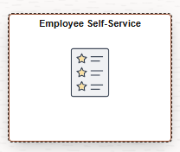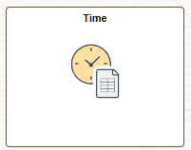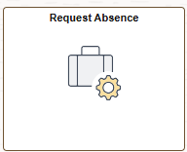

You can enter your timesheet weekly or in bulk if you are sure of your absence dates.

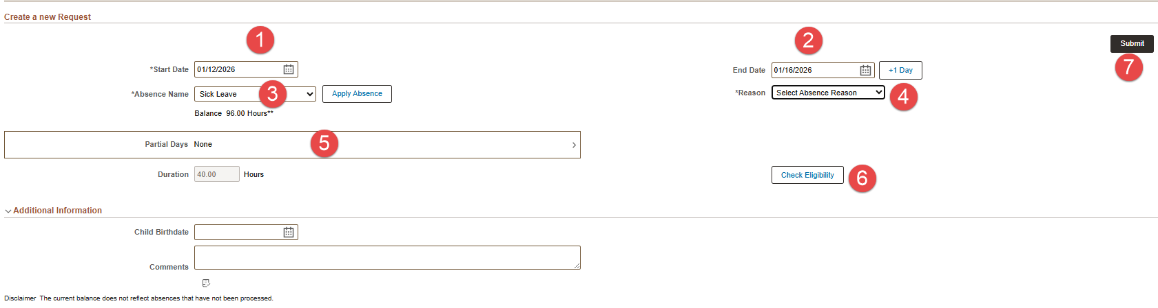

- Select your date range
- Select Absence Name (choose Sick Leave, Vacation, or Unpaid based on your contract)
- Select Reason (reason codes should correspond with Absence Name)
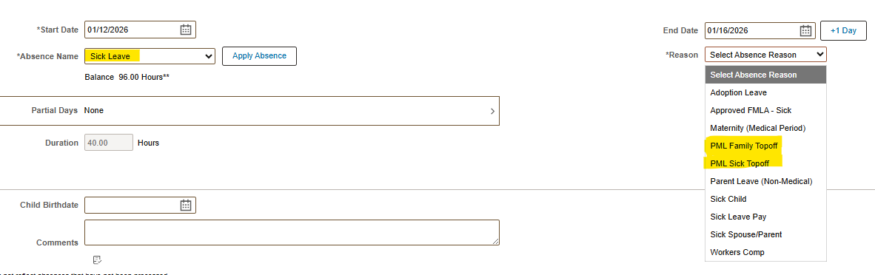
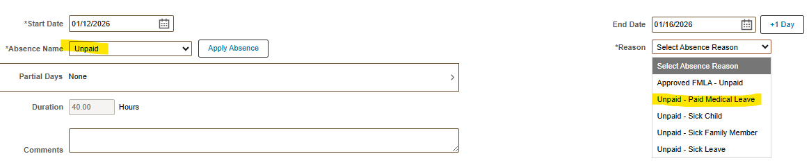
- Check the Partial Days box and enter the number of top-off hours (repeat for unpaid hours)
- Check eligibility
- Submit your request

Important Notes About Top-Off
- Top-off hours should never equal your full scheduled workday since you are already receiving partial pay from the State.
- The purpose of top-off hours is to supplement the difference between your wages and what you receive from the State and/or STD benefits to bring you to 100% of your salary or less.

Timesheet Entry Requirements
- All employees using top-off should have two entries: one for top-off hours and one for unpaid hours.
- The combination of top-off and unpaid hours cannot exceed your normal daily hours based on your FTE.
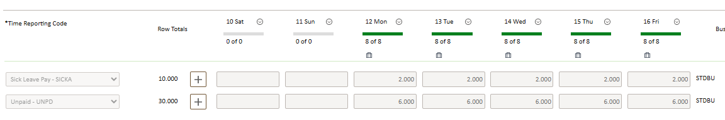
- Once you have exhausted all sick and/or vacation time, you must still submit a timesheet for all days as Unpaid for your total weekly hours based on your FTE.
- If you choose not to use top-off, you are still required to submit a weekly timesheet with all unpaid hours based on your FTE.
