Program Philosophy

The Fox Chapel Area School District pre-kindergarten program is designed to promote positive approaches to learning.

These areas include designing supportive classroom environments; strengthening social, emotional, and behavioral skills in students; and working collaboratively with families.

Our approach is also aligned to the outcomes set by the Pennsylvania Early Learning Standards and is designed to maximize students’ academic learning, achievement, and growth.

Program Pathways to Readiness

Social-Emotional Development (self-awareness, self-regulation, social competence, and social awareness)

Oral Language Development (speaking and conversation, listening comprehension, vocabulary, and sentence structure)

Emergent Reading (concepts of print, phonological awareness, alphabet knowledge, and comprehension)

Fine Motor Development with Emergent Writing (focusing on strengthening small muscles in the hands, promoting better letter formation)

Math Development (number sense, geometry and spatial sense, measurement, and classification and patterns)

STEAM (science, technology, engineering, the arts, and math)

Contact Information

Dr. Ashley Constantine
Executive Director of Elementary
Education and Instruction
ashley_constantine@fcasd.edu

Mrs. Katelyn Toth
Principal, Kerr Elementary School
katelyn_toth@fcasd.edu

Mrs. Katy Wygant
Pre-Kindergarten Teacher,
Kerr Elementary School
katy_wygant@fcasd.edu

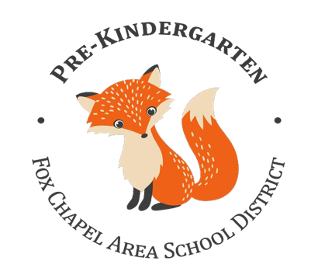



For more information
visit…

the FCASD Pre-K website

prek.fcasd.edu


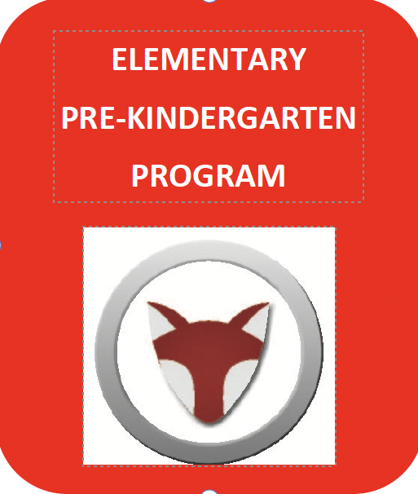


Frequently Asked Questions
What are the eligibility requirements?
*Students must turn 4 on or before
September 1.

*Family income of no more than 300% of the federal poverty guidelines.

*Parent/guardian must be able to provide transportation.

*Student must be toilet trained.

*Resident of the Fox Chapel Area School District.

What are the program requirements?
*Class hours are 8:30 a.m.-3 p.m.

*Will follow the FCASD school calendar.

*After 10 absences, children may be withdrawn from the program.

How many students and teachers will be in the class?
*20 students maximum

*One lead teacher and one full-time assistant.

What does it cost?
*Eligible families will incur no costs. Students will receive breakfast, lunch, and a snack daily.

Where will the Pre-K program be located?
*The Pre-K class will be located at
Kerr Elementary School, 341 Kittanning Pike, Pittsburgh, PA 15215.

What does a typical day look like?

8:30-9:00 Arrival/Breakfast

9:00-9:45 Morning Meeting, Calendar, Free Choice

9:45-10:00 Fundations

10:00-10:30 Big Day for Pre-K Experience with Large and Small Group Work

10:30-11:00 Gross Motor Activity/Recess

11:00-11:40 Family-Style Lunch

11:40-12:30 Big Day for Pre-K Experience with Center Time

12:30-1:30 Rest

1:30-2:00 Big Day for Pre-K Experience with Large and Small Group Work

2:00-2:40 Special Area Class and Gross Motor Development

2:40-3:00 Snack and Pack

3:00 Dismissal

How will parents be involved?
*Parents will partner with the school via various opportunities such as literacy and math family nights and parent-teacher conferences.

How do I enroll my child?
*Pre-Enrollment: January 19-April 10, 2026
Complete and Provide:
- FCASD Pre-K Program Application
- FCASD Pre-K Income Verification
- Proof of Income (W-2 or 3 current paystubs)
- Signed Commitment Form

*Student Selection – Week of April 20, 2026
20 students who meet the FCASD Pre-K criteria will be selected via a random selection process (if needed).
- Letters will be mailed to families (acceptance or wait list).

*District Enrollment
- Families will follow FCASD enrollment procedures to enroll online.
*Student Registration Meeting
- Families will attend a Pre-K registration meeting.

How do I get an application?
*Download a copy from the Pre-K website
prek.fcasd.edu
Or call 412-967-2455 for an application.

Where do I return my application?
*Please send the completed application along with the required paperwork to:
Fox Chapel Area School District Pre-Kindergarten
c/o Dr. Ashley Constantine
611 Field Club Road
Pittsburgh, PA 15238

What school will my child attend after the Pre-K year?
*Your child will go to their district assigned home school for the remainder of their elementary years.

