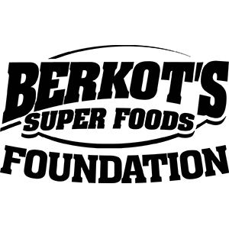

Berkots Charity Foundation Scholarship Application

Mission
The Berkots Charity Foundation Scholarship Program is dedicated to providing financial assistance to local students wishing to pursue a degree at a post-secondary education institution. The objective of the scholarship is to honor high school students who have exemplified outstanding achievements in academics, extracurricular activities, employment, and community involvement.
One (1) \$1,000 scholarship will be awarded and made payable directly to the institution the recipient will attend.

Applicant Information
Full Name:

Home Address:

City, State, ZIP:

Phone Number:

Email Address:

Academic Information
High School Name:

High School Address:

Expected Graduation Date:

Cumulative GPA (on a 4.0 scale):

ACT and/or SAT Score(s):
(Optional – scores are not required but may be considered)

Intended College / University:

Intended Major or Program of Study:

Extracurricular Activities
Please list school or community activities you have participated in during high school (sports, clubs, arts, leadership roles, etc.). Include positions held and years of involvement.

Employment History
Please list any part-time or full-time employment during high school. Include employer name, position, and dates of employment.

Community Involvement / Volunteer Service
Describe your involvement in community service or volunteer activities. Include organizations, roles, and approximate hours contributed.

Personal Essay
In 500 words or less, please describe how your academic achievements, extracurricular activities, employment, and community involvement have prepared you for your future goals.

Recommendations letter
(Optional)
Name of Recommender:

Title / Relationship:

Organization / School:

Phone or Email:

Certification and Signature
I certify that the information provided in this application is true and complete to the best of my knowledge. I understand that any false or misleading information may result in disqualification from consideration.
Applicant Signature:

Date:

Submission Instructions
Please complete this application and submit it by the stated deadline. Completed applications must be emailed as a fillable PDF to:
KristinKotara@berkotsfoundation.org Application Deadline: April 15, 2026

