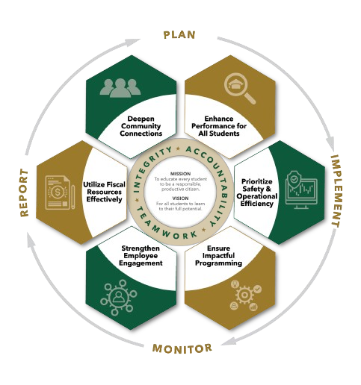


January agenda
Autrey Mill Middle School Governance Council
Date | time January 12 2026| 7:45 am | Location Room A130

SGC Members: Trey Martin, Principal | Emma Cornwall, Teacher |Maud de Groot, Teacher | Ashley Perry, School Employee | Matthew McNamara, School Employee |Kathleen Newquist, Parent | Jessica Saszi, Parent |Beth Zampieri, Parent| Korina Calbay, Community Member | Jacob Marmer, Community Member
Time | Item | Owner
7:45am | Call to Order | Cornwall
7:46am  7:47am | Action Item: Approve Agenda  Action Item: Approve November Minutes  Discussion Item: Pin Distribution | Cornwall  Cornwall  All Members
7:50am  8:10am  8:15am | Discussion Item: Goal update  Discussion Item: Charter Proposals  Action item: Charter Dollar Proposals | Matt McNamara  All Members  Cornwall
8:20am | Informational Item: Principals Update | Mr. Martin
8:30am  8:35am | Discussion Item: Draft Next Meeting Agenda  Discussion Item: Change Next Meeting Date  February 19, 20 or 25  Discussion Item: Budget Committee Meeting  February 12 or 13  Action Item: Meeting Adjournment | All Members  Cornwall  Budget Committee

Meeting Norms
Silences Phones | Be Respectful of Others’ Opinions | Work for the Good of All Students

