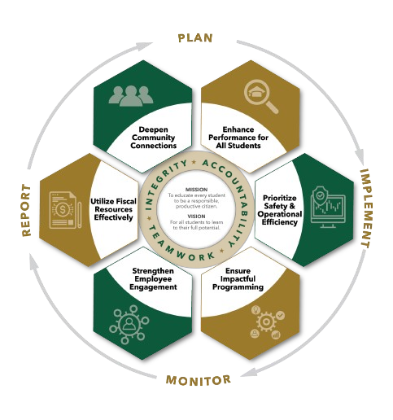


November minutes
Autrey Mill Middle School Governance Council
Date | time November 10, 2025| 7:45 am | Location Room A130

SGC Members: Trey Martin, Principal | Emma Cornwall, Teacher |Maud de Groot, Teacher | Ashley Perry, School Employee | Matthew McNamara, School Employee |Kathleen Newquist, Parent | Jessica Saszi, Parent |Beth Zampieri, Parent| Korina Calbay, Community Member | Jacob Marmer, Community Member
Time | Item
7:47am | Call to Order
7:47am  7:48am | Action Item: Approve Agenda  Motion to Approve: de Groot  Second: Perry  All in favor  Action Item: Approve October Minutes  Motion to Approve: Perry  Second: de Groot  All in favor
7:48am  7:55am | Public Comment  No comments  Informational Item: District 5 update - Kristin McCabe  Initial information on CCRPI scores is very positive.  FCS is facing a budget crunch; recent election resulted in the passing of the tax law exempting residents get 65+ from paying full property tax contribution to education resulting in extensive reduction in property tax dollars. Additionally FCS student enrollment is down resulting in reduced state funding.  Board is developing a 5 year plan to be presented in June 2026.  AMMS getting facility upgrades over the next two upcoming summers.  Encourages voters to remain aware of future property tax legislation and its impact on education funding.  Ms. McCabe will present additional information at a community meeting on November 19 at 9:30 am at Taylor Road Middle School.
8:05am  8:10am  8:15am | Discussion Item: Strategic Plan  Admin assigned to work with selected students to help them reach ELA proficiency goals. Working to strengthen workforce engagement; investigating additional PD day. Attendance numbers are consistent year over year. Office referrals are down year over year since August.  Discussion Item: Charter Proposals  Action item: Charter Dollar Proposals  PE Department requests $2591 to service/repair school owned golf cart that is used throughout school for multiple events.  Motion to Approve: de Groot  Second: Zampieri  All in favor  Coach Shellnut requests funds to purchase replacement scooters for Adventure Quest and other school functions. Cost for 6 scooters is $569.  Motion to Approve: Zampieri  Second: Marmer  All in favor  Nomitha Thomas requests Everyday Speech software to use with speech students. This software supports social skills and provides support for social situations. Benefits approximately 50 students at an annual cost of $500.  Motion to Approve: Perry  Second: Saszi  All in favor  - Modified from original request - to be rewritten by de Groot * ELA department requests planning days for new ELA standards in Units 4 and 5 (January/March). After discussion council agrees to fund substitute staffing for all ELA teachers to have two half day planning opportunities. This will benefit all AMMS students and will cost $2100.  Motion to Approve: Zampieri  Second: Newquist  All in favor
8:30am | Informational Item: Principals Update  CCRPI data currently not available to share, but initial indications are positive. Upcoming parent coffee. Sponge Bob musical production this weekend.
8:40am  8:45am | Discussion Item: Draft Next Meeting Agenda  Action Item: Meeting Adjournment  Motion to Approve: Perry  Second: McNamara  All in favor

Meeting Norms
Silences Phones | Be Respectful of Others’ Opinions | Work for the Good of All Students

