K-3 Home Library Opt-Out

Our school was invited to participate in
Governor’s Early Literacy Foundation’s K-3 Home Library program this summer.

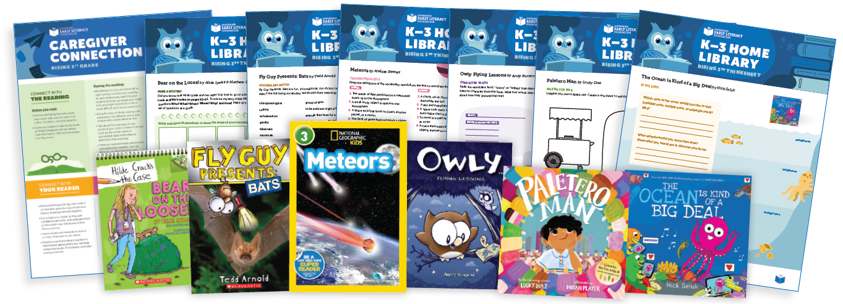

Through this program, all rising 1st-3rd grade students in our school district are being given the opportunity to receive six high-quality books and activity pages, delivered to their homes this summer at no cost to families.

By completing the process below, you are opting your child OUT of participating in the K-3 Home Library program in Summer 2026.
This means your child will NOT receive six books delivered to your home this summer at no cost to you.

If you choose NOT to participate please call your child’s school. Please leave your name, your child’s name, and grade. Taking this step will ensure your child will NOT receive the free books.
* In order to opt out of the free books, contact your child’s school by Friday, January 16th.

Thank you!

