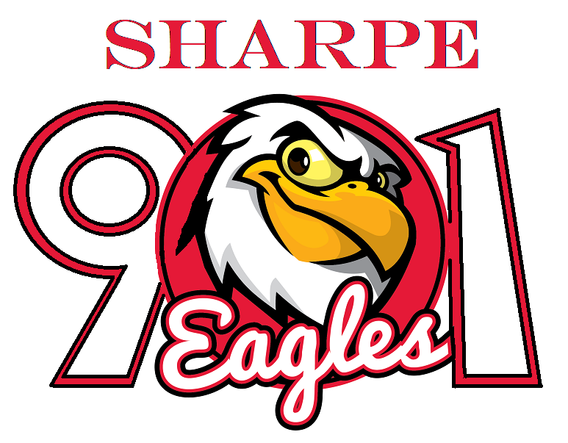
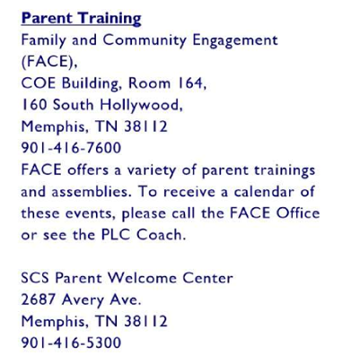
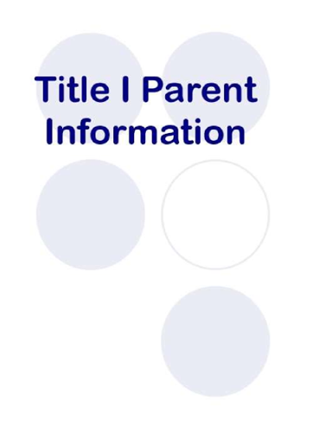
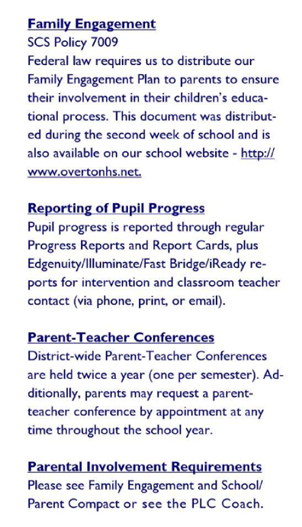

Sharpe Elementary
Memphis, TN. 38016
901-416-5020

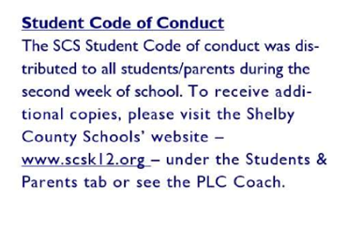
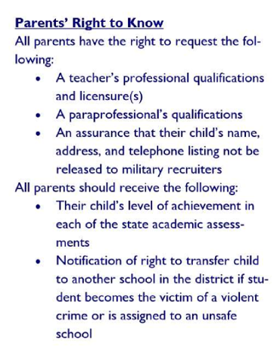
Sharpe operates a school wide Title I Program
Federal law requires us to distribute a School/Parent
Compact to parents to ensure their involvement in their children’s educational process. This document was distributed at the Annual Title I meeting and is also located on the school’s website.
Sharpe maintains a current School Improvement Plan which is updated annually to reflect current data and changing student needs. A copy of the School’s Improvement Plan is located on the school’s website.

