JANUARY
VOL . 14 | ISSUE 5 | JANUARY 7, 2026

LINCOLN ELEMENTARY NEWSLETTER

PRINCIPAL: Audrey McKell | 435.245.6442 | audrey.mckell@ccsdut.org
PTA PRES.: BriAnne Thomson | lincoln.elementary.pta.ut@gmail.com

A MESSAGE FROM OUR PRINCIPAL
Welcome Back, Lincoln Families!
One of the greatest joys of working in elementary education is the gift of a fresh start. Every day offers our students a new chance
to explore fresh horizons, deepen their understanding, and grow into the individuals they aspire to become. It is with this spirit of enthusiasm that we embrace all the opportunities 2026 has in store for us!
As we settle back into our school routines, please take a moment to review these friendly reminders to help keep our days running smoothly:
- Timely Attendance: Success starts with being here! Classes begin promptly at 9:05 am.
  - Mon–Thu Dismissal: 3:35 pm
  - Friday Dismissal: 2:20 pm
- Dress for the Season: Recess is vital for physical and social growth. Please ensure your child has a warm coat, hat, gloves, and sturdy winter boots so they can enjoy their time outdoors comfortably.
- PE Shoes: If your child wears winter boots to school, please remember to pack a pair of sneakers on Physical Education days so they can safely participate in gym activities.
- Traffic & Safety: To keep our students safe, please use the designated drop-off/pick-up area at the back of the school. The front zone is strictly reserved for our buses. Your patience during these busier winter months is truly appreciated!
- Stay Informed: In the event of severe weather, we utilize the SwiftReach system for automated alerts. Please double-check that your contact information is current in PowerSchool to ensure you receive timely updates regarding delays or closures.
My door is always open for any questions, concerns, or ideas you’d like to share. Thank you for entrusting us with the education and well-being of your children.
Here’s to a successful and enriching year ahead! Warm regards,
Audrey McKell



UPCOMING EVENTS

JAN 5 – Back to School!

JAN 7 – PTA Meeting
12:25 - 1:05 – Mrs. Frenzel’s Room

JAN 19 – Martin Luther King Jr Day, No School

JAN 22 – School Community Council Meeting
3:45 – Media Center

FEB 5 – PTA Meeting
12:25 - 1:05 – Mrs. Frenzel’s Room

FEB 12 – Valentine’s Class Parties

FEB 13 – Professional Development Day, No School

FEB 14 – Happy Valentine’s Day!

FEB 16 – Presidents’ Day, No School

FEB 27 – End of Trimester, No School


JOIN THE LINCOLN ELEMENTARY PTA!
Did you know there is no time commitment needed to be a member of the Lincoln PTA? Members can volunteer to help as little or as much as they would like. Scan the QR code or email lincoln.elementary.pta.ut@gmail.com to get involved!

CACHE VALLEY SPELLING BEE
Our Lincoln Elementary School Spelling Bee finalists are: Alice Herzog, Livia Esplin and Landon Foulger. These students will go on to represent Lincoln at the Cache Valley Spelling Bee.
When: January 15, 2026 Time: 6:00 PM (Spellers will need to be there at 5:15pm to check in)
Location: Summit Elementary School in Smithfield

SAVE THE DATE – LINCOLN SCIENCE FAIR
Save the date for our 2026 Science Fair! It will be held on March 19th at 7:00 PM. More information coming soon.

PTA NOMINATIONS FOR THE 2026-2027 SCHOOL YEAR
It’s time to submit names for next year’s PTA executive board. You can submit names to our President, BriAnne Thomson directly, or put them in the PTA box in the office. Names need to be submitted by February 1st.
Our nominating committee will be Melynn Wood, Caitlyn Capener, and Annette Staffanson, with Meghan Esplin and Bobbi Hadfield as alternates.

VOLUNTEERING
Interested in helping out at Lincoln? We’d love to have you as a room parent! Please contact our room parent coordinator, Tessa Thornley at lincoln.elementary.pta.ut@gmail.com. Class Valentine’s parties will be held on February 12th. It’s a great time to join the room parents and help out!

 STUDENT SPOT

Can you pot all six differences between the two penguins?

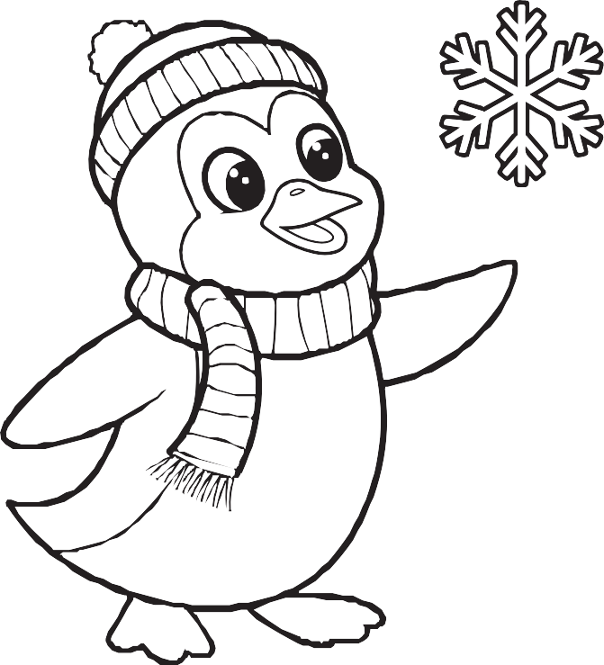
If you’d like to submit information for this newsletter, please email Elise Egbert at elisecreates@gmail.com by the 27th of the month.

