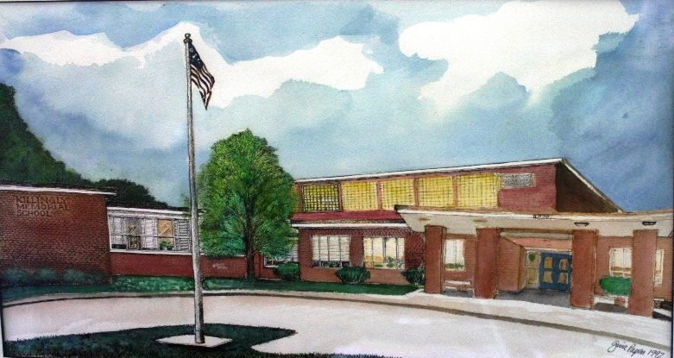 | Killingly Memorial School  Fall 2025

Principal’s Message

Dear Killingly Memorial School Parents and Guardians,

Our 25-26 school year has gotten off to a fantastic start! Teachers and students continue to build strong classroom routines and procedures as we focus on creating a safe, supportive, and engaging learning environment. Through our PBIS Character Education Program, we emphasize positive behavior and important character traits that lead to success. Students are regularly recognized for being Safe, Responsible, and Respectful as we work toward our shared goal of fostering a community where every learner can reach their potential in a caring and inclusive setting. The mission of Killingly Memorial School, a partnership of school, family, and community, is to nurture a safe, caring, responsible, respectful, positive environment where all children can learn and achieve academic and social success.

Our after-school enrichment clubs are in full swing, with over 200 students participating in Robotics, Lego, Crafts, Crochet, Clay, Space, Wacky Science, Team Games, and Pokémon Clubs! Students enjoy a free snack each day and are already looking forward to the spring session.

Killingly Memorial students had a fantastic time celebrating fire prevention week. A big thank-you to the Danielson and East Killingly Fire Departments for bringing fire trucks and emergency vehicles to KMS and teaching our students about fire safety. They especially loved trying on firefighter gear and seeing Mr. Jonasch and I lifted high in the fire truck bucket!
This year, KMS students and staff were invited to dress up for Halloween as part of our attendance challenge. Thanks to great attendance, the whole school participated! Costumes included Mario and Luigi, a princess, Spider-Man, and even the Sanderson Sisters from Hocus Pocus. It was wonderful to see everyone enjoying the day and showing school spirit.

We recently held our second Community Meeting of the year, where we celebrated with students who consistently follow our PBIS expectations. Each class honored a Student of the Month, and our Unified Arts teachers recognized additional students for their outstanding effort and character. Fourth graders also can serve as Koala Captains, assisting with announcements and school responsibilities. We also recognized a staff member with the Golden Koala Award for going above and beyond. These meetings always bring such positive energy and pride to our school.

Parent Conferences will take place on Tuesday, November 18th, from 5-7, and Thursday, November 20th from 1:45-3:45 and 5-7. Please make sure to sign up for a conference time with your child’s teacher.

Killingly Memorial School is a truly remarkable place, filled with dedicated teachers, enthusiastic students, and supportive families. Thank you for your continued partnership in making KMS a wonderful community for all.

In Partnership,

Mrs. Chahanovich, Principal

November 2025
Monday | Tuesday | Wednesday | Thursday | Friday
3 | 4 NO School  Voting Day  Staff Development Day | 5 | 6 | 7  Newsletter home in Friday Folder
10 | 11 NO School  Veteran’s Day | 12 | 13 | 14  Last Day of Marking Period at KMS
17 | 18  Parent Teacher Conferences 5-7pm | 19 | 20 HALF day at KMS  Parent Teacher Conferences  1:45-3:45 and 5-7pm | 21
24 | 25  Community Meeting | 26 HALF Day  Thanksgiving Break | 27 | 28  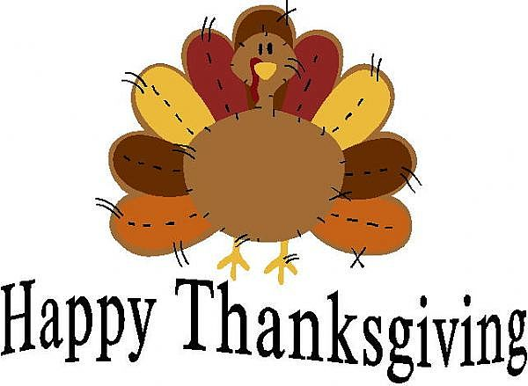
December 2025
Monday | Tuesday | Wednesday | Thursday | Friday
1 | 2 | 3 | 4 | 5 Early Release Day  Staff Development Day
8 | 9 | 10 | 11 | 12
15 | 16 | 17 | 18 | 19
22  Community Meeting | 23 | 24 HALF Day  Winter Vacation | 25 NO School  Winter Vacation | 26 NO School  Winter Vacation
January 2025
Monday | Tuesday | Wednesday | Thursday | Friday
29  Winter Vacation!!!!  | 30 | 31 | 1 | 2
5 | 6 | 7 | 8 | 9 Early Release Day  Staff Development Day
12 | 13 | 14 | 15 | 16  Progress Reports home in Friday Folders
19 NO School  MLK Jr. Day | 20 NO School  Staff Development Day | 21 | 22 | 23
26 | 27 | 28 | 29 | 30  Community Meeting
Grade Two
This year, Killingly continues to implement the Language Arts curriculum from CKLA, designed with two key components. The Knowledge component builds reading comprehension skills through engaging in science and social studies topics, while the Skills component focuses on developing phonics and decoding abilities.

In Skills Unit 1, students began by reading words with basic spellings for the five short vowel sounds. Moving forward, students will begin participating in WIN (What I Need) time. During WIN, all second-grade teachers will work with groups of students across the grade level to focus on targeted phonics and reading skills. Split by team, students will move to a classroom to work with a teacher who will provide instruction tailored to their specific learning needs.

For the Knowledge component, students explored the ancient Greek civilization, focusing on its geography, mythology, and its influence on modern society, particularly democracy. They learned about city-states like Sparta and Athens, as well as the first Olympic Games held in honor of Zeus.

In the next unit, students will begin learning about the twelve Greek gods and goddesses that ancient Greeks believed lived on Mount Olympus. They’ll explore myths, fictional stories that explain nature, teach morals, and entertain. In class, they’ll hear well-known myths like “Prometheus and Pandora” and “Arachne the Weaver.” To support learning at home, parents can review the gods and their roles, discuss phrases like "cold feet" connected to myths, and use vocabulary words like myth, mortal, and immortal in daily conversation.

In math, students have practiced adding and subtracting within 100 using strategies based on place value, properties of operations, and the relationship between addition and subtraction. In the beginning, students used diagrams, connecting cubes, and base-ten blocks to solve problems and develop place-value understanding. Then, students are asked to subtract one- and two-digit numbers by decomposing tens, using manipulatives like base-ten blocks to support their thinking. Finally, students solve one-step story problems involving different types of addition and subtraction scenarios, encouraging them to represent their thinking clearly and explain their problem-solving process.

In the upcoming unit, students will measure and estimate lengths in both metric and customary units, solving story problems within 100. They will begin with metric measurements using base-ten blocks and create their own centimeter rulers, reinforcing place value and learning to measure with meters for longer items. Next, they’ll explore customary units like inches and feet, making choices about which unit is best based on object size. Finally, students will represent measurement data online plots, marking lengths and labeling measurement units. Parents can support by encouraging students to measure household objects and discuss unit choices.

Thank you for your ongoing support and partnership in your child’s education! At home, you can support learning by setting aside a few minutes each day for reading together, practicing high-frequency words, and reviewing addition and subtraction facts to 20. These simple routines help reinforce what we’re learning in class and build confidence. We look forward to continuing to work with your students!
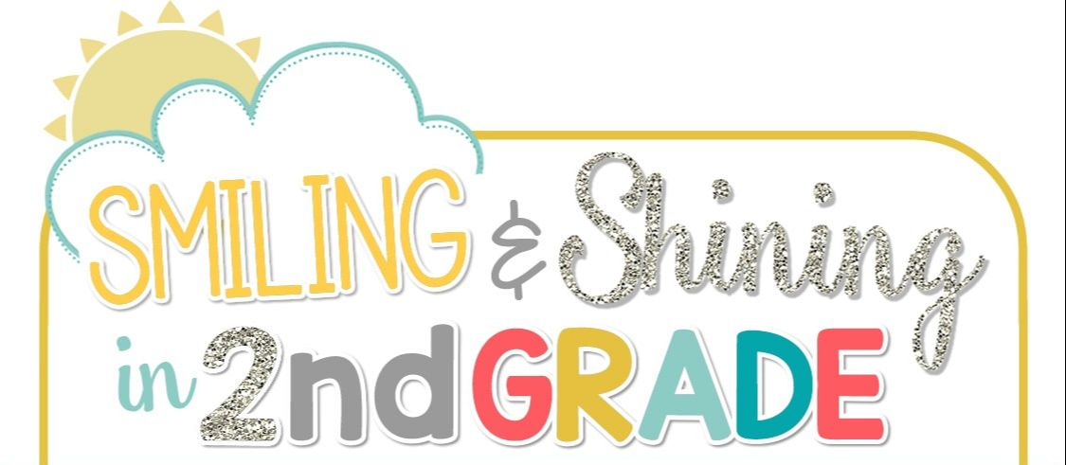

Grade Three

Social Studies:
Third grade has been busy learning about the geography of Connecticut this fall. Students have learned where we are on the map and how where we live affects how we live. Students have discovered the importance of the land, water and climate in our region. We’re now moving into learning about the Native Americans indigenous to this area. Students will look at the food, homes, and other important aspects of the Native Americans' lives.

Math:
In math, third graders have been learning about multiplication. Students have worked on showing multiplication and equal groups and arrays. Students have also been working hard on learning their multiplication facts from memory. We are now working on the relationship between multiplication and area. Students have been measuring rectangles and other figures with rulers then using multiplication to find the area. Students will continue to work on their multiplication throughout the year. Soon students will shift into learning how to add and subtract 3-digit numbers, with and without regrouping.

Social Emotional Learning:
Third grade students continue to work with the mood meter that they used in second grade to identify and explain how they are feeling each day. Students refer frequently back to the mood meter during the day to check in and regulate their emotions. Students have learned how to use emotion words to describe how they are feeling to others and also identify emotions in others. Students continue to listen to read aloud stories and have discussions surrounding regulation of emotions and identifying emotions. Students also began the Safer, Smarter Kids program again this year. This program starts by teaching students to have trusted adults in their lives, and how to be a good citizen and their community.

CKLA:
Third graders have been working hard on our reading program, Core Knowledge Language Arts. Students began the year looking at classic tales, and diving into the themes of the story “The Wind in the Willows.” Students examined the themes Friendship, Hospitality, Responsibility and Irresponsibility, and were able to give details about which characters showed that theme throughout the story and why. In our second reading unit, students put on the hats of taxonomists. Through reading and writing activities, students learned how to classify animals based on their characteristics such as if they have a backbone, and if they are warm- or cold-blooded animals. Students took the knowledge they gained and completed an animal research project. They chose an animal and were able to classify that animal into groups based on its characteristics, just like real taxonomists!

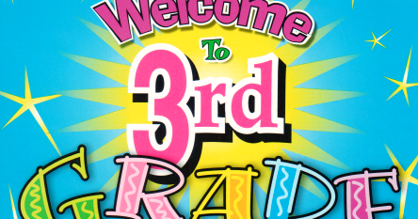

Grade Four

Math

Fourth graders started the year off working extremely hard! We have completed Units 1 and 2 in Illustrative Math (IM), which focused on factors, multiples, and fractions. We have generated equivalent fractions and used this skill to help compare and order fractions. We have started unit 3 and are now learning to multiply fractions by whole numbers. This unit will also include adding and subtracting fractions and mixed numbers. Please remember to have your child(ren) practice their math facts nightly!

CKLA - Reading and Writing

In CKLA students have completed Unit 1 of Personal Narratives. We have now moved onto Unit 2 Part 1, learning about the Middle Ages. Students have been learning about the breakdown of the Roman Empire, focusing on the region of Europe. Students have been participating in whole group discussion to help them comprehend the variety of complex texts. They have also been engaging in deep conversations with their peers to further develop their understanding of the world around them. We have begun working on writing persuasive and informative paragraphs. Students have had the opportunity to fill out a number of graphic organizers and cite evidence from the text to help with note taking and transform those notes into paragraphs to state their opinion about a specific topic. They know many facts about the Middle Ages, and we are sure they would love to share them with you!

Social Studies

When we first started our year in 4th grade at KMS, we studied our map skills and how to identify our location in the world. Then, we began studying the regions of the United States and the 50 states of America! Through catchy tunes and fun games, we hope to master the state’s names, capitals and locations by the end of the year. This year we will focus on the regions of the United States and why each region belongs together. We have started our journey through the United States in the Northeast. We have discussed geography, economics, history, and climate. Our journey will continue with the Southeast.

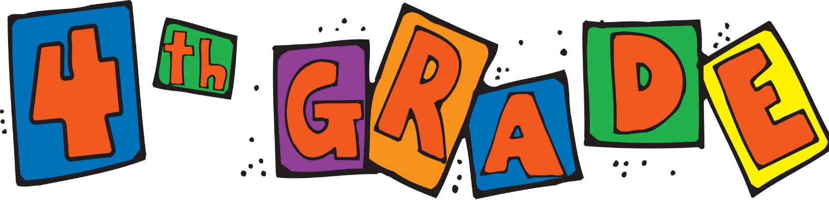


Notes from Ms. Larson
KMS Music November 2025

We are off to a great school year! Classes are settling into music routines, and we are diving into some challenging but rewarding material. Below are some updates on what we are learning in music for each grade.

What Did We Learn?
3rd Grade:
In the first few months of school, we reviewed the rhythms we learned last year including quarter notes, eighth notes, and quarter rests. We also focused on reading the notes: do, re, mi, fa, and so on the staff through singing and playing these notes on boomwhackers.
2nd Grade:
In the past two months, we reviewed the difference between beat and rhythm. We have also explored patterns in music by performing and creating movements to many musical works. We are beginning our review of ta and ti-ti rhythm patterns as we bring the ideas of rhythm and patterns together.
4th Grade:
At the beginning of the school year, we focused on reviewing musical concepts to prepare for the recorder. 4th graders have received their recorders in class and are making excellent progress! We are beginning to learn the notes B, A, and G. We will soon be working on songs that include those notes, especially “Hot Cross Buns!”


ART NEWS
Grade 2
After a project learning about the art element of lines, students learned about how to use lines and shapes to make patterns. They learned about the horizon line, what a landscape is and how to draw a landscape with 3-D houses. They are learning how to use a lot of supplies as they make patterns in their fields.
Grade 3
Grade 3 Learned about the artist Yayoi Kusama, a Japanese artist who became famous in the 60s for her work with polka dots. The students are creating pumpkin pictures in her style with various materials. If you happen to go to the Hartford Atheneum, you can see one of her giant polka dot pumpkin sculptures there!
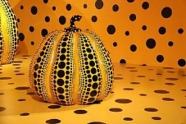
Grade 4
Grade 4 students had a blast making Tim Burton Spooky black and white portraits. We focused on value in art using a range of tones.
They are starting to learn about positive and negative space in art. Only 4th graders learn about this element of art expanding on what they have learned about line, shape, color, value and texture. They are creating abstract works using their hands to trace and Zentangle designs.
DONATIONS NEEDED IN ART CLASS
Black sharpies fine point
Greetings from the KMS Library!

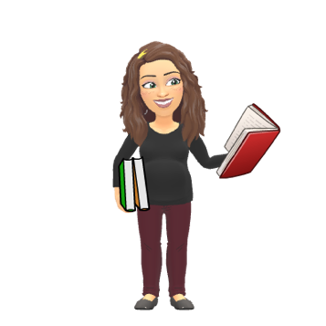
Greetings from the KMS Library! It’s been a busy start to the school year. So far students in grades 2 through 4 have worked on:

- Learning the expectations of a good library user
- Understanding the process of borrowing and returning library books
- Practicing basic care for library books
- Appreciating classic stories from selected series
Looking ahead we will focus on…
- Continued success as good library users
- Appreciating stories and focusing on independent reading for enjoyment
- Soon we will be practicing “Stop, Drop, & Read” during library time. This practice will help students build stamina and grow as readers!

🔬 Science at KMS: Exploring, Experimenting, and Excited About Learning!
What an amazing quarter it’s been in Science for all our KMS students! Each grade has been busy exploring hands-on experiments and discovering how the world around us works.
🌟 Fourth Grade – Energy in Action!
Our fourth graders have been diving into the different forms of energy — MELTS (Mechanical, Electrical, Light, Thermal, and Sound). So far, we’ve focused on Mechanical, Thermal, and Electrical energy. One of their favorite activities was exploring Kinetic and Potential Energy by designing their very own skateboard parks! They’ve loved seeing energy in motion and understanding how it transfers from one form to another.
🚗 Third Grade – Motion and Forces Everywhere!
Third graders have been discovering that everything has patterns and that forces are all around us in our Motion and Forces unit. Students took on fun challenges—like figuring out how to move cars without touching them, and experimenting with friction and gravity while designing their own slides. We even took a virtual roller coaster ride to see forces in action! What a thrilling way to bring science to life.
🧊 Second Grade – The States of Matter
Second graders have had a blast learning about the three states of matter: solid, liquid, and gas. They explored how heating and cooling can cause matter to change state and learned that some changes are irreversible. Their favorite moment was watching an ice cube melt in real time, seeing science unfold right before their eyes! Our fourth graders also connected these ideas to thermal energy transfer, making for a fun and meaningful learning experience across grades.
🎃 Pumpkin Science – A Year-Long Experiment
We’ve kicked off our year-long pumpkin experiment! Students are observing changes week by week and revisiting their hypotheses as the pumpkin slowly transforms. It’s an exciting, ongoing project that helps them see the scientific process in action — observation, prediction, and discovery!
🍁 Science is Everywhere!
From melting ice to spinning radiometers, the students at KMS are learning that science is full of fun, curiosity, and endless exploration. We can’t wait to see what discoveries come next!
Thank you, Ms. Vincent
If there are any questions please feel free to contact me at kvincent@killinglyschools.org
Physical Education
Dear KMS Families,

It has been a fantastic start to the school year in Physical Education! During the first few months, students have been busy learning and playing cooperative games that focus on teamwork, communication, and good sportsmanship. We’ve also worked on throwing and aiming at different targets, helping students build accuracy, coordination, and confidence while staying active and having fun.

As we move into the next part of the fall, fourth graders will be starting their first round of fitness testing. This round serves as practice for the spring tests and gives students a chance to learn proper form and set personal goals for improvement. Second and third graders will soon begin our scooter unit, which focuses on balance, coordination, and safety as we explore a variety of creative and movement-based activities.

Please remember that students need to wear sneakers on PE days. Safe footwear helps everyone move comfortably and participate fully in all activities.

I’m so proud of the effort, teamwork, and positive energy students have brought to PE so far this year. It’s been a joy watching them grow and challenge themselves, and I’m looking forward to an active and fun rest of the fall season.

Sincerely,
Miss Gallagher
REMEMBER to wear your

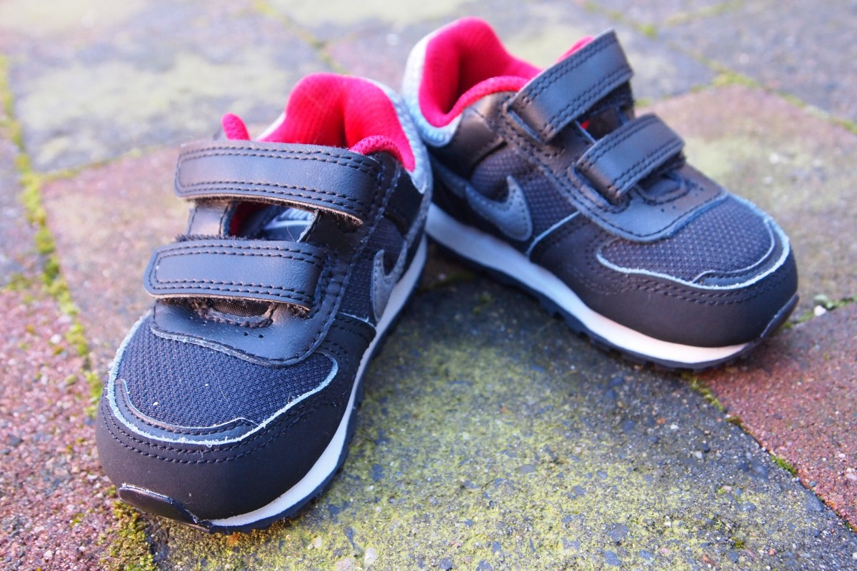
on GYM day!!!

Happy Fall from Ms. Costa and Ms. Reyes
Math Intervention

As October ends and the fall season is in full swing, our classrooms are buzzing with mathematical thinking! Our mathematicians have been working hard at work developing key skills and strategies that will support their math thinking all year long. We’ve wrapped up some exciting units and are beginning to lay the groundwork for new learning as we head into November. Below, you’ll find an overview of what we’ve been working on, how you can support math thinking at home, and a sneak peek at what’s coming next.
Grade 2:
- Addition and subtraction within 20 using a variety of strategies
- Addition and subtraction within 100 using base ten blocks and the split strategy (breaking numbers into tens and ones)
- Solving one- and two-step word problems with real-world context
Grade 3:
- Introduction to multiplication: what it means and how it works, using equal groups, arrays, and repeated addition to build understanding
- Applying multiplication strategies to solve area problems, using rectangular arrays and real-world models
Grade 4:
- Understanding fractions as part of a whole
- Exploring equivalent fractions and comparing fractions
- Representing fractions on number lines and in visual models
🍁 Fall & Thanksgiving Math Fun!
Here are a few festive ways to bring math into your home this season:
🦃 Thanksgiving Cooking = Measurement Fun!
Involve your child in helping measure ingredients while cooking or baking. Talk about fractions (1/2 cup vs. 1/4 cup) and double or halve recipes together.
🍂 Leaf Math:
Go on a walk and collect leaves. Sort them by size, color, or type, and create a bar graph or tally chart.
📏 Pumpkin Math:
Estimate the number of seeds in a pumpkin, measure the height or circumference, or graph how many pumpkins you see at the store.
Meet the Reading Specialists—Mrs. Morrone and Miss Hosko
📚📚📚📚📚📚📚
Here at KMS, Mrs. Morrone and Miss Hosko work with a wonderful team of tutors and paraprofessionals who have experience and a passion to teach children. There has been a lot of thought going into having the students work on many different skills related to reading, including decoding words, fluency practice, and comprehension activities.
All students should be reading every night. Reading aloud with your children and taking turns reading is excellent practice when they are home with you. Stop often and talk about what you are reading. The practice of reading regularly at home can increase your child’s comprehension of a topic and how smoothly they read.
Reading opens so many doors for children. Whether they are learning about something new or escaping into an imaginary world, it is important to instill in all children that reading is a fun and positive experience. Reading starts with learning the basics, like phonics, but the goal is to comprehend what you are reading whether it be informational, fictitious, or science fiction.

News from the SPEECH ROOM

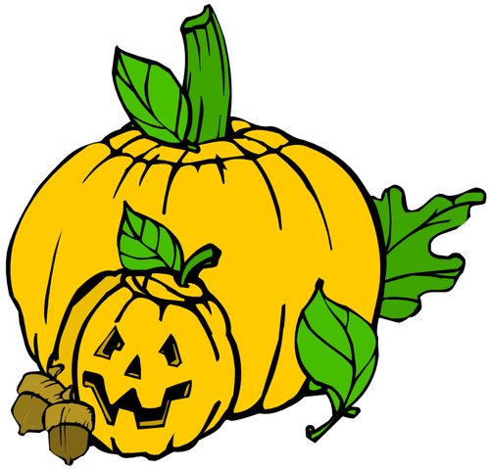
We are learning about the Fall Season, and the Holidays during Fall. We are reading,”The Apple Pie Tree,” “Apple Trouble,” “The Biggest Pumpkin Ever,” and “Room on the Broom.”

We are describing ,categorizing, sequencing and learning synonyms. (ex. Fall and Autumn)

Parents:

Discuss the differences between Fall and Winter. What happens to the animals, trees, and temperature? Talk about basic concepts, large, small; big, little…..

Help your student describe an Apple and Pumpkin…
What are they? (fruit, vegetable) What do they look like? ( color, shape…)
What parts do they have? What can you make with them?

We are also working on the TH sound. Try practicing the tongue cooler sound (the tongue slightly protrudes between the top and bottom teeth) when saying THanksgiving, or THree.

Mrs. Orbegozo, MS. CCC,SLP
Mrs. Boyle C-SLPA

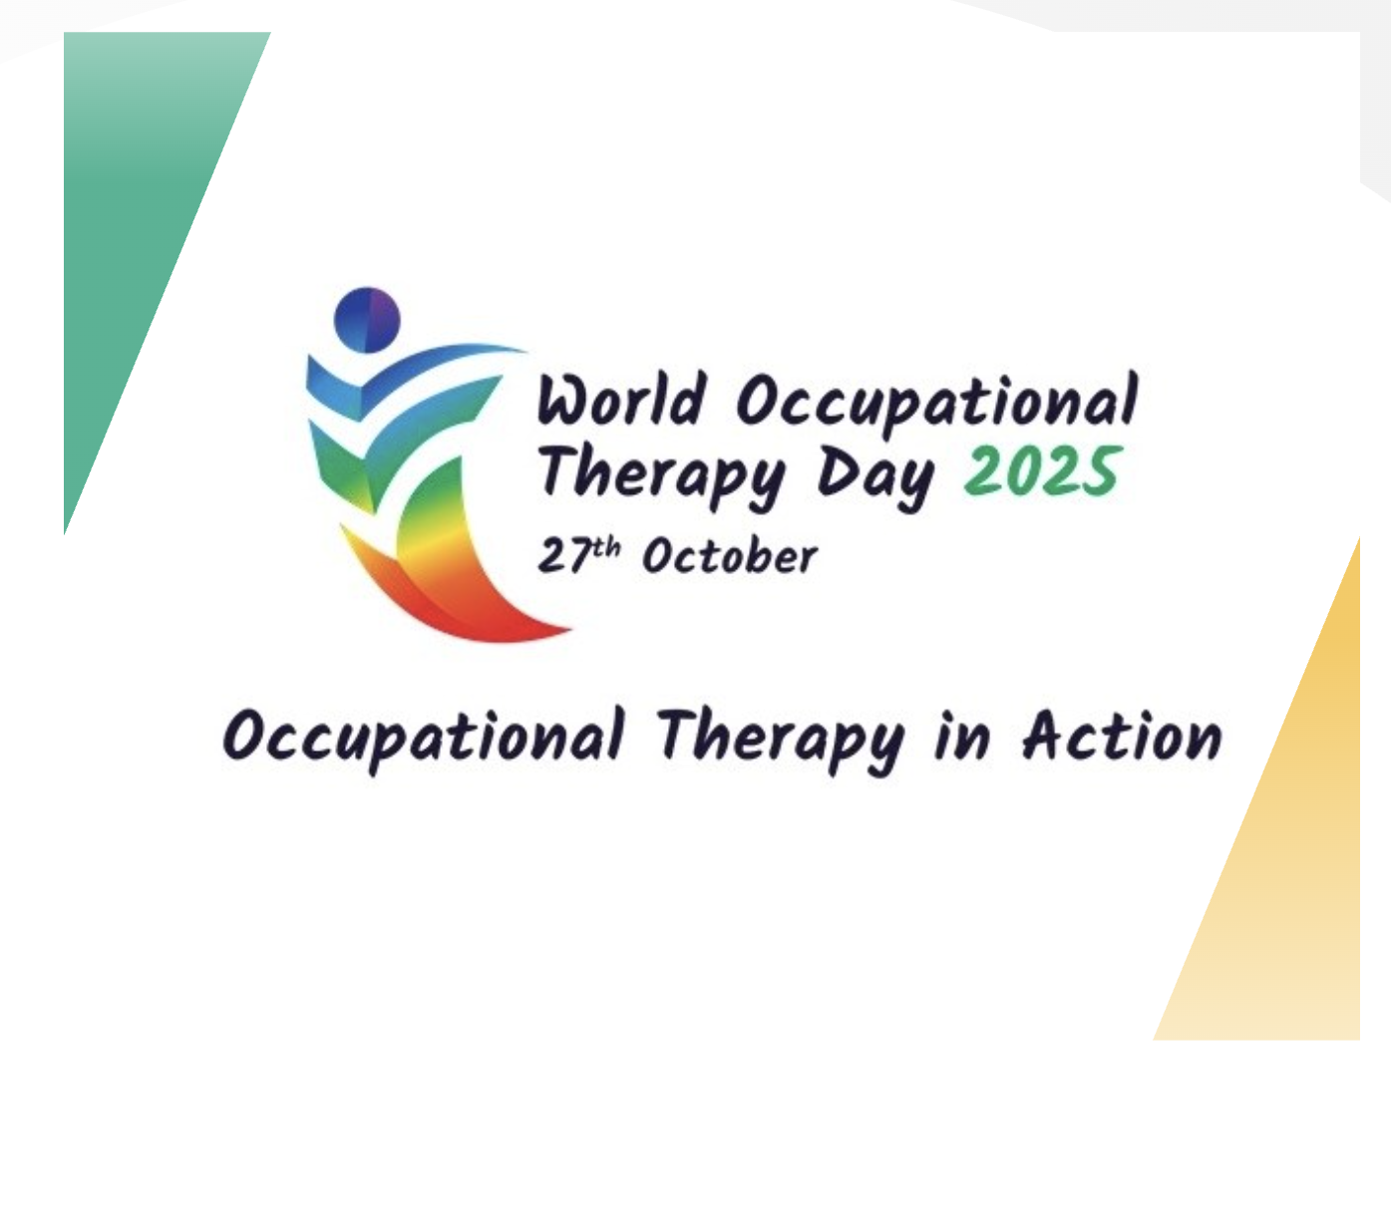
Information from
Occupational Therapy
Thank you to the KPS occupational therapy practitioners--for ALL that you do!

Is Your Child's Backpack Too Heavy?

Heavy backpacks can hurt your child's back, neck, and shoulders. They can also cause poor posture and muscle strain. Here's how to keep your child safe and comfortable.

The Simple Rules
Weight Limit: *Your child's backpack should weigh no more than 10% of their body weight.
*If your child weighs 70 lbs, their backpack should weigh 7 lbs or less. Weigh it on your bathroom scale!
How to Pack: *Put the heaviest items (textbooks, binders) closest to your child's back
*Pack items tightly so they don't slide around. *Check daily – remove anything not needed that day
Wearing It Right: *Use BOTH shoulder straps (never just one!)
*Adjust straps so the backpack sits snug against the back. *Use the hip belt if there is one
Quick Fixes: *Let your child hand-carry one book if the backpack is too heavy
*Ask the teacher if some books can stay at school or in a locker. *Consider a rolling backpack if needed.
*Check if digital versions of textbooks are available
What to Watch For: *If your child complains of back or shoulder pain, or leans forward when wearing their backpack, it's too heavy. Take action right away.

Source: American Occupational Therapy Association (AOTA)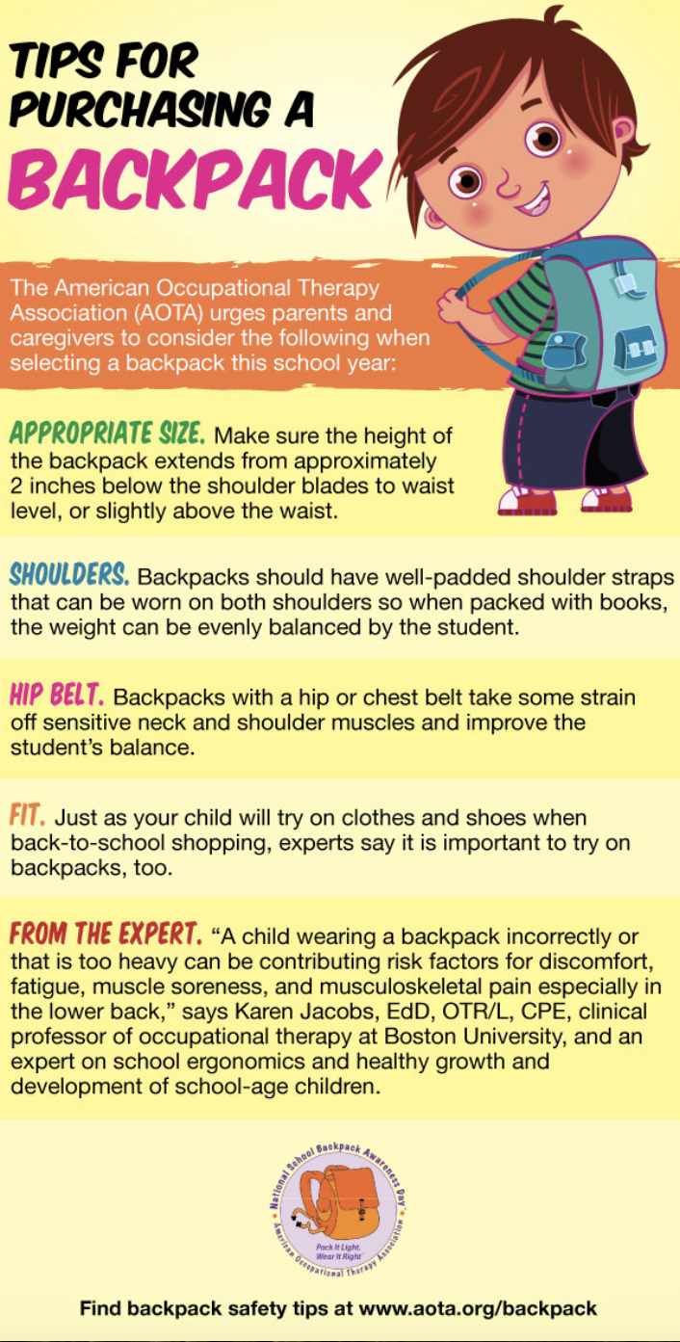
KMS Community News
Travelling Trophy
*given to one classroom per grade with the best percentage attendance for the month
SEPTEMBER
Grade 2--Mrs. Lanzoni’s Class Grade 3--Mrs. Bitgood’s Class Grade 4--Mrs. Colucci’s Class
OCTOBER
Grade 2--Mrs. Lanzoni’s Class Grade 3--Ms. Breen’s Class Grade 4--Ms. Tenaglia’s Class
and Mrs. Crabtree’s Class
Golden Koala Award
SEPTEMBER OCTOBER
Scott Johnson Tessa Powell
Student of the Month
SEPTEMBER OCTOBER
Grade 2  Mrs. Crabtree-Layla Santiago  Ms. Fratoni-Nico Spardello  Mrs. Juhola-Hadley Tocchio  Mrs. Lanzoni-Theodore Swan  Mrs. Maheu-Alexis Craig  Ms. McMerriman-Jason Swope  Ms. Moulton-Scarlett Naumec  Ms. Riordan-Erick Quintanilla  Ms. Sakidovitch-Avery Lavoie | Grade 2  Mrs. Crabtree-Jacob Hardell  Ms. Fratoni-Frankie Hernandez  Mrs. Juhola-Kage Turner  Mrs. Lanzoni-Jacob Correllus  Mrs. Maheu-Isabelle Lamarque  Ms. McMerriman-Hazel Amott  Ms. Moulton-Mia Insixiengmay  Ms. Riordan-Nolan Medeiros  Ms. Sakidovitch-Myles Boulet
Grade 3  Mrs. Bitgood-Preslie Goyette  Ms. Breen- Peyton Preslie  Ms. Gaulin-Jaxon McIntire  Mrs. Hand-Gia’Lahna Humphries  Ms. Paul-Denali Twerdi  Mrs. Penner-Kylee Corneau  Ms. Siegmund-Luca Drolet  Ms. Tillinghast-Weston Roode | Grade 3  Mrs. Bitgood-Larayah Walker  Ms. Breen-Logan Wood  Ms. Gaulin-Lily Palazzi  Mrs. Hand-Mike Rugira  Ms. Paul-Juan Williamson  Mrs. Penner- Jordan Munsen  Ms. Siegmund-Hailey Roberts  Ms. Tillinghast-Alexandra Tempest
Grade 4  Ms. Breen-Penelope Beshaw  Mrs. Burdick-Eloise Wentworth  Mrs. Campbell-Victoria Huynh  Mrs. Colucci-Connor Nevers  Mrs. Delfarno-Christian Corbin  Ms. Ellal-Bentley Colon  Mrs. Scott-Avery Bakanowsky  Ms. Tenaglia-Rose Cote | Grade 4  Ms. Breen-Jayce Richardson  Mrs. Burdick-Kaisyn Drew  Mrs. Campbell-Rylee Voyer  Mrs. Colucci-Caroline Hardell  Mrs. Delfarno-Haeden Riendeau  Ms. Ellal-Kashlyn Vilaiphone  Mrs. Scott-Waylon Violette  Ms. Tenaglia-Ryan Parden

Koala Captains
SEPTEMBER OCTOBER
Ms. Breen-Veronica Watkins  Mrs. Burdick-Everlee Boulais  Mrs. Cambell-Bella Fernandez  Mrs. Colucci-Felicity Nizeul  Mrs. Delfarno-Harper Lindsey  Ms. Ellal-Coraline Chalifoux  Mrs. Scott-Alannah Ouellette  Ms. Tenaglia-Elliana Bransfield | Ms. Breen-Delilah Wilbur  Mrs. Burdick-Faith Machamer  Mrs. Delfarno-Jack Jarominkski  Ms. Ellal-Cooper Sweeney  Ms. Lee-Andy Odoardi  Ms. Salisbury- Eleanor Tumolo  Mrs. Scott-Kaydence Jepson  Ms. Tenaglia- Santiago Vilchis

