

OSIG Scholarship Guidelines
- To qualify, students must be currently enrolled in an OSIG member school in good standing as of January 1.
- The scholarship will be awarded annually to three graduating high school seniors from each quadrant (as classified by OSIG) in the state of Oklahoma. There will be no discrimination made as to this scholarship based on race, color, religion, national origin or sex, by either OSIG or participating member schools. The quadrants, Northwest, Northeast, Southwest & Southeast are designated by the boundaries of Interstate 40 running East and West and Interstate 35 running North and South. The high school address will be used in determining which quadrant the applicant is located. *See attachment
- The scholarship will be awarded to the top three finalists from each quadrant. The award amounts will be
$2,000 for the first finalist, $1,500 for the second, and $1,000 for the third.
- Each recipient will receive a one-time cash scholarship, to be used by the student to help defray the costs of post-secondary education and related expenses. The check will be made payable to the scholarship recipient.
- Each school is responsible for distributing to its students information pertaining to the scholarship application, rules and deadlines.
- Each school must screen and evaluate its own applicants based upon criteria set forth on the OSIG Scholarship Application Form and then choose a single finalist to be forwarded to OSIG for consideration. Each member school district may submit only one entry for consideration.
- Entries must be postmarked by March 3, 2023 in order to be considered.
- OSIG will appoint a scholarship committee selected by the OSIG Board of Directors of not less than three persons but no more than five to determine the scholarship recipients. The decision of the scholarship panel will be final.
- If a student from an OSIG board member’s school district is a finalist for scholarship, that board member will be excluded from any and all aspects of the judging process.
- The superintendents of the school districts attended by each of the quadrant winners will be notified in writing of the award being made to the student.
- The scholarship will be awarded on or before the graduation date of each quadrant winner. The scholarship monies will be distributed upon proof of acceptance in a post-secondary institution.
- The selection is based on academic excellence, leadership in school activities and/or work experience and community service. Each applicant must be a graduating high school senior and must complete the OSIG Scholarship Application by application deadline.
- Applicants need to collect three letters of recommendation from responsible adults who have observed their growth and development over a period of time. One should be by a school employee that is familiar with the applicant's school accomplishments.
- Applicants are required to submit to OSIG two (2) copies of the application materials. These materials include the completed application, copies of seven semester (grades 9-12) transcripts, letters of recommendation and ACT/SAT test scores.
- The panel will select finalists who will be interviewed by the panel. The applicant must pay travel expenses to and from the interview. OSIG cannot pay the travel costs.

Scholarship Checklist

Name:
Last First Middle Initial

Step 1: Make sure you qualify for this scholarship.
- I am a graduating high school senior at an OSIG member school in good standing as of January 1.

Step 2: Provide all the necessary information

I have done the following:

- Completed the Application.
- Signed the Application.
- Had a representative of my school sign the Application.
- Attached copies of seven semester (grades 9-12) transcripts.
- Provided three completed Letters of Recommendation from responsible adults. One letter written by a school employee.
- Provided ACT/SAT Test scores.
- Provided a 750-word essay explaining your academic and/or professional goals and how you will use this scholarship to help achieve them.
- Provided a copy of acceptance letter(s) to post-secondary institution.
- Provided two copies of all of the application materials.
- Postmarked by March 3, 2023.

Step 3: Confirm your understanding

I understand the following:

- I must have my completed and signed application and accompanying documents mailed to the Oklahoma Schools Insurance Group postmarked by the submission deadline for scholarship consideration: Oklahoma Schools Insurance Group Scholarship Committee, P. O. Box 3068, Tulsa, OK 74101

Application Signature Date:

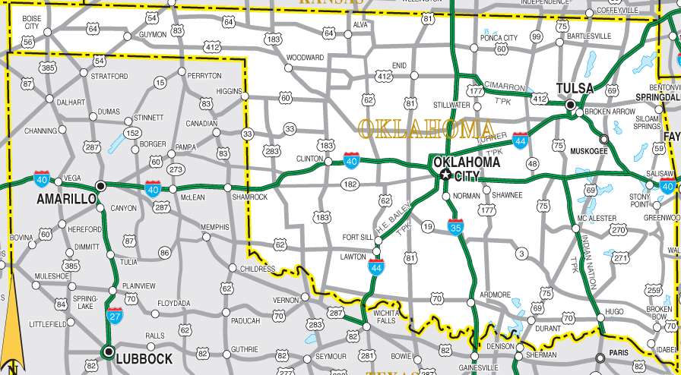

Scholarship Application Form
Please Print or Type

School Information:

Quadrant: (Northeast, Northwest, Southeast, Southwest)

School District:

Applicant Contact Information:
Last Name | First | Middle Initial
Address
City | State | Zip
Phone Number
Email

Scholastic Information:

How long has the applicant attended this school district? Is the applicant a graduating high school senior? What is the applicant's current grade point average? on a scale
SAT Score: ACT Score: Class Rank: Total in Class: To what post-secondary institutions has the applicant applied?

To what post-secondary institutions has the applicant been accepted?

(Copy of Acceptance Letter(s) must be included)

What field of study does the applicant plan to pursue?

Other Information (attach a separate sheet if more space is needed):

Please list applicant's scholastic honors, activities, and/or leadership positions, and year(s) in which those occurred.

Please list applicant's extracurricular activities and/or community honors and year(s) in which those occurred.

Explain your academic and/or professional goals and how you will use this scholarship to help achieve them.
(Maximum 750 Words)

NOTE: This application must be accompanied by a certified 7-semester transcript (through the first semester of the applicant's senior year in high school), a certified SAT/ACT score sheet (if taken) and three letters of recommendation as outlined in the scholarship guidelines.

Verification of Information:

I, , to the best of my knowledge, have accurately and truthfully answered the questions on this application. I understand that if any of the information on this application is found to be intentionally false or if any responses are not my personal work product, I will be removed from consideration for this scholarship.

Signature of Applicant

Date

To the best of my knowledge, the information on this application sheet is accurate and truthful.

Signature of Principal

Date

Return Application with required materials to:
OSIG Scholarship Committee P O Box 3068
Tulsa, OK 74101

OSIG Scholarship Scoring Sheet
(OSIG scholarship committee will use this sheet to determine recipients)

Quadrant: School District: Applicant Name:

INSTRUCTIONS FOR EVALUATOR: There are 100 possible points which may be awarded. Questions 1 and 2 are objective (no evaluator discretion), with a set of points assigned to and awarded from the category into which the applicant falls. Questions 3, 4, and 5 are subjective (evaluator has discretion), with a range of possible points within each category. The evaluator should first choose the category most applicable, then award a point value within the range assigned to that category.

CRITERIA POINTS AWARDED

1) | Grade Point Average (Note, all honors courses | (Enter Mandatory Points)
1) | must be converted to a 4-point scale):
1) | If 4.0, award 25 points
1) | If 3.5 to 3.99, award 23 points
1) | if 3.0 to 3.49, award 21 points
1) | if 2.9 or below, award 20 points
2) | SAT/ACT Scores (if both taken, use highest score) | (Enter Mandatory Points)
2) | If 1200 or better SAT or 27 or better ACT, award 20 points
2) | If 1100-1199 SAT or 21-26 ACT, award 18 points
2) | If 999-1099 SAT of 20 ACT, award 16 points
3) | Scholastic Honors, Activities, and/or Leadership Positions: | (Enter Discretionary Points)
3) | If well rounded/excellent, award 11-15 points
3) | If limited/good, award 6-10 points
3) | If few/fair, award 0-5 points
4) | Extracurricular and/or Community Honors: | (Enter Discretionary Points)
4) | If well rounded/excellent, award 15-20 points
4) | If limited/good, award 10-14 points
4) | If few/fair, award 0-9 points
5) | Goals Question: | (Enter Discretionary Points)
5) | If excellent reasoning, writing and grammatical skills, award 16-20 points
5) | If good reasoning, writing and grammatical skills, award 11-15 points
5) | If fair reasoning, writing and grammatical skills, award 0-10 points

TOTAL POINTS AWARDED:

