Services – Offer of FAPE: Service Options and Potential Harmful Effects Guidance Document

Services – Offer of FAPE
Service Options and Potential Harmful Effects Guidance Document

There are two questions we must answer on the Services – Offer of FAPE IEP page.

- The service options that were considered by the IEP team (List all):

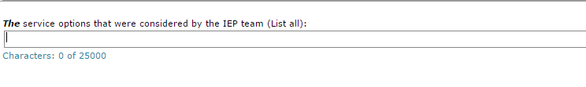
First, we must consider the continuum of services when considering a placement in the LRE. Use the following continuum of services to assist in determining what LRE is for a particular student:

- General Education Class
- General Education Class – Supplemental aids or services
- General Education Class – Some direct instruction by special education staff. Less than 21% of time out of the classroom for special education services
- General Education Class – 21% to 60% of instructional day in a separate classroom.
- Some/or no instruction in General Education Class – 60% or more of the instructional day in a separate classroom (intensive services)
- Special day school – Separate facility (public or nonpublic) with no general education students on campus
- Residential School
- Hospital Program
- Home Instruction

Once LRE has been established, a statement should be made about that setting in the first dialogue box (see above question). This box should include more than 1-2 words. Examples of this include:
- Due to the nature and severity of the disability, the student requires (describe the level of service from the continuum of services) in a (describe the setting) in order to address academic and functional needs. Or
- The IEP team discussed the following educational placements (describe all applicable settings) and the IEP team has determined that the appropriate educational setting is (describe the agreed upon setting).
- In selecting LRE, describe the consideration given to any potential harmful effect on the child or on the quality of services that he or she needs:

This section must also be filled in, providing an explanation of the potential harmful effects of the above placement, and how those effects will be reduced and/or mitigated with the services selected by the IEP team. This box CANNOT be left blank. Some examples of how this process may look include the following:

IEP team discussed the following potential harmful effects of this placement -
- Decreased access to the instructional opportunities available in integrated settings
- Decreased access to instructional opportunities with typical peers
- Decreased opportunities for appropriate social interactions with typically-developing peers
- Potential negative impact to student’s self-esteem
- Limited access to peers in the home community since placement is not located at the student’s school of residence
- Increased stress associated with transitioning to and from the general education setting to the specialized academic instruction setting

Once the potential harmful effects have been identified and addressed, a statement should be made about those effects in the second dialogue box (see above question). Examples of this include:

- IEP team does not believe there will be any significant harmful effects and determined (student)’s needs outweigh any minimal harmful effects at this time. Or
- Due to the nature and severity of the disability, the student requires small group instruction in a self-contained classroom in order to address academic and functional needs.

