Dear Parents,
The 21st Century Community Learning Center (21st CCLC) is an after-school program where students in 7th-12th grade receive free academic support in English Language Development, Math, Reading, Social & Emotional Learning, and STEAM (Science, Technology, Engineering, Arts, and Mathematics) activities. Snack & transportation provided

Program Hours: Monday-Thursday 2:30 PM-5:30 PM (3 hrs.) No Program Fridays
Location: Penn's Grove Middle School

The first day of the 21st Century after-school program will be Monday, October 13th
The program’s end date is Thursday, May 14^{th,} 2026.

Program Schedule(s):
Middle School
2:15-2:30: -Middle School student arrival & snack
2:30- 3:00 -Homework Help/ Study Hall
3:00-3:30- Physical Activity/Outside
3:30-4:30: STEAM Activity
4:30-4:35- Clean up
4:30-5:00- Physical Activity/School Store
5:00-5:15 – Tech Time
5:30- Dismissal

High School
2:30- 2:45- High School arrival & snack
2:45-3:15-Homework Help/ Study Hall
3:15-3:30- Brain break
3:30-4:30- STEAM Activity
4:30- 4:35- Clean up
4:35-5:00 Physical Activity/School Store
5:00 -5:15- Tech Time
5:30-Dismissal

*Open Enrollment with limited space/staff available*
REGISTRATION DEADLINE FOR THE SCHOOL YEAR IS MARCH 31st, 2026.

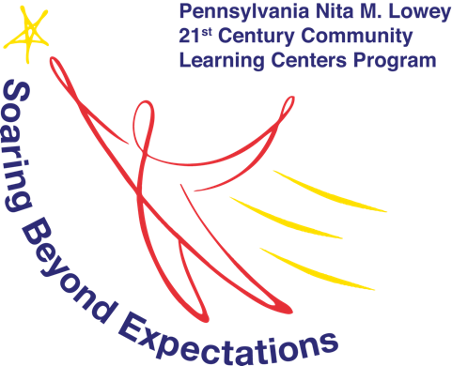

Program contacts
Middle School – Vianca Manchay 484-947-7863 or ViancaM@cciu.org
High School – Charlis Cooper 484-790-1165 or Charlisc@cciu.org

Nita M. Lowey's 21st Century Community Learning Center is funded in full or in part with a grant provided by the PA Department of Education.
Community demographics are used for data collection purposes in fulfilling grant requirements.

Student Info:

Name: ___________________________ ___ __________ Grade: _______

Full Address: ___________________________ ___ _________________________
___________________________ ___ ____________________________________

*Allergies*: ___________________________ ___ __________________________

Academic Info & Release:
- Homeroom teacher: __________________________________________________

- Does your child have an Individualized Education Plan (IEP)?
Yes No I don’t know

- Is your child receiving English as a second language (ESL) or Title 1 services?
Yes No I don’t know

- What are your child’s main areas of need?

Math Reading Writing Learning English Homework

Social Emotional Learning Other: ________________________

Report Card and Grade Release
To better support your child’s academic efforts, we request a copy of your child’s grades be sent to our office. All report cards are confidential and will be seen only by 21st Century staff, tutors, or volunteer mentors. Is 21st Century Program authorized to receive a copy of your child’s grades?

Yes No

School Advocacy Release
I, the parent or legal guardian of the above-mentioned student, hereby authorize 21st Century and the Oxford Area School District to receive and disclose any information that would help address my child’s social, emotional, academic, or career-related progress.

Yes No

Press/Photo/Video Permission Release
I grant permission to photograph / video my child and identify him/her with the 21st Century Community Learning Centers program, CCIU, and web-based media (including social media).

I DO grant permission to photograph/video my child

I DO NOT grant permission to photograph/video my child

__________________________ _______________ Signature of Parent /Guardian Date

Transportation Release
- A school bus will transport high school students to the middle school to attend the program.
- There is a bus available to take students home at the end of the program, or students can walk home.

I give my child permission to be transported from Penns Grove Middle School to home via bus.
Yes No

I give my child permission to walk home from Penns Grove Middle School.
Yes No

**CELL PHONE POLICY**
Cell phone use will be restricted during program instructional time to minimize distractions, improve academic performance, and prevent negative behaviors. Phones will be kept in a clear storage case, where they will be visible & safe. Phones will be retrieved at 5:00 pm before the program's end time. Parents/Caregivers are instructed to contact Program Coordinators or the school classroom directly for communications during program time.

Students who do not follow this policy may be restricted from program participation.

We understand the cell phone & communication policy

__________________________ _______________ Signature of Parent /Guardian Date
__________________________ _______________ Signature of Student / Date

Participation & Attendance Agreement
I permit my student to attend the after-school program at Penn’s Grove Middle School. I understand that the program will begin immediately after school and last until 5:30 p.m.

What days does your student plan to attend 21st Century Program?
Consistent schedules help us with planning and overall program enrollment.

Monday Tuesday Wednesday Thursday

Preferred language & methods of communication:
English Spanish other: _____________
Email Text Phone

Emergency Contact Information:

Emergency Contact Phone Number: _______________________________
Name of Emergency Contact: _____________________________________

Parent/Guardian’s Name: ________________________________________
Primary Phone Number: _________________________________________
Parent/Guardian email address: _________________________________

Thank you for completing the 21st Century After-School Program application. A Program Coordinator will be in touch with program info and your child’s start date.

