Diablo View Middle School
Course Catalog 2026-2027



300 Diablo View Lane
Clayton, CA 94510
Diablo View Website

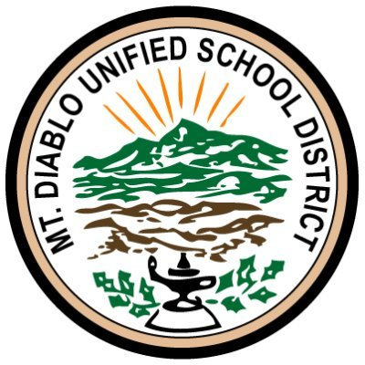

Mt. Diablo Unified School District
1936 Carlotta Drive Concord, CA 94519
925.682.8000 | mdusd.org

Welcome to Diablo View!

Diablo View Middle School is planning for the 2026-2027 school year. This is a course description booklet for grades 6, 7, & 8. Please read over the information and course descriptions and assist your child in filling out the course selections on Homelink.

Mt. Diablo Unified School District is UNDER THE GUIDANCE AND LEADERSHIP OF:

UNDER THE GUIDANCE AND LEADERSHIP OF
Dr. Adam Clark, Ed.D., Superintendent
Linda Mayo, president, Board of Education
Debra Mason, vice president, Board of Education
Brian Lawrence, trustee, Board of Education
Thomas McDougall, trustee, Board of Education
Keisha Nzewi, trustee, Board of Education
Alan Barrera Orellana, student trustee, Board of Education

Mt. Diablo Unified School District Title IX Non-Discrimination Statement

The Governing Board is committed to providing equal opportunity for all individuals in education. District programs, activities, facilities and practices shall be free from discrimination, harassment, intimidation, and bullying based on actual or perceived ancestry, age, color, disability, gender, gender identify, gender expression, nationality, race or ethnicity, religion, sex, sexual orientation, actual or potential parental, family, marital status, or association with a person or a group with one or more of these actual or perceived characteristics (Governing Board Policy 0410).

Contact Us / How to File a Complaint
For questions, concerns or complaints regarding student harassment, discrimination, intimidation and bullying, and complaints regarding compliance with Title IX employee issues, please contact Kristy Avila, Title IX Coordinator/Civil Rights Officer, at avilak@mdusd.org or by phone at (925) 682-8000 x4291.

Diablo View Middle School
300 Diablo View Ln
Clayton, CA 94517
925- 672-0898 main line
FAX 925- 672-4327
Diablo View Website

Principal | Vicki Wilson
Vice Principal | Danielle Bouchard
Office Manager | Karen Gunter
Secretary | Deidra Faleafine
Attendance Secretary & Registrar | Makenna Holmes-Joseph
Academic Counselor | Cassi Niles, Martha Brown

Table Of Contents

Required Courses & Traditional Course Sequence Guide | 5
Academic Course Descriptions | 7
Elective Courses: Overview & Selection Process | 14
Elective Courses Descriptions | 15
Intervention and Special Education Services | 20
Homelink Parent & Student Portal Online Course Request Instructions | 21

Required Courses

Below is a list of the required courses for each grade. On the following pages you will find information and course descriptions for Academic Courses, Physical Education Courses, Elective Courses, and Intervention and Special Education Courses.

6th Grade:
- 6th Grade Core:
  - English 6
  - World History I
- Reading
- Math 6
- Science 6
- PE 6
- One Elective
  - 6th Grade Rotation or
  - Year-long music elective
6th Graders will be scheduled for a maximum of one elective course.

7th Grade:
- 7th Grade Core:
  - English 7
  - World History II
- Math 7 or Math 7 Accelerated
  - Note: Student placement is based on test scores, grades, teacher recommendation, and standardized assessments.
- Science 7
- PE 7
- Two Electives
7th Graders will be scheduled for a maximum of two elective courses.

8TH GRADE
- 8th Grade Core:
  - English 8
  - U.S. History
- Math 8 or Algebra
  - Student placement is based on test scores, grades, teacher recommendation, and standardized assessments.
- Science 8
- PE 8
- Two Electives
8th Graders will be scheduled for a maximum of two elective courses.

Diablo View Middle School Traditional Course Sequence Guide

Content Area | Grade 6 | Grade 7 | Grade 8
English | English 6 | English 7 | English 8
Social Studies | World History I | World History II | United States History
Mathematics | Math 6 | Math 7 OR  *Math 7 Accelerated | Math 8 OR*Algebra I
Science | Science 6 | Science 7 | Science 8
World Languages  (OR)  Reading for 6th Grade CORE | Reading | Spanish 1A | Spanish 1B
Physical Education | PE 6 | PE 7 | PE 8
Electives | 6th Grade Rotation Wheel  (May include: Art, Health, Drama, Enrichment, Computers)  Beginning Band | Symphonic Band  Concert Band  Drama  PE Elective  Art  Digital Media Arts  Video  Communications/ Wake Up  *Jazz Band  *Yearbook  *Leadership  *TA or Office TA  *Online Application or try out Required
Intervention  School Recommendation Only | ALD/ELD  Academic Success  Math Support | ALD/ELD  Academic Success | ALD/ELD  Academic Success

Academic Course Descriptions

Availability of classes is subject to student sign-ups, student need, contractual class size limits and MDUSD Board Policy.

ENGLISH:

English 6 and Reading | 6th Grade Core
Purpose: Students will continue to develop reading, writing, speaking, listening and thinking skills. Each student will study significant literature and develop language arts skills in the three Core Class content areas: English, history, and reading. Each student will be expected to meet district and state standards for academic achievement.
Activities: Students will read significant literature in a variety of genres. Each student will analyze literature, specifically focusing on relevance to a student’s life. Each student will write for a variety of purposes and audiences. Teachers will integrate activities with content areas of study.

English 7 | 7th Grade Core
Purpose: Students will develop reading, writing, speaking, listening and thinking skills. They will study significant literature, including fiction, poetry, drama and informational texts. Students will develop language arts skills for all content areas to meet district and state standards for academic achievement.
Activities: Students will read significant literature in a variety of different genres. They will read a variety of expository texts and analyze literature, focusing on the literary features authors use to enhance their writing. They will write for a variety of purposes and audiences, with particular attention paid to documenting support. Teachers will be integrating activities with content areas preparing students for the written portion of the state test.

English 8 | 8th Grade
Purpose: Students will be provided opportunities to continue developing language arts skills. Reading comprehension, literary response, and analysis are stressed, according to Common Core Standards.
Activities: Students will read and respond to significant works of literature, including novels, short stories, non-fiction, poetry and drama. Independent reading of fiction and non-fiction is emphasized to foster reading development and enjoyment. Writing instruction focuses on writing strategies to develop clear, focused essays with an awareness of audience and purpose. Narrative, responses to literature, and descriptive essays are based on the eighth grade core literature, along with letters, journals, and logs. The review of parts of speech, grammatical rules and standards of spelling, punctuation and capitalization is related to the writing program. Students will also participate in a variety of practices in public speaking such as short speeches, oral interpretation, class discussions, or drama.
HISTORY:

World History I | 6th Grade Core
Purpose: Students will be provided experience in the areas of geography, history, anthropology, sociology, religion, economics and aesthetic citizenship/ government. The study follows Common Core Standards, which include the following ancient civilizations: Prehistoric Times, Mesopotamia, Kush, Egypt, Greece, India, China and Rome. Students will learn about and gain awareness of historical events, both past and present, and understand their own importance in history and to integrate learning with the outside world, including the skills necessary to be able to access information (life-long learning).
Activities: Lessons are designed to improve student skills and teach new skills needed to read and write for a wide variety of purposes. A variety of approaches to learning include: map and graph reading, historical studies, examining current events and integrating technology. Students will develop study skill techniques appropriate to content areas to enhance learning.

World History II | 7th Grade Core
World History and Geography of the Medieval and Early Modern Times
Purpose: Students will study the social, cultural, and technological changes that occurred in the world from A.D. 500-1789. After a review of Ancient Rome, they will examine the growing economic and cultural interactions among diverse civilizations and the global exchange of ideas. The following cultures are included in the 7th Grade Common Core Standards: Middle East, Africa, Asia (India, China, and Japan), Latin America, and Europe (Renaissance, Reformation, Scientific Revolution, Enlightenment, and Age of Exploration).
Geography units will be interwoven within all units.
U.S. History | 8th Grade
United States History and Geography: Growth and Conflict
Purpose: Based on Common Core Standards, students will study ideas, issues, political evolution and events from the American Revolution and framing of the U.S. Constitution until World War I. Geography skills will be emphasized in all units as well as cultural diversity.
Activities: Students will understand and evaluate the critical turning points of the American people, contributions of various cultures, and development of the political, economic, and social structures that comprise the country today. Students will demonstrate knowledge of U.S. Constitutional democracy, political parties, foreign policy, sectional divisions and historical contributions of men and women of various ethnic backgrounds.

MATH:

Students are provided with a mathematical education based on Common Core Standards. Students are placed in math classes based on grade level, test scores, math grades, teacher recommendation and standardized assessments.

Math 6 | 6th Grade
6th grade students will learn fundamental concepts of addition, subtraction, multiplication, division, whole numbers, integers, decimals and fractions through the strands of mathematics: number sense, geometry, algebra and functions, measurement, logic, probability and statistics, continued review and emphasis on basics. Problem solving strategies, computational skills, and understanding of concepts will be emphasized.

Math 7 | 7th Grade
This course provides 7th grade students with the math knowledge, concepts, and skills identified in the Common Core Standards. Emphasis is on providing a thorough, in-depth foundation in the pre-algebra math strands (i.e., number sense, algebra and functions, measurement and geometry, statistics, data analysis and probability and mathematical reasoning) to enable students to be successful in 8th grade math or Algebra I. This course will develop all of the pre-algebra standards. The ability to communicate mathematical reasoning and understanding will be incorporated into all math topics.

Math 7 Accelerated | 7th Grade
This course provides students with the math knowledge, concepts and skills identified in Common Core Standards. Emphasis is placed on providing a thorough, in-depth foundation in the pre-algebra math strands (i.e., number sense, algebra and functions, measurement and geometry, statistics, data analysis and probability and mathematical reasoning) to enable students to be successful in 8th grade math or Algebra I. This course will develop all of the pre-algebra standards. Math 8 and/or Algebra I standards will be included where appropriate in the course to support the rigor.
This course differs from Math 7 in that it contains content from Math 8. The additional content, when compared to the Math 7 course, demands a faster pace for instruction and learning and greater independence on the part of the students. Students should expect nightly homework five days a week. The ability to communicate mathematical reasoning and understanding will be incorporated into all math topics.

Math 8 | 8th Grade
This course is aligned with the Common Core Standards for 8th grade mathematics. The emphasis is on transitioning from concrete, basic math skills to abstract algebra, geometry, and statistical concepts. Students collect, model and analyze data and patterns in real-world and career-related situations. They develop the ability to communicate, understand, and critique mathematical reasoning through reading, writing and speaking. Students focus on math-specific study skills, perseverance, attention to precision and preparation for success in Algebra I.

Algebra I | 8th Grade
This is a high school level College Prep course. In order to earn credit as an “A-G” requirement for applying to a UC or CSU University, students must earn a “C” or better in each quarter.
This course covers the full 25 Common Core Standards for Algebra I. Emphasis is on writing, solving, and graphing linear and quadratic equations. The ability to communicate mathematical reasoning and understanding will be incorporated into all topics. Algebraic skills and concepts are developed and used in a wide variety of problem solving situations.

SCIENCE:
At each level, students will also explore human impact on the environment and focus on an engineering component on selected topics.

Science 6 | 6th Grade
The major emphasis in Science 6 is on Earth science, with the integration of life and physical science. Content includes major ideas relevant to energy in the earth’s systems:
- Earth Science: Students will demonstrate their intricate knowledge of how the sun drives the water cycle to create weather and climate.
- Life Science: Students will learn about structure and function of cells and body systems and apply this knowledge to concepts of genetics and reproduction.
- Physical Science: In regards to energy, students will explain the connections among particles, temperature, mass and density.
- Grade 6 integrated science will focus on:
--systems and subsystems in earth and life science
--earth system interactions cause weather system
--causes and effects of regional climates
--effects of global warming on living systems

Science 7 | 7th Grade
This course includes life science and the integration of physical principles and Earth processes.
- Life Science: The emphasis is on how the chemical reactions of photosynthesis and cellular respiration play vital roles in determining the size and diversity of ecosystems. Within this unit, students will follow the flow of matter and energy through an ecosystem, identifying patterns of interactions among autotrophs and heterotrophs.
- Physical Science: This unit focuses on chemistry. Students are introduced to atomic structure, the Law of Conservation of Matter, properties of substances and chemical reactions. Students will learn about particle motion relative to thermodynamics.
- Earth Science: The first focus ties directly into the life science emphasis on ecosystems by exploring the wide range of natural resources embedded within them. Students will learn about the effect of human activity, including the development of synthetic materials, on these resources as well as be challenged to develop solutions for maintaining the health of the planet’s ecosystems.
  - The second major area of learning for Earth Science relates to geologic processes. Students will investigate the development of Earth’s layers following the creation of the planet and how these layers facilitate plate tectonics. Students will draw parallels between geologic processes and the rock cycle, earthquakes, volcanism, and the cycling of Earth’s materials.
- Positive Prevention Plus: An MDUSD-adopted curriculum that focuses on human reproductive systems, sexually transmitted diseases, and sexual exploitation.
- Grade 7 Integrated science will focus on:
--organisms and nonliving things are made of atoms
--matter cycles and energy flows through organisms and rocks
--natural processes and human activities shape Earth's resources and
ecosystems
--sustaining biodiversity and ecosystem services in a changing world

Science 8 | 8th Grade
This course emphasizes physical science with linkages to earth and life science.
- Physical Science: Students will understand how and why objects move (and not move), they will also observe how energy plays a role and discover how these interactions are not limited to what we can see (ie waves and electromagnetic radiation.)
- Earth Science: Students will learn about Earth's 4.6 billion year old history, and systems in space, taking into consideration the scale of space phenomena and how processes like moon phases, eclipses and seasons work.
- Life Science: Students will master genetics and its influence on the growth and development of organisms, including how DNA and genes allow for traits in organisms, and how organisms are likely to use these traits to adapt to their environment, allowing for change in their species over vast periods of time.
- Grade 8 Integrated science will focus on:
--objects moving and colliding
--noncontact forces influence on phenomena
--evolution and its impact on life's unity and diversity
--sustaining local and global biodiversity

PHYSICAL EDUCATION:

PE 6, PE 7, & PE 8
These are the California state-required physical education courses for middle school. All three years are required. Student placement is based on grade level.
Purpose:
- Students will develop interest and proficiency in movement skills essential to lifelong participation in physical activity.
- Students will achieve their highest level of physical performance through setting realistic personal goals and applying all available knowledge, movement experiences, and personal resources.
- Students will develop and maintain their highest possible level of physical fitness and wellness to meet the demands of physical performance during work, play, and emergency situations.
- Teachers will work with students surrounding the fundamentals of movement through sequential motor skills development.
- Students will develop appropriate social behavior by working independently and with other students during planned activities
- Students will continue to develop a positive self image and strive toward self-realization through planned physical activities.
Activities:
- Units might include basketball, volleyball, football, soccer, softball, track and field, dance, movement exploration, physical fitness, aerobic exercise to music, hockey, lacrosse, shuffleboard, tennis, volleyball, and pickleball.
- Students will participate in regular cardiovascular tests and will complete state-mandated physical fitness testing by the end of the second semester.

Elective Courses

Elective Course Selection Process: Elective courses provide students with the opportunity to explore a variety of subjects and introduce enrichment and variety to the academic day. Often, middle school students discover special interests through their elective experiences that are important to their future. When selecting electives, consider factors such as student interest, course length, and long-term goals. Families and students should work together to select the electives that best suit their child.

6th grade students select one elective, either 6th Grade Rotation or a year-long music course that is open to all grade levels. The 6th Grade Rotation course allows students to explore four different non-academic subjects.

7th and 8th grade students take two different year-long elective courses. Our music electives are designed to enhance musical skills so students can engage with musicality throughout their educational career. The World Language electives, such as Spanish, may allow students to start in the second level of the same language in high school. The physical education elective enhances wellness, coordination, and sports skills through exercise and physical learning opportunities. Drama, art, digital media arts, and Yearbook provide a creative outlet for students, while Leadership provides opportunities for developing communication skills and leadership.

Since electives may fill up or be limited or canceled from too few sign-ups, it is important for 7th and 8th graders to select their top four elective preferences - two main choices and two alternates. Due to availability and scheduling constrictions, students may be assigned any two of these four electives. While a student’s top two choices are not guaranteed, please be aware that students who fail to select four different electives may be scheduled into an open elective that they did not choose if what they chose is unavailable or doesn’t fit with the rest of their schedule.

Elective Course Descriptions

Availability of classes is subject to student sign-up, student need, contractual class size limits and MDUSD Board Policy.

6TH GRADE ROTATION (6th Grade only):
The 6th Grade Rotation elective consists of four quarter-long courses each. Subject areas are selected yearly by the school administration. Students choose the 6th Grade Rotation elective course as a whole and do not select specific subject areas.
Listed below are some examples of classes that might be offered. Offerings will depend upon teacher availability and new subjects may be added.

- Art: Students will be introduced to the fundamentals of art, such as drawing and painting. Students will also learn about different artists and art history.
- Communications: Students will be introduced to the Spanish language and culture. Students will learn basic Spanish for conversational skills and about Spanish culture and traditions.
- Computers: Students will become familiar with basic computer skills, understand standard programs, and practice with resources and programs that will enhance the student’s experience with the curriculum from other subject areas. Students will research projects and present their work. Class curriculum is based on the ISTE (International Society for Technology in Educations) standards for technology integration.
- Drama: Students will become familiar with the fundamentals of drama, such as public speaking and dialogues.
- Enrichment: The Enrichment Rotation is a selection of four differentiated, project-based classes which offer motivated students the opportunity to explore different areas of interest in depth while interacting with peers with similar interests. Students engage in individual and group tasks that offer the opportunity to apply and refine skills learned in core classes and provide connections between core curriculum, higher education and career opportunities. The responsibility for learning that is integrated and cross-disciplinary is placed on the learner, developing “one who solves problems or develops new ideas through a combination of divergent and convergent thinking and functions with minimal external guidance in selected areas of endeavor.” (Betts & Knapps, 1981)
- Health: Students will be introduced to the development, delivery, and evaluation of planned sequential health curriculum for middle school students. The course is designed to positively influence students’ knowledge, attitudes, skills, and behaviors related to health.
- Music Appreciation: Students will be introduced to a variety of genres of music. Students will learn rhythm using different objects as instruments. The class will incorporate group work and choral skills in the curriculum as well.
- Service: Students will be introduced to and become familiar with skills needed to be a successful student. Topics in the areas of organization and executive functioning skills are addressed. Students learn to use their planner and organize a binder as well as to set goals and timelines. Students may also use these skills to engage in activities to promote and maintain a positive school culture.

MUSIC ELECTIVES:

Beginning Band (Primarily 6th grade, but open to all students)
The Cadet Band is open to string, woodwind, brass, and percussion students with one to two years of playing experience. The students will be exposed to various musical styles.
Students are required to participate in the following performances and make a one-year commitment: Winter Concert, Spring Concert, and other scheduled festivals.

General Music, Theory 1
This course provides an understanding of the basic elements of Music Theory (written and aural skills) in order to continue studies in the advanced intermediate levels by learning to read and notate music. Listening to, analyzing, evaluating, performing, creating and responding to music are the fundamental music processes in which humans engage. Students learn by singing, playing instruments and creating music which enables them to acquire music skills and knowledge that can be developed throughout their foundational studies.

Concert Band (7th Grade)
Concert Band is open to string, woodwind, brass, and percussion students with one to two years of playing experience. The students will continue to build on skills acquired in beginning band and will be exposed to various musical styles found in Band repertoire. Students are required to participate in the following performances and make a one-year commitment: Winter Concert, Spring Concert, and other scheduled festivals.

Band/Symphonic (Symphonic Band) (8th Grade, 7th grade with teacher recommendation)
The Symphonic Band is open to advanced string, woodwind, brass, and percussion students with three to four years of playing experience. The students will rehearse and perform standard band literature as well as contemporary music. Instructor approval is required. Students are required to participate in the following performances and make a one-year commitment: Winter Concert, Spring Concert, and other scheduled festivals.

Band/Jazz (Jazz Band) (Tryouts and teacher recommendation required)
Jazz Band admits students by audition only; please see music teacher. General instrumentation includes alto saxophones, tenor saxophones, baritone saxophone, trumpets, trombones, piano, guitar, string bass and drums. Students are required to participate in the following performances and make a one-year commitment: Winter Concert, Spring Concert, and other scheduled festivals.
Prerequisite: students are admitted by audition only.
ELECTIVES:

Art I (7th & 8th Grade only) (Y)
This course will teach students basic drawing, painting, and three-dimensional sculpture with ceramics. Students will also learn art history and art appreciation through the artwork they create. Students will study different artists, time periods and themes, and produce different work for each unit. A variety of art contests and publication opportunities will be available to students.

Art II
During this course, we will look at Art of various artists and periods in Art History and will create works of art in styles related to them. You will be challenged to think visually and problem solve creatively using the Elements of Art learned in Art 1 and the Principles of Design including Balance, Emphasis, Proportion, Movement, Rhythm/Repetition/Pattern, Variety and Unity in the production of 2D and 3D works of art. Exposure to multiple methods of Art production will help inspire your creativity and expand your artistic style! PREREQUISITE: Art I and teacher recommendation

Communication/Wake-Up (7th & 8th Grade only) (S - Paired with Digital Media Arts)
This course examines film as a major collaborative art form including the history and aesthetics of film and other moving images. Students participate in the production of the school video magazine, Wake Up Diablo View. Students learn the various skills necessary for the creation of a multimedia production. This will involve a great deal of teamwork and will require cooperation, initiative and responsibility.

Digital Media Arts (7th & 8th Grade only) (S - Paired with Communications)
This course is designed to introduce students to the fundamentals, terminology, techniques and applications of digital imaging to create original works of art. Students will produce still or animated images using photo editing, animation, drawing and painting applications. Students will explore these applications through a series of real world design challenges. The applications chosen for this course are web based, allowing for easy access at home.

Drama/Musical Theater (7th & 8th Grade only) (Y)
Students who enjoy singing, acting, and being dramatic, or love being a part of a stage crew, are encouraged to join Musical Theater. Students learn performance skills and techniques including acting, singing, improvisation and movement for musical theater. Students also learn about aspects of technical/stage crew and develop public speaking skills, creative problem solving, tolerance and acceptance. Students will build these skills through musical theater lessons and games as well as rehearsals for two productions during the school year.

Leadership (7th & 8th Grade only) (Y)
This class can only be requested by completing the Google Form Application. If a student is accepted, this course will take the place of a main choice elective.
The Leadership class is responsible for planning student activities, fundraisers, and other school-wide or community service work. Class instruction focuses on project management, collaboration skills, communication skills, responsibility and developing personal leadership skills. Selection is by a submitted application with a written essay and teacher recommendations. Leadership students must maintain a 2.5 GPA. Officers must maintain a 3.0 GPA. Leadership students are expected to be positive role models at Diablo View and in the community. Any student discipline or negative behavior comments on a student’s report card and/or progress report during the school year may result in the student being removed from the class.
Prerequisite: selection is by an application process with teacher recommendations.

Music Appreciation/Digital Music Design (7th & 8th Grade only) (S- Paired with Video Production)
This is a semester-long class where students learn about music production class through a music creation program, and then guides them through the process of creating songs. Students will learn how songs are built, timed, organized, and edited.

Office Aide (Office TA) (7th & 8th Grade only) (Y)
This class can only be requested by completing the Google Form Application. If a student is accepted, this course will take the place of a main choice elective.
Students assist in the front office, deliver passes, interact with the public and represent Diablo View. Only 7th and 8th grade students may apply, and students can be enrolled in a maximum of one TA period per day. Students must meet teacher assistant criteria and sign performance agreements. Students must have “C’s” or better and have no attendance or discipline issues to be admitted to and remain in this course.
Prerequisite: Office Aides must go through an application process. Applications will be reviewed and students will be selected based on their application essay, grades, and behavior.

Physical Education Elective (7th & 8th Grade only) (Y)
This is a physical education course that can be taken in addition to the California state-required PE course for a student’s grade level. It includes cardio and strength training, sports education, and mindfulness and wellness exercises. This is a year-long course.

Spanish IA (7th & 8th Grade only) (Y)
This course is an introduction to the Spanish language and culture. Students will receive practice in speaking, listening, reading and writing; the course prioritizes practical conversation and literacy in the language and explores cultural aspects of Spanish speaking countries. This class provides the opportunity to gain insight into the culture of our bilingual state. This course can help prepare students for Spanish 1 in high school, and is a prerequisite for Spanish 1B. Students must be passing their core classes in order to participate in Spanish 1A or have teacher approval.

Spanish IB (7th & 8th Grade only) (Y)
This class builds upon the skills students learned in Spanish 1A and continues to emphasize listening, speaking, reading and writing the language. Students will also continue to learn more about Spanish speaking cultures inside and outside of the United States. Students who do well in Spanish 1A & Spanish 1B (B or better) are eligible to take Spanish 2 in high school.
Prerequisite: Spanish IA in 7th grade with a grade of “C” or better all four quarters, or by teacher approval.

Teacher Assistant (TA) (7th & 8th Grade only) (Y)
Students are assigned to assist a specific teacher during that teacher’s class. Only 7th and 8th grade students may apply for TA positions, and students can be enrolled in a maximum of one TA period per day.
Prerequisite: teacher approval. Grades and school behavior will be reviewed and checked prior to a position being authorized.

Video Production (7th & 8th Grade only) (S - Paired with Digital Music Design)
In video production, students collaborate with a team of students to create a script and produce a film. Students will learn film vocabulary, criticism, grammar, production elements, genre, and will become proficient in the use of camcorders and a variety of editing equipment. This class ends with a film festival at the end of the semester that students are required to attend.

Yearbook (7th & 8th Grade only) (Y)
This class can only be requested by completing the Google Form Application. If a student is accepted, this course will take the place of a main choice elective.
This class produces the Diablo View Yearbook. Students will learn how to use digital cameras and principles of design for the printed yearbook. Yearbook students are expected to be positive role models at Diablo View and in the community. Any student discipline or negative behavior comments on a student’s report card and/or progress report during the school year may result in the student being removed from the class.
Prerequisite: selection is by an application process with teacher approval.
Intervention And Special Education Services
The Mt. Diablo School District recognizes that the traditional school setting is not appropriate for all students. Consequently, the district offers an array of alternatives for those youngsters who: have needs are better met in small groups, need more individualized attention, or are supported by contact with a variety of adults. The district recognizes that some students are self-motivated and prefer to work independently. Others require monitoring and a highly structured situation. Diablo View Middle School provides the following programs for students with special needs and students needing academic intervention.

ENGLISH LANGUAGE INTERVENTION
The purpose of these courses is to enhance students’ self-confidence and promote English language proficiency for personal, social, and educational purposes. A special emphasis is placed on developing each student’s academic English proficiency.
Placement is based upon ELPAC scores, length of time classified as an English Language Learner (ELL), and recommendation from the district English Language Development office.

ELD: English Language Development: This class is leveled 1-4 for students who have been in the United States for approximately 5 years or fewer.

ALD: English Learner Academic Language Development: This class is for long-term English Learners (LTEL) who have not yet met the requirements for reclassification and who continue to struggle academically.

SPECIAL EDUCATION
Only students with an Individual Education Plan (IEP) may be in the following classes.

Academic Success: This course is designed to support Special Education students in their grade-level standards. It provides academic support in order to improve a student’s academic performance. The course also addresses literacy skills in English, math, science, and history. Teachers pre-teach and review concepts and help students develop study skills and organization skills. Academic Success is offered to students in place of one elective class to support them in regular education classes. Placement in these classes is based upon the student’s IEP and will affect elective selections.

Full Time Special Education: Students in this program require special instruction for the majority of their day. Placement in these classes is based upon the student’s IEP and will affect elective selections.

Part Time Special Education: Students in this program attend general education classes for the majority of the school day. Placement in Special Education support classes is based upon the student’s IEP and will affect elective selections.
Instructions for HomeLink Student or Parent Portal Online Course Requests

- Video Instructions

Written Instructions:

Instructions for HomeLink Student or Parent Portal Online Course Requests:

- Sign in to the Aeries HomeLink Portal.
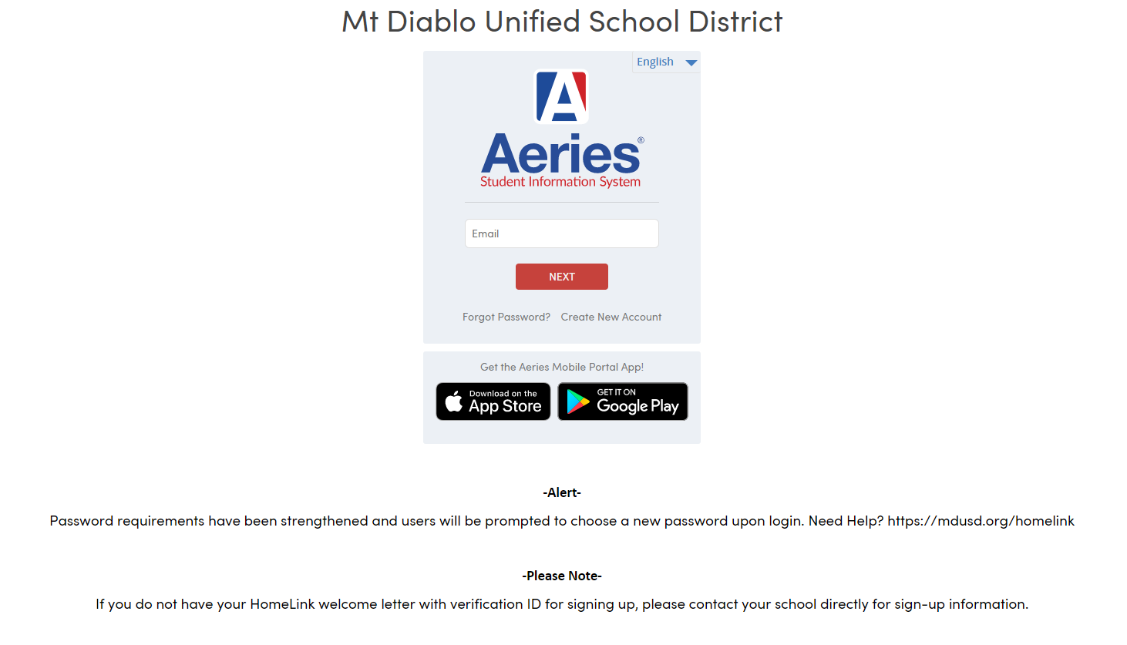
2. In the Parent or Student Portal click on Classes > Course Requests Entry.
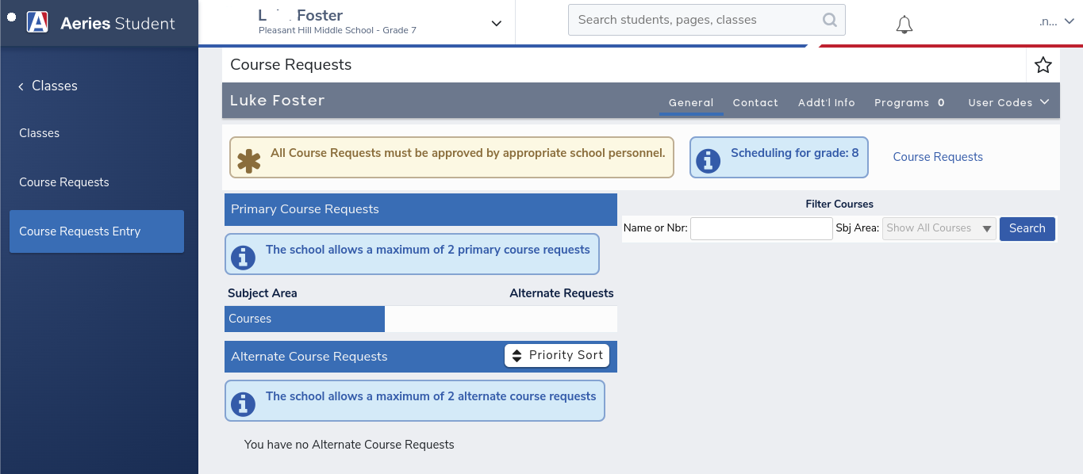

3. Use the Filter Courses section to view available courses by clicking on the “Search” button.

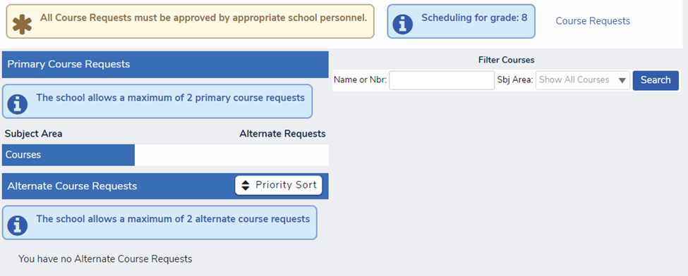

4.A new box will appear. Choose two elective courses by clicking on the Course title.
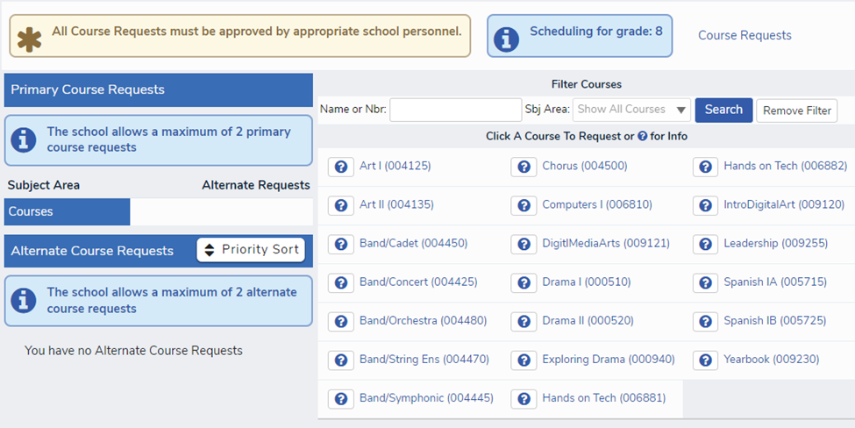
You will see a box that asks you to confirm your choice by clicking “Request Primary.”
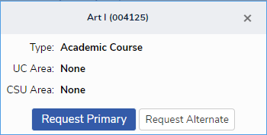

5. Primary course requests will appear on the left side of the screen, as in this example. From this screen you should:

  - Add Alternate course requests by selecting a course and clicking on the Request Alternate button when the window pops up.
  - Remove a course request by clicking on the garbage can next to the course title.

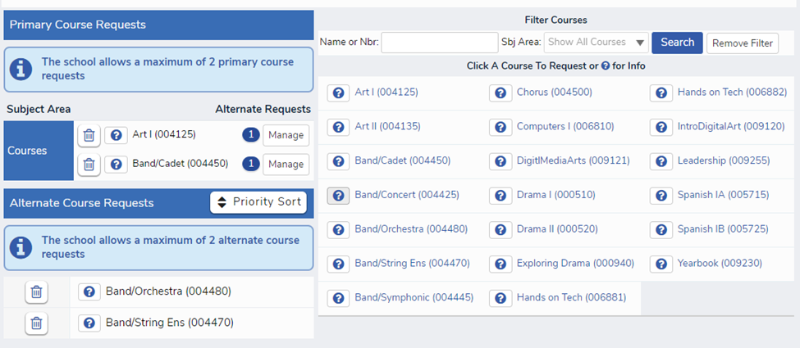

OPTIONAL: Clicking on the Manage button results in a pop-up box where you can link the Alternate Course Request to the primary choice.
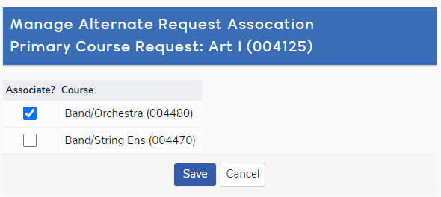

Make sure that you see your two Primary Course Requests on the top and two Alternates in the bottom section.
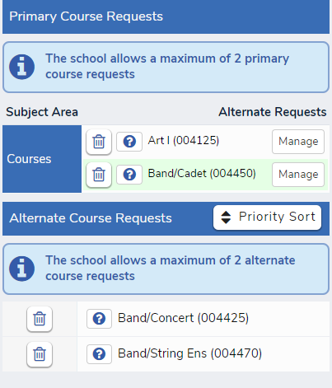

You can now exit HomeLink. Thank you!

