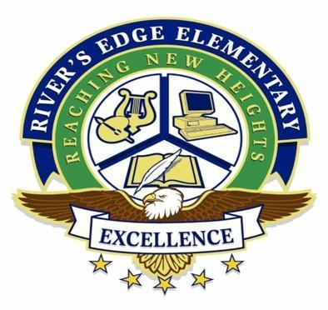
205 Northbridge Road
Fayetteville, Georgia 30215
Phone: 770 460-2340 Fax: (770) 968-2343

Dr. Dira Harris Adrian Oliver
Principal Assistant Principal

Purpose: This meeting aims to facilitate a discussion between teachers, parents, community members, and students regarding school improvements, student instruction, and student advancement.

Meeting called to order: December 12, 2025, at 0735 by Vice President Ashley Smiley

Attendance:
- Dr. Dira Harris – Principal
- Nicoya Davidson – President
- Ashley Smiley – Vice President
- Tora McCoy – Secretary
- Taneisha Jackson - Parent Liaison
- Anetrea Davis- Parent
- Brandi Hill – Parent
- Brandi Pennington- Teacher
- Davida NLN - Parent
- Katrice Soto - Parent
- Montrella Rhodes Parent / Business Partner
- C. Johnson- Parent
- Robbie NLN - Parent
- Shenika Hall- School Counselor
- Tanice Jackson – Parent
- Tyquisha Fuller- Parent
- Jessica Shaw - Parent

Agenda:
1. Welcome/Introductions
2. Current school concerns
3. New Business
4. Partnerships and School Level Building Support
5. Principal Updates on Construction
6. Dr. Harris transition / vacancy protocol
7. School Council responsibility
8. Student Academic Support
9. New Business for next meeting scheduled

Important Information:
- District training for new members will be presented online on the following dates prior to the next scheduled meeting. Individuals must pre-register for training no later than 5 business days prior.

- January 12th
School Council meetings are open to the public and will be held on the following dates at 7:15 am in Room 11 (Parent Liaison Suite) unless otherwise specified: January 12th, March 9th and a make-up date of May 11th if necessary.

Welcome/Introduction:
- Dr. Dira Harris, Principal
- Nicoya Davidson, President
- Ashley Smiley, Vice President
- Tora McCoy, Secretary

Current School Concerns:
- Construction updates to the building, ground improvements, safety concerns and concrete ramps for playgrounds are still ongoing and expected to be completed mid-January. Point of Contact: Mr. Lee REES Head Custodian
- Both playgrounds (K-2/Special Needs) and (3rd-5th) are complete, except for grass and a safety ramp for students with special needs to access the playground. The completion date will be updated at the next scheduled meeting.
- The roof project and installation of a safety bridle on the cafeteria ramp are still in progress.
- The intercom system throughout the building is complete, except for a few classrooms that are not connected.

Partnerships and Building Support:
- Delta Community has been added as a partner
- Barber partnership completed
- A faith-based/mentoring partnership is in place for staff.
- We are looking for additional partners to support staff monthly appreciation. Vice President suggested Delta Community support during Teacher Appreciation Week.
- Partnership solicitation paperwork is available.

Principal Transition Updates
December 19, 2025 official last day
Fire Drill for December completed
Inclement Weather packages completed
School Climate survey will be sent out in January. We need 100% completion from parents and students.
Pre Planning dates for January 5/6 2026
Students return January 7th
Teacher Evaluation completed
Digital Citizenship class completed for. 3/4/5 grades
District initiative 4 E’s completed
Financial School Audit completed. Results not received as of yet.
Grades for second semester will close out on December 12 unless enrolled 10 days or less.
Letter of intents have been shared
EOY close out for the short term action plan (1 Touch 2 Ears) and will begin to transition to (Higher Order Thinking Questions)

School Council Responsibilities
School council members who have completed training may receive communication from the district to be a part of selection process of the new Rivers Edge Elementary Principal. Dependent upon when a suitable replacement is found, a new principal could be named in January or February. If not, a retired principal will be assigned in the interim.

Student Academic Support
MOY MAP Testing for K-5 has begun
AMIRA testing begins upon January 2026 return from break.
Teachers should share all information during winter conferences. AMIRA data may not be available but MAP will be.

New Business:
None

*********************************************************************************************

The information contained herein is public.

Adjourned: 0805

Minutes submitted by: Tora McCoy, Secretary

