INCLINE HIGH SCHOOL JROTC

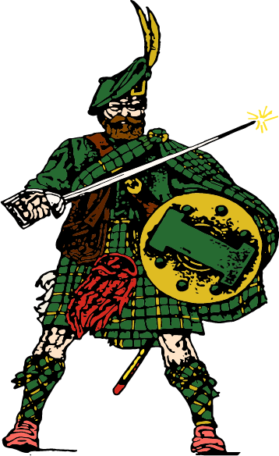

JROTC CADET HANDBOOK (SOP)

(05 AUG 2025)
Purpose

This SOP (Standard Operating Procedures) applies to students enrolled in Incline High School JROTC. It specifies the procedures and policies that Cadets will follow while enrolled in this program as well as the procedures and policies that the Instructors will use to administer the JROTC Program. This SOP is yours to keep. Become familiar with it and refer to it often. You will be expected to know and comply with its provisions. You will be expected to have your Highlander SOP in class each day.

INDEX
Topic Page

Introduction 4
Enrollment Benefits & Opportunities 5
Expectations 7
Army Values 8
Leadership Principles / Traits 9
Army Phonetic Alphabet 10
Foundation of Army JROTC 11
Mission of JROTC / Incline HS Mission & Beliefs Statement 12
Acronyms & Abbreviations 13
Program Information 14
Physical Training (PT) 16
Drill 17
Uniform Wear & Appearance 18
JROTC Uniform Guides 23
Highlander Ribbons 27
Uniform Inspection 28
Uniform Inspection Study Guide 29
JROTC Extra-Curricular Activities 30
Duties & Responsibilities of Cadet Leaders 32
Promotion System 42
Reduction / Demotion 48
IPE Study Guide 49
NCO Promotion Study Guide 51
Officer Promotion Study Guide 54
Cadet Drill Exam (IPE) 56
NCO Drill Exam 57
Cadet Rank Abbreviations 58
Battalion Chain of Command and Staff 59
Army Chain of Command 60
JROTC Rank Structure 61
Cadet / Junior Leader of the Month Board Program 62
Cadet / Junior Leader of the Month Study Guide 65
Best Company Competition 75
Cadet Challenge Criteria 79
Membership & Publicity 81
JROTC Cadet Leadership Camp (JCLC) 83
Student Status 84
Flag Duty 86
Instructor Division of Duties 87
Introduction

As a JROTC Cadet, you are embarking on one of the most interesting and valuable educational experiences of your high school career. In JROTC you will be given the opportunity to participate in your education while learning to be a better citizen. This program provides you with tools and skills you can use to succeed in high school, but far more important, these tools and skills will be useful for the remainder of your life. JROTC is a program intended to prepare young men and women for college and the challenges they will encounter in life.

This SOP has been prepared to summarize the JROTC Program at Incline High School. It outlines the objectives of the program, provides general information on subjects that will be taught, and explains procedures that will be used within the JROTC Program.

It should be clearly understood that the JROTC Program is not designed to prepare Cadets for military service and we do not recruit for the military. Our prime interest is to develop Cadets’ self-discipline, a sense of responsibility, leadership ability, and an understanding and application of good citizenship.

We believe that communication with parents is of vital importance to the success of our program. Becoming a JROTC Cadet is an important step in a young person’s progress toward adulthood. As Instructors, we intend to make the experience both meaningful and lasting. We want to assure parents and Cadets that we share your primary concern; that education must be placed at the top of the priority list and must remain there. Thank you for allowing your child to be part of our program.

Philip Risi Karlea Henderson
1SG (Ret), USA SSG USA
Senior Army Instructor (SAI) Army Instructor (AI)
philip.risi@washoeschools.net karlea.henderson@washoeschools.net

JROTC Enrollment Benefits & Opportunities

There are many benefits of JROTC. In addition to the leadership instruction and practical experience that you will gain by participation, you may also take advantage of the following:

A. Washoe County School District:
- Successful completion of four semesters of JROTC will satisfy the PE
requirement for graduation.
- Successful completion of the fifth semester of JROTC will satisfy the Health requirement for graduation.
- Upon completion of three years in the program and the successful completion of the Career and Technical Education Military Science exam, Cadets will graduate with a CTE certification (see C. below)

B. Military Service Opportunities:
Enrollment and completion of the Army JROTC program in no way obligates a student to military service; however, it is possible for the student to be recommended for advanced enlistment rank should the student decide to enlist. This recommendation may be made by the Senior Army Instructor. Specifics of this recommendation are as follows:

- Cadets completing at least two or three years of Army JROTC
may be recommended for enlistment in the regular or reserve components of the U.S. Army or any other service in the rank of Private E-2 depending on current recruiting requirements.
- Cadets must be in good standing in the program for a favorable
recommendation.

C. Military Science CTE (Career & Technical Education) College and Career Ready
High School Diploma
A CTE diploma endorsement is awarded to students who: (1) complete the CTE course sequence with a grade point average of 3.0 or higher; (2) pass the state end-of-program technical assessment for the program; and (3) pass the Workplace Readiness Assessment for employability skills

D. College Opportunities:

- Those Cadets completing at least three years of Army JROTC may be recommended for constructive credit for completion of Military Science I and Military Science II (Freshman and Sophomore year curriculum of the Senior Army ROTC program). Advance placement in the SROTC program requires approval of the Professor of Military Science at that institution.
- Army JROTC Cadets applying for one of the several hundred four-year
ROTC Scholarships or one by the Air Force and Navy, enjoy bonus points in the selection process by virtue of their JROTC Cadet status provided they are recommended by the Senior Army Instructor. Recipients of these scholarships may also receive government payment for tuition, books, lab fees and other authorized expenses. Scholarship recipients may attend the college or university of their choice hosting the ROTC program of the branch of service awarding the scholarship, if otherwise acceptable to that institution. There is a service obligation upon graduation.
- Outstanding Army JROTC Cadets may be recommended by the Senior
Army Instructor for competitive appointment to one or more of the several service academies if the unit remains an Honor Unit with Distinction.
- Outstanding Army JROTC Cadets applying for appointment to the
United States Coast Guard Academy or to the United States Merchant Marine Academy may also be recommended by the Senior Army Instructor.

Expectations of JROTC Cadets

- Be prepared, courteous, and professional.

- Late work will not be accepted unless you have an “excused” absence on the date the assignment is due. Those assignments may be turned in with a minimum 15% penalty exceeding the due date.

- Bathroom breaks disrupt classroom instruction. Use the bathroom before you arrive at class.

- Copying someone else’s work or cheating on an exam, quiz, or assignment will earn you a zero, a referral to the office, and a phone call to your parent / guardian.

- If you have an excused absence from class, you are responsible for requesting the missed assignment. If you missed a test, quiz, uniform inspection, PT day, drill day, etc., discuss the matter with your MS (Military Science) Instructor and reschedule your test, quiz, or inspection with your Instructor.

- Be on time. If you are not in formation in the Range at the start of the period, you will be considered tardy unless you have a valid pass.

- You are provided with a daily nutrition break and lunch therefore food is not allowed in the classrooms during instruction. The JROTC range will be open during lunch at which time food may be consumed in the range as long as you clean up after yourself. Food / drinks are never permitted in the Classroom.

- Extra credit assignments will not be given, so please do not ask. They are counterproductive to good student performance in a variety of ways: Extra credit saps motivation for good performance on required assignments. If you are not satisfied with your grade, concentrate on doing your best on your remaining assignments. The time to be concerned with grades is at the beginning of the semester. Please do not go to your Instructor with sad stories about failing grades, incurring parental wrath, etc. We will sympathize, but we will grade all students according to the syllabus guidelines and rubric.

- Hats, hoods, backpacks, headphones, and earbuds will not be worn in the classroom or in formation.

- Vulgar language is disrespectful and is not tolerated in JROTC.

- Cellphones will be secured at the beginning of class at the charging stations.
Army Values

Loyalty – bear true faith and allegiance to the U.S. Constitution and to your peers

Duty – fulfill your obligations

Respect – treat people as they should be treated

Selfless Service – put the welfare of the nation before your own

Honor – live up to all values

Integrity – do what is right, legally and morally

Personal Courage – face fear, danger, or adversity

Leadership Principles

- Know yourself and seek self-improvement.
- Be technically proficient.
- Seek and take responsibility for your actions.
- Make sound and timely decisions.
- Set the example.
- Know your Cadets and look out for their welfare.
- Keep your Cadets informed.
8. Develop a sense of responsibility in your Cadets.
9. Ensure each task is understood, supervised, and accomplished.
10. Build a team.
11. Employ your team in accordance with its capabilities.

Leadership Traits

1. Bearing 8. Integrity
2. Courage 9. Judgment
3. Decisiveness 10. Justice
4. Dependability 11. Knowledge
5. Endurance 12. Loyalty
6. Enthusiasm 13. Selflessness
7. Initiative 14. Tact
Army Phonetic Alphabet

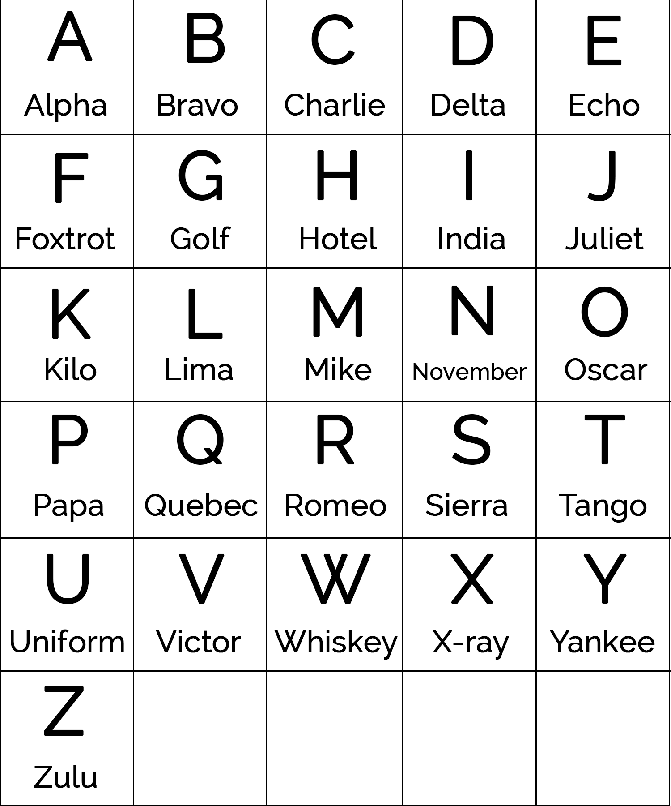

Foundation of Army JROTC

The United States Army Junior Reserve Officers' Training Corps (JROTC) came into being with the passage of the National Defense Act of 1916. Under the provisions of the Act, high schools were authorized the loan of military equipment and the assignment of active-duty military personnel as instructors. The JROTC Program has changed greatly over the years. Once looked upon primarily as a source of enlisted recruits and officer candidates, it became a citizenship program devoted to the moral, physical, and educational uplift of American youth. While in JROTC you will learn to:

Appreciate the ethical values that underlie good citizenship. Citizenship, taught through a study of history and government, demonstrates the importance of commitment. It strengthens your character and resolves as you grow.

Develop leadership potential and learn to live and work cooperatively with others. Teamwork and leadership are essential to the smooth operation of any organization. You will learn leadership to increase your skills not only to lead, but also to work as a member of a team. Drill, Cadet Challenge, and other competitions make learning teamwork and leadership both challenging and fun.

Think logically and communicate effectively both orally and in writing. You will learn important skills in writing, reading, and test-taking that will allow you to excel in your classes outside of JROTC. You will learn basic life skills like problem-solving, financial planning, and conflict resolution that will help you in the modern world.

Understand ways to resist negative peer pressure and support others. It is one thing to know how to make better choices for yourself, and another to teach others to do the same. Through service learning you will be able to help others to develop the positive strategies you have learned that will enhance their quality of life.

Developmental management abilities. You will be able to assess your skills and learn to make more logical, positive decisions and choices. You will learn how to set goals and develop an action plan that will help you to achieve those goals. As you become a better citizen, a better leader, and a better team member, your self-esteem will greatly improve. Your “Can Do” attitude will show beyond JROTC.

Become familiar with military history as it relates to America’s culture and with the history, purpose, and structure of the military services. Learn not only about important events in our history, but also about their effect on our society. Discover the role the military services play in supporting our nation.

Understand the importance of high school graduation in relation to a successful future. Develop the means and motivation to graduate from high school.

Learn about college and other advances for educational and employment opportunities, and develop the skills necessary to work effectively as a member of a team. You will learn about the many varied opportunities that are available to you upon graduation. The foundation and competency skills required to work effectively as a team are ingrained throughout the JROTC curriculum.

Mission of JROTC:

To Motivate Young People to be Better Citizens

Incline High School Mission

The mission of Incline High School is for ALL students to graduate ready for college or career in the global 21st Century.

Incline High School Belief Statements

IHS promotes Integrity, Humanity, and Scholarship.
IHS develops responsible individuals who contribute to society.
IHS provides a comprehensive education in a rigorous, supportive, and safe environment.

Acronyms & Abbreviations

PT: Physical Training
BDE: Brigade
BN: Battalion
CDR: Commander
BC: Battalion Commander
SPO: Special Projects Officer
CO: Company Commander
CSM: Command Sergeant Major
CTE: Career & Technical Education
XO: Executive Officer
1SG: First Sergeant
SL: Squad Leader
PL: Platoon Leader
PSG: Platoon Sergeant
SAI: Senior Army Instructor
AI: Army Instructor
DAI: Director of Army Instruction
JROTC: Junior Reserve Officers’ Training Corps
MS1: Military Science 1 (1st year Cadet)
MS2: Military Science 2 (2nd year Cadet)
MS3: Military Science 3 (3rd year Cadet)
MS4: Military Science 4 (4th year Cadet)
NCO: Non-Commissioned Officer
GAP: Grades, Attitude, and Participation
ASU: Army Service Uniform
JCLC: JROTC Cadet Leadership Camp
OIC: Officer in Charge
NCOIC: Non-Commissioned Officer in Charge
JPA: JROTC Program of Accreditation
JLAB: JROTC Leadership & Academic Bowl
IPE: Initial Promotion Exam
AAR: After Action Review
ACU: Army Combat Uniform

Program Information

Grading Policy

Cadets (regardless of MS level) are graded as follows:

Academic (Exams / Quizzes / Assignments) 35 %
Uniform Day / Inspection 20 %
Physical Training 20 %
Semester Final Exam 15 %
Drill 10 %

Participation

Participation is key in JROTC. Cadets are expected to participate in all JROTC activities and, although not mandatory, are highly encouraged to participate in extra-curricular activities.

Attitude and Conduct

Cadets will display proper courtesy toward Instructors and the Cadet Chain of Command. Cadets will always conduct themselves in a mature manner, including non-JROTC classes.

A Cadet’s quarterly citizenship grade will be based on a merit / demerit point system. Cadets will receive demerit points for violations of JROTC and/or school policies listed below (Note: list is not all inclusive). Upon accumulating 25 demerit points, a Cadet’s citizenship grade will be reduced by one letter grade. Cadets also have the opportunity to earn merit points to eliminate demerit points by participating in school Color Guards and/or other school-related activities. Merit points awarded will range from 1 to 5 points depending on the activity.

Potential Violations (point deductions may very depending on severity)
Tardy to class
Technology violations (cell phone, earbuds, etc.)
Inappropriate behavior and/or language
Dress code violations (bare midriff, sagging pants, etc.)
Military bearing and discipline

Class Fee

A $25.00 class fee is collected at the beginning of the school year for miscellaneous JROTC expenses (PT shirt, uniform accouterments, transportation to events, etc.). Occasionally, Cadets may be required to bring money for food, snacks, etc., at certain events.

Integrated Curricular Activities

JROTC provides Cadets opportunities to participate in numerous voluntary after-school and weekend activities. These include, but are not limited to, Community Service, Rifle Team, Honor Guard, Color Guard, Drill Team, Orienteering, Drone Team, etc. Although not mandatory, Cadets are strongly encouraged to participate in our co-curricular and extra-curricular activities.

Mandatory Activities

Certain activities within the JROTC Program are considered critical for the proper administration and accomplishment of the JROTC Mission. For this reason, the following activities are mandatory (graded) for every Cadet enrolled in the Highlander JROTC Program:

- Homecoming Parade (Friday, September 19, 2025)
- Veterans Day Parade (Tuesday, November 11, 2025)
- Awards Night (Wednesday, April 29, 2026)
- Dining In (Wednesday, May 20, 2026)

Schedule

The typical schedule for the Highlander JROTC Battalion is:
Monday / Tuesday: Academic
Wednesday: Uniform Wear & Inspection / Drill & Ceremonies
Thursday / Friday: Physical Training

Physical Training (PT)

Cadets are required to participate in Physical Training (PT) in order to earn their PE credit and PT Grade (20%). The uniform for PT will be athletic shoes, shorts or sweatpants, and t-shirt. Physical fitness and an appreciation of the importance of being fit is an integral part of this Battalion. Each Cadet, regardless of their level of physical conditioning or limitations, is expected and encouraged to participate to the best of their abilities. Cadets are not graded for their level of achievement but rather their degree of participation, attitude, and effort. Students with health limitations, such as asthma or other medical conditions, will have this annotated on their Privacy Act Statement as well as inform their MS Instructor before engaging in Physical Training. Physical Training will primarily be conducted by the Company First Sergeant under the direct supervision of the Instructor Staff.
Cadets can earn 10 points each time they participate in PT. The following guide will be used when assigning a Cadet’s PT Grade:

10 points:
- Participation (5 Points)
  - 1 point:
Minimal participation and effort
Argumentative and or Vulgar Language
Displaying poor leadership / followership

  - 2 point:
Poor Motivation
Displaying minimal leadership / followership

  - 3 point:
Improper behavior during formation (talking, poor bearing, etc.)
Minimal effort
Improper attire (no athletic shoes, no athletic pants, no PT shirt, etc.)

  - 4 point:
Reduced effort

  - 5 point:
Satisfactory in all areas

- Proper Shoes and Socks (1 Point)
- Proper Athletic Pants (1 Point)
- Proper Athletic Shirt (1 Point)
- Sportsmanship (1 Point)
- Attitude (1 Point)

Drill & Ceremonies

Cadets are required to participate in drill in order to earn their Drill Grade (10%).
Drill within JROTC is primarily designed to foster a sense of camaraderie and teamwork, obtain company competition points toward “Best Company,” and to provide leaders a valuable opportunity to practice their leadership skills. Although there is no set drill uniform, Cadets are encouraged to wear athletic or comfortable shoes in order to facilitate their ability to conduct drill. No high heels or dress shoes are allowed to be worn on drill days. Cadets can earn 10 points each time they participate in drill. The following guide will be used when assigning a Cadet’s Drill Grade:

- Participation (5 Points)
  - 1 point:
Minimal participation and effort
Argumentative and or Vulgar Language
Displaying poor leadership / followership

  - 2 point:
Poor Motivation
Displaying minimal leadership / followership

  - 3 point:
Improper behavior during formation (talking, poor bearing, etc.)
Minimal effort
Improper attire (no athletic shoes, no athletic pants, no PT shirt, etc.)

  - 4 point:
Reduced effort

  - 5 point:
Satisfactory in all areas

- Correct Uniform with no deficiencies (3 Point)
- Sportsmanship (1 Point)
- Attitude (1 Point)

Uniform Wear & Appearance

A vital component of the JROTC Program’s effectiveness is the pride and self-discipline that Cadets bring to their program. It is the responsibility of each Cadet to present a neat and military appearance and to take pride in their appearance.

Cadets are required to wear the JROTC Army Service Uniform (ASU) in order to earn their Uniform Grade (15%). Cadets will typically wear the uniform at least once per month. On the scheduled Uniform Day, Cadets will wear the uniform to school and remain in uniform for the entire school day in order to receive a grade. During the Cadet’s JROTC period, they will be inspected in order to ensure that all required standards set forth in this SOP are adhered to. Cadets can earn up to 100 points each time they participate in a Uniform Day / Inspection. If a Cadet is absent (excused) during a Uniform Day / Inspection, they will make arrangements with their Instructor who will assign an alternate day in which the Cadet can wear the uniform and be inspected. If a Cadet does not take the necessary action to make up the missed Uniform Day / Inspection, they will receive a zero. If a Cadet is present during a Uniform Day / Inspection but fails to wear their uniform, they will make arrangements with their Instructor who will assign an alternate day in which the Cadet can wear the uniform and be inspected with the potential to earn a maximum of 50 points (50% penalty).

Highlander Uniform Policy

Cadets are issued a JROTC uniform at no cost. They are responsible for the proper care, safekeeping, and cleanliness of these items. At the beginning of the school year, Cadets will be issued a clean uniform. At the end of the school year, the uniform will be returned to JROTC for dry cleaning. Parents or guardians are financially liable for the cost to replace any items lost or damaged through the fault or neglect of the Cadet concerned. Parents or guardians will be required to sign a written statement to that effect prior to the issue of uniform items to the Cadet. Any lost or damaged items not turned in will be reported to the Incline H.S. bookkeeper who will flag the student’s records until the items are returned or paid for through the bookkeeper’s office. Cadets will maintain their uniform at home during the school year. During a scheduled uniform day, inspections will be made of haircuts and/or appearance, hygiene, shoes, brass, and cleanliness of uniforms as well as proper placement of awards and decorations. Any Cadet wishing to wear the Cadet uniform on a special occasion not directed by the SAl must first obtain that permission. The standards for Cadet appearance are listed below. The following uniform and appearance standards apply when a Cadet is in uniform only:

- Uniforms must present a neat and clean appearance. Loose strings will be cut from the uniform. No jewelry, chains, combs, pens, pencils, or similar items will appear exposed on uniforms. The Army JROTC Cadet uniform will not be mixed with civilian clothing. Bulky items in pockets distract from the uniform. While in uniform, Cadets will not place their hands in their pockets except momentarily to place or retrieve items.

- Cadets may wear a wristwatch, a wrist identification bracelet, and a total of two rings. Attaching, affixing, or displaying objects, articles, jewelry, or ornamentation to, through, or under their skin, tongue, or any other body part is prohibited*. Females are authorized to wear earrings with the Army JROTC Cadet uniform and ACU only. While wearing the Army JROTC Cadet uniform, earrings may be screw-on, clip-on, or post-type earrings in gold, silver, white pearl, or diamond. The earrings will not exceed 6 mm or ¼ inch in diameter, and they must be unadorned and spherical. When worn, the earrings will fit snugly against the ear. Females may wear earrings only as a matched pair, with only one earring per ear lobe. Gauges are not authorized for wear with any Cadet uniform. Female Cadets may wear stud earrings while in the ACU.

* To include, but not limited to, no septum piercings, no eyebrow piercings, no lip piercings, or no nose rings.
No more than two flush jewelry studs or clear plastic studs are allowed in the nostrils.
Clear plastic studs are allowed on other body parts if necessary to prevent the hole from closing.

- Hair Styles: Many hairstyles are acceptable, as long as they are neat and conservative. Hair will be neatly groomed. Hair that is clipped closely or shaved to the scalp is authorized. The length and bulk of hair will not be excessive or present a ragged or extreme appearance. If dyes, tints, or bleaches are used, colors used must be natural to human hair and not present an extreme appearance. Hairstyles will not interfere will proper wearing of military headgear. The headgear, when worn in uniform, will not appear bulging or distorted, and without excessive gaps between the headgear and the head. There is no minimum hair length for Cadets, and Cadets are permitted to have natural highlight. Hair that falls over the eyebrows or ears will be pulled back. Hair holding ornaments (barrettes, pins, clips, headbands), if used, must be transparent or similar in color to hair, and will be inconspicuously placed. Headbands should not be wider than 1 ½ inches. Cadets are permitted to wear a ponytail, two braids, or one singular braid in all uniforms. Cadets are authorized to wear multiple neat-in-appearance hairstyles at once. Colors that detract from a professional uniform appearance are prohibited. It is the responsibility of instructors to use good judgment in determining if applied colors are acceptable, based upon the overall effect on Cadets’ appearance.

- Facial hair: Sideburns will be neatly trimmed. Sideburns will not extend below the lowest part of the exterior ear opening. The face will be clean-shaven, except for permitted mustaches.

- Fingernails: All Cadets will keep fingernails clean and neatly trimmed. Female Cadets are permitted to wear any color fingernail polish as long as they match in type and style. Do not extend more than ½ inch for acrylic nails from the tip of the finger. The following ruler is to scale:

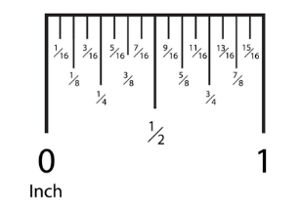

- Hygiene and Tattoos: Cadets are expected to maintain good hygiene while in uniform. Tattoos are authorized; however, tattoos or brands that are extremist, indecent, sexist, or racist are prohibited, visible with any uniformed activity, as they are prejudicial to good order and discipline within the unit, the school, and the community. If a Cadet has a tattoo on the face, it will not prohibit the Cadet from participating in JROTC. Instructors should advise that facial tattoos could prohibit the Cadet from joining the Armed Forces.

- Cosmetics: Exaggerated or faddish cosmetic styles are inappropriate with the uniform and will not be worn. Female Cadets may wear non-extreme shades of lipstick.

- When the Class B Uniform is worn (no jacket, no tie), only the nametag and rank will be worn.

General Care and Cleaning of Uniform items

- Coats, trousers, slacks, and ties: DRY CLEAN ONLY
- Shirt and blouse: Machine washed and dried.
- Berets: Brush lightly. Do not machine wash or dry clean.
- Dress shoe: Spray with Windex and wipe with a soft cloth.
- Brass: Polish with a soft, dry cloth. No Windex.

Shoulder Cords

The only cords authorized to be worn in the Highlander Battalion are as follows:

- White Color Guard Cord: Awarded to Cadets who have participated in 3 Color Guard Events.

- Red Drill Team Cord: Awarded to Cadets who have participated in 3 Drill Meets (Regulation & Exhibition with/without arms, Rifle Spinning and Guidon). In order to retain the cord, Cadets must remain active members of the Drill Team.

- Orange Honor Guard Cord: Awarded to Cadets who have participated in 1 Honor Guard / Sabre Arch event.

- Black Raider Team Cord: Awarded to Cadets who have participated in 1 Raider Challenge event. In order to retain the cord, Cadets must remain active members of the Raider Team.

- Tan Rifle Team Cord: Awarded to Cadets who have participated in 2 Junior Varsity or Varsity Rifle Matches. In order to retain the cord, Cadets must remain active members of the Junior Varsity or Varsity Rifle Team.

- Gold National Honor Society Cord: Awarded to Cadets who have been selected to the National Honor Society.

- Green Drone Team Cord: Awarded to Cadets who have participated in 2 Drone competitions. In order to retain the cord, Cadets must remain active members of the Drone Team.

- Blue JLAB Team Cord: Awarded to Cadets who have been participated in the JROTC Leadership & Academic Bowl for the current school year only.

NOTE: Cadets must be active members of JROTC co-curricular activities in order to wear team activity cords. Former members may continue to wear the ribbon and arc pin but not the cord. If only one cord is worn, it is worn on the left shoulder. If two cords are worn, the position cord will be worn on the left shoulder, activity cord will be worn on the right shoulder. If two activity cords are worn, it is the Cadet’s choice on which shoulder to place them. Cords not listed here are not authorized for wear.

Arc Pins

The only Arc Pins authorized to be worn in the Highlander Battalion are:

- Honor Guard Arc Pin: Awarded to Cadets who have participated in 1 Honor Guard event.

- Color Guard Arc Pin: Awarded to Cadets who have participated in 2 Color Guard events.

- Drill Team Arc Pin: Awarded to Cadets who have participated in 2 Drill Meets in Regulation Teams (Regulation with/without arms, Exhibition with/without arms, Rifle Spinning, and Guidon only).

- Raider Arc Pin: Awarded to Cadets who have participated in 1 Raider Challenge Meet.

- PT Excellence Arc Pin: Awarded to Cadets who have participated in the 8th Brigade PT Test.

- Flag Detail Arc Pin: Awarded to Cadets who have participated in an annual Flag Raising ceremony.

- JCLC Arc Pin: Awarded to Cadets who have successfully completed JCLC.

- Cadet Challenge Arc Pin: Awarded to Cadets who have qualified for the National or Presidential standards of the Cadet Challenge.

- Academic Arc Pin: Awarded to Cadets who have been selected to the National Honor Society.

- Rifle Team Arc Pin: Awarded to Cadets who have participated in 1 Junior Varsity or Varsity Rifle Match.

- Orienteering Arc Pin: Awarded to Cadets who have participated in 1 Orienteering event.

NOTE: Arc Pins not listed above are not authorized for wear.

JROTC UNIFORM GUIDES

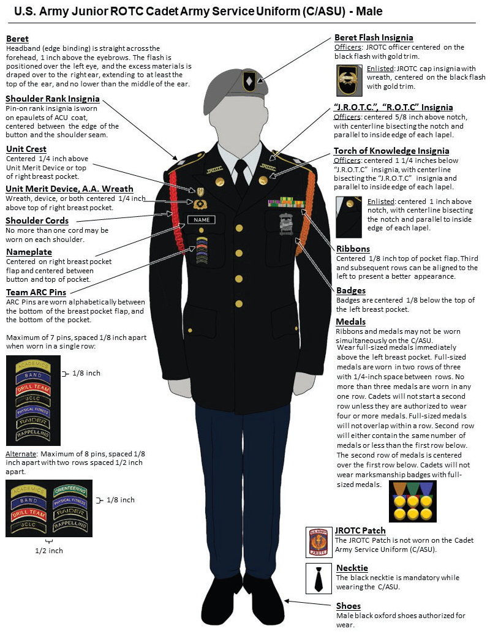

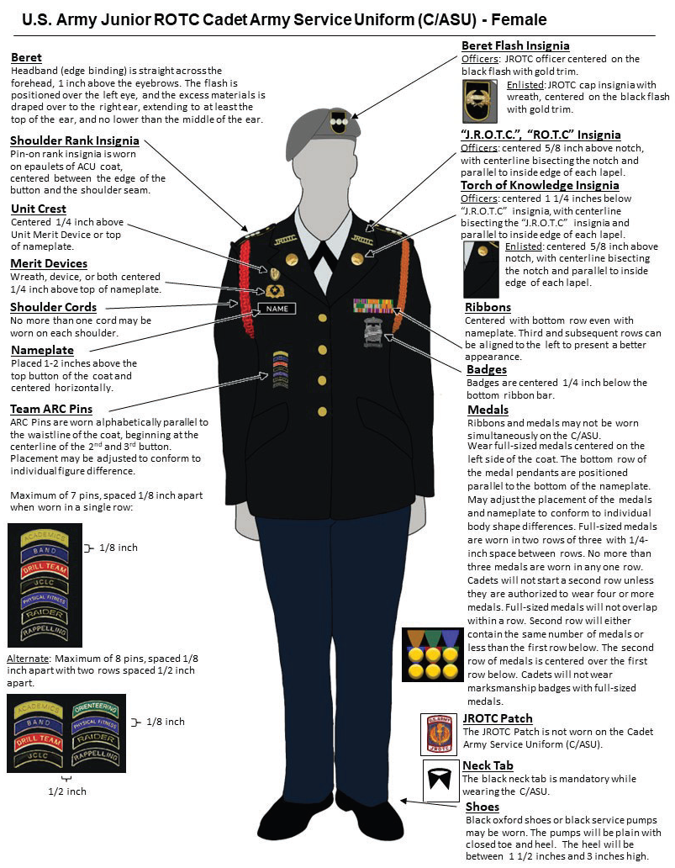

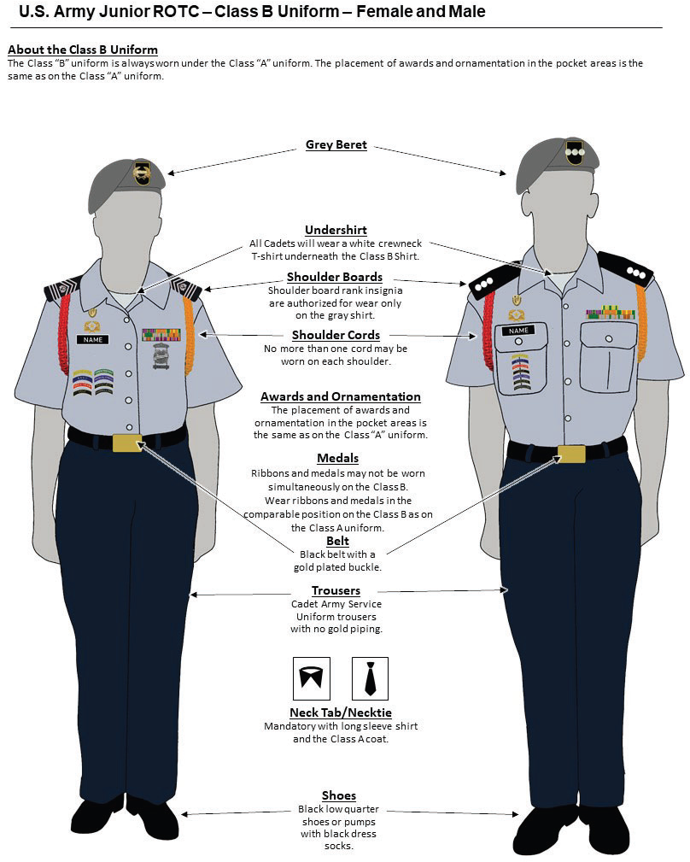

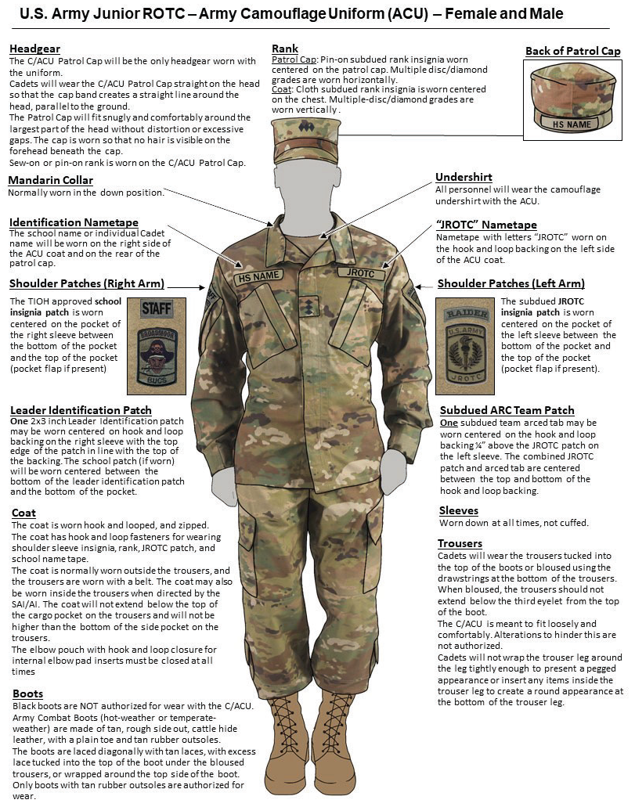

  Heroism  Awarded to any JROTC Cadet who performs an act of heroism |   Superior Cadet  Awarded annually to one outstanding Cadet in each LET level |   Distinguished Cadet  N-1-1  Awarded annually to one Cadet who exhibits the highest degree of excellence in scholastics (Superintendent) |   Academic Excellence  N-1-2  Awarded annually to one Cadet in each LET level for achieving the highest grades (Principal)
  Academic Achievement  N-1-3  Awarded annually to those Cadets who maintain a grade of “A” in JROTC and “B” in the remaining academic subjects (DAI) |   Perfect Attendance  N-1-4  Awarded to Cadets with no unexcused absences during each semester (SAI) |   Student Government  N-1-5  Awarded to Cadets elected to a student government office (Principal) |   LET Service  N-1-6  Awarded to Cadets successfully completing the first semester of each LET year (SAI)
  Honor Roll  N-1-7  Awarded to Cadets appearing on the school-wide Honor Roll (Principal) |   JLAB Competition  N-1-8  Awarded annually to Cadets who have participated in the JLAB Competitions (SAI) |   CPR Certification  N-1-9  Awarded to Cadets who have completed CPR Training (SAI) |   MS End of Program Award  N-1-10  Awarded to Cadets who passed the Military Science End of Program Exam (SAI)
  DAI / SAI Leadership  N-3-1  Awarded annually to the one Cadet in each LET level who displays the highest degree of leadership (SAI) |   Personal Appearance  N-3-2  Awarded annually to Cadets who consistently present an outstanding appearance (SAI) |   Proficiency  N-3-3  Awarded annually to Cadets who have demonstrated an exceptionally high degree of leadership, academic achievement, & performance of duty (SAI) |   Drill Team  N-3-4  Awarded annually to drill team members (SAI)
  Orienteering  N-3-5  Awarded annually to Cadets who are members of the orienteering team (SAI) |   Color / Honor Guard  N-3-6  Awarded annually to Cadets who have done 5 combined color/honor guards (SAI) |   Rifle Team  N-3-7  Awarded annually to rifle team members (SAI) |   Raider Team  N-3-8  Awarded annually to Cadets who are members of the Raider Team (SAI)
  Commendation  N-3-9  Awarded to Cadets whose performance of duty exceptionally exceeds that expected of Cadets of their grade (SAI) |   Good Conduct  N-3-10  Awarded annually to Cadets who have demonstrated outstanding conduct throughout the school (SAI) |   JCLC  N-3-11  Awarded to Cadets for JCLC participation (SAI) |   SSB Meritorious Service  N-3-12  Awarded annually to Cadets for meritorious service in the Silver State Brigade (DAI)
  Best Company  N-3-13  Awarded annually to Cadets who are in the winning company of the “Best Company” competition (SAI) |   Best Platoon  N-3-14  Awarded annually to Cadets in the winning platoon of the “Best Platoon” competition (SAI) |   Best Squad  N-3-15  Awarded annually to all Cadets in the winning squad of the “Best Squad” competition (SAI) |   Varsity Athletics  N-2-1  Awarded annually to Cadets participating in varsity sports (Principal)
  JROTC Physical Fitness  N-2-2  Awarded annually to Cadets scoring in the 85th percentile or above in all 5 Cadet Challenge events (SAI) |   JROTC Athletics  N-2-3  Awarded annually to Cadets scoring in the 50th percentile or above in all 5 Cadet challenge events (SAI) |   JCLC Rappelling  N-2-4  Awarded annually to Cadets who have participated in the Rappelling event in JCLC (SAI) |   Cadet Olympics  N-2-5  Awarded annually to Cadets who compete in the annual Cadet Olympics (SAI)
  Parade  N-4-1  Awarded to Cadets who have participated in the Veterans Day and the Nevada Day Parade (SAI) |   Recruiting  N-4-2  Awarded to Cadets who recruit one Cadet into the JROTC program each semester (SAI) |   JCLC Distinguished Graduate  N-4-3  Awarded annually to Cadets who were distinguished graduates of the JCLC program (DAI) |   Selfless Service  N-4-4  Awarded annually to Cadets who have successfully demonstrated selfless service within their community (SAI)
  JPA Participant  N-4-5  Awarded to Cadets who have participated in the JPA (SAI) |   Service Learning  N-4-6  Awarded annually to Cadets who participate in service projects. (SAI) |   Excellent Staff Performance  N-4-7  Awarded annually to Cadet Staff Officers for excellent performance (SAI) |   Academic Achievement Insignia  Awarded to Cadets with a B average in all subjects and an A in JROTC (SAI)

SY 25-26 HIGHLANDER BATTALION UNIFORM INSPECTION
CADET NAME | MILITARY BEARING (25) | SHOES / SOCKS (5) | GIG LINE (5) | BUCKLE / BELT (5) | TORCHES (5) | LINT / THREADS (5) | TIE / NECK TAB (5) | NAMETAG (5) | BDE CREST / HUD (5) | RIBBONS / MEDALS (5) | RANK (5) | BERET (5) | HAIR / SHAVE (30) | JEWELRY (30) | NAILS / POLISH (30) | DIRTY UNIFORM (30) | KNOWLEDGE # 1 (10) | KNOWLEDGE # 2 (10)
NOTES:

HIGHLANDER BATTALION
IN-RANKS INSPECTION
STUDY GUIDE

Q: Who is your Company Commander?
A: My Company Commander is Cadet Captain ______________________________________

Q: Who is your Company First Sergeant?
A: My Company First Sergeant is Cadet First Sergeant _________________________________

Q: Who is the Highlander Battalion Commander?
A: The Highlander Battalion Commander is Cadet Lieutenant Colonel ___________________

Q: Who is the Highlander Battalion Command Sergeant Major?
A: The Highlander Battalion Command Sergeant Major is Cadet Command Sergeant Major
_________________________________

Q: Who is the Director of Army Instruction (DAI)?
A: The Director of Army Instruction is Lieutenant Colonel Scott Caldwell

Q: Who is your Senior Army Instructor (SAI)?
A: My Senior Army Instructor is First Sergeant Philip Risi

Q: What is the mission of JROTC?
A: The Mission of JROTC is to Motivate Young People to Be Better Citizens

Q: What does JROTC stand for?
A: JROTC stands for Junior Reserve Officer Training Corps

Q: What does the acronym MS stand for?
A: MS stands for Military Science

Q: Name your Winning Color and what it represents.
A: My Winning Color is ______________ and it represents ___________________________

Q: If you were promoted one rank, what rank would you be?
A: If I were promoted one rank, my rank would be ________________________________

Q: Who is your school Principal?
A: My school principal is ________________________________________

Q: What percentage of your JROTC grade is a Uniform Inspection?
A: The Uniform Inspection is 20% of my JROTC grade

Q: What rank is this? (Flashcards)
Extra-Curricular Activities

JROTC Cadets are highly encouraged to participate in JROTC and school-wide extracurricular activities. To be eligible for extra-curricular activities, you must first meet those requirements set forth by the Washoe County School District as well as the Incline JROTC Department including any physical requirements of the particular activity. Some of those requirements are:

- Meet the 90% attendance requirement
- Possess a passing grade in JROTC
- Possess a 2.0 GPA (minimum)

Color Guard

The Highlander Color Guard presents the “Colors” at all home sporting events, special assemblies, local parades, and any other requirement specified by the school principal, SAI, or DAI Office. The Color Guard competes in several Drill Meets and performs during the JROTC Program of Accreditation (JPA). Color Guard members will practice after school on days and times designated by the Color Guard coach. Any Cadet in good standing may participate as a member of a Color Guard. Color Guard members are expected to practice after school on days and times designated by the Color Guard coach.

Honor Guard

The Highlander Honor Guard performs at the annual Homecoming Football Game by performing a sabre arch for the King & Queen Court.

Drill Team

The Highlander Drill Team consists of Cadets who take part in competition precision drill each year and participate in Washoe County School District competitive drill meets. Team members are expected to practice after school on days and times designated by the Drill Team coach.

Rifle Team

The Highlander Rifle Team consists of Cadets who train and compete in district marksmanship competitions with sporter air rifles. The team competes in “shoulder to shoulder” matches with other schools in the district. All equipment is provided by JROTC.

Orienteering Team

The Highlander Orienteering Team consists of Cadets who train and compete in district and local competitions with map and compass.

JROTC Leadership & Academic Bowl Team (JLAB)

The Highlander JLAB Team consists of Cadets who train and compete in district and national competitions in challenging leadership and academic knowledge bowls.

Drone Team

The Highlander Drone Team consists of Cadets who train and compete in district drone competitions. All equipment and necessary materials will be provided to Drone Team members free of charge.

Duties & Responsibilities of Cadet Leaders

Cadet leaders are expected to demonstrate the ability to follow as well as lead. It is impossible to list every responsibility of a Cadet leader. Leadership is best earned through experience and the application of “common sense” actions. There are no foolproof set of rules in leadership but there are some very good principles to assist you in making that “best decision.” A few are provided below:

- Learn and apply the Leadership Principles and Traits to the best of your ability. Judge yourself against these tested and proven principles. Sustain those in which you feel strong or adequate and seek ways of improving those in which you feel inadequate.
- Learn the proper drill commands. Insist that they be performed with precision.
- Be courteous and respectful. It is the mark of a good leader. Courtesy should not extend only to your superiors but to your subordinates as well.
- Epitomize proper military bearing and appearance at all times. You will find that it lends a sense of dignity, urgency, and authority to your subordinate’s performance. Remember, actions speak louder than words; there is no substitute for setting the proper example.
- Supervise the training of your subordinates. Insure that not only have they heard the words, but that they know how to accomplish the task at hand. Help and instruct them when needed and never ridicule or permit others to ridicule your subordinate’s performance.
- Be loyal to both your superiors and your subordinates. Always keep their well-being in mind. Always remember that loyalty works both ways, to your subordinates as well as to your superiors.

The following leaders and their assigned positions are required to be enrolled in 8th period (after school) both semesters in order to be assigned to these key leadership positions within the Highlander Battalion. Failure to enroll in and attend 8th period will result in removal from your position and possible loss of rank. These key positions are:

Battalion Commander (BC)
Executive Officer (XO)
Command Sergeant Major (CSM)
Special Projects Officer (SPO)
Administrative Officer (S1)
Training Officer (S3)
Logistics Officer (S4)
Public Affairs Officer (S5)
Special Staff Positions (JPA Officer, Service-Learning Officer, etc.)
Leadership Position Eligibility

The leadership philosophy within the Highlander Battalion is that it is an honor and privilege to hold a leadership position. The right to lead must be both earned and sustained. A Cadet must first, through demonstrated ability, desire, and qualification, earn their leadership position. Cadets must continue to deserve that leadership position by ongoing commitment, self-improvement, and periodic re-evaluations. A leader must be prepared to lead not only by the authority of their rank and position, but more importantly by their actions and example. To earn the initial right to a leadership position, Cadets must first meet certain qualifying criteria. Once eligible, they must continue to prove their eligibility through written exams, maintenance of minimum academics and conduct, and demonstrated examples of leadership ability. The eligibility standards are outlined below:

Initial Eligibility

- Achieve all promotion requirements set forth in this SOP and demonstrate leadership qualities commensurate with the available leadership position.
- Be recommended by the company chain of command and Instructors.
- Maintain the following:

GPA: 2.0 GPA (Minimum)
Citizenship: No F’s in any class

Sustained Eligibility

- Perform in a satisfactory manner in the assigned leadership position.
- Maintain a 2.0 or better GPA.
- Maintain a Citizenship Grade with no F’s in any class.
- No in-school or outside of school suspensions.
- No integrity, honor, or behavior violations (documented in a counseling statement).

Cadet leaders failing to meet or sustain minimum standards will be subject to removal from their leadership position and reduction in rank per the Instructors’ discretion. If reduced in rank, Cadet leaders start back through the promotion system, as set forth in this SOP.

Duties and Responsibilities by Position

Duties and responsibilities include but are not limited to the following:

Battalion Commander

- Perform as the primary liaison between the JROTC Instructors and the Highlander Cadets.
- Coordinate with the JROTC Instructors and provide guidance to the JROTC staff and Cadet leadership for the planning and execution of all JROTC events.
- Command the Battalion by taking responsibility for everything the Battalion accomplishes or fails to accomplish and make use of the subordinate chain of command.
- Develop goals for the Battalion and oversee the progress towards those goals.
- Lead by example; the primary role model for appearance, behavior, and attitude for the entire Battalion.
- Mentor and train all Company Commanders in the performance of their duties.
- In coordination with the JROTC Instructors, be the final decision authority for JROTC staff actions, promotions, and JROTC Cadet issues.
- Be the primary briefing officer for all JROTC briefings and events.
- Attend all Battalion and District meetings and events as well as District Cadet & Junior Leader Boards as required.

Battalion Executive Officer

- Take command of the Battalion in the Battalion Commander’s absence.
- Attend all Battalion and District meetings and events in the Battalion Commander’s absence.
- Supervise and mentor the Highlander JROTC staff.
- Ensure that all requirements on the JPA checklist are met by the staff at all times.
- Responsible for the collection of company After Action Reviews (AAR’s). Maintains file at the Battalion level for discussion in Battalion Staff meetings
- Coordinate with the Instructors and the Battalion Commander to prioritize actions.
- Coordinate with the S3 to insure the JROTC calendar of events is current.
- Lead the Command and Staff meetings.
- Maintain and update the Battalion Staff Board.
- Prepare the JROTC Academic and Leadership Teams for JLAB competition.
- Maintain an accurate accounting of JROTC student funds.
Battalion Command Sergeant Major

- Advise the Battalion Commander on issues pertaining to enlisted Cadets.
- Be the Battalion expert on drill and ceremonies.
- Mentor and train all Company First Sergeants in the performance of their duties. Conduct a “1SG’s Call” a minimum of once per month.
- Conduct all Battalion Cadet & Junior Leader Boards in a professional manner.
- Lead by example; the enlisted role model for appearance, behavior, and attitude for the entire Battalion.
- Attend all Battalion and District meetings and events as well as District Cadet & Junior Leader Boards as required.
- Attend JROTC staff meetings and provide input as necessary to ensure that the interests of enlisted Cadets are represented.
- Prepare the JROTC Program of Accreditation (JPA) Color Guard.
- Schedule, plan, prepare and provide oversight of all Color and Honor Guards.
- Brief and escort VIP’s to the Highlander JROTC Program events and functions.
- Maintain all National, State, and JROTC Highlander Battalion Colors.
- Develop & Maintain the Battalion Flag Duty Roster.

Special Projects Officer (SPO)

a. Coordinate with the SAI and the Battalion Commander to prioritize and execute special projects, events, and activities.
b. Maintain records on special projects as outlined by the Cadet Battalion
Commander, Battalion Executive Officer, and Instructors.
c. Responsible for the planning and execution of the annual Highlander
Dining In.
d. Responsible for the planning and execution of at least one Battalion MWR event each quarter.
- Maintain and update the Battalion Daily Announcements Board.

Battalion S1 (Administration Officer)

- Ensure that all requirements on the S1 section of the JPA checklist are met.
- Maintain and update active Cadet records in the JUMS program.
- Produce JUMS generated orders for all promotions and Cadet awards.
- Responsible for completion of the Battalion Organization Chart.
- Maintain Cadet administrative records and ensure they contain all requirements.
- Coordinate with the Company Commanders to ensure Cadet portfolios are being maintained in accordance with current Cadet Command and District standards.
- Maintain copies and rosters of the Battalion’s Privacy Act Health Statements.
- Brief VIP’s on the S1 functions, current status, and historical data.
- Attend Cadet staff meetings and be prepared to discuss any JROTC issues from the S1 perspective.
- Manage all invitations to JPA /Awards Night, “Thank You” letters, and holiday and sympathy cards as needed.
- Manage the Battalion Promotion Board system.

Battalion S3 (Training and Operations Officer)

- Ensure that all requirements on the S3 section of the JPA checklist are met.
- Produce and maintain the JROTC events calendar.
- Produce and publish weekly training schedules.
- Prepare and publish permission slips for all Battalion events.
- Produce and publish planning documents for all JROTC activities in a timely manner.
- Maintain file copies of all coordination with the school and community for any support requested by the Highlander Battalion.
- Coordinate with the SAI to process, prioritize, and plan all requests for JROTC competitions, community support, and service-learning projects.
- Update the Unit Report in JUMS after every event executed by the Highlander Battalion or its members.
- Responsible for the Highlander Battalion Safety Program.
- Be prepared to brief VIP’s on the S3 functions, upcoming events, and completed events.
- Attend Cadet staff meetings and be prepared to discuss any JROTC issues from the S3 perspective.
- Update and maintain Cadet Challenge information in JUMS.
- Update and keep the "Company Competition" chart current and posted.

Battalion S4 (Logistics Officer)

- Input and post all JROTC equipment and uniform information into JUMS.
- Ensure that all requirements on the S4 section of the JPA checklist are met.
- Produce and maintain a signed, JUMS generated, clothing record for every Highlander Cadet.
- Maintain an accurate inventory of all JROTC property.
- Coordinate with the AI to ensure that the primary hand receipt matches the number and serial numbers of the items on hand.
- Organize and maintain the Supply Room in an efficient manner and ensure the area is free from safety or fire hazards.
- Tag all government equipment to distinguish it from school and government property.
- Brief VIP’s on the S4 functions, equipment status, security and supply issues.
- Attend Cadet staff meetings and be prepared to discuss any JROTC issues from the S4 perspective.
- Coordinate with the S1 for orders to issue promotions and awards.
- Maintain documentation demonstrating coordination with the Cadet leadership and staff for all supply matters.
- Maintain accountability and an adequate supply of all ranks, badges, ribbons, and other accouterments.

Battalion S5 (Public Affairs Officer)

- Ensure that all requirements on the S5 section of the JPA checklist are met.
- Produce and publish quarterly JROTC newsletters that inform Cadets, students, parents, and school administrators of future JROTC events and accomplishments.
- Coordinate to have JROTC information published in local newspapers. Maintain documentation of all requests and published articles.
- Maintain the JROTC bulletin boards in order to advertise JROTC activities and promote higher enrollment.
- Coordinate with the Yearbook Staff to have JROTC news and events published.
- Coordinate with the Instructors for Feeder School visits and membership drives.
- Brief VIP’s on the S5 functions, web site, and Feeder School information.
- Attend Cadet staff meetings and be prepared to discuss any JROTC issues from the S5 perspective.
- Maintain the Battalion’s unit history and annual scrapbook.
- Design and publish promotional brochures and flyers for Highlander events.
- Ensure that photos of all Battalion events are taken, distributed, and displayed.
- Responsible for the Awards Night slideshow.
- Coordinate with the JROTC Instructors to establish and maintain a Highlander Battalion web page.

Battalion JPA & Service-Learning Officer(s)

- Ensure that all requirements on the JPA and Service-Learning sections of the JPA checklist are met.
- Coordinate with the SAI and the Battalion Commander to prioritize and execute JPA & Service-Learning activities.

Company Commander

- Command the Company by taking responsibility for everything the Company accomplishes or fails to accomplish and make use of the subordinate chain of command to conduct all operations.
- Coordinate directly with the Battalion Commander and the Battalion Executive Officer to organize and direct Company personnel to accomplish all required activities.
- Lead by example; the primary role model for appearance, behavior, and attitude for the Company.
- Develop goals for the Company and oversee the progress towards those goals.
- Inspect Cadets in the Company to insure they meet appearance standards.
- Recommend Cadets for awards, promotions, and reductions.
- Motivate the company to accomplish goals, objectives, and participation in events and activities.
- Attend all Battalion meetings and events as required.
- Train and mentor Company XO and Platoon Leader.

Company First Sergeant

- Assist the Company Commander to oversee Company activities and tasks.
- Perform as the primary drill instructor for the Company.
- Perform as the primary physical training (PT) instructor for the Company.
- Train the Company Guidon Bearer.
- Lead by example; the enlisted role model for appearance, behavior, and attitude for the Company.
- Inspect Cadets in the Company to insure they meet appearance standards.
- Recommend Cadets for the Promotion Board and the Cadet and Junior Leader of the Month Boards.
- Work closely with the Cadet Command Sergeant Major.
- Recorder during in-ranks inspections.
- Forms the Company.
- Is a board member for all NCO and Cadet Boards.
- Monitor performance of all NCO Cadets and mentors NCO’s accordingly.
- Assist Company XO in administrative duties. i.e., promotion and award order requests, participation rosters, etc.

Company Executive Officer

- Assist Commander with training the company and responsible for the company in the absence of the Commander.
- Responsible for completion of company After Action Reviews (AAR’s). Forwards them to the Battalion XO.
- Coordinate events and activities and completes and submits all Company participation rosters to the Battalion XO.
- Responsible for the accurate scoring of the Cadet Challenge and other activities as required.
- Supervise rehearsal of Cadet classes.
- Responsible for the submission and follow-up of all promotion and award requests.
- Perform other duties assigned by the Company Commander.
- Plan and executes Cadet birthday celebrations and company parties.
- Responsible for completion of the Company Organization Chart.
- Collect all Privacy Act Statements and other documents and forwards to the S1.
- Responsible for the accountability of all equipment issued to the Company.

Platoon Leader

- Keep Company Commander informed of all Platoon issues.
- Know and teach all Cadet regulations.
- Assist Platoon Sergeant in preparing Cadets for promotion and Cadet boards.
- Reinforce Battalion and Company Commander policies and procedures.
- Assumes command of the company in the Company XO’s absence as required.
- Ensure Platoon is prepared for inspections and other events and activities.
- Responsible for communication with platoon members.
- Work closely with Company Commander and Platoon Sergeant.
- Responsible to ensure that Flag Duty is completed.
- Lead by example; the primary role model for appearance, behavior, and attitude for the entire Platoon.

Platoon Sergeant

- Train Squad Leaders in Platoon.
- Perform as the drill instructor for the Platoon in the absence of the First Sergeant.
- Lead PT for the Platoon in the absence of the First Sergeant.
- Sit on Cadet & Junior Leader Boards in the absence of the Company First Sergeant.
- Keep Platoon Leader informed.
- Select and prepares Cadets for Cadet and Junior Leader of the Month Boards.
- Ensure Platoon is prepared for inspections and other events and activities.
- Pre-inspect the squad leaders.
- Mentor and train Squad Leaders.
- Account for Cadets in the Platoon.
- Assume Command of the Platoon in the absence of the Platoon Leader.
- Ensure Platoon cleans up areas after all events and classes.
- Work closely with the Company First Sergeant and Platoon Leader.
- Perform other duties required by the Platoon Leader.
- Lead by example; the primary enlisted role model for appearance, behavior, and attitude for the entire Platoon.

Squad Leader

- Responsible for the accountability, training, discipline, morale, and uniform appearance of the Squad.
- Primary trainer of drill and physical training in the Squad.
- Is thoroughly familiar with drill and uniform regulations and knows the requirements for both male and female uniforms.
- Ensure Squad is trained to perform Flag Duty and other tasks.
- Observe and supervise their Cadets at all times.
- Know each Squad member’s name, basic information, strengths and weaknesses.
- Recommend qualified Cadets for promotions, awards, and appearance at the Cadet & Junior Leader Boards.
- Thoroughly pre-inspects Cadets’ uniforms on uniform days or for any event.
- Is responsible for their subordinate’s actions.
- Motivate squad members at all times and in preparation for all events.
- Lead by example; the primary role model for appearance, behavior, and attitude for the entire Squad.

Company Supply Sergeant

a. Assist with the issuing of uniforms and equipment to Cadets.
b. Assist the Company Commander with all supply-related issues.
c. Coordinate with the Battalion S4 on all supply issues as needed.
d. Responsible to ensure that the necessary PT equipment is drawn and taken to
the designated PT area.

Company Photo Sergeant

a. Assist the Battalion S5 with taking photos of all Company events.
b. Maintain Battalion camera charged and ready at all times.
c. Submit Company photos to the Battalion S5 and SAI as needed.

Guidon Bearer

- Responsible for the care and safe keeping of the Company Guidon at all times.
- Maintain and carry the Guidon in formation.
- Know the Guidon procedures described in TC 3-21.5.
- Train the alternate Guidon Bearer.
- Know the history, purpose and tradition of the Guidon.
- Compete in the “Best Drilled Guidon” Competition.

Highlander Cadets

- Follow the instructions of the JROTC Instructors and Cadet chain of command.
- Strive to improve as a student and citizen by fully participating in and applying the lessons learned in JROTC.
- Wear the JROTC uniform properly and with pride on all uniform days and for designated JROTC activities in accordance with the standards in the Cadet Reference Guide and this SOP.
- Maintain a current JROTC Cadet portfolio.
- Complete Flag Duty as assigned.
- Be on time for class and all formations.

Promotion System

Promotions within the Highlander Battalion are made on behalf of deserving, capable, and qualified Cadets. Promotions are merit-based and measurable and are subject to final approval by the Instructors. Incline High School’s Army JROTC Program is designed to recognize and reward a Cadet’s exemplary performance of duties by providing a fair and equitable promotion system.

Authorized Ranks

Each position within the Highlander Battalion has an associated authorized rank. “Authorized rank” means the highest rank a Cadet assigned to that leadership position could expect to earn. In some cases, the rank of a Cadet will be less than that authorized for that particular leadership position. This occurs because Cadets are not automatically promoted to the authorized rank when assigned to the leadership position. This policy allows for a Cadet’s growth in his / her assigned position. Listed below are the ranks authorized per position:

Position Authorized Rank

Squad Member Private
PV2
Private First Class
Corporal

Guidon Bearer Private First Class
Corporal

Squad Leader Sergeant
Staff Sergeant

Supply NCO Sergeant
Staff Sergeant

Photo NCO Sergeant
Staff Sergeant

Platoon Sergeant Sergeant First Class
Master Sergeant

First Sergeant Master Sergeant
First Sergeant
Battalion CSM Sergeant Major
Command Sergeant Major

Platoon Leader Second Lieutenant
First Lieutenant

Company Executive Officer Second Lieutenant
First Lieutenant

Company Commander First Lieutenant
Captain

Battalion Staff Officer First Lieutenant
Captain

Battalion Executive Officer Captain
Major

Battalion Commander Lieutenant Colonel

Initial Promotion

Initial promotions will be a direct result of a new Cadet’s demonstrated knowledge and proficiency. At approximately the sixth week of the first semester, all new Cadets (regardless of MS Level) will be given the Initial Promotion Exam (IPE). The IPE score is the average of the combined drill proficiency exam and the written exam (Introduction to JROTC) taught in the MS1 class. The minimum qualifying standards are listed below. A Cadet’s personal effort and aptitude will determine the rank that they will earn. After the IPE, new Cadets cannot be promoted until after the end of the first quarter.

Determination of Initial Rank: (IPE Results)

90% and above: Private First Class (PFC)
70% - 89%: Private Second Class (PV2)
69% and below: Private (PVT)

Promotions for all ranks
See Promotion Matrix in the following pages:
HIGHLANDER BATTALION PROMOTION MATRIX

PV2 | Initial Promotion Exam (IPE) 70 - 89%
 | “B” Grade in JROTC
 | 2.0 Overall GPA
 | No F’s in any class
PFC | Initial Promotion Exam (IPE) 90% and above
 | “B” Grade in JROTC
 | 2.0 Overall GPA
 | No F’s in any class
CPL | “B” Grade in JROTC
 | 2.0 Overall GPA
 | No F’s in any class
 | Promotion Board Recommendation
SGT / SSG | LET 2 or LET 1 and Appointment as Squad Leader, Photo/Supply
 | NCO Promotion Exam 75% and above
 | “B” Grade in JROTC
 | 2.0 Overall GPA
 | No F’s in any class
 | Promotion Board Recommendation
SFC / MSG | LET 2 + Appointment as Platoon Sergeant
 | NCO Promotion Exam 75% and above
 | “B” Grade in JROTC
 | 2.0 Overall GPA
 | No F’s in any class
 | Promotion Board Recommendation
HIGHLANDER BATTALION PROMOTION MATRIX

1SG | LET 2 + Appointment as First Sergeant
 | NCO Promotion Exam 75% and above
 | “B” Grade in JROTC
 | 2.5 Overall GPA
 | No F’s in any class
SGM / CSM | LET 3 + Appointment as Battalion CSM
 | NCO Promotion Exam 75% and above
 | “B” Grade in JROTC
 | 2.5 Overall GPA
 | No F’s in any class
2LT / 1LT | LET 2 + Appointment as Platoon Leader, Co XO, or Staff
 | Officer Promotion Exam 75% and above
 | “B” Grade in JROTC
 | 2.0 Overall GPA
 | No F’s in any class
 | Promotion Board Recommendation
CPT | LET 2 + Appointment as Company Commander or Staff
 | Officer Promotion Exam 75% and above
 | “B” Grade in JROTC
 | 2.5 Overall GPA
 | No F’s in any class
HIGHLANDER BATTALION PROMOTION MATRIX

MAJ | LET 3 + Appointment as BN XO
 | Officer Promotion Exam 75% and above
 | “B” Grade in JROTC
 | 2.5 Overall GPA
 | No F’s in any class
LTC | LET 4 + Appointment as Battalion Commander
 | “B” Grade in JROTC
 | 2.5 Overall GPA
 | No F’s in any class
 | BC Selection Board

Note 1: Cadets must complete all the requirements of their current rank before they can be considered for the next promotion.
Note 2: Cadets may request a waiver (in writing) of any item on the matrix if there is a valid reason. Both Instructors and the Battalion Commander will then consider the request and render a decision.
Note 3: A reduction in rank will be considered for Cadets who do not maintain the required GPA and / or academic grade in JROTC commensurate with their rank. Once reduced, Cadets must meet all criteria in order to recover their previously held rank.
Note 4: Promotion Boards will consist of the Company Commander (or Battalion Commander for staff) and at least one Instructor (SAI or AI). Cadets choosing not to appear before the board will not be promoted. Promotions boards will be conducted in the ASU uniform.

Promotion Board members will consider the following criteria when Cadets report for the promotion Board:

Company Guidon
Battalion Guidon
Drill Proficiency
Veterans Day Parade
Highlander Homecoming Parade
Battalion Cadet of the Month (Winner)
Battalion Junior Leader of the Month (Winner)
Battalion Cadet of the Month (Competitor)
Battalion Junior Leader of the Month (Competitor)
District Cadet of the Semester (Winner)
District Junior Leader of the Semester (Winner)
Community Service
School Support
JROTC Essay (90% or better)
JROTC Essay (75% - 89%)
Overall GPA (3.5 or better per quarter)
Overall GPA (2.5 - 3.4 per quarter)
Cadet Challenge Completion (all 5 events)
Presidential Cadet Challenge Awardees
National Cadet Challenge Awardees
Uniform Inspection (95% or better)
Dining-In Attendance
JLAB Team (Academic / Leadership)
Rifle Team Member
Raider Team Member
Orienteering Team Member
Color Guard
Honor Guard
Cadet Olympics Participant
Displaying Citizenship / Initiative / Leadership

Late Enrollees

Students joining the Battalion after the IPE will be trained and prepared by their respective Cadet Chain of Command. When the Company Commander believes the new Cadet to be capable, the Instructors will administer and evaluate them. Once all of the criteria have been met, these Cadets will be promoted.

Reductions in Grade (Demotions)

Any Cadet Officer, Non-Commissioned Officer, or Cadet may be reduced in rank and / or removed from their position for any of the following reasons (not all-inclusive):

  - Insubordination toward any Cadet of a higher rank who is appointed over the Cadet in question and who gives a reasonable directive

  - Insubordination toward a JROTC Instructor

  - Demonstrated inability to serve in their rank or position

  - Improper conduct

  - Chronic tardies

  - Failure to meet the academic grade and / or GPA commensurate with the assigned rank

  - Suspension from school or in school suspension for serious violations of school rules such as:

Fighting
Drugs
Truancy
Plagiarism / Cheating

  - Failure to wear the ASU uniform on required uniform days or wearing the uniform in a denigrating manner. For example:

Not having a proper haircut
Not shaving
Male Cadets wearing earring(s) while in uniform
Female Cadets wearing improper nail polish

  - Lack of Motivation

  - Failure to Fulfill a Commitment

Initial Promotion Exam (IPE) Study Guide

- What does “JROTC” stand for?
  - Junior Reserve Officers’ Training Corps

- What is the mission of JROTC?
  - To motivate young people to be better citizens

- What does “MS” stand for?
  - Military Science

- Who is your Company Commander?
  - My Company Commander is c/CPT _______________________________

- Who is your Company First Sergeant?
  - My Company First Sergeant is c/1SG _______________________________

- Who is the Highlander Battalion Commander?
  - The Highlander Battalion Commander is c/LTC _____________________

- Who is the Highlander Command Sergeant Major?
  - The Highlander Command Sergeant Major is c/CSM _________________

- Who is your Senior Army Instructor (SAI)?
  - My Senior Army Instructor is First Sergeant Philip Risi

- What does the color red on the US Flag represent?
  - The color red on the US Flag represents hardiness and valor

- What does the color blue on the US Flag represent?
  - The color blue on the US Flag represents vigilance and justice

- What does the color white on the US Flag represent?
  - The color white on the US Flag represents purity and innocence

- What does “BC” stand for?
  - “BC” stands for Battalion Commander

- The thirteen stripes on the U.S. Flag represent the thirteen original…
  - Colonies

- What does “GAP” stand for?
  - “GAP” stands for Grades, Attitude, and Participation

- What does “SAI” stand for?
  - “SAI” stands for Senior Army Instructor

- In order to fly a flag at night, the flag must be…
  - Illuminated

- When state flags are flown on the same staff as the U.S. Flag, the…
  - U.S. Flag is always on the top position

- What is the Highlander Grading Scale?
  - The Highlander Grading Scale is:

Academic: 35%
Uniform Inspection: 20%
PT: 20%
Semester Final Exam: 15%
Drill: 10%

- Identify each letter of the phonetic alphabet

20.Identify all Army JROTC ranks

NCO Promotion Exam Study Guide

Everything in the Cadet Initial Promotion Exam (IPE) plus the following:

- What does “AI” stand for?
  - “AI” stands for Army Instructor

- When marching, what is the normal length of a step?
  - The normal length of a step is 30 inches

- What does the gold star represent?
  - The gold star represents Honor Unit with Distinction

- Who wrote the National Anthem?
  - Francis Scott Key wrote the National Anthem

- When was the National Anthem written?
  - The National Anthem was written during the battle of Fort McHenry in the War of 1812

- What is the name of the National Anthem of the United States?
  - The Name of the US National Anthem is the Star-Spangled Banner

- When did Nevada become a state?
  - Nevada became a state on October 31, 1864

- Who is the Commander-in-Chief?
  - The Commander in Chief is the President of the United States

- When the command “Forward March” is given, which foot moves first?
  - The Left foot moves first

- Are the medals and ribbons of the same award permitted to be worn at the same time?
  - No, only the ribbon or the medal are allowed to be worn at a time. Not both

- What are the seven Army Values?
  - The seven Army Values are:

Loyalty
Duty
Respect
Selfless service
Honor
Integrity
Personal courage

- How must a male Cadet’s hair be worn when in uniform?
  - Hair neatly trimmed with sideburns no lower than the bottom of the ear opening

- How must a female Cadet’s hair be worn when in uniform?
  - Hair must be styled so that it does not fall below the bottom of the collar

- Define leadership?
  - Leadership is the ability to influence and guide others so as to accomplish a mission

- What are the first ten Amendments to the U.S. Constitution called?
  - The first ten Amendments are called the Bill of Rights

- In order to fly a flag at night, the flag must be:
  - Illuminated

- What do the thirteen stripes on the U.S. Flag represent?
  - The thirteen stripes represent the thirteen original colonies

- What was the original name for Veterans Day?
  - The original name for Veterans Day was Armistice Day

- Why is Veterans Day historically significant?
  - It was the date that World War I ended

- What does it mean to “Set the Example?”
  - “Set the Example” means that you are the role model and must set high but attainable standards

- On which foot is the command “Rear March” given?
  - “Rear March” is given on the right foot

- What are the two parts of a command?
  - The two parts of a command are the preparatory command and the command of execution

- What is the gig line?
  - The gig line is an imaginary line that traces down the shirt opening, in line with the buckle and the opening of the trousers

- What does “JPA” stand for?
  - “JPA” stands for JROTC Program of Accreditation

Officer Promotion Exam Study Guide

Everything in the IPE and NCO Promotion Exam plus the following:

- List the 11 Principles of Leadership:
#1 – Know Yourself and Seek Self-Improvement
#2 – Be Technically Proficient
#3 – Seek and Take Responsibility for Your Actions
#4 – Make Sound and Timely Decisions
#5 – Set the Example
#6 – Know Your Cadets and Look Out for Their Welfare
#7 – Keep Your Cadets Informed
#8 – Develop a Sense of Responsibility in Your Cadets
#9 – Ensure Each Task is Understood, Supervised and Accomplished
#10 – Build a Team
#11 – Employ Your Team in Accordance with its Capabilities

- What are the staff positions and their responsibilities?
a. XO: Executive Officer
Second in command; coordinates the efforts of the
battalion staff in planning, coordination, and execution of battalion events
SPO: Special Projects Officer
Performs duties as assigned by the Battalion Commander
S1: Personnel Officer
Responsible for battalion administrative duties
S3: Plans & Operations Officer
Assists the Battalion Commander in the preparation, conduct, and supervision of all training activities
S4: Supply Officer
Responsible for maintenance, record keeping, issue and
turn in of U.S. Government Property
S5: Public Affairs Officer
Responsible for unit history, photo, and video support of BN events

- Who takes command when the Battalion / Company Commander are absent?
a. Battalion / Company Executive Officer (XO)

- What are the duties of the Company Commander?
a. The Company Commander is responsible for everything the company does or fails to do. The CO is responsible for the training, efficiency, discipline, administration, and wellbeing of the company

5. What does it mean to “Be Technically Proficient?”
a. Being able to accomplish tasks or jobs as a well-trained team

6. What does it mean to “Keep your followers informed?”
a. Explain to your subordinates the reasons behind decisions to maintain a higher level of understanding

7. What does it mean to “Develop a sense of responsibility in your followers?”
a. To give a sense of pride and responsibility when they successfully accomplish a new task

Highlander Battalion
Cadet Drill Proficiency Exam

Name: ____________________

Company: _________

Parade, Rest 1 2 3 4
Attention 1 2 3 4
At Ease 1 2 3 4
Attention 1 2 3 4
Left, Face 1 2 3 4
Right, Face 1 2 3 4
About, Face 1 2 3 4
About, Face 1 2 3 4
Right, Face 1 2 3 4
Present, Arms 1 2 3 4
Order, Arms 1 2 3 4
Stand At, Ease 1 2 3 4
Attention 1 2 3 4
Right, Face 1 2 3 4
Forward, March 1 2 3 4
Right Flank, March 1 2 3 4
Left Flank, March 1 2 3 4
Rear, March 1 2 3 4
Rear, March 1 2 3 4
Mark Time, March 1 2 3 4
Halt 1 2 3 4
About, Face 1 2 3 4
About, Face 1 2 3 4
Left, Face 1 2 3 4
Fall Out 1 2 3 4

Total Possible Points: 100

Total Points Earned:

Highlander Battalion
NCO Drill Proficiency Exam

Name: ____________________

Company: _________

Attention 1 2 3 4
Parade, Rest 1 2 3 4
Attention 1 2 3 4
Left, Face 1 2 3 4
Right, Face 1 2 3 4
About, Face 1 2 3 4
About, Face 1 2 3 4
Present, Arms 1 2 3 4
Order, Arms 1 2 3 4
Stand At, Ease 1 2 3 4
Attention 1 2 3 4
Right, Face 1 2 3 4
At Ease 1 2 3 4
Attention 1 2 3 4
Forward, March 1 2 3 4
Right Flank, March 1 2 3 4
Left Flank, March 1 2 3 4
Column Left, March 1 2 3 4
Column Right, March 1 2 3 4
Rear, March 1 2 3 4
Rear, March 1 2 3 4
Mark Time, March 1 2 3 4
Halt 1 2 3 4
Left, Face 1 2 3 4
Fall Out 1 2 3 4

Total Possible Points: 100

Total Points Earned:

Cadet Rank Abbreviations
(In order from highest to lowest)

Officer Ranks

c/COL: Cadet Colonel
c/LTC: Cadet Lieutenant Colonel
c/MAJ: Cadet Major
c/CPT: Cadet Captain
c/1LT: Cadet First Lieutenant
c/2LT: Cadet Second Lieutenant

Enlisted Ranks

c/CSM: Cadet Command Sergeant Major
c/SGM: Cadet Sergeant Major
c/1SG: Cadet First Sergeant
c/MSG: Cadet Master Sergeant
c/SFC: Cadet Sergeant First Class
c/SSG: Cadet Staff Sergeant
c/SGT: Cadet Sergeant
c/CPL: Cadet Corporal
c/PFC: Cadet Private First Class
c/PV2: Cadet Private Second Class
c/PVT: Cadet Private

Highlander Battalion
Chain of Command and Staff

Battalion Commander (BC): ______________________________________

Command Sergeant Major (CSM): ______________________________________

Battalion Executive Officer (XO): ______________________________________

Special Projects Officer (SPO): ______________________________________

BN S1: ______________________________________

BN S3: ______________________________________

BN S4: ______________________________________
BN S5: ______________________________________

JPA Officer: ______________________________________

Service-Learning Officer: ______________________________________

___ Company Commander: ______________________________________

___ Company First Sergeant: ______________________________________

___ Company Commander: ______________________________________

___ Company First Sergeant: ______________________________________

___ Company Commander: ______________________________________

___ Company First Sergeant: ______________________________________

___ Company Commander: ______________________________________

___ Company First Sergeant: ______________________________________

Army Chain of Command

Commander in Chief: President_________________________

Secretary of Defense: Honorable _______________________

Secretary of the Army: Honorable _______________________

Army Chief of Staff: General _________________________

Cdr, TRADOC: General _________________________

Cdr, Cadet Command: Major General ___________________
__
Cdr, 8th Brigade: Colonel _________________________

Director of Army Instruction (DAI): Lieutenant Colonel Scott Caldwell

Senior Army Instructor (SAI): 1SG Philip Risi

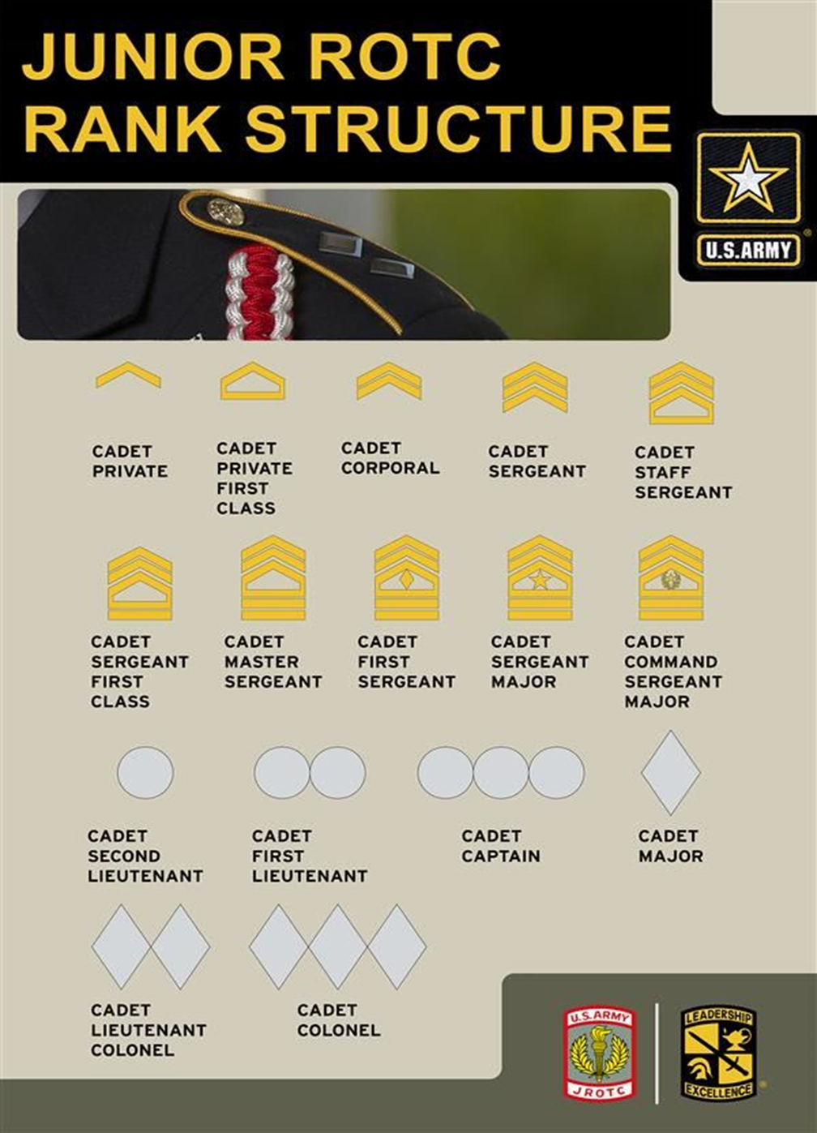
Highlander Battalion
Cadet & Junior Leader of the Month Program

General

The Cadet and Junior Leader of the Month Program is an incentive program designed to both motivate and recognize outstanding Cadets. This program is managed by the Cadet Battalion CSM. A different candidate is selected by their Company Commander and / or First Sergeant each month. Candidates then participate in an interview board process. In this interview, Cadets will be evaluated in the areas of uniform wear and appearance as well as on general JROTC knowledge, military bearing, and by the way each Cadet represents themselves (articulate and confident). The board consists of the Battalion CSM and every Company First Sergeant. The winner of the Cadet and Junior Leader of the Month Board is eligible to compete at the District Cadet & Junior Leader of the Semester Board. Cadet of the Month Candidates must be 9th graders only. Candidates of the Junior Leader of the Month Board must be 10th graders only. Cadets can only appear before the board once per year in each board category.

Recognition and Awards: Listed below are the recognition/awards for the various levels of competition:

A. Cadet/Junior Leader of the Month: Will have their photograph taken and posted on the Cadet/Junior Leader of the Year Bulletin Board where it will remain for the remainder of the year. The winner of each board will also receive a Battalion coin.

B. Cadet/Junior Leader of the Semester: Will have their photograph retaken and posted on the bulletin board. Will receive the commendation ribbon (N-3-9). Earns the right to compete for the Cadet/Junior Leader of the Year at the District board.

Board Tips and Pointers

Studying for the board will help you pass the knowledge portion, but you also need to learn board procedures. You can do this by conducting practice boards within your company. Ensure that your uniform looks good and that it is clean, fits correctly, and is pressed. Get a good night’s rest before the board. You will perform better if you are fresh and alert. Have your leader check your uniform and appearance prior to the board.
Reporting to the Board
- Knock LOUDLY 3 times on the door of the board room and enter only when told to do so.
- Approach the President of the Board and your chair by using proper facing movements and position yourself in front of the chair and the President.
  - Halt at attention, render a crisp salute, and report to the President of the Board. (For example: "Sergeant Major, Cadet Smith reports for the Cadet Board; Junior Leader Board, Promotion Board, etc.) Hold your salute until the President of the Board returns it.
  - After reporting to the board, you will be asked to perform two “About Faces” in order for the board members to check your uniform, haircut, etc.
  - Once you are told to be seated, look over your left shoulder, step to the rear with your left foot and be seated. While seated, sit straight with both feet flat on the floor and approximately one foot apart. Place your hands, fingers outstretched, on your thighs.
Answering board member's questions
- Do your best not to show nervousness and listen very carefully to questions being asked of you. Begin your answers to questions by using their rank: "First Sergeant / Sergeant Major.”
- Speak loudly enough so that all board members will hear you and distinctly enough so that you will not be misunderstood. If you feel your voice start to waiver because of nervousness, raising your voice will help to steady it.
- Direct your answers to the person asking the questions.
- Do not give answers you do not know. If you do not know an answer simply say "Sergeant Major / First Sergeant, I do not know the answer to that question." Do not become frustrated because you miss a question.
- If you do not understand the question, ask the board member to repeat it.
- If you fumble an answer, you may ask the board member for “Permission to recover.” The board member will say “Permission granted,” at which point you will attempt to answer the question again. Do not overuse this however.
- It is highly recommended that you repeat or rephrase the question as part of your answer. For example, when asked what the mission of JROTC is you respond with "Sergeant Major, the mission of JROTC is..."
- You will be asked at least one open-ended or opinion question. When asked your opinion, be sure it is YOUR opinion. Board members do not penalize you for an opinion they do not agree with. They only want to evaluate your knowledge, speaking ability, and ability to intelligently present an opinion.
Departing the board

Once dismissed by the President of the Board, assume the position of attention. Render a salute and hold your salute until it has been returned. There is no need to say anything to the President of the Board at this time. Leave the room using proper facing movements. Do not discuss the questions or anything else with other Cadets attending the board because this is an integrity violation.

Cadet and Junior Leader of the Semester and Year Board
Study Guide
(5 August 2025)

General Junior ROTC Knowledge

- Name the congressional act that launched the JROTC Program. (U1C1L2)

Answer: The National Defense Act of 1916

- In which year was The Reserve Officers’ Training Corps Vitalization Act passed? (U1C1L1)

Answer: 1964.

- What do the letters JROTC stand for? (U1C1L1)

Answer: Junior Reserve Officers Training Corps.

- What is the mission of JROTC? (U1C1L2)

Answer: “To motivate young people to be better citizens.”

- What is the title of the officer in charge of a school’s JROTC Program? (U1C1L2)

Answer: Army = Senior Army Instructor
Navy = Senior Naval Science Instructor
Air Force = Senior Aerospace Science Instructor

- Which uniform is worn during ceremonies, social functions, formal inspections, and as required by your instructor? (U1C1L2)

Answer: Army = Class A (Army Blue)
Navy = Service Dress Blues
Air Force = Service Dress

- What is the minimum Cadet enrollment required for a school to have a JROTC Program? (U1C1L1)

Answer: At least 100 Cadets or 10% of the student body, whichever is less.

- In what year was Public Law 93-165 passed allowing females to be counted towards the enrollment requirement for JROTC? (U1C1L1)

Answer: 1973.

- What does the acronym NCO stand for? (U1C1L2)

Answer: Non-Commissioned Officer.

Leadership

- Define leadership. (U1C1L1)

Answer: The ability to influence, lead, or guide others so as to accomplish a mission in a manner desired.

- Define teamwork. (U1C3L1)

Answer: Coordinated effort among members of the same group.

- Define “Integrity.” (U1C1L7)

Answer: The characteristic of having high moral values and behavior.

- Define “Loyalty.” (U1C1L7)

Answer: Refers to a person’s willingness to bear true faith and allegiance to the U.S. Constitution and their peers.

- Define “Tact” as a leadership trait. (U2C1L2)

Answer: The sense of what to say to avoid offending others, hurting their feelings, or making them mad.

- Define “Selfless Service.” (U1C1L7)

Answer: Refers to a person’s willingness to put the welfare of the nation before his/her own.

- Define “Delegating” as it pertains to leadership style. (U2C1L4)

Answer: A style of leadership where the leader gives some decision-making authority to others.

- Define “Directing” as it pertains to leadership style. (U2C1L4)

Answer: A style of leadership where the leader tells others what to do and how to do it.

- Define “Participating” as it pertains to leadership style. (U2C1L4)

Answer: A style of leadership where the leader consults with others before making decisions
Drill and Ceremonies

- What are the two parts of a command? (U2C3L2)

Answer: The preparatory command and the command of execution.

- What foot do you call “To the Rear, March” or “Rear, March” on? (U1C3L3)

Answer: The right foot.

- On which foot can you give the command “Halt” on? (U1C3L2)

Answer: Either.

- How many inches are there in a normal step in marching? (U1C3L2)

Answer: Army & Navy = 30 inches.
Air Force = 24 inches.

- At what position are you allowed to speak while in formation? (U1C3L2)

Answer: At the position of “Rest.”

- What command gets all the Cadets to salute? (U1C3L2)

Answer: The command of “Present Arms.”

- What is the rate of march for “Quick Time”? (U1C3L2)

Answer: Army & Navy = 120 steps per minute.
Air Force = 100 to 120 steps per minute.

- What is the rate of march for “Double Time”? (U1C3L2)

Answer: 180 steps per minute.

- What command(s) can be given from the position of “Parade, Rest”? (U1C3L2)

Answer: Navy & Air Force = “Attention.”
Army = “Attention,” “Stand at Ease,” “At Ease,” or “Rest.”

- On what foot is the command of “Column Right” given when marching? (U1C3L3)

Answer: The right foot

First Aid & Health

- What is First Aid? (U2C4L1)

Answer: Immediate care given to a victim of injury or sudden illness before professional medical help arrives.

- What do the letters CPR stand for and what is it used for? (U2C4L3)

Answer: Cardiopulmonary Resuscitation is a first aid procedure that is used when someone is unconscious. CPR combines chest compressions and rescue breaths.

- Describe “Shock.” (U2C4L3)

Answer: “Shock” is a life-threatening condition in which the circulatory system fails to deliver enough blood to vital tissues and organs.

- What is the “Heimlich Maneuver” (abdominal thrusts) used for? (U2C4L3)

Answer: To clear an airway blockage.

- Describe what is meant by “universal precautions.” (U2C4L1)

Answer: Universal precautions are actions taken to prevent the spread of disease by treating blood and other bodily fluids as if they were contaminated.

- Name two of the six types of nutrients. (U2C6L3)

Answer: Carbohydrates, Proteins, Fats, Vitamins, Minerals, and Water.

- For minor sprains please describe the R.I.C.E method. (U2C4L1)

Answer: Rest—Rest the affected joint for 24 to 48 hours.
Ice—Apply ice as soon as possible for no longer than 20 minutes at a time.
Compression—Compress the injured part by wrapping it in a bandage.
Elevation—Elevate, or raise, the injured part above the level of the heart to reduce swelling.

- What are the seven life-saving steps? (U2C4L1)

Answer: 1. Check to see if the victim is conscious.
2. Check for breathing and heartbeat.
3. Check for bleeding.
4. Check for signs of shock.
5. Check for fractures.
6. Check for burns.
7. Check for head injury.
- How many chest compressions do you give when performing adult CPR? (U2C4L3)

Answer: Give 30 chest compressions.

Chain of Command

- Define “Chain of Command”. (U1C1L2)

Answer: Chain of Command is a succession of leaders through which authority and commands pass from the leader to subordinate, and then down through the ranks.

- What are the three parts of the Pyramid of Authority? (U1C1L2)

Answer: 1 - Unity of Command
2 - Span of Control
3 - Chain of Command.

- Who is the Commander in Chief of the Military? (Chain of Command wall)

Answer: President Donald Trump.

- Who is the Secretary of Defense? (Chain of Command wall)

Answer: The Honorable Lloyd J. Austin lll.

- Who is the (ask specific service appropriate) Army Chief of Staff, or Chief of Naval Operations, or Air Force Chief of Staff? (Chain of Command wall)

Answer: Navy = Admiral Michael M. Gilday
Army = General James McConville
Air Force = General Charles Brown

- Who is the Chairman of the Joint Chiefs of Staff? (Chain of Command wall)

Answer: General Mark Milley

Military Customs and Courtesies

- Who wrote the “Star-Spangled Banner”? (U1C1L3)

Answer: Francis Scott Key.

- What do the 13 stripes on the United States flag represent? (U1C3L3)

Answer: The 13 original colonies.

- Explain the "position of honor." (U1C3L3)

Answer: A military courtesy of keeping people of senior rank or status to your right while walking or sitting.

- The signal for the start of the official duty day is called what? (U1C3L3)

Answer: Reveille.

- When may the United States Flag be flown at night? (U1C3L3)

Answer: When it is properly lit.

- When does a Cadet end their salute to a superior? (U1C3L3)

Answer: Hold your salute until the officer returns your salute.

- What do the colors on the United States Flag represent? (U1C3L3)

Answer: Red = Hardiness and valor.
White = Hope, purity, and innocence.
Blue = (the color of heaven) for reverence to God, loyalty, vigilance,
perseverance, and justice.

- When is it appropriate to call a room to attention? (U1C3L3)

Answer: When an officer enters the room for the first time each day.

- What is Reveille (re-və-lē)? (U1C1L3)

Answer: The signal for the start of the duty day.

- What is Retreat? (U1C1L3)

Answer: The signal for the end of the official duty day and also serves as a ceremony for paying respect to the flag

United States Military History and Civics

- Who were our primary antagonists during World War I?

Answer: Germany, Austria, and Hungary?
- Who were our primary antagonists during World War II?

Answer: Germany, Italy, and Japan.

- What happened on December 7, 1941 in Hawaii?

Answer: The Japanese attacked Pearl Harbor.

- Who was the Commander of the Revolutionary Army?

Answer: General George Washington.

- What war accounted for the most American deaths?

Answer: The Civil War of the United States.

- What war did we fight in during the 1960s and 1970s?

Answer: The Vietnam War.

- What country did the United States and its’ allies fight in the first Gulf War?

Answer: Iraq.

- What are the first 10 Amendments of the United States Constitution known as? (U2C8L1)

Answer: The Bill of Rights.

- What are the three branches of the federal government? (U2C8L1)

Answer: Executive, legislative, and judicial.

- Which amendment guarantees the “Freedom of Speech”? (U2C8L2)

Answer: The First Amendment.

- At what age is a United States Citizen first allowed to vote? (U2C8L2)

Answer: At 18 years of age.

- Which amendment guarantees the “Right to Bear Arms”? (U2C8L2)

Answer: The Second Amendment.

- What are the two ways individuals may become American citizens? (U2C8L2)

Answer: By being born or naturalized in the United States.
- Define “Naturalization” as it applies to becoming an American citizen? (U2C8L2)

Answer: Legal process by which citizens from another country can become American citizens.

- Who was the Prussian officer credited with turning the continental Army around during the Revolutionary War? (U1C3L1)

Answer: Baron Friedrich Von Stueben

- The "Star Spangled Banner" was written during the British bombardment of what military installation? (U1C1L3)

Answer: Fort McHenry

Navy JROTC Ranks and Rates

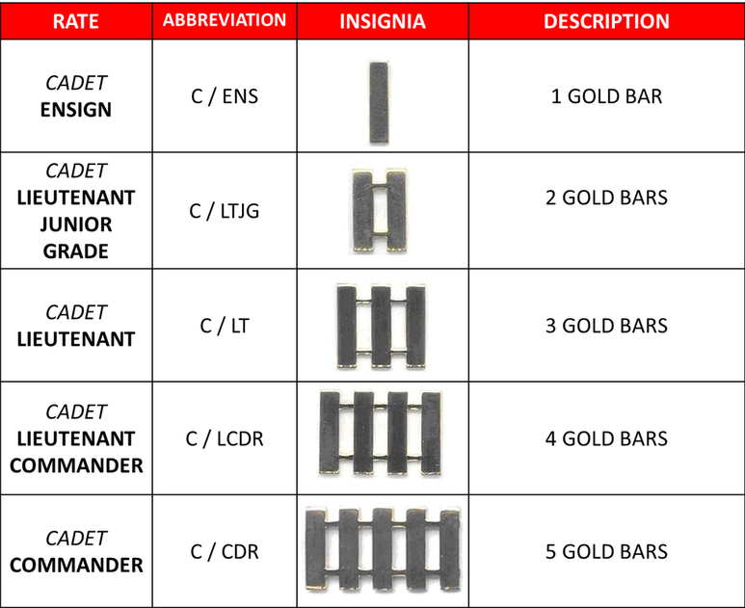

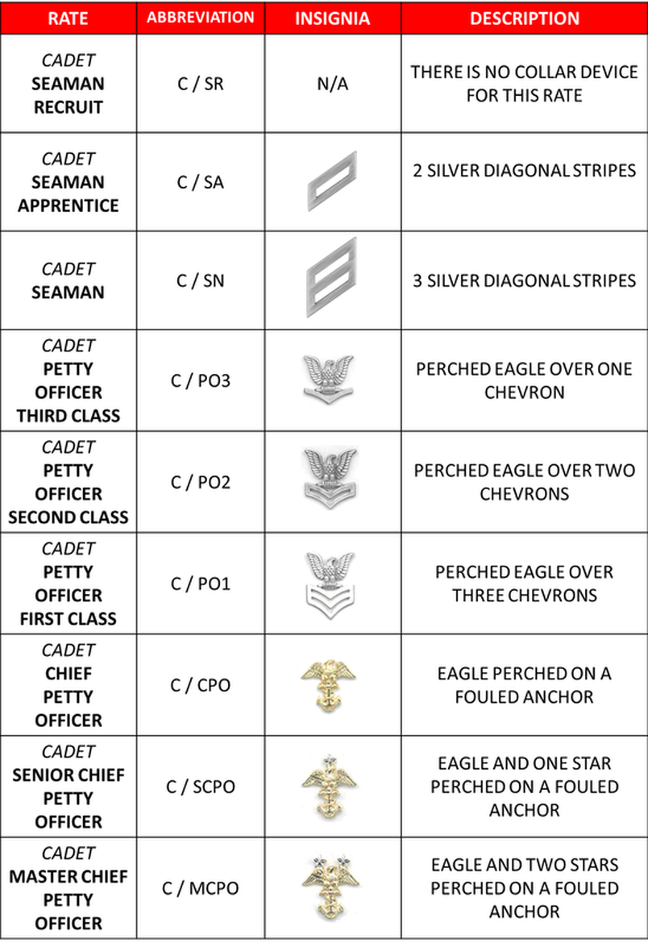

Army JROTC Ranks

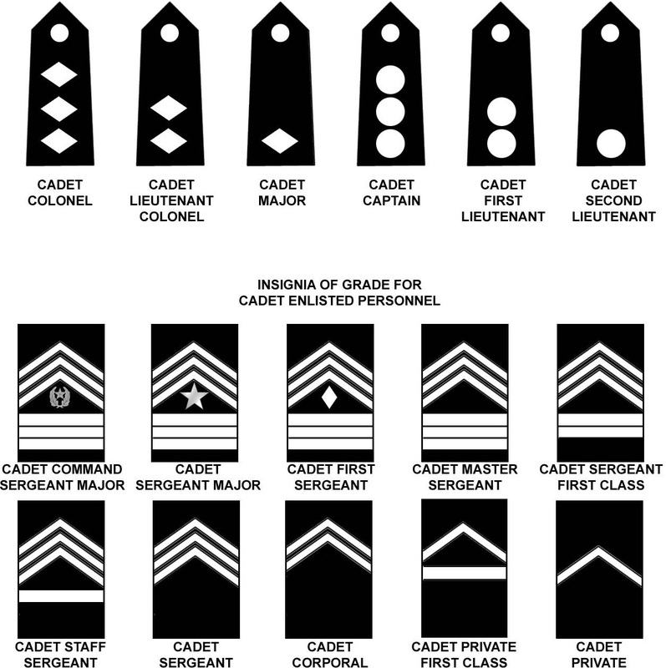

HIGHLANDER BATTALION BEST COMPANY COMPETITION

Best Drilled Cadet

1st ________ 100 Points
2nd ________ 85 Points
3rd ________ 70 Points
4th ________ 55 Points

Best Drilled Squad

1st ________ 100 Points
2nd ________ 85 Points
3rd ________ 70 Points
4th ________ 55 Points

Best Drilled Guidon

1st ________ 100 Points
2nd ________ 85 Points
3rd ________ 70 Points
4th ________ 55 Points

Best Drilled Platoon

1st ________ 100 Points
2nd ________ 85 Points
3rd ________ 70 Points
4th ________ 55 Points

Veterans Day Parade Participation

1st ________ 100 Points
2nd ________ 85 Points
3rd ________ 70 Points
4th ________ 55 Points

Best Flag Duty Completion

1st ________ 100 Points
2nd ________ 85 Points
3rd ________ 70 Points
4th ________ 55 Points

TOP Cadet / JL of the Month

1st ________ 100 Points
2nd ________ 85 Points
3rd ________ 70 Points
4th ________ 55 Points

Cadet Olympics Participation

1st ________ 100 Points
2nd ________ 85 Points
3rd ________ 70 Points
4th ________ 55 Points

JLAB Participation

1st ________ 100 Points
2nd ________ 85 Points
3rd ________ 70 Points
4th ________ 55 Points

Homecoming Parade Participation

1st ________ 100 Points
2nd ________ 85 Points
3rd ________ 70 Points
4th ________ 55 Points

Best GPA

1st ________ 100 Points
2nd ________ 85 Points
3rd ________ 70 Points
4th ________ 55 Points

Dining-In Participation

1st ________ 100 Points
2nd ________ 85 Points
3rd ________ 70 Points
4th ________ 55 Points

Best Cadet Challenge

1st ________ 100 Points
2nd ________ 85 Points
3rd ________ 70 Points
4th ________ 55 Points

Raider Challenge Participation

1st ________ 100 Points
2nd ________ 85 Points
3rd ________ 70 Points
4th ________ 55 Points

Orienteering Meet Participation

1st ________ 100 Points
2nd ________ 85 Points
3rd ________ 70 Points
4th ________ 55 Points

Cadet Challenge Criteria

Curl-ups: Conduct this event on a flat surface, preferably with a mat. Start Cadets in a lying position on their backs with their knees up so their feet are flat on the floor and about 12 inches from their buttocks. Cadets should have their arms crossed with their hands placed on opposite shoulders and their elbows held close to the chest throughout the exercise. The feet are to be held by a partner at the instep. At the command "ready, go," Cadets raise the trunks of their bodies, curling up to touch the elbows to the thighs. They then lower their backs so that their shoulder blades touch the floor/mat. This constitutes one repetition of a curl-up. During each repetition, bouncing off the floor/mat is not allowed, and the fingers must touch the shoulders at all times. Cadets must try to complete as many curl-ups as possible in 60 seconds.

Pull-ups: Conduct this event using a horizontal bar. The bar should be high enough so that Cadets can hang with their arms fully extended and their feet free of the floor/ground. Have Cadets assume the hanging position on the bar using either an overhand grasp (palms facing away from body) or underhand grip (palms facing toward body). Cadets begin the exercise by first raising their body until the chin is over the bar without touching it. To complete one repetition, the body must be lowered to the full hang starting position. During each repetition, the body must not swing, and legs must not kick or bend. Cadets are scored on the number of pull-ups they can correctly execute. There is no time limit on this event. For Cadets who cannot accomplish one-pull-up, have them do the flexed-arm hang (below) as an alternate event.

Push-ups: Lie face down on the mat in push-up position with hands under shoulders, fingers straight, and legs straight. Your legs should be parallel and slightly apart, with the toes supporting the feet. Straighten the arms, keeping the back and knees straight, then lower the body until there is a 90-degree angle at the elbows, with the
upper arms parallel to the floor. A partner holds their hand at the point of the 90-degree angle so that you go down only until your shoulder touches the partner’s hand, then back up. The push-ups are done to a metronome (or audio tape, clapping, drums) with one complete push-up every three seconds, and are continued until you can do no more in rhythm, have not done the last three in rhythm, or you have reached the target number for the 85th percentile Health Fitness Award. This event should be used when a Cadet cannot execute one pull-up.

V-Sit: Conduct this event on a flat, clean floor. Use a yardstick and adhesive tape to make a baseline that is two feet long. Make a measuring line perpendicular to the midpoint of the baseline extending two feet out from either side of the baseline. Place one inch and half-inch marks along the measuring line with "0" where the baseline and measuring line intersect. Have Cadets remove their shoes and sit on the floor with the soles of their feet, placed immediately behind the baseline. The measuring line should be between their heels, which should be 8 to 12 inches apart. Cadets must clasp their thumbs so that their hands are together, palms down, and place them on the floor between their legs. While their legs are held flat on the floor by a partner (or partners), Cadets performing the exercise keep the soles of their feet perpendicular to the floor (feet flexed) and slowly reach forward along the measuring line as far as possible keeping the fingers in contact with the floor. Cadets receive three practice tries for the v-sit reach. On the fourth extension, Cadets must hold their farthest reach for three seconds. Scores are recorded where fingertips touch the floor to the nearest half-inch. Scores beyond the baseline are recorded as plus scores, whereas those behind the baseline are recorded as minus scores.

One-Mile Run: Conduct this event on a flat area that has a known measured distance of one mile with a designated start and finish line. At the command "ready, go," start the Cadets running the one-mile distance. Although walking is permitted, encourage Cadets to cover the distance in the shortest time possible.

Shuttle Run: Conduct this event on an area that has two parallel lines 30 feet apart. The width of a regulation volleyball court can serve as a suitable area. Start Cadets at the standing position. At the command "ready, go," have the Cadets run to the opposite line, pick up one block, run back to the starting line, and place the block behind the line. Cadets then run back and pick up the second block, which they carry across the line. Two runs are allowed for this event with the better of the runs recorded. Scoring should be to the nearest tenth of a second.

Membership and Publicity

The following information is intended to supplement that guidance and philosophy set forth in the Washoe County School District JROTC Brigade SOP. The following criteria and directions are intended to establish the specifics that pertain to the Highlander Battalion.

Membership / Recruiting Activities

Cadets of the Highlander Battalion should understand that recruiting activities are not restricted to only our “official” Middle School membership drive activities. We represent the “Corps of Cadets” anytime we are in uniform or in the public eye. This dictates that we all present the best image and conduct possible, always exhibiting those qualities of leadership and citizenship that have become expected of a member of the Incline High School Corps of Cadets. A Cadet’s words, actions, and appearance should at all times represent Incline High School’s and this battalion’s high standards, thus insuring the continued outstanding reputation that this unit has earned over the years.

Middle School Visits

The “feeder school” that this Battalion has responsibility for is Incline Middle School. Select Cadets of this battalion will annually visit this school. Visits are normally planned as close as possible to the Incline High School pre-registration of the incoming ninth graders in the spring. Initial coordination for these visits will be made between the SAl and the Middle School Administration. Once a date has been established, the SAl, Battalion Commander, and S5 will decide whom to take and what to do at the school for that particular year. Generally, participants will be: The Battalion Commander; the Battalion S5; Color Guard members; and selected outstanding MS1s who attended Incline Middle school. Individual Cadets are not to visit the middle schools at any other time, either officially or unofficially representing the Highlander Battalion.

Recruiting Ribbon Qualification

Eligibility criteria for the recruiting ribbon (N-4-2) is outlined on page 25 of this Handbook. In addition to the criteria set forth therein, a Cadet must be responsible for the enrollment of at least one member. The names of any new or potential Cadets will be screened by the S5 to ensure that the proper Cadet receives credit. The Cadet recruiting the new prospect will not receive credit until that individual has in fact joined the Battalion.

Cadets should also remember that membership activities / efforts need not be limited to the annual middle school visits. There are many good potential members here on the campus who are or might be interested in enrolling. Cadets must always be at their best setting those examples of leadership and citizenship that motivate others that want to belong to the best.

Publicity

The S5 has primary staff responsibility for publicity within the Battalion. The S5 will affect liaison with the yearbook staff, the Daily Announcements student, and local news / media contacts as possible. Timely newsworthy items will be submitted to the appropriate agency. Examples of news stories or items of interest are Veterans Flag Raising Ceremony, Military Ball, Drill Meets, JPA, Service-Learning Projects, Cadet Olympics, Leadership Camps, and Awards Nights. This list is not all inclusive and the S5 is free to develop other appropriate themes as the situation dictates. Articles and information regarding this JROTC Battalion must first be submitted to the SAl for review and approval. Articles referencing this Battalion, its students and Cadets and their activities will be reviewed by the SAl and must have the approval of the Incline High School Principal.

Although it is the S5 who has direct responsibility for ‘‘spreading the word” about the great things that we achieve, it is the public opinion, generated by individual conduct, appearance, and words that most directly influence the public image of the Highlander Battalion. Keeping this fact in mind, it’s easy to understand that our observed actions, conduct, and appearance, viewed by other campus students, other school JROTC Cadets, and the community, most dramatically determines our reputation and worth.

Membership / Publicity Improvement

All members of this Battalion are encouraged to submit their ideas regarding the improvement or enhancement of our efforts.

JCLC (JROTC Cadet Leadership Camp)

JROTC Cadet Leadership Camp (JCLC) is an annual event sponsored by the WCSD JROTC District Office designed to provide eligible Cadets with a series of challenging confidence-building activities as well as leadership opportunities in a safe field trip activity. JCLC takes place typically during the 4th quarter of the school year. Due to the small number of slots available, the following criteria is established to send only the most qualified Cadets in the Highlander Battalion:

Grades

LET 1 – GPA 2.50 and a B or better in JROTC, No F’s in any class
LET 2 – GPA 2.50 and a B or better in JROTC, No F’s in any class
LET 3 – GPA 2.50 and a B or better in JROTC, No F’s in any class
LET 4 – Attendance by exception only

Attitude

Cadets must possess a positive attitude in the performance of JROTC duties as observed throughout the school year

Participation

Cadet must possess a history of participation in JROTC activities throughout the school year. In addition to the criteria above, Cadets should possess demonstrated leadership potential.

Student Status

When a JROTC Cadet routinely fails to meet appropriate standards of behavior and/or performance and the school administration is unable or unwilling to place the student in another elective class, the Cadet may be placed in “student status.” This measure is taken as a last resort for Cadets who have routinely demonstrated an unwillingness or desire to comply with the stated goals and principles of the Highlander JROTC Program. When a Cadet is placed on “student status” his / her status changes from “Cadet” to “student” meaning that he/she no longer is entitled to the privileges of being a Cadet. Actions that will be taken are:

- The Cadet is ineligible to participate in all JROTC extra-curricular activities (Military Ball, Dining-In, JCLC, Cadet Olympics, Community Service, School Support, Veterans Day Parade, Orienteering, Rifle Team, Awards Night, Color Guard, Honor Guard, etc.)
- The Cadet will turn-in their uniform
- The Cadet will be reduced in rank to private
- The Cadet is ineligible to receive awards and decorations
- The Cadet will be removed from their leadership position (if applicable)

Student Status is not designed to be permanent but rather as a measure to attempt to bring the Cadet into compliance. A student can regain their “Cadet” status by making significant and measurable improvement. (It is important to note, however, that being placed on “student status” two or more times may cause a student to be dis-enrolled from the JROTC Program). The “Student Status Contract” on the following page will be completed to document the action as well as provide the student with measurable steps that he / she can take to be removed from student status.

STUDENT STATUS CONTRACT

As of _______________________ (date) I, _____________________________, will be placed on student status within the Highlander Battalion due to: (circle)

1. Lack of Participation
2. Poor attitude towards my duties
3. Excessive Tardiness / Absences
4. Not dressing on Uniform Wear & Inspection days
5. Plagiarism / Cheating
6. Disrespect of Instructor Staff
7. Drug Use
8. Disrespect of Cadet Leadership
9. Integrity Violations
10. Fighting
11. Other: _________________________________________________

As a result of my actions, I will immediately turn in my uniform and lose all privileges and honors awarded to Cadets. I am now considered a student in a JROTC class. As such, I recognize that I may lose 20% from my grade since I cannot participate in uniform inspections. In order to make up the 20% I have the option of completing a make-up assignment provided by my MS Instructor.
In order to be removed from student status, I will demonstrate significant improvement in the area/areas mentioned above. I understand that my status will be reviewed thirty days from the date I was placed on student status and I will submit a written request to the Battalion Commander to be removed from student status. If significant and measurable improvement has been made, I will have my uniform returned to me and be readmitted as a Cadet in the Highlander Battalion. A copy of this contract will be forwarded to my Parent / Guardian.

Philip Risi
1SG, (Ret.) USA
Senior Army Instructor (SAI)

I have received a copy of this contract and understand its meaning.

_________________________________ ____________________
Student Signature Date
Flag Duty

Each morning Highlander JROTC Cadets are responsible for raising the American Flag in front of the JROTC building as well as lowering the flag at the end of the school day. The raising of the flag is conducted in accordance with TC 3-21.5 procedures. The primary purpose of Flag Duty is to allow each Cadet to experience the honor associated with the ceremonious raising of our National Colors.

Procedures

Flag Duty will be assigned monthly on a rotating basis to each Company. Each Company First Sergeant has the overall responsibility for the proper and timely raising and lowering of the U.S. Flag. First Sergeants will complete a weekly duty roster ensuring that all Cadets have an opportunity to either raise or lower the flag each day. The roster will be posted in the Rifle Range. First Sergeants will inquire of the JROTC Instructors when the U.S. Flag is required to be flown at half-mast.

The flag will be raised and lowered daily in a ceremonious manner and never permitted to touch the ground. The flag will then be properly folded in a tricorn shape and placed in the Range.

Each company First Sergeant will have primary responsibility to supervise the raising and lowering of the flag during their duty month. First Sergeants will be responsible to raise it if their assigned Cadet fails to perform the duty. Flag Duty will be one of the criteria for a company earning or failing to earn the “Best Company” competition presented during Awards Night.

Highlander JROTC
Instructor Division of Duties
(as of 05 August 2025)

1SG Risi | SSG Henderson | SHARED DUTIES
MS2, 3, & 4 INSTRUCTOR | MS1 INSTRUCTOR | JCLC (ALTERNATE YEARS)
PRIMARY STAFF ADVISOR | CSM & S4 ADVISOR | VETERANS DAY PARADE
BUDGET & VENDING | FLAG DUTY COORDINATOR | MILITARY BALL
MIDDLE SCHOOL VISITS COORDINATOR | ALTERATIONS / DRY CLEANING | FRESHMAN SEMINAR
BUS / TRANSPORTATION REQUESTS | CADET / JUNIOR LEADER BOARDS | OPEN HOUSE
FOOTBALL GAME CANNON | DISPLAY CASES | 8TH GRADE FAMILY NIGHT
JPA CIP & SLP BRIEFING | JPA IN-RANKS / CG INSPECTION | CADET CHALLENGE
FACILITIES REQUESTS | PROMOTION BOARDS | DISTRICT JROTC MEETINGS
SERVICE ACADEMIES COORDINATOR | JLAB TEAM COACH | AWARDS NIGHT
AWARDS NIGHT COORDINATOR | COLOR GUARD COACH | DRILL
S.H.A.R.E. INSTRUCTOR | RIFLE TEAM COACH | UNIFORM ISSUE
SVC LEARNING PROJ COORDINATOR | RAIDER TEAM COACH | PT
COMMUNITY SERVICE COORDINATOR | ORIENTEERING TEAM COACH | HOMECOMING PARADE
MS2,3,4 JUMS INPUT | MS1 JUMS INPUT | 9-11 FLAG RAISING CEREMONY
 |  | DINING IN
 |  | BC SELECTION BOARD
 |  | UNIFORM INSPECTIONS
CADET OLYMPICS:  - 6 PERSON MILE RUN  - 50 YARD DASH  - MILE RELAY  - 8 PERSON STRETCH | CADET OLYMPICS:  - PUSHUP TEAM  - PULLUP TEAM  - SITUP TEAM  - MALE / FEMALE TUG O’ WAR

