
St. Petersburg High School
COURTYARD BRICK FUNDRAISER

We are raising money to help fund campus improvements for St. Pete HS.
The bricks for sale here will be placed in our new courtyard in the center of our campus.
Buy a brick, Leave your legacy!
- Honor or remember a special teacher or friend
- Remember a loved one
- Mark a special date in your own life
- Show support for your business, school or other organization
There are endless reasons and possibilities for what you can engrave on your brick!

Bricks are available in – 4X8 Red Clay Laser Engraved.
Brick engraving will be done in all caps. Each line will be centered.
If requesting clip art, text will be limited.

Yes, we’d like to purchase a permanent brick. Please engrave our brick as follows:
SPACED ON THE FORM = TEXT and any Symbol are considered ONE Space (Period, Comma, Dash).
All text is automatically centered and placement of clip art is OUR DISCRETION.
4X8 Brick = _____ $100- 3 lines max of 18 letters per line (NO CLIPART)
4X8 Brick = _____ $110- Up to 3 lines max of 15 letters per lines with approved CLIPART (see attachment) # _______
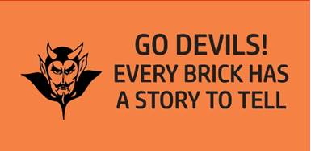
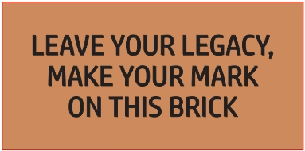
For Example only

*Payment by: ____ Check, # ___________ or ____ Cash Receipt # ___________
(Checks to be made payable to: St. Pete High School)

Name: ____________________________________________________ Phone: ______ __________________
Address: __________________________________________________________________________________
City: _________________________________ State: _________________________ Zip: _______________
Email Address: _____________________________________________________ Amt. Paid: ______________
If you have any questions, please contact: Karen Roehm—Principal’s Secretary at 727-893-1842 (ext. 2005)
roehmk@pcsb.org
St. Petersburg High School
2501 5th Avenue North
St. Petersburg, FL 33713


