WESTPORT PUBLIC SCHOOLS CONNECTICUT



REQUEST FOR PROPOSALS
FOR

STAPLES HIGH SCHOOL

Personal Duress Security System Installation

WESTPORT, CT 06880

#26-014-RFP

Issued for Bid: December 11, 2025

REQUEST FOR PROPOSALS FOR:

STAPLES HIGH SCHOOL
Personal Duress Security System Installation

#26-014 - RFP

The deadline for submission of proposals is Thursday, January 15, 2026, at 2:00 p.m. EST. Submit one (1) sealed paper copy and one (1) electronic copy (on flash drive) of the proposal to:

Elio Longo
Chief Financial Officer
Westport Public Schools
110 Myrtle Avenue
Westport, CT 06880

LATE OR INCOMPLETE BIDS WILL NOT BE ACCEPTED

Mark in left hand corner of the bid envelope:

RFP: #26-014-RFP
Elio Longo
Chief Financial Officer
Due: January 15, 2026, at 2:00 p.m. EST

Submitted by: ______ __________________

The designated contact for this RFP is listed below. All questions regarding this RFP must be submitted in writing to the designated contact within the timeframes set forth in the RFP Schedule. Copies of questions and responses will be issued to all respondents as an Addendum to this RFP as set forth in the RFP Schedule.

Designated contact: John Koplas, Sr. Project Manager at Colliers Project Leaders (john.koplas@collierseng.com).

- RESERVATION OF RIGHTS:

  - The Town of Westport reserves the right to qualify multiple respondents.

  - The Town of Westport reserves the right to reject any and all proposals submitted in response to this Request for Proposals (“RFP”).

  - The Town of Westport reserves the right to terminate this RFP process at any time.

  - The Town of Westport reserves the right to waive any non-conformity with the requirements of this RFP.

  - The Town of Westport reserves the right to seek clarification from a respondent at any time throughout the RFP process for the purpose of resolving ambiguities or questioning information presented in the proposal.

  - The Town of Westport reserves the right to apportion the award among one or more respondents.

- RFP SCHEDULE:

RFP Issued: Thursday, December 11, 2025
Pre-Bid Review Meeting on Site-Non-Mandatory: Thursday, December 18, 2025 at 3:00 p.m.
(Meet at the front of Staples High School-Door #1 at Main Lobby)
Deadline for Questions: Tuesday, December 30, 2025 at 1:00 p.m.
Answers Issued by Addendum: Tuesday, January 6, 2026 by 2:00 p.m. Proposals Due: Thursday, January 15, 2026 at 2:00 p.m.

III. INTRODUCTION

- The Town of Westport is looking for a company to furnish and install all materials and equipment, including receivers, necessary to provide a mobile personal duress instant alert pendant security system within the existing three-story, 475,000 SF Staples High School campus and along the schools’ exterior perimeter.
- Staples High School is located at 70 North Avenue in Westport, CT.
- The Town of Westport received grant funding for this project from the Connecticut Department of Emergency Services and Public Protection through the Multimedia School Security Grant Program in 2023. This grant is due to expire at the end of September 2026 so this project must be completed in advance of that date. Refer to the Project Macro Schedule within the attached Exhibits.
- This personal duress security system is to be based on either a hardwired radio frequency or a system reliant on other technologies such as wireless or cellular transmission to a central monitoring system at the Westport Police Department or other designated emergency response call center may be considered. Note, however, that the cellular coverage within portions of the campus is not consistent, with several dead zones due to the age of the building, sub-grade and basement areas, or certain wall material construction.
- As part of this proposal, costs associated with a small, hand-held fob device to be provided for each member of the staff and administration located within the Staples High School campus are also to be included. Based on current staffing figures, the number of pendants supplied should be calculated at a total of 300 pendants.
- As noted previously, the Town of Westport must have this work completed no later than the end of September 2026, to satisfy the grant requirements. Any necessary installation work is to be addressed during off-hours while the school is in session (if/as necessary), during the school break time frames, and/or following the end of the 2025-26 school year (anticipated to be about June 16, 2026), and the start of the 2026-27 school year (commencing on August 26, 2026).
- A non-mandatory site review meeting is scheduled for 3:00 p.m. on Thursday, December 18, 2025. Meet at the front of the high school’s Main Lobby and we will proceed as a group to review the campus and required scope of work.
- If any bidders cannot attend this meeting date and are still interested in performing a site visit and reviewing the existing Staples High School campus, you must contact the Westport Facilities Department in advance, at (203) 341-1270, and coordinate this visit with Ted Hunyadi, Director of Facilities.

IV. SCOPE OF BASIC SERVICES

A. The following services are required of the installer:
- The company shall furnish and install all materials and equipment necessary to provide a mobile duress pendant security system within the Staples High School campus and at the adjacent school perimeter.
- Provision of the systems hand-held fob devices; assume a total of 300 fobs.
- Schematic floor plans are provided as Exhibit 3. More detailed building plans and drawings can be reviewed – by appointment only - with the Westport Facilities Department offices, located at 1 Canal Street, Westport, CT. They can be reached at (203) 341-1270.
- All materials and work will be in accordance with applicable codes and regulations.
- Scheduling of any work is to be coordinated with the Westport Facilities Department and Ted Hunyadi.
- The work is to be completed in advance of the September 30, 2026 deadline for the associated grant funding provided by the State.
- All work areas are to be kept clean and orderly through the duration of the project.
- Any additional damage created to the school property as a result of this project scope of work shall be repaired by the contractor at no further cost to the district.
- Obtain all necessary permits as required (fees will be waived).
- Note that the project will be subject to Prevailing Wage Rates.

V. PROPOSAL REQUIREMENTS

In order to be considered, proposals submitted in response to this RFP shall include the following information, which shall be presented in the below established format:

- A brief narrative of your firm’s experience and history in providing installation of these security systems.

- Disclose whether any shareholder, director, officer or employee is currently employed by the Town of Westport or was an employee of the Town of Westport during the two (2) year period preceding the date of the proposal.

- The following criteria, not listed in priority order, shall be considered in evaluating and selecting the proposing companies based upon qualifications and written proposal submissions:

  - Quality of proposal
  - Experience of company with similar installation projects
  - Success of completed projects
  - Experience of proposed installation team and any consultants
  - Fee for services

VI. COMPENSATION

- Compensation for the proposed services shall be based on a combination of a lump sum fee for the defined "Basic Services" and forecasted costs associated with the defined "Reimbursable Services & Expenses".

- Compensation for travel time incurred to and from the site, reimbursements, meals, etc.,
whether associated with the provision of Basic or Reimbursable Services, shall NOT be considered or reimbursed.

- Reimbursable expenses shall be billed at cost with no markup.

- Any desired additional services beyond the defined scope shall be mutually agreed to in writing and shall be based upon mutually agreed to hourly rates.

VII. QUESTIONS

All questions shall be submitted in writing to Mr. John Koplas, Sr. Project Manager, via email to john.koplas@collierseng.com and a copy to Mr. Elio Longo, Chief Financial Officer, elongo@westportps.org by 1:00 p.m. on Tuesday, December 30, 2025. Addenda will be prepared and posted to the district bidding website by 2:00 p.m. on Tuesday, January 6, 2026.

VIII. INSURANCE REQUIREMENTS

The successful respondent shall furnish a certificate of insurance to the Board for the following insurance coverage within ten (10) days from contract execution. The certificate of insurance shall contain the project description and name the Board as an additional insured. All insurance coverage shall be written with an insurance company licensed to conduct business in the State of Connecticut. Insurance coverage shall remain in full force for the duration of the contract term including any and all extensions. Such certificate of insurance shall specify that the Board will receive thirty (30) days' notice of any cancellation, non-renewal or reduction in coverage and limits originally provided.

- General Liability with a combined single limit of $1,000,000 per occurrence, $2,000,000 aggregate for bodily injury and property damage.
- Automobile Liability with a combined single limit of $1,000,000 per occurrence, $2,000,000 aggregate for owned, non-owned, and hired vehicles.
- Workers Compensation with a minimum of $500,000 as required by the State of Connecticut.
- Professional Liability with a combined single limit of $1,000,000 per occurrence, $2,000,000 aggregate.
- Umbrella Liability with a combined single limit of $1,000,000 per occurrence, $2,000,000 aggregate for bodily injury and property damage.

IX. OTHER

- The Board reserves the right to reject any and all proposals when it deems such action is in the best interests of the Board and also to select a respondent that the Board determines best meets its needs.

- Costs and fees contained in the proposal will remain valid for a period of ninety (90) days after the closing date for submission of proposals and may be extended beyond that time by mutual agreement between the Board and the respondent.

X. EXHIBITS

- Fee Proposal Form
- Project Macro Schedule
- Staples High School-schematic floor plans (2 pages)

EXHIBIT 1 – Fee Proposal Form

Westport Public Schools
Personal Duress Security System Installation at Staples High School
# 26-014-RFP

Bid Due Date = Thursday, January 15, 2026, at 2:00 p.m. EST

Scope of Work

Fee

Bid Option 1A: Labor costs for hardwired radio frequency backbone based instant alert pendant system within the Staples High School and adjacent school perimeter | $
Bid Option 1B: Material costs for hardwired radio frequency backbone based instant alert pendant system within the Staples High School and adjacent school perimeter | $
Bid Option 2A: Labor costs for a wireless or cellular transmission alert pendant system within the Staples High School and adjacent school perimeter | $
Bid Option 2B: Material costs for a wireless or cellular transmission alert pendant system within the Staples High School and adjacent school perimeter | $
Provide 300 hand-held fob devices | $
Costs not addressed or included within the pricing breakdown above (be specific) | $
Total Fee | $
Reimbursable Expenses, if any, Not Included in Fees Above: | $

Receipt Confirmation of Issued Addendum:

Addendum #1 _______ Dated _______________________
Addendum #2________ Dated _______________________

Print Name (Authorized Representative of Company) Date

Signature (Authorized Representative of Company) Date

EXHIBIT 2 – Project Macro Schedule

Westport Public Schools
Personal Duress Security System Installation at Staples High School
# 26-014-RFP

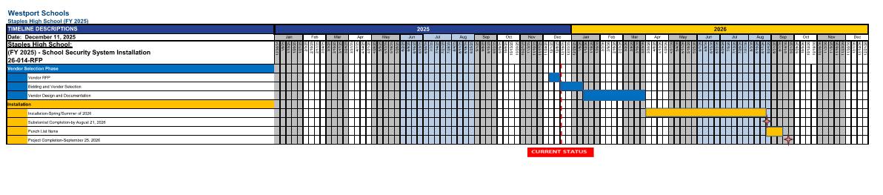

EXHIBIT 3 – Staples High School - Lower Level and First Floor Plan

Westport Public Schools
Personal Duress Security System Installation at Staples High School
# 26-014-RFP
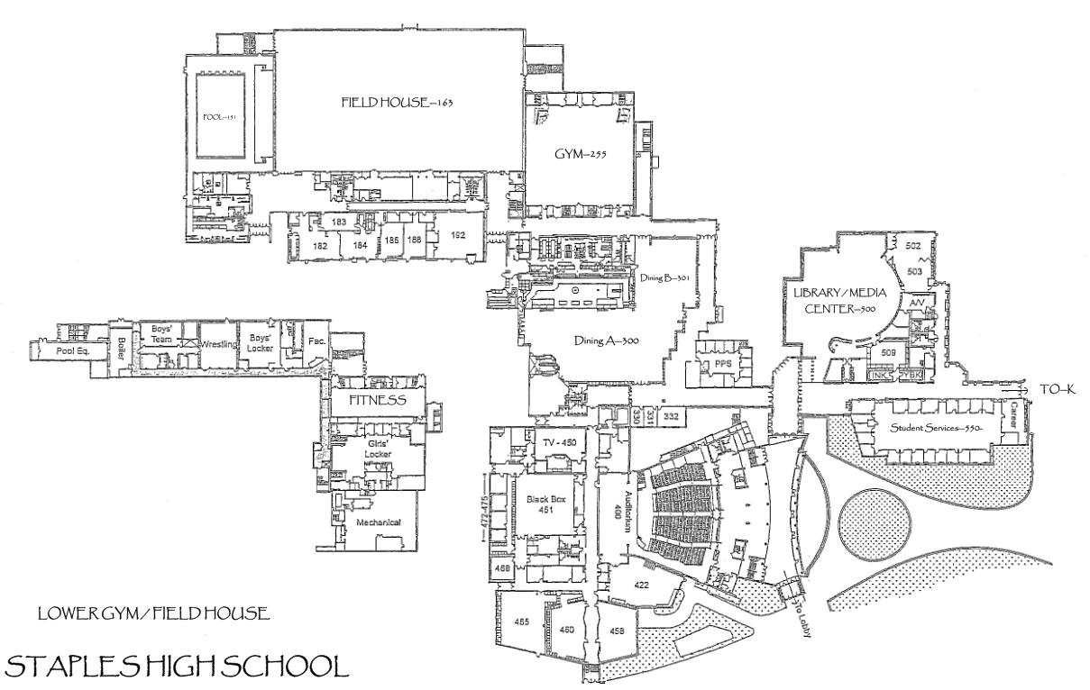

EXHIBIT 3 – Staples High School – Classroom Wing Floor Plans

Westport Public Schools
Personal Duress Security System Installation at Staples High School
# 26-014-RFP

