Community Friends: a tuition based, preschool program for children ages 4-5 who demonstrate age-appropriate skills including good language and social-emotional skills and a developmentally appropriate activity level. Community friends are enrolled in Early Childhood Special Education classrooms and taught by an Early Childhood Special Education teacher.
- Must be toilet trained
- Morning or afternoon classroom option
- School readiness and social-emotional skills taught

Busing is not available for this program

FOR MORE INFORMATION:

Right Track
Call 701-323-4419
or 701-328-8842

Early Head Start, Head Start,
Early Childhood Special Education & Community Friends
Call 701-323-4400
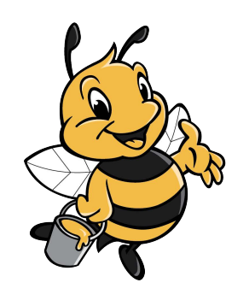

720 N. 14th St.
Bismarck, ND 58501
(701) 323-4400
https://becep.bismarckschools.org/

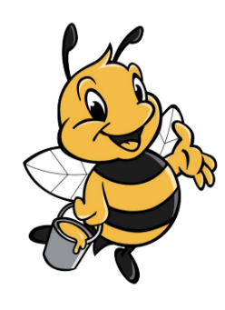

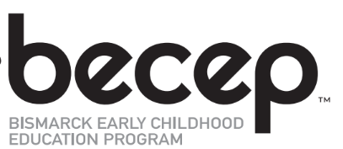



Serving Children
Ages Birth-to Kindergarten

WHAT IS BECEP?
Bismarck Early Childhood Education Program (BECEP), a part of Bismarck Public Schools, is made up of five programs serving children ages birth-5 and their families. Together, these programs serve more than 1,500 children!

BECEP MISSION
BECEP partners with families and community to promote the overall development of children to reach their full learning potential.

BECEP VISION

We believe parents are a child’s first and most important teachers. We also believe children learn skills best that are embedded into their daily routines and activities by caregivers who are familiar to the child and with whom they feel safe. All staff at BECEP are committed to this philosophy and strive to partner with parents and other caregivers in teaching children the skills they need to know in all developmental areas.

Right Track: a free, in-home developmental screening program for all children ages birth to 3 living in Burleigh, Emmons, Grant, Kidder, McLean, Mercer, Morton, Oliver & Sheridan Counties
- Information and activities to promote child development
- Parenting ideas and support
- Referrals to other community agencies and events
- Serves over 1,200 children



Spreadshirt - https://www.flickr.com/photos/spreadshirt/4811257421

Creative Commons License Deed
https://creativecommons.org/licenses/by/2.0/

Early Head Start: a free, in-home preschool program serving 10 infants and toddlers with and without disabilities and 2 expectant parents (priority given to teen parents) living in Burleigh, Emmons, & Kidder Counties. Eligibility is based on federal income or eligibility guidelines. Services are provided by a child development specialist.
- Family group activities offered
- Information and activities to promote child development
- Parenting ideas and support

Head Start: a free, preschool program for children ages 3-5 with and without disabilities living in Burleigh, Emmons, & Kidder Counties. Eligibility is based on federal income or eligibility guidelines. Classes are taught by a Head Start teacher & paraprofessional staff.
- Full days; 5 days a week
- School readiness and social-emotional skills taught
- Information and activities to promote child development
- Parenting support provided
- Serves 119 children

Early Childhood Special Education: a free, preschool program for children ages 3-5 who meet eligibility criteria based on the Individuals with Disabilities Education Act (IDEA) and live within the Bismarck Public School District. Classes taught by an Early Childhood Special Education teacher & paraprofessional staff.
- Individualized Education Plan (IEP) to meet child needs
- Services provided in a preschool classroom, in the community, at home, or through outpatient, determined by child’s IEP Team
- Possible services include: special education resource services, speech therapy, physical and occupational therapy, & vision and hearing services
- Morning or afternoon classroom option
- School readiness and social-emotional skills taught
- Serves over 200 children

