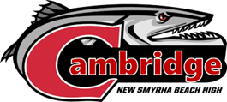

NEW SMYRNA BEACH HIGH SCHOOL

1015 Tenth Street, New Smyrna Beach, FL 32168
(386) 424 – 2555

Cambridge Advanced International Certificate of Education
APPLICATION

The AICE program is an academically rigorous and engaging program aimed at high-achieving students. Cambridge courses are demanding pre-university courses that emphasize higher order thinking, verbal, problem solving, teamwork, and investigative skills. Highly motivated students who excel academically and are well rounded in their extracurricular activities will be attracted to this program.
​


​In order to be eligible for the NSBHS AICE Program, students must have a FAST ELA Reading PM of 3 or higher and have completed or be currently enrolled in Algebra I. ​

​Students will be evaluated on the following: ​
- Grades ​
- Level of difficulty of classes taken (honors, advanced) ​
- District, State, and/or other standardized test scores ​
- Student Handwritten Essay ​
- Attendance​/Behavior
- Teacher Recommendations ​

​The NSBHS High School AICE Application Packet includes the following: ​
- Student Application/Information form ​
- Entrance Essay Prompt and Response Pages
- Teacher Recommendation Forms to be completed by a Math and English teacher

​ALL APPLICATIONS ARE DUE AT NEW SMYRNA BEACH HIGH SCHOOL
ON OR BEFORE January 30, 2026
NEW SMYRNA BEACH HIGH SCHOOL

1015 Tenth Street, New Smyrna Beach, FL 32168
(386) 424 – 2555 (extension 38562)

Cambridge Advanced International Certificate of Education
APPLICATION

Student Information ​
Name: ​ | ALPHA: ​
Date of Birth:​ | ALPHA: ​
Middle School: ​
Student Email: ​
​
Parent/Guardian Information ​
Name: ​
Mailing Address: ​
​

​
Phone Number: ​
Email​ (Please print clearly):​

​
Teacher Recommendations ​
Please provide the names of the teachers who are filling out your recommendation forms. ​
English: ​
​
Math:​
​
Correspondence will be conducted via parent email.

Cambridge AICE Diploma Program Application
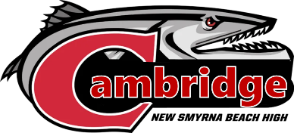
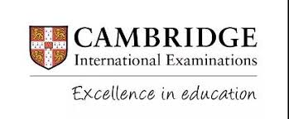

Student Name: __________________________________________ Alpha ID: _______________

Current School: _________________________________________

Parent/Guardian Name: __________________________________

Application Checklist:

- I have applied for the Cambridge Program through the Parent Portal on FOCUS.

- I have given the teacher recommendation form to my current math AND ELA teachers.

- I have completed the student essay in 500 - 1,000 words in my own handwriting.

- Everything is completed and returned to Nicole McDonald, Cambridge AICE Program Coordinator at New Smyrna Beach High by January 30, 2026.

Acknowledgement Statement and Signature:

I understand that I am applying to be a part of the Cambridge AICE Diploma Program and that it is a rigorous academic program that will require me to complete upper-level coursework and to maintain high levels of academic and behavioral integrity as well as to put in the time and effort it will take to pass these classes and exams on the path to earning the Cambridge AICE Diploma.

Student signature: ___________________________________ Date: ____________________

I understand that my student is applying to become a part of the Cambridge AICE Program and that the program is a rigorous academic course that will require time and effort on the part of my student in order to be successful in the program.

Parent/Guardian signature: ___________________________________ Date: __________________

Cambridge AICE Diploma Program Application

Contact Information

All application documents must be submitted by January 30, 2026. Application documents may be returned:
- In person to the high school main office front desk
- By U.S. postal mail to the chosen high School
- Scanned and emailed to the school’s Cambridge AICE Coordinator

Please use the following addresses when mailing or delivering documents in person:

New Smyrna Beach High School
Attn: Nicole McDonald, Cambridge Coordinator (ntmcdona@volusia.k12.fl.us)
1015 10th Street
New Smyrna Beach, FL 32168
www.nsbhigh.com/academics/cambridge

Please use the following email address for questions and when submitting documents via email:

Nicole McDonald
ntmcdona@volusia.k12.fl.us

Student Name: ________________________________________ Alpha ID: ___________

Student Essay

In your own handwriting, please respond to the writing prompt below using complete sentences in essay format (500 to 1000 words). If you need additional space, please use your own notebook paper. Typed essays will not be accepted.

Submit your application essay by January 30, 2026, to the Cambridge AICE Coordinator at your choice school through county mail or email a scanned copy.

Explain why you should be accepted into the Cambridge AICE Program and what qualities you will bring to the program. You are encouraged to include personal experiences, hobbies, and/or interests that may highlight your qualifications for the Cambridge AICE Program.

______________________________________________________________________________________________________________________________________________________________________________________________________________________________________________________________________________________________________________________________________________________________________________________________________________________________________________________________________________________________________________________________________________________________________________________________________________________________________________________________________________________________________________________________________________________________________________________________________________________________________________________________________________________________________________________________________________________________________________________________________________________________________________________________________________________________________________________________________________________________________________________________________________________________________________________________________________________________________________________________________________________________________________________________________________________________________________________________________________________________________________________________________________________________________________________________________________________________________________________________________________________________________________________________________________________________________________________________________________________________________________________________________________________________________________________________________________________________________________________________________________________________________________________________________________________________________________________________________________________________________________________________________________________________________________________________________________________________________________________________________________________________________________________________________________________________________________________________________________________________________________________________________________________________________________________________________________________________________________________________________________________________________________________________________________________

NEW SMYRNA BEACH HIGH SCHOOL

1015 Tenth Street, New Smyrna Beach, FL 32168
(386) 424 – 2555

Request for Math recommendation:

As part of the prerequisites for acceptance to the New Smyrna Beach High School Cambridge AICE Diploma Program, I have been asked to provide a letter of recommendation from my Math teacher. Would you be so kind as to complete the recommendation?
The deadline for submitting the letter is January 30, 2026. Please visit the following link or QR code below to complete the recommendation.
https://forms.office.com/r/kykSCpnHBx
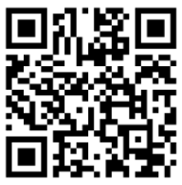

All recommendations should be submitted to Nicole McDonald: ntmcdona@volusia.k12.fl.us

Thank you in advance for your time.
Regards,

STUDENT NAME ALPHA DATE

*Please send/give the above information to your Math teacher to request a recommendation.

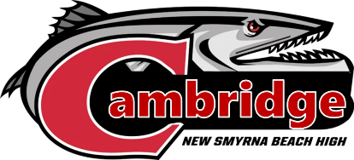

NEW SMYRNA BEACH HIGH SCHOOL

1015 Tenth Street, New Smyrna Beach, FL 32168
(386) 424 – 2555

Request for English (ELA) recommendation:

As part of the prerequisites for acceptance to the New Smyrna Beach High School Cambridge AICE Diploma Program, I have been asked to provide a letter of recommendation from my ELA teacher. Would you be so kind as to complete the recommendation?
The deadline for submitting the letter is January 30, 2026. Please visit the following link or QR code below to complete the recommendation.
https://forms.office.com/r/kykSCpnHBx

All recommendations should be submitted to Nicole McDonald: ntmcdona@volusia.k12.fl.us

Thank you in advance for your time.
Regards,

STUDENT NAME ALPHA DATE

*Please send/give the above information to your English/ELA teacher to request a recommendation.

