MHS Meeting Notes
November 13th 2025
MHS Library 7pm

Attendees: Dr. Euker, Katie Shireman, Patrick Qin, Chrissy Charles, Helena Skoogh Harz, and Deanna Roeger

President Report: Katie reviewed mini grants with the group. Dr. Euker was able to provide funding for one which requested calculators so that was off the table. Element approved for $250 for publication, Pilman granted $206 for new car seats, and $35 approved for the MHS TC for Privacy pop up tent.

Vice President Report: No report

Secretary Report- Deanna brought up closing down the PO Box Mailbox this month. Katie will do and Deanna will return her key. Chrissy will post the Winning Warriors who are freshman Tony Ascencion, sophomore Kaiden Doll, Junior Ryan Walter, and senior Malachi Vance.

Treasurer Report- Patrick mentioned waiting on the check from Fall Fest to be cashed. Deanna will make sure it’s deposited but no new activity. He did mention that even with last year’s monies combined with what we have, we will still be down about $1500-$2000 for what we projected. After the holidays we will send another reminder and see if anything comes in and then determine if to cut costs we just don’t offer any spring mini-grants. We are currently at $7,283.44.

Principal Report- Dr. Euker mentioned the cookie incentive has been positively received so far. She thinks once it’s implemented and on-going then more will catch on who may not have heard what it was all about. Done every two weeks. Dr. Euker is redoing the main entrance by working with a designer (MHS grad) to create an honor wall and an honor book that will have better Methacton M branding on it to update the building/name recognition/symbol. Name plates will then go up on the walls. The walls are also movable so if building redone it can be relocated.

Counselor Report- Dr. Peck emailed in the following:
- Financial Aid Night – Monday, November 17 from 6:00 to 7:30 PM, the High School Counseling Department will host a Financial Aid Night in the LGI.
  - Hear important information on scholarships, grants, loans and navigating the high costs of college so it is (hopefully) less painful.
  - Presenting: Evelyn Disla of PHEAA Pennsylvania Higher Education Assistance Agency and Katrina Kelly of West Chester University’s Office of Financial Aid.
  - Families of 11th and 12th grade students are STRONGLY encouraged to attend.
  - There is no registration
- 1st Quarter grades will be ready next week and students who need the counselors to send 1st QTR grades to a college or university need to come to the counseling office and complete a request.
- HOBY Leadership Program
We are excited to announce that applications are now open for the Hugh O’Brien Youth Leadership (HOBY) Seminar Scholarship Competition! This is a free leadership opportunity for one selected sophomore to represent Methacton High School at the 2026 HOBY State Leadership Seminar, which will be held June 12–14, 2026 at Neumann University in Aston, PA.
What is HOBY?
HOBY is a nationally recognized leadership program designed specifically for 10th grade students. During this 3-day, in-person seminar, participants—known as Ambassadors—take part in interactive activities, team experiences, and discussions that help them discover their personal leadership strengths and how to make a positive impact in their schools and communities. Ambassadors also join a large, supportive network of HOBY alumni from across the state and country.
How to Apply:
Interested students must complete the Google application form linked below, including brief written responses to three short-answer questions (75 words or fewer each).
Application Deadline:
Friday, November 21st
A committee will review all applications name-blind. Two students will be selected:
- One school representative who will attend the seminar for free
- One alternate who may attend if the representative is unable to do so
HOBY Application Form:
https://docs.google.com/forms/d/e/1FAIpQLSc9fNa5Ipqn6kTWpmg47db6CxU2Sd1WG8h5foOUoc5vB8ab1g/viewform?usp=sf_link
Want to Learn More?
Visit: https://www.hoby.org/programs/state-leadership-seminars/
You may also review the attached informational materials and sample schedule.
If you have any questions, please contact Mrs. Henning in the Counseling Office at rhenning@methacton.org.

We encourage all 10th grade students to apply.
Teacher Report- Andrea Borgman emailed in the following:
NOVEMBER 2025
NEWS FOR HOME AND SCHOOL
ACTIVITY | NEWS
METHACTON  MENTORS  CLUB  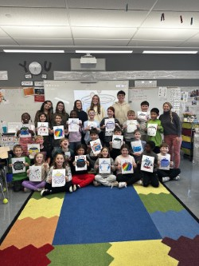 | Methacton Mentors Visit Eagleville & Worcester Elementary! 🕸🎃  Our Methacton Mentors spent the day working with multiple grade levels at Eagleville and Worcester Elementary Schools! This year, we’re focusing on lessons and crafts centered around social-emotional learning.  This month’s theme was Kindness and Friendship — we talked about what it means to be a good friend and shared ways to show kindness to both friends and strangers. Students created a giant “Spider Web of Kindness” to show how our actions connect us all, and made festive “Witch’s Friendship Potions” to celebrate caring and creativity!  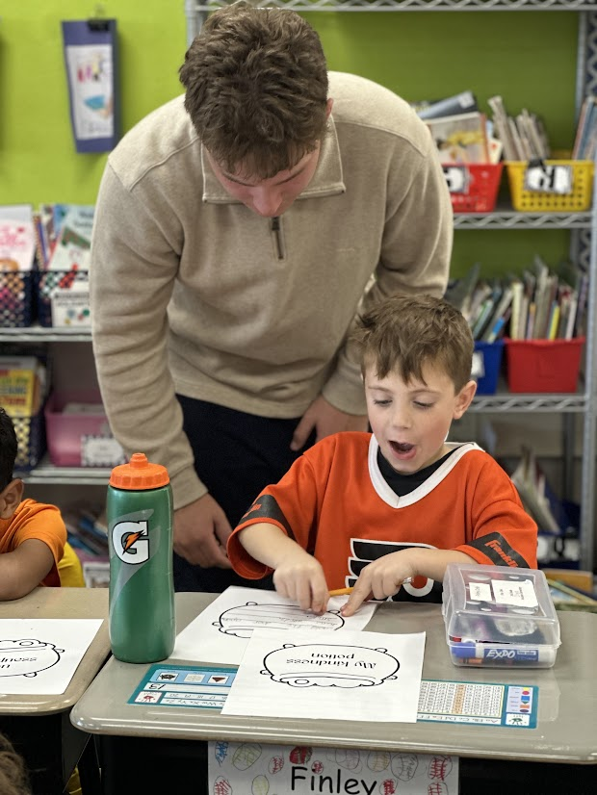
THEATER  CLUB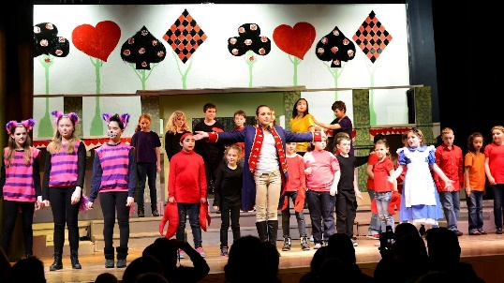 | Alice in Wonderland starts on Nov. 13 and ends with a 4pm show on Sat. Nov.15.  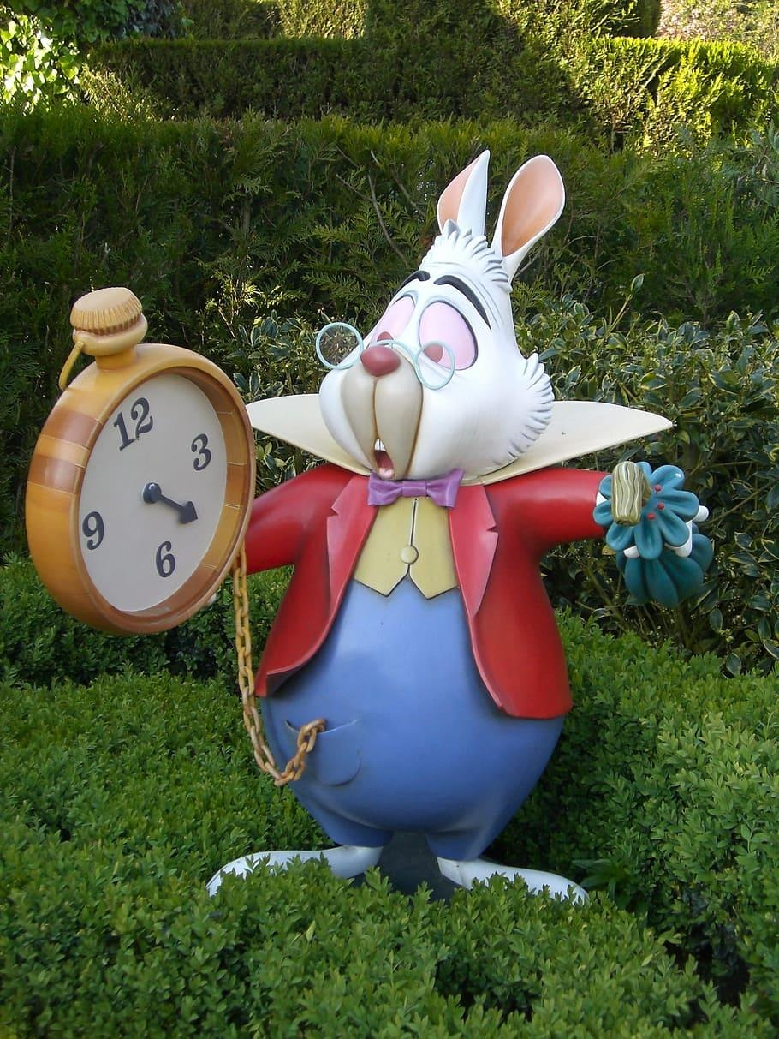
BOCCE | BOCCE starts on N0v. 17 and will run on Monday’s and Thursday’s.  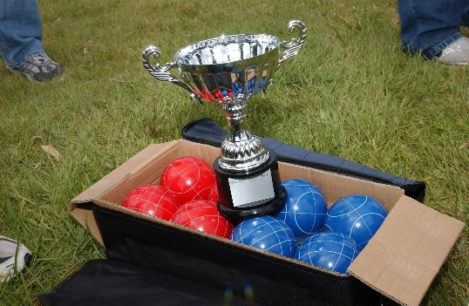
ART  DEPT. | This month the Advanced Ceramics and AP Art Students took a trip to the Philly Craft Show. The students has the opportunity to see how traditional craft techniques are pushed into contemporary, innovative forms, seeing real-world examples of concepts learned in class, such as design principles, craftsmanship, artistic voice, and understanding how professional artists develop cohesive bodies of work.
Seniors and  College | 12th grade students visited MCCC and were provided a campus tour last month.  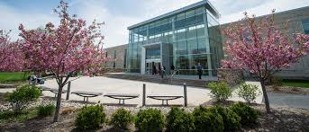
Orchestra and Music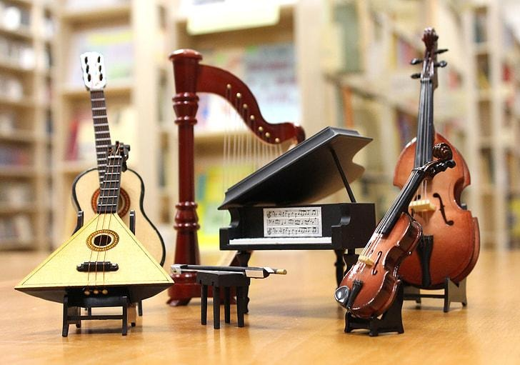 | Several MHS students participated in Montgomery County Honors String Orchestra on Monday, November 10th at Perkiomen Valley Middle School East. We have very talented musicians in our school  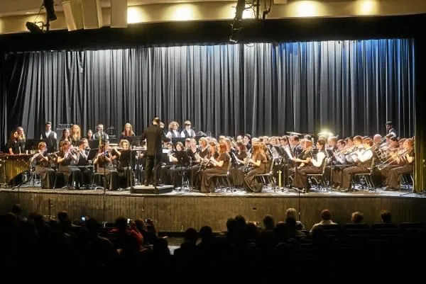
COMMUNITY  CARES | The Community Cares students have taught two presentations to Skyview and Arcola students. In September they taught a lesson on internet safety and in November they taught a lesson on Cultural Respect. High school students spent time being trained by Mission Kids and the Arc Alliance before presenting these lessons to the younger students. They are looking forward to their next lesson later in November.
YEARBOOK | Order your Yearbook and Senior Baby Ad now. The Senior Baby Ad deadline is December 19th. Both the Yearbook and the Senior Baby Ad (attachment included) can be purchased at www.Jostens.com.  Thank you.  Chris Lloyd
TRAVEL TO  FRANCE | December is the last time for students to register for the France trip for this summer. If interested, they can see or email Mr. Alzamorra or Mr. Ranieri :)

SEA Report-
The Methacton Special Education Alliance Home & School is a district-wide Home & School that provides a network of support for parents and caregivers of students with developmental, intellectual, emotional or physical disabilities, 504 Plans, IEPs or GIEPs. The SEA H & S offers access to relevant information and education while providing opportunities to connect with other parents and caregivers. We advocate for collaboration among families, school administrators, educators and professionals, to foster successful educational outcomes.

You can find more information about us at Methacton.org > Community > Methacton Coordinating Council > Special Education Alliance.

The SEA is always looking for new H&S Representatives within our buildings especially in our elementary schools. Let us know if you’re interested! Responsibilities include attending our bi-monthly Home & School meetings, as well as your school’s monthly Home & School meetings, and relaying any pertinent information between the two. It’s a great way to stay connected and make new friends! Email SEAMethacton@gmail.com to let us know you’re interested.

Special thank you for those who ordered the orange ‘SEA Belonging’ shirt for October 16th Unity Day from Shirt and Ink.

Our next Home & School meeting will be November 13th at 7:00 pm in the MHS Library. Mrs. Joelle Mensch, Supervisor of Special Education at MHS, will be at our next meeting to discuss the Apartment program and Special Education at the High School.

**Due to the nature of our outreach we hold our meetings entirely in person. All are welcome to attend.**

Our Fall Family Social was October 25th @ Eagleville Park. The event was very well attended by families throughout the Methacton community. Special thanks to Methacton Key Club for volunteering their time to help run the event.

The October 30th Notice of Recommended Educational Placement and Prior Written Notice presentation with Diane Perry from the PEAL Center was very informative and well received. Registrants will receive Diane’s power point and the link to the recording in the upcoming days/ weeks.

Kendra Scott fundraiser at King of Prussia mall is scheduled for Sunday, December 7th 2-4. Be on the look out for the flyer and promotional code to be used online.

SAVE THE DATE! Sunday, January 25th Rep Joe Webster and The Arc Alliance are hosting a free inclusive resource fair at the Philly Expo Center in Oaks for information about post-high school education, employment, and services for students with IEPs and 504s. More details to come. This event will include college and vocational programs from throughout Northeastern PA, as well as local job coaches, facilitators, volunteer opportunities, recreational opportunities, and services provided. We will share the flyer and registration information once we have it.

Check out SEAofMCC on Facebook and Instagram to find out more about our bi-monthly zoom presentations and more:

December 4th - IEP Essentials with Diane Perry from PEAL Center

December 4th - 6th - Variety Club Holiday Lane

January 29th H&S Meeting @ 7 pm MHS Library

February - Topic TBD

March 26th - H&S Meeting @ 7 pm MHS Library

April 9th - Parents’ Night Out

May 28th H&S Meeting @ 7 pm MHS Library

June 5th - Free Summer Social @ Eagleville Elementary

We are also excited to share our partnership with Shirt and Ink and SEA H&S Merch! The link is on our FB and Instagram page. Get yourself some gear for the new school year.

Please reach out to SEAMethacton@gmail.com with any questions or concerns.

MCC Report- Next meeting is on Monday November 17th in Skyview Library. May be potential treasurers guide revisions.

Upcoming Events-Staff Appreciation Thursday January 22nd.
No School Nov 26-28 (Thanksgiving Break).
Dec. 6 SAT Testing.
No School Dec. 24th -January 2nd (Winter Break)
Next Mtg. Zoom January 8th at 7pm.

