
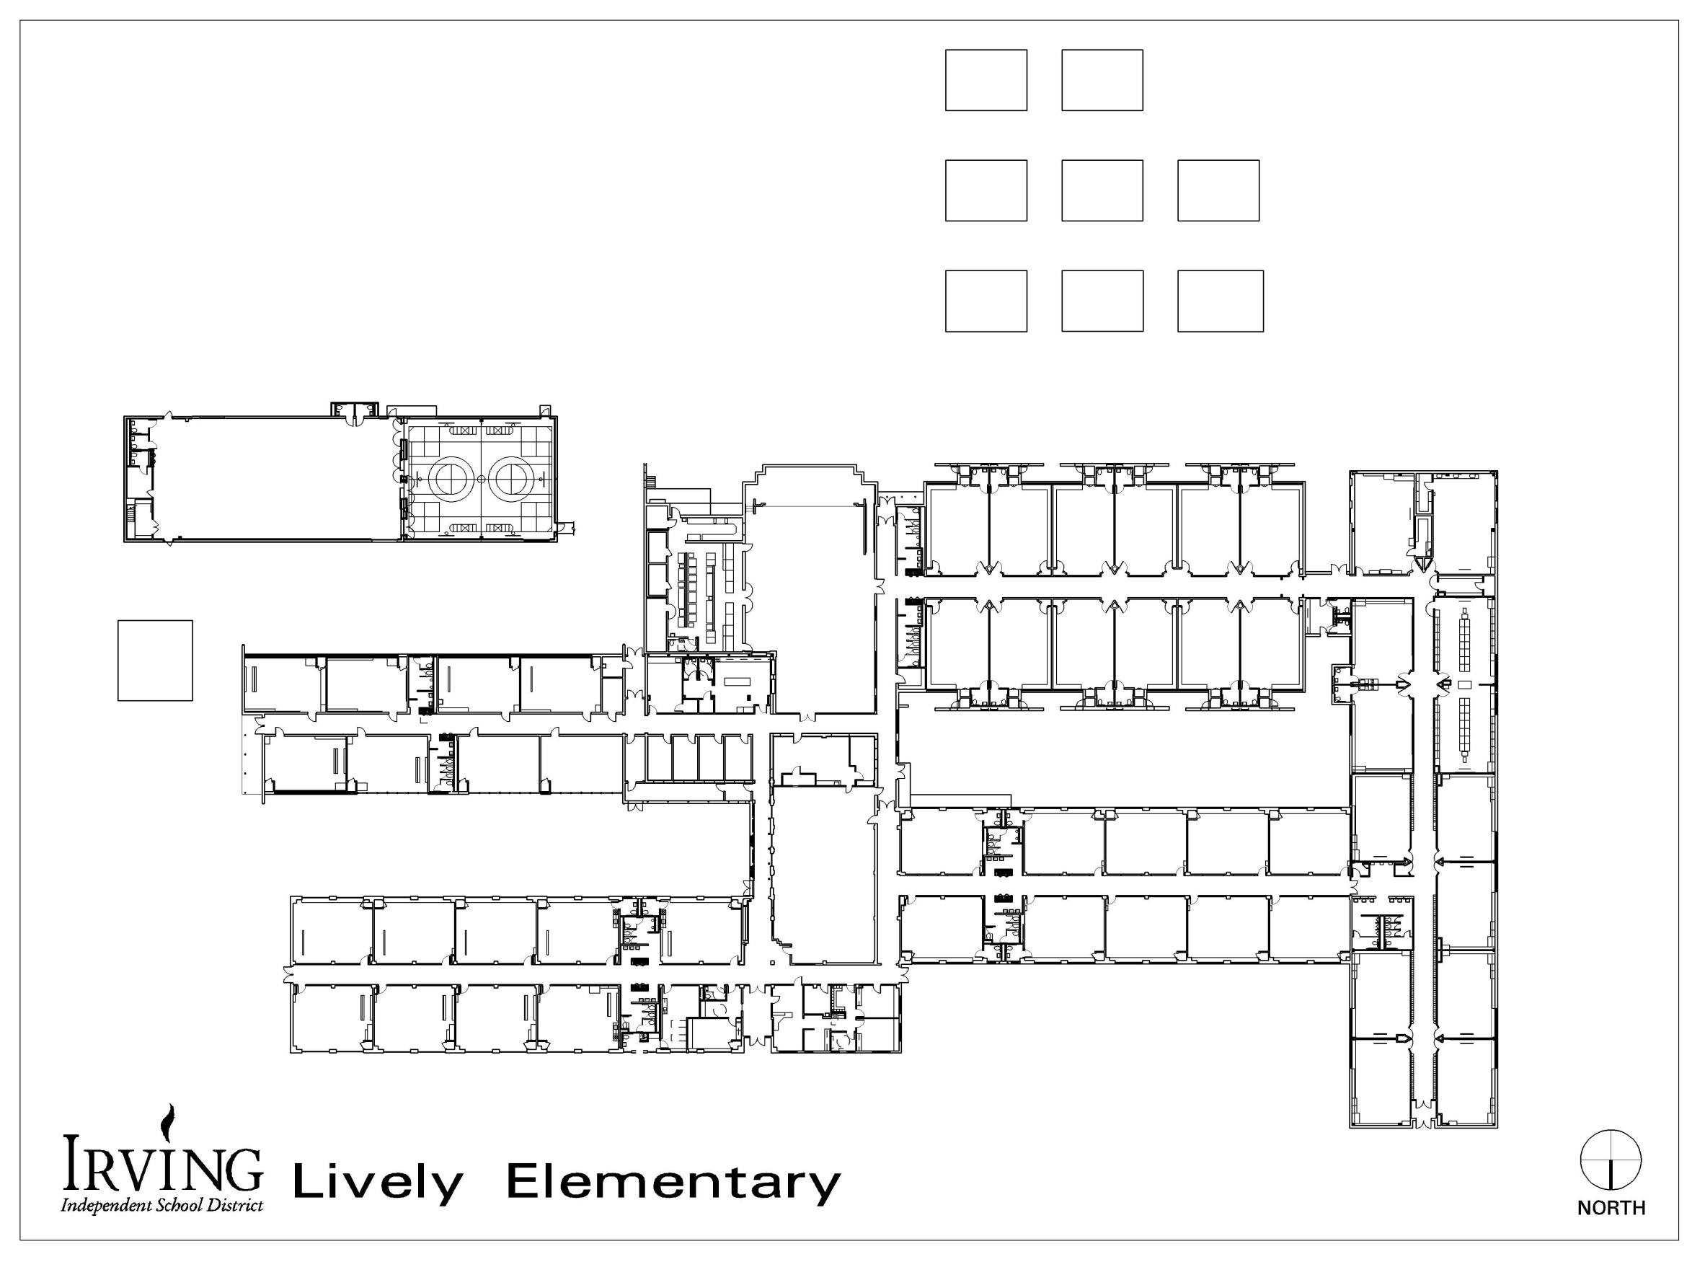
Car Riders
HOV/Daycare

PreK-5th grade
3rd-5th grade
PK-2nd grade


Outer lanes will be for pick up and the middle lane will be for passing.
YMCA

East Side Walkers
West Side Walkers
2015 - 2016 2016

.

.

.

