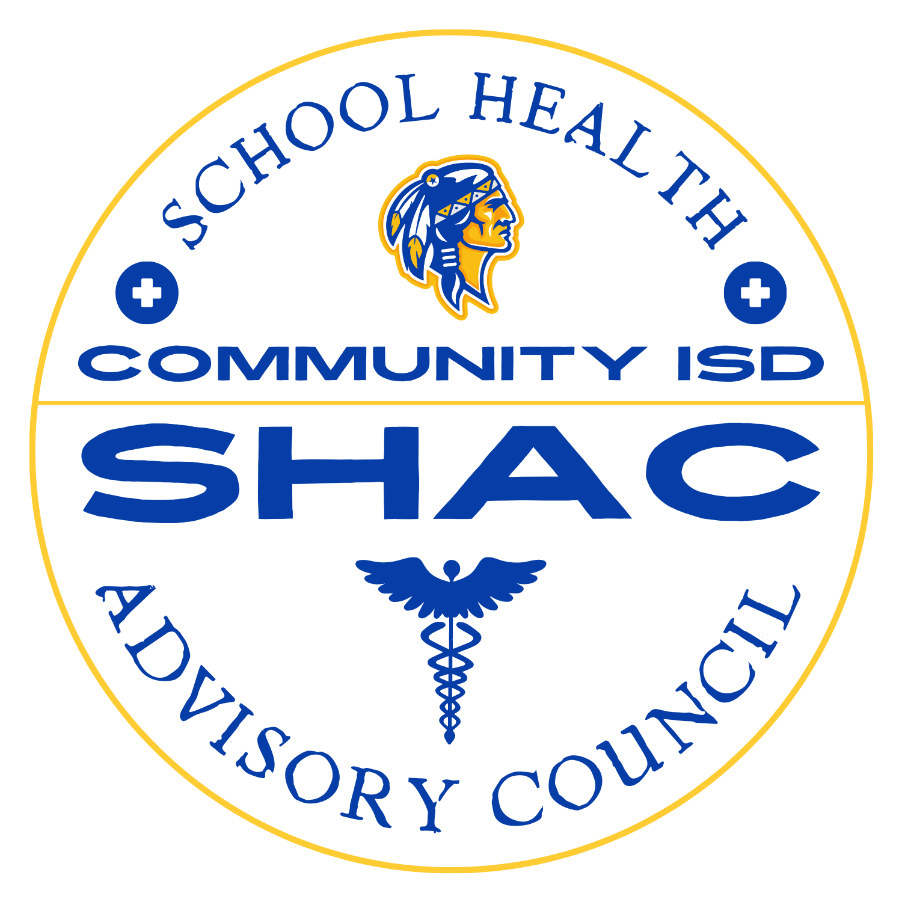

Community ISD SHAC
December 3, 2025 Meeting @ 6 pm
Terry Pope Administration Building
Minutes

Attendance:
Mallory Scott
NaTosha Lee
Amy Smith
April Sawyer

1800- Call to order

- Meeting Introduction and Attendance
  - Introduction of new co-chair, Hillary Gindrat in place of Mallory Scott
  - Approval of previous meeting minutes (September 10, 2025) proceeded with a motion and a second
- Review of previous Meeting and Current Health Services Update
  - Discussion of recent Texas Senate Bill 12 and its implications of health services consent forms and medication administration in schools
  - Updates on vaccine exemption affidavit process and the potential impact on unvaccinated student population
  - Cardiac Emergency Response Plan requirements and the related drills reviewed
- ByLaws and Committee Guidelines.
  - Annual review of SHAC bylaws highlighted
  - Emphasis on the advisory role of SHAC to the school board regarding student, staff and family wellness
  - Reminders about committee composition, meeting attendance requirements and voting quorum rules
- Triennial Wellness Assessment
  - Main focus on the triennial wellness assessment, last completed in the 2023-2024 school year
  - Clarification sought regarding whether assessment needs board approval
    - Consensus was that board approval is only necessary if there are changes
  - Plan set to complete the next assessment by end of current school year
  - Use of the WellSAT 3.0 tool to evaluate and align district wellness policies with best practices.
  - Review of previous assessment results
    - Most goals met, but partially met goals include nutrition messaging and physical activity promotion for staff
    - Action: Further discussion and goal-setting with nutrition director and other staff to improve partially met goals
- Proposed Student Health Survey
  - Health Services Coordinator proposed a district-wide student health and wellness survey to better understand student needs
    - Discussion ensued about grade-appropriateness and necessity of parental consent due to Senate Bill 12.
    - Concerns raised about survey fatigue and multiple consent forms being sent to parents recently
    - Director of Student Services suggested to leverage existing data from recent climate and CKH surveys, possibly reducing need for a new survey
  - Action: Hold off on launching new survey; Health services coordinator to connect with Director of Student Services for access to existing survey data
- Resources and Future Meetings
  - Recommendation to subscribe to the “Friday Beat” e-newsletter for helpful health and wellness resources
  - Future SHAC meetings scheduled for February 11th and April 8th, 6-7pm
- Questions, Comments and Adjournment
  - No further questions or comments from attendees

1814- Meeting adjourned

