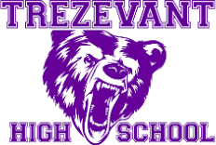

TREZEVANT HIGH SCHOOL SCHOOL/PARENT COMPACT 2025 - 2026

Parent/Guardian's Agreement
I want my child to be successful academically. To support my child's learning, I will encourage him/her by doing the following:

- Share the responsibility for improving my child's academic achievement with the entire school staff and my child.
- Develop a partnership with the school to help children achieve the State's high standards.
- Support my child's learning by:
-Monitoring their school attendance, homework completion and television watching
-Participating, as appropriate, in decisions relating to the education of my child and positive use of their extracurricular time.
- Believe in the importance of communication between teachers and parents on an on-going basis through, at a minimum:
-Attend parent and teacher conferences at least annually to discuss the parent-school compact as it relates to my child's achievement
-Read the frequent progress reports sent home, i.e. nine-week report cards, periodic progress reports, TCAP/End of Course/TNReady and Mastery Connect reports.
-Will take advantage of the reasonable access to staff given to parents and to volunteer, participate, and observe in my child's class.
- Check with my child for information sent home, promptly read and sign it.
- Making sure my child is at school and/or logged into Microsoft Teams for each class each day on time with required supplies.
- Communicate with my child's teacher frequently to find out how my child is doing in school including reviewing the Progress Reports sent home after the third week of each nine-week grading period and reviewing the report card each nine-weeks.
- Establish a quiet, well-lit place for homework and monitor homework regularly.
- Teach social skills to promote positive interactions with all.
- Support the school and make sure my child obeys the school rules.
- Encourage my child to read by providing a library card for my child and letting my child see me read.

Parent's Signature:

Name of Child (Please print) Grade:

Student's Agreement
It is important that I work to the best of my ability. Therefore, I shall strive to do the following:

- Attend school regularly in person and/or virtually and report to classes on time.
- Display respect for all.
- Come to school and/or login in each class on Microsoft Teams each day with pens, pencils, paper, and other necessary tools for learning.
- Complete and return homework and class assignments in a timely manner.
- Observe regular study hours.
- Ask questions when I do not understand.
- Comply with rules of student conduct, including the uniform policy.
- Share the responsibility for improving my academic achievement with my parents and the entire school staff

Student's Signature: Grade:

Teacher's Agreement
It is important that students achieve. To support my students' learning, I shall strive to do the following:

- Share the responsibility for improving student academic achievement with parents and students.
- Provide high-quality curriculum and assignments at a pace appropriate for my students.
- Provide homework assignments for students, when applicable.
- Provide necessary assistance to parents so they can help with the assignments.
- Encourage students and parents by providing information about the students’ progress.
- Provide constant preparation for my students to succeed on District and State tests.
- Determine student's educational needs and adjust my instruction to accommodate those needs.
- Use Microsoft Teams, Blackboard and/or some method to forward information related to class and homework assignments and school events.
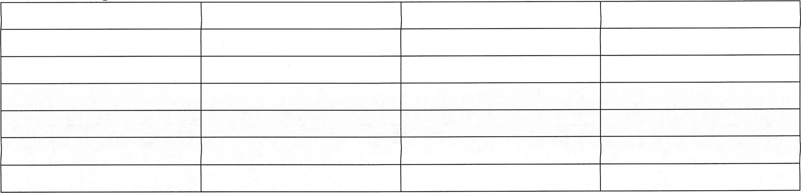
- Participate in extracurricular activities and school-related functions. Teacher's Signatures:

Trezevant High School's Responsibility
As a Trezevant High School administrator, I support parent, student, and teacher involvement focused on student success.
Therefore, the administration and staff of Trezevant High School will strive to do the following:

- Jointly develop with parents, a School/Parent compact that outlines how parents/school/ staff/students will share responsibility for improving student academic achievement.
Provide high-quality curriculum and instruction in a supportive and effective learning environment that enables the children to meet the State's student academic achievement standards.
- Hold parent and teacher conferences in schools at least annually to discuss the school-parent compact as it relates the individual child's achievement.
Give frequent student progress reports to parents.
- Give parents reasonable access to staff, to volunteer, participate, and observe in their child's class.
- Distribute a written and/or electronic copy of the school level Family Engagement Plan.
- Notify parents of the written School Level Family Engagement plan in an understandable and uniform format, and to the extent practicable, provide it in a language parents can understand.
- Make the School Level Parent Involvement Plan available to the local community.
- Develop a partnership with parents to help children achieve the State's high standards.
- Provide a safe environment to foster student learning based on respect for all.
- Enforce all the rules set forth by Shelby County Schools and Trezevant High School.

Signature
Eric Brent, Principal

English: Memphis-Shelby County Schools offers educational and employment opportunities without regard to race, color, religion, sex, creed, age, disability, national origin, or genetic information.

Spanish: Las Escuelas de Memphis-Condado Shelby ofrecen oportunidades educativas y de empleo sin distinción de raza, color, religión, sexo, credo, edad, discapacidad, origen nacional, o la información genética.

Revised: May 7, 2025

