Campus Improvement Plan
2025-2026

Submitted for Board Approval on _____________ 2025
Board Approved Date: __________ 2025

Vision

Sorensen Elementary School expects to develop knowledgeable and high achieving students. This will be accomplished through quality instructional programs in nurturing and trusting environment.

Mission

Sorensen Elementary School will provide all students with an exceptional education in a nurturing yet challenging environment that fosters academic success, social development, enthusiasm for education and a life-long quest for knowledge. As a school community, we strive to instill the importance of a well-rounded education with a commitment to preparing our students for a higher education and future leadership. We are dedicated to providing academic and social skills for all students using best teaching practices to provide a quality instructional program that sets the foundation for all future learning. In partnership with school, parents, students and community, we will work together to create an atmosphere of trust, respect, and collaboration.

Texas Accountability System


B

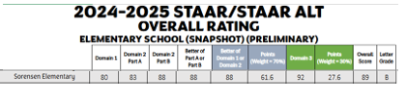

Preliminary Data

Preliminary Data

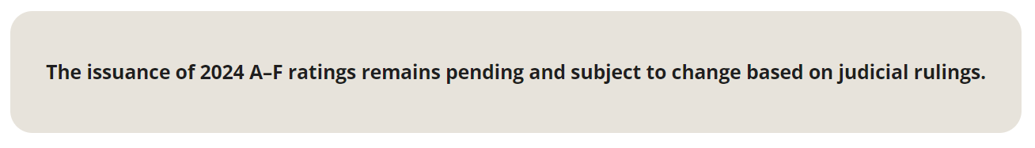
Retrieve on Nov. 11, 2024 from: 2024 Accountability System | Texas Education Agency (Add your link for your campus)

NAME | POSTION
GISELLE MARTINEZ | PRINCIPAL
EIRA HERNANDEZ
LILIANA GARCIA
CLL
PARENT
LIANA GARCIA | SPED TEACHER
GLORIA BUSTAMANTE-GARZA | LEAD TEACHER
 | LEAD TEACHER

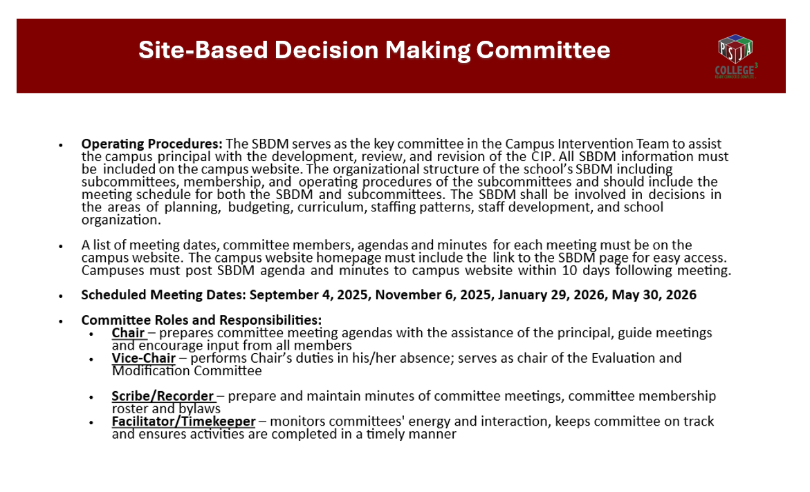

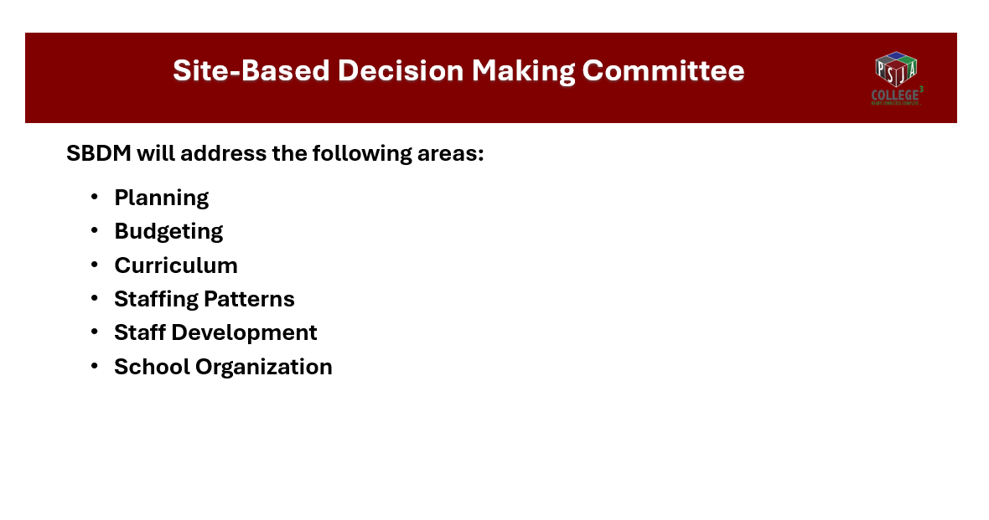

Texas Accountability System

B

Preliminary Data

Preliminary Data

Retrieve on Nov. 11, 2024 from: 2024 Accountability System | Texas Education Agency (Add your link for your campus)

Strategic Direction
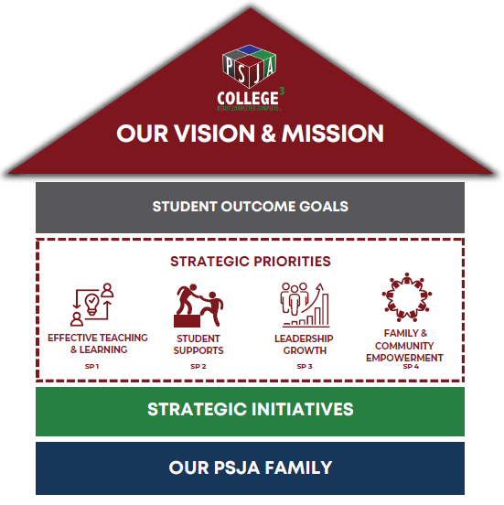

PSJA School Board
Diana Serna, President
Ricardo Rodriguez, Vice-President
Griselda Quintanilla, Secretary
Ramona Barron, Assistant Secretary
Yolanda Castillo, Member
Cynthia A. Gutiérrez, Member
Carlos G. Villegas, Jr., Member
Superintendent's Cabinet
Dr. Alejandro Elias, Superintendent of Schools
Rebecca Gonzales, Chief Financial Officer
Dr. Rebecca Garza, Assist. Supt. Human Capital Development
Ranulfo Marquez, Assist. Supt. for Academics
Dr. Lauro Davalos, Assist. Supt. For Technology
Rafael Gonzalez, Assist. Supt. for Operations

Senior Staff
Dr. Susana Arredondo, Executive Officer for Elementary Schools
Dr. Virna M. Bazan, Executive Officer for Elementary Schools
Mario Bracamontes, Sustainability Administrator
Dr. Nora Cantu, Executive Officer for Academics
Alfredo Carrillo, Executive Officer for Human Resources
Dr. Yolanda Gomez, Executive Officer for Learning Acceleration
Dr. Claudia Gonzalez, Executive Officer for Elementary Schools
Dr. Iris Guajardo, Executive Officer for Secondary Schools
Dr. Nora Rivas-Garza, Executive Officer for Secondary Schools
Dr. Linda Uribe, Executive Officer for College Readiness
Campus Executive Summary

Demographics:
Pharr-San Juan-Alamo ISD serves students from three different cities, who come from similar backgrounds and way of life.
The student body at PSJA ISD is majority Hispanic with the following breakdown of student populations:
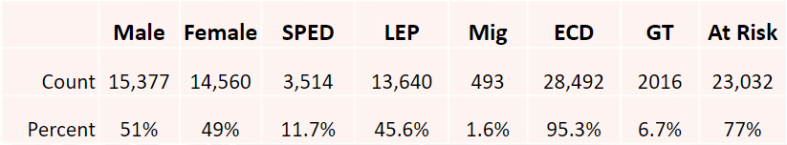
With the district’s proximity to Mexico, 45.60% of the students are considered Emergent Bilingual (EBs) with Spanish being the language spoken at home.

Student Performance:
Using preliminary student performance data, Pharr-San Juan-Alamo has been rated a "B" District by the state of Texas on the 2024 Accountability. In Domain I, Student Achievement Domain, STAAR Performance was at a component score of a 46, College Career and Military Readiness (87), PSJA ISD earned a grade of 79.
In Domain II, School Progress (77), Academic Growth (77) and Relative Performance (85) with an Eco Dis at a 93.8%, PSJA ISD earned a scale score of 85. Domain III, Closing the Gaps Domain, PSJA scale score was an 84.

The overall 2024 Accountability Rating for Pharr-San Juan-Alamo ISD was a score of
85. In grades 3-8 all tested STAAR subjects and EOC assessments, PSJA ISD administered 41,464 tests which translates to over 98% participation for the 2023-2024 school year.

Executive Summary Continued

Student Performance:

For the 2024-2025 school year, the Student Performance goals are the following:
• The percentage of all students that score meets grade level or above on STAAR combined Reading and Mathematics will increase
from 48% (50% Reading, 45% Math) in June 2024 to 50% by June 2025.
• The percentage of students who perform at meets grade level or above on STAAR Reading will increase by three percentage points
by June 2025.
• The percentage of students who perform at MEETS grade level or above on STAAR Mathematics will increase two percentage points
by June 2025.
• The percentage of students who perform at meets grade level or above on STAAR Reading will increase by three percentage points
by June 2025.
• The percentage of graduates that meet or exceed the criterion for College, Career, and Military Readiness Performance Status will
increase from 87% in June 2024 to 97% by June 2025
• The percentage of graduates who earn an industry certification will increase by June 2025.
• The percentage of graduates that meet or exceed the criterion for College, Career, and Military Readiness Performance Status will
increase from 87% in June 2024 to 97% by June 2025.
• The ALL-student group will meet 70% of the ESSA Long-Term and Interim Goals for reading and mathematics in the Academic
Growth by June 2025.
• The ALL-student group will meet 70% of the ESSA Long-Term and Interim Goals for reading and mathematics in the Academic
Growth by June 2025.

Executive Summary Continued
Effective Teaching and Learning:
PSJA ISD Curriculum & Instruction Office oversees implementation of a TEKS aligned curriculum that is relevant, rigorous and engaging for all PSJA ISD students.
Alignment of the curriculum is an ongoing process and includes integration of TEKS Resources, development of a comprehensive curriculum, as well as intensive and relevant continuous professional learning. Curriculum, programs, and resources are reviewed, and adjustments are made based upon collaborative analysis of student data and the emergence of new research.
All PSJA ISD comprehensive high schools are designated Early College, which makes them innovative high schools that allow students to attend college and high school simultaneously. Early College High Schools offer rigorous instruction and provide academic, social, and emotional support services to help students succeed.
Starting in the 2023-2024 academic year, PSJA ISD implemented the UN's 17 Sustainable Development Goals (SDGs) across its entire school system.
The district is:
1. Integrating SDGs into their curriculum to give students practical, real-world knowledge and experience for global competitiveness
2. Taking a system-wide approach to sustainability through a multi-departmental committee
3. Coordinating efforts across various departments including Curriculum, HR, Operations, Health Services, Construction, Transportation, Child Nutrition, Police, and Communications
Additionally, PSJA ISD offers a Dual Language Program as an academic experience designed for students to develop stronger cognitive and academic skills through the development of on-level bilingualism and biliteracy. Through a rigorous curriculum, students who participate in the program are academically instructed in Spanish and English, from Pre-Kinder to 12th grade.
As a result, students can master both languages and enhance their education by developing the ability to fluently speak, read, write, and think critically in Spanish and English, which allows them to compete successfully in a global economy.
Furthermore, PSJA ISD teachers are equipped and trained to teach rigorous content and make learning experiences memorable preparing all students for the competitive world. Advance Placement at all high school campuses offers students the opportunity earn post-secondary credentials if they earn a three or higher. Currently, 216, Met the criterion score on an AP/IB exam in any subject translates to 10%.
Campus Educational Improvement Committee Members
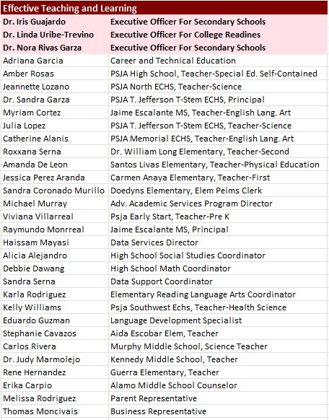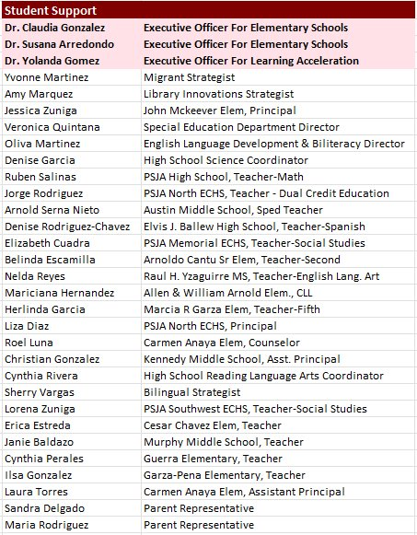

Campus Educational Improvement Committee Members
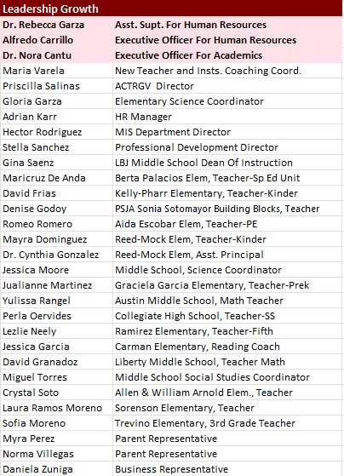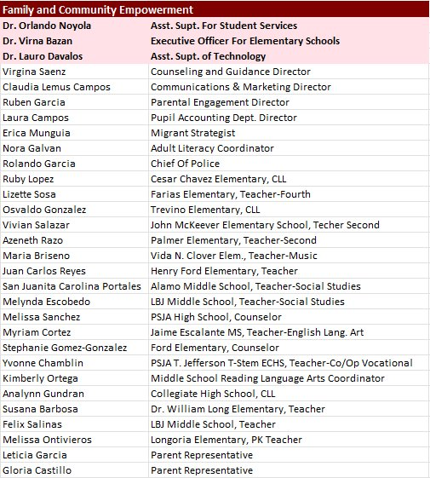

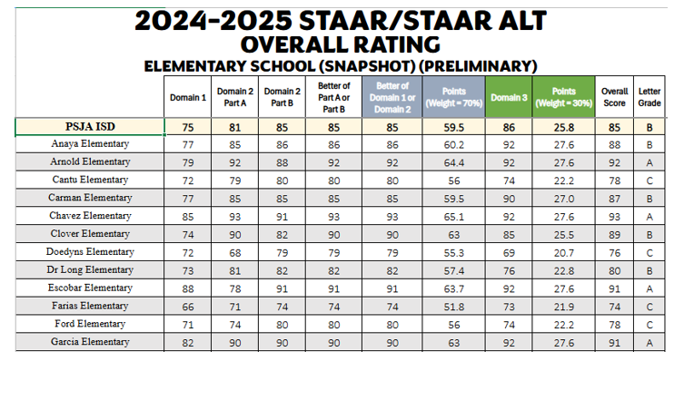

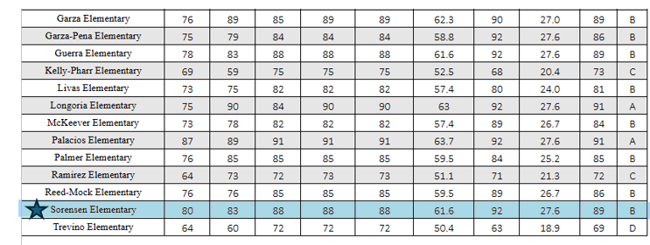

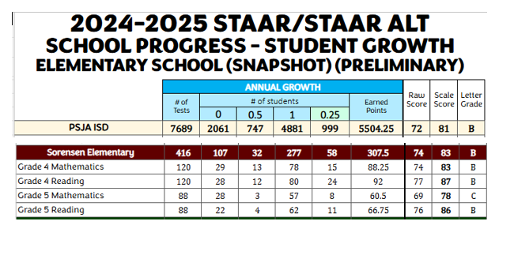

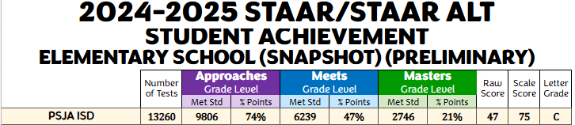

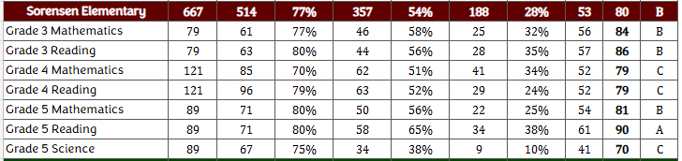
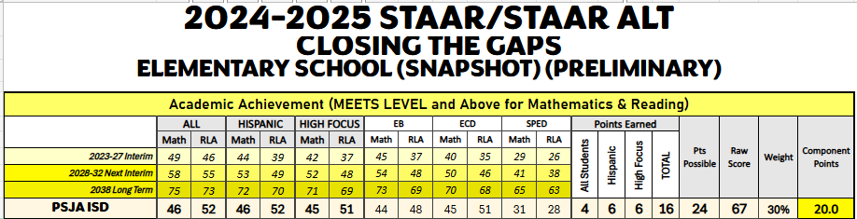

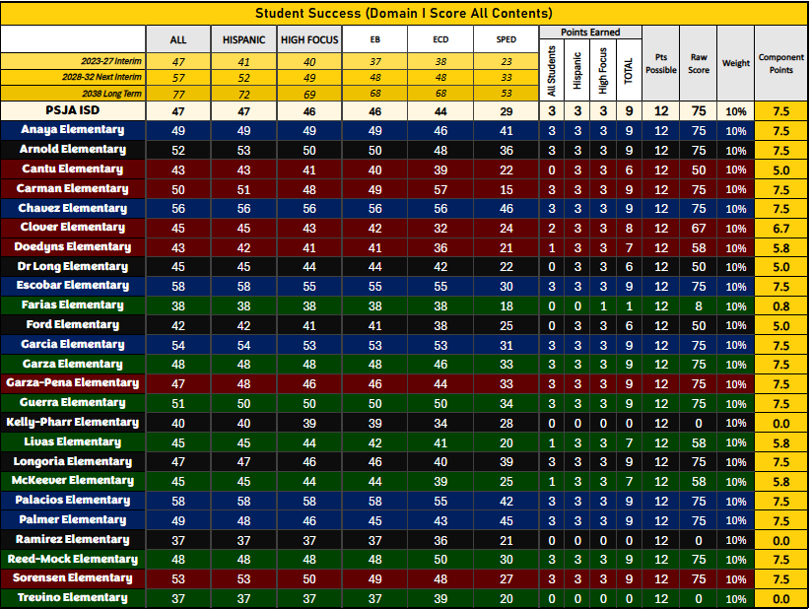

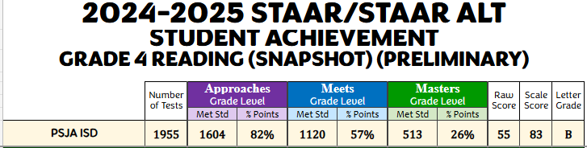

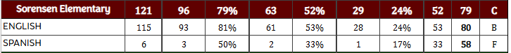
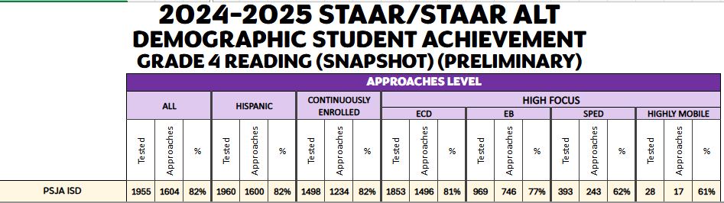

Comprehensive Needs Assessment

Demographics
Demographics Summary
Special Education:
The following accountability sources were used to review the Special Education data by the Campus Site-Based Decision-Making Committee (SBDM): State of Texas Assessments of Academic Readiness (STAAR) results, Performance Based Monitoring Assessment System (PBMAS) and State Performance Plan (SPP) indicators to determine strengths and needs of our Special Education students. In addition, the Special Education Department was very involved in the curriculum writing and revision for grades K-5 during the summer to ensure that the general curriculum meets the needs of our special education students. Professional development is also coordinated with the curriculum and instruction department to ensure that all general education teachers are well versed in best practices that support the learning of special education students.
Needs:
Align student goals and objectives outlined in IEP with TEKS being assessed on STAAR, STAAR Online, TELPAS.
Personnel Needs:
Campus Administrators will work closely with Human Resources (HR) to ensure the selection of highly qualified employee(s) holding valid state issued certification.
Professional Development Needs:
Special Education Staff will be included in all Professional Development (PD) provided by the campus/district in the areas that are to be addressed by individual students. The Special Education Department will work closely with the Campus and provide PD in the area of co-teaching to implement the inclusion model effectively. Resource teachers will work collaboratively with homeroom teachers to ensure IEP implementation.

Emergent Bilinguals (EB):
The following accountability sources were used to review the Bilingual Education/Dual Language (BE/DL) Department data by the SBDM Committee: State of Texas Assessments of Academic Readiness (STAAR) results, Performance Based Monitoring Assessment System (PBMAS) and TELPAS indicators to determine strengths and needs of our EL students. The BE/DL Department was very involved in the curriculum writing and revision for grades K-5 during the summer to address the needs of our EL students and align the curriculum between English and Spanish Language Arts that led to a more coherent and consistent bi-literacy program.

GOAL AREA 1: Student Achievement
Areas Reviewed: Student Performance
Strengths
Pharr-San Juan- Alamo provides the campus with a standards-aligned Guaranteed and Viable Curriculum and scope and sequence. The district curriculum is developed and adjusted after the district content- based assessments and benchmark data are analyzed. The development and adjustment of the district curriculum is led by
the Curriculum & Instruction Department, and includes teachers, district content coordinators, and district Executive Officers for each level. The district also provides teachers and campus leaders access to assessments aligned to the standards and expected levels of rigor. A data assessment platform to capture immediate assessment data by item and student is inclusive as part of the curriculum practices and curriculum implementation. In addition:
- Curriculums and assessments are aligned to Texas Essential Knowledge and Skills (TEKS) and included in a year-long scope and sequence. After each
assessment, campus and district staff conduct data review sessions and adjustments are immediately made to the scope and sequence and resources are evaluated.
- The scope and sequence, units of study, and assessments are aligned to the standards for all state assessed subjects and grade levels in grades Pk-2nd, 3rd-5th, middle and high school.
- Assessments that are aligned to state standards at the appropriate level of rigor are administered strategically throughout the year to determine student
progress. Corrective instruction is built into the curriculums and scope and sequence.
- Instructional materials with key ideas, essential questions, and recommended materials including content-rich texts, are used across classrooms. The instructional materials include resources intentionally designed to meet the needs of students with disabilities and English learners among other student groups.
- Professional development is provided throughout the year in response to classroom observations, formative assessments and campus performance.

Challenges
The area of literacy, specifically in reading comprehension and writing has been a challenge district-wide and great emphasis and resources are being dedicated to this area of need. Additionally, the 2024 STAAR Performance results indicate academic gaps in mathematics.
- The All-Student Group in ELA/Reading at Meets Grade Level Standard or Above was at 52%.
- High Focus Student Group in ELA/Reading at Meets Grade Level Standard or Above was at 47%.
- Emergent Bilingual Student Group in ELA/Reading at Meets Grade Level Standard or Above was at 40%.
- Special Education (Current) Student Group in ELA/Reading at Meets Grade Level Standard or Above was at 38%.
- Student reading on level by third grade is an area that we as the district continue to work on and monitor. 61% of 3rd grade students scored 0 points on the ECR (43 students).
- Cross curricular writing must be done at all grade levels
- Professional development for teaching writing must be provided at all grade levels.
- The All-Student Group in Mathematics at Meets Grade Level Standard or Above was at 52%.
- High Focus Student Group in Mathematics at Meets Grade Level Standard or Above was at 47%.
- Emergent Bilingual Student Group in Mathematics at Meets Grade Level Standard or Above was at 40%.
- Special Education (Current) Student Group in Mathematics at Meets Grade Level Standard or Above was at 38%.

Goal Area 1: Student Achievement

Annual Goal 1: The percentage of all students that score meets grade level or above on STAAR combined Reading and Mathematics will increase from 48% to 60% by June 2026.

Objective 1: The percentage of students performing at meets grade level or above on STAAR reading/math 3rd-5th will increase by having access to a standards-aligned guaranteed and viable curriculum.

Strategy 1: Curriculum writing initiatives with in-person learning for Reading Language Arts, RLA, SLA and Math based on needs assessment using data and trends will be executed. Data will be used to inform instruction for differentiated lessons to identify spiraled skills and highly tested student expectations.

Timeline: June 2025- June 2026
Title I School Components: Title I, Title II, Title III, Special Ed. & Bilingual Funds, Migrant Funds
Persons Responsible: Principal, Assistant Principal, CLL, Reading Coach, Teachers
Action Steps:
1)CLC meetings will address lesson planning and the TEKS. Focus will be on lesson internalization.

2) Data will be shared with parents regarding their child's level of performance and expected outcome by June 2026 at parent meetings (STAAR, TPRI, Tejas LEE, TXKEA, BM1, BM2, CBA).

3) Conduct data analysis every six weeks by leadership team to monitor root cause, improvement and drive action plans.

Resources | Evidence of Implementation | Evidence of Impact | Formative Evaluation
•TEKS Resource System  •Curriculum Templates/Calendar  •I-Ready, Lead4ward, My Reading and Math Aca,, Summit K12, Region 1, Forde-Ferrier  •State and local student data  Purchase supplies such as paper, colored paper, sent. strips, binders, markers, folders, skill boxes, poster boards, chart paper for small group interv.  Project-based learning act. Tri-folds, copier machine, mat. need | •Curriculum documents  •Lesson plans  •Collaborative Learning Leader [CLL] agendas  •Walkthrough documents  •Lesson Internalization  DMAC data, Tutorial/Intervention | •Student Achievement gains on the STAAR  •Teacher retention  •TELPAS  •Results Driven Accountability  •Reports  STAR Reports, I-ready, BOY, CBA, BM1, BM2 and STAAR | •Formative assessments  •Benchmarks [BMs]  •STAAR  •TELPAS  •Results Driven Accountability  •Student Growth Measures [SGMs] Pre/Post Test  •IReady Diagnostic
Strategy 2: Provide supplemental tutorial programs and summer school/enrichment for students identified as at-risk using manipulatives, leveled readers, and supplemental resources, instructional material, and technology (ipads, chromebooks, ipad/chromebook cases, desk top computers, poster machine, etc.. to meet the needs of students at each performance level (Approaches, Meets, Masters) and address all five components of reading.

Title I School Components: Title I - IV, State Bilingual Funds, State Comp. Special Ed. & Bilingual Funds, Migrant Funds
Persons Responsible: Principal, Assistant Principal, Reading Coach, Teachers

Action Steps:
1) Data will be used to identify students in need of extended learning opportunities and purchase supplies such as paper, chart tablets, colored paper, sentence strips, markers, painting supplies for small group instr/interventions and enrichment camp. (need copier machine/materials for teachers)

2) Implement quality instructional reading programs that focus on the five essential components of a reading program to meet the needs of all students. (Accelerated Reader, purchase books of different genres, SSRW, Phonics practice, Savaas, Mosaico)

3) Provide compensation for intentional tutoring groups.

Resources | Evidence of Implementation | Evidence of Impact | Formative Evaluation
•Walk-through documents  •Pacing Guides  •Curriculum  •Instructional Rounds Documentation  •Coordinator/Direct or Feedback Forms  •Lesson Plans  •PSJA LIFE (Literacy Impact for Excellence)  •I-Ready Provide supplemental tutorial programs and summer school/enrichment for students identified as at-risk using manipulatives, leveled readers, and supplemental resources, instructional material, and technology (ipads, chromebooks, ipad/chromebook cases, desk top computers, poster machine, etc.. to meet the needs of students at each performance level (Approaches, Meets, Masters) and address all five components of reading.  Phonemic Awareness  Phonics  Fluency  Comprehension & Vocabulary | •Walkthrough documents  Lesson plans  Tutoring/Int. Plans  Fluency Progress Monitoring | •BM1 and BM2 scores show increases in student achievement and student performance growth | •Formative assessments  •Benchmarks [BMs]  •STAAR/TELPAS  •ACT and SAT  •Results Driven Accountability  •IReady Diagnostic

Strategy 3: Ongoing support for the implementation of the RLA and Math curriculum through CLCs. Monitor student writing samples every six-weeks to make certain writing is occurring throughout the curriculum.

Timeline: August 2025 - June 2026
Title I School Components: Title I - IV, State Bilingual Funds, State Comp.
Persons Responsible: Principal, Assistant Principal, Reading Coach, Teachers
Action Steps:
1) Use WFTB writing rubric to score and analyze student writing from PK-5th grade.

2) Purchase writing journals and quality literature (trade books) for teachers to model effective writing strategies and use mentors.

3) Use assessment data to drive intervention plans and build intervention time into the day at every level

Resources | Evidence of Implementation | Evidence of Impact | Formative Evaluation
•Training Material/Agenda  •District Curriculum  •Pacing guide  •Year- at- a- Glance,  •Weekly Lessons  •State and Local Data  •Lexia Core 5  •Power Up  •I-Ready  Accelerated Reader software program and licenses | •Training Agenda  •Collaborative Learning Community Meetings | •BM1 and BM2 scores show increases in student achievement and student performance growth  •Increase level of performance in STAAR | •Formative assessments  •Benchmarks [BMs]  •STAAR/TELPAS  •Results Driven Accountability  •TELPAS  •I-Ready

Goal Area 2: Closing the Gap

Annual Goal 1: Emergent Bilingual Students will demonstrate 60% or above on progress composite to composite on Telpas domain by June 2026.

Objective 1: All student groups will be monitored weekly to ensure that at least 90% of each domain is met by June 2026 to meet the 10% of the Closing Gap.

Strategy 1: Monitor implementation of ELP strategies to accelerate the progress of EB’s.

Timeline: June 2025- June 2026
Title I School Components: Title I, Title II, Title III, Special Ed. & Bilingual Funds, Migrant Funds
Persons Responsible: Principal, Assistant Principal, CLL, Reading Coach, Teachers
Action Steps: ELPS training will be provided for all staff members to serve the needs of our EB students.

1) Teachers will schedule observations for administration feedback on ELPS implementation.

2) Teachers will provide TELPAS based assessment practice throughout the school year, embedded throughout the curriculum.

3) Teachers and administrators will monitor student growth on proficiency levels and set goals for each students’ proficiency level.

Resources | Evidence of Implementation | Evidence of Impact | Formative Evaluation
- District Curriculum  - I-Ready Reading  - ELPS  - TELPAS Release Assessment  - Biliteracy Benchmarks  - Summit K12 | DMAC data reports  Campus Performance Reviews (CPR)  Progress Monitoring Reports  Teacher-student conference  Follow the yearly Success Plan for Summit  Walk-through feedback  LPAC notes  Lesson Plans  (Accelerate)  Language Acquisition Monitoring | Closing the achievement gap among student groups  Increase academic performance of all student groups in all BM, STAAR | Weekly Assessments  CBA I  BM I & II  Telpas BM 1 assessments  Summit K12 summative/interim  STAAR  TELPAS

Strategy 2: Monitor the progress of all EB’s through district formative assessments.

Title I School Components: Title I - IV, State Bilingual Funds, State Comp. Special Ed. & Bilingual Funds, Migrant Funds
Persons Responsible: Principal, Assistant Principal, CLL, Teachers

Action Steps:
1) Leadership team will monitor EB students marking period grades each period.

2) Team will monitor EB’s via EB instructional and assessment checklist at BOY, MOY and EOY.

3) Monitor biliteracy journals for attainment towards TELPAS writing growth.

Strategy 3: Teachers in grades K-2 will use the Footsteps to Brilliance program to implement biliteracy.
3rd-5th grade DL teachers will implement biliteracy curriculum with fidelity.

Title I School Components: Title I - IV, State Bilingual Funds, State Comp. Special Ed. & Bilingual Funds, Migrant Funds
Persons Responsible: Principal, Assistant Principal, CLL, Teachers

Action Steps:
- Leadership will conduct periodic walk-throughs for implementation of curriculum K-5th.
- Leadership team will monitor biliteracy journals for fidelity of implementation.
- Provide support for students having difficulty with domains.
.

Goal Area 3: Improve Safety, Public Support, Culture and Climate

Annual Goal 3: All students will receive balanced instruction on Social Emotional Learning and implementation of the 21st century skills.

Objective 1: All students will be monitored weekly to ensure that all students receive balanced instruction on SEL and implementation of 21st century skills.

Strategy 1: Teachers will implement partner pairs and classroom talk throughout the curriculum to address positive social skills.

Timeline: June 2025- June 2026
Title I School Components: Title I, Title II, Title III, Special Ed. & Bilingual Funds, Migrant Funds
Persons Responsible: Principal, Assistant Principal, CLL, Reading Coach, Teachers
Action Steps: ELPS training will be provided for all staff members to serve the needs of our EB students.

1) Embed planning days for each unit of inquiry throughout each six-weeks.

2) Complete unit of planner in Science and Social Studies curriculum.

3) Attend any PD trainings to gain further knowledge in curriculum and instruction.

Resources | Evidence of Implementation | Evidence of Impact | Formative Evaluation
- District Curriculum  - Lead Teachers  - Teachers | Progress Monitoring Reports  Teacher-student conference  Walk-through feedback  Lesson Plans  student journals | Teacher/Student Feedback | Journals  Assessment
Strategy 2: Campus-wide implementation of Project RESSPECT Skills and SEL curriculum.

Title I School Components: Title I - IV, State Bilingual Funds, State Comp. Special Ed. & Bilingual Funds, Migrant Funds
Persons Responsible: Principal, Assistant Principal, CLL, Counselor, Reading Coach, Teachers

Action Steps:
1). School counselor will conduct weekly classes with all grade levels.
2). Project RESSPECT skill of the Week will be reviewed with students by the counselor, AP, Principal during weekly meetings.
3). SEL journal implementation by counselor.

Strategy 3: Campus-wide implementations of IB Learner profile attributes and attitudes celebrated monthly.

Title I School Components: Title I - IV, State Bilingual Funds, State Comp. Special Ed. & Bilingual Funds, Migrant Funds
Persons Responsible: Principal, Assistant Principal, CLL, Counselor, Reading Coach, Teachers

Action Steps:
1). Teachers and staff will highlight RESSPECT Skills of the Month throughout the curriculum.
2). Students will be recognized and awarded for demonstrating attribute of the month (Scholar of the Month).

Goal Area 3: Improve Safety, Public Support, Culture and Climate

Annual Goal 3: All students will receive balanced instruction on Social Emotional Learning and implementation of the 21st century skills.

Objective 1: All students will be monitored weekly to ensure that all students receive balanced instruction on SEL and implementation of 21st century skills.

Strategy 1: Teachers will implement SEL Approaches to Learning throughout the curriculum to address positive social skills.

Timeline: June 2025- June 2026
Title I School Components: Title I, Title II, Title III, Special Ed. & Bilingual Funds, Migrant Funds
Persons Responsible: Principal, Assistant Principal, CLL, Reading Coach, Teachers
Action Steps: ELPS training will be provided for all staff members to serve the needs of our EB students.

1) Embed planning time into weekly CLCs to plan, prepare, implement and re-evaluate units of inquiry. Compensations for IB trainings.

2) Analyze Units of Inquiry assessment and policies for implementation for unit of inquiries (purchase manipulatives and materials for all units and exhibitions. Payment of IB yearly fees.

Resources | Evidence of Implementation | Evidence of Impact | Formative Evaluation
Implement the following:  SEL lessons to all students on campus to promote international-mindedness via science and social | Progress Monitoring Reports  Teacher-student conference  Walk-through feedback  Lesson Plans  student journals  Progress Monitoring Reports  Walk-through feedback  Lesson Plans  Portfolios | Feedback  Journals | Student journals

Strategy 2: Implement the following stages of the NAEYC accreditation for PK students to promote international-mindedness via science and social studies units of inquiry:
-Stage 1: Enrollment & Self-Study
-Stage 2: Application for Accreditation
-Stage 3: Candidacy
-Stage 4: Meeting and Maintaining Status
-

Timeline: June 2025- June 2026
Title I School Components: Title I, Title II, Title III, Special Ed. & Bilingual Funds, Migrant Funds
Persons Responsible: Principal, Assistant Principal, CLL, Reading Coach, Teachers
Action Steps:
1). Embed planning time into weekly CLC’s to plan, prepare, implement and re-evaluate NAEYC standards. Compensations for trainings.
2). Analyze assessment and policies for implementation for all unit age-appropriate activities (purchase manipulatives and

Goal Area 3: Improve Safety, Public Support, Culture and Climate

Annual Goal 3: By June 2026, 100% of staff will be trained on campus safety protocols and procedures.

Objective 1: All staff will be monitored to ensure 100% are trained on campus safety protocols and procedures.

Strategy 1: Campus will continue to implement an Emergency Response Team (ERT) to ensure all safety protocols and procedures are in place.

Timeline: June 2025- June 2026
Title I School Components: Title I, Title II, Title III, Special Ed. & Bilingual Funds, Migrant Funds
Persons Responsible: Principal, Assistant Principal, Nurse, Head Custodian, Emergency Response Team, Teachers, Campus Guardian

Action Steps:

1) Conduct monthly ERT drills and post-drill feedback meetings.

2) Train all staff on state and district-mandated trainings such as, but not limited to sexual harassment, Leana’s law, David’s law, diabetes, allergic reactions, seizures, stop the bleed, CPR, and CPI.

3) Staff will be trained on crisis situations with assigned roles and responsibilities.

Resources | Evidence of Implementation | Evidence of Impact | Formative Evaluation
School Map  All Doors must be numbered  District Safety Plan  Campus Safety Plan | Safety Org, Chart of ERT  Monthly ERT Meetings  Safety Meetings  Safety Trainings | Emergency Response Team Drills | Health Service campus drills  District Safety Audits

Resources | Evidence of Implementation | Evidence of Impact | Formative Evaluation
School Map  All Doors must be numbered  District Safety Plan  Campus Safety Plan | Safety Org, Chart of ERT  Monthly ERT Meetings  Safety Meetings  Safety Trainings  Monthly Safety documentation | Firedrills  Lockdowns  Bus evacuation for Headstart students  Inclement weather drills for students | Health Service campus drills  District Safety Audits

Strategy 2 : Campus will conduct monthly fire drills and lockdowns twice a year.

Timeline: June 2025- June 2026
Title I School Components: Title I, Title II, Title III, Special Ed. & Bilingual Funds, Migrant Funds
Persons Responsible: Principal, Assistant Principal, Nurse, Head Custodian, Emergency Response Team, Teachers, Campus Guardian

Action Steps:

1) District and campus security guard will conduct weekly safety audits to ensure safety protocols are in place consistently.

2) Head custodian will attend district safety meetings.

- Headstart will conduct safety drills and staffing’s on student health concerns.

Goal Area 4: Increase Staff Quality, Recruitment and Retention

Annual Goal 4: Increase Staff Quality, Recruitment and Retention

Objective 1: All staff will be monitored to ensure 50% receive a rating of ACCOMPLISHED OR ABOVE on T-TESS Dimension 1.4

Strategy 1: Conduct CLC’s on critical thinking in alignment with the T-TESS rubric.

Timeline: June 2025- June 2026
Title I School Components: Title I, Title II, Title III, Special Ed. & Bilingual Funds, Migrant Funds
Persons Responsible: Principal, Assistant Principal, CLL, Reading Coach, Teachers
Action Steps:

1) Conduct weekly CLC’s on Dimension 1.4.

2) Conduct artifact analysis on Dimension 1.4.

3) Monitor walk-throughs, intervisitations, and PD goals for teachers below Accomplished Dimension 1.4.

4). Curriculum alignment to drive instruction and create learning centers to address differentiation in the classroom.

Resources | Evidence of Implementation | Evidence of Impact | Formative Evaluation
T-Tess Rubrics  T-Tess Appraiser training guide  TEKS planning guide | Walk-through feedback | Lesson Plans  CLC agendas  CLC student artifacts  Walk-throughs | Increase teacher performance on T-TESS  Progress towards teacher PD goals at the mid and end of year.

Strategy 2: Teachers will participate in curriculum writing to enhance academic performance in all content areas.

Timeline: June 2025- June 2026
Title I School Components: Title I, Title II, Title III, Special Ed. & Bilingual Funds, Migrant Funds
Persons Responsible: Principal, Assistant Principal, CLL, Reading Coach, Teachers
Action Steps:

1) Teachers will align curriculum with state standards.

2) Attend professional development meetings to gain clarity on curriculum expectations and timelines.

3) Teachers will stay current with research-based instructional strategies.

4). Teachers will develop learning objectives, essential questions and performance tasks.

Resources | Evidence of Implementation | Evidence of Impact | Formative Evaluation
T-Tess Rubrics  T-Tess Appraiser training guide  TEKS planning guide | TEKS  District Curriculum | Lesson Plans  CLC agendas  CLC student artifacts  Walk-throughs | Increase teacher performance on T-TESS  Progress towards teacher PD goals at the mid and end of year.

