November Consent Agenda 2025
DAC Family Engagement Report November 2025
HIGH SCHOOL ENROLLMENT EXTENDED TO FRIDAY, NOVEMBER 7!
﻿EIGHTH-GRADE STUDENTS AND PARENTS
you have several extra days to select an MPS high school for the 2026–27 school year and apply during high school enrollment, which now is open through Friday, November 7, 2025.

To find a high school that best fits your needs, visit How to Select a School on the district website and select by location or program. To access the online enrollment form, visit the High School Enrollment page. Enrolling now offers the best opportunity for a chance at your first-choice school—some schools fill up quickly!

Time is running out! Students who do not select a high school by November 7 will be assigned to a nearby high school with seats available.

Learn more and enroll!


STUDENT FREE BREAKFAST AND LUNCH WILL CONTINUE
Milwaukee Public Schools is proud to serve free breakfast and lunch to all students on school days. As our country looks to the loss of Supplemental Nutrition Assistance Program (SNAP) benefits beginning on November 1, we want to assure families that their students will continue to get free breakfast and lunch in school on every school day. In addition, students in after-school programs who normally receive a snack and/or dinner will continue to receive these.
Families who need emergency food or other resources can find information through Impact, Inc.
· Text MKEfood to 898-211
· Phone the Impact 211 hotline by dialing 211
· Visit the IMPACT, Inc. website at impactinc.org/impact-211

The Milwaukee County Emergency Food Distribution map can also be used to find nearby locations offering meals and groceries.

EVERY DAY COUNTS! CONTINUE GREAT ATTENDANCE HABITS
Star students are in school every day! Missing even one or two days per month means that children miss out on learning.

We want all our students in school every day so they can continue good attendance habits that started in fall.

If your family needs support getting children to school every day, contact the Parent Coordinator at your child's school. They may be able to locate resources to support attendance.

Families: Remember that you can check attendance by logging in to the Campus Parent Portal at mpsmke.com/parentportal. If you need assistance, scroll down in this newsletter for contact information.

MPS CELEBRATES HBCU WEEK
MPS will host activities November 10–14 to help students of all ages and educators learn about Historically Black Colleges and Universities, apply for financial aid and scholarships, and learn what to expect in college.
Check out the list of activities and learn how you can participate!
MPS IS HIRING! VISIT OUR CAREER FAIRS!
MPS seeks exceptional individuals to join our team! The district will host monthly fairs to help job seekers explore careers and learn more about working in MPS.
The district will be looking for teachers, substitute teachers, paraprofessionals, food service managers, and more.
Each job fair will be seeking specific positions; contact our recruitment coordinators to find out what jobs will be offered by emailing mpscoordinators@milwaukee.k12.wi.us.
MPS Central Services–5225 W. Vliet Street, Milwaukee, 53208
· Wednesday, Nov. 12, 2025, from 10:00 a.m. to 12:00 p.m.
· Wednesday, Dec. 3, 2025, from 10:00 a.m. to 12:00 p.m.
More Fairs Have Been Added on Thursdays!
Thursday, Nov. 13, 2025, from 5:00–7:00 p.m. at Pulaski High School (2500 W. Oklahoma Ave., Milwaukee, 53215)
Thursday, Dec. 4, 2025, from 5:00–7:00 p.m. at Milwaukee High School of the Arts (2300 W. Highland Ave., Milwaukee, 53233)
Read more about excellent benefits and open positions.

PARENT/STUDENT HANDBOOK ON RIGHTS, RESPONSIBILITIES, AND DISCIPLINE
Families! Do you have questions? This handbook is the best source of information to be informed about behavior and discipline, attendance, student records, transportation, winter weather, student medications, and family supports. Please read this booklet with your student before school starts.
Read more about the MPS Code of Conduct and everything you need for a successful school year at mpsmke.com/rights.


WHERE'S THE BUS? Download the App!
Student safety is a top priority in MPS. District families have access to an exciting app to help track their child’s bus—WheresTheBus! This app allows families to track their child’s bus in real time.
The app is free! Families can access WheresTheBus from any internet-enabled device—smartphone, tablet, PC, or iPad. Apple iOS and Android apps are available.
To access WheresTheBus, families must have a Campus Parent (parent portal) account with a login and password. These can be set up two ways:
● At each child’s school during regular school hours; an ID is required; OR
● At MPS Central Services, 5225 W. Vliet St., Milwaukee, WI 53208, Monday through Friday from 9:00 a.m. to 5:00 p.m.; an ID is required
Learn more and read how to access the app on the MPS website at WheresTheBus.
EVERY DAY COUNTS!
Milwaukee Public Schools wants every student to succeed! The first step toward a great year is to be in school all day, every day. Children who are not in school are missing out on learning. Each time a child misses school, their classmates are still learning and moving forward. Children can quickly fall behind if they are not in school every day.
If you have a family situation that makes it difficult to get your child to school on time, talk to the teacher, parent coordinator, school social worker, or principal. They might have ideas or solutions to assist you.
Visit our Attendance webpage for information about attendance and family supports.

IMPORTANT: MPS STUDENTS REQUESTING A TRANSFER
MPS uses an online process to enroll in school, but current MPS students who wish to transfer to another MPS school must have a parent or guardian make the request in person.
Help is available Monday through Friday,
8:30 a.m. to 4:30 p.m.
Requests must be made at MPS Central Services, 5225 W. Vliet St., Milwaukee, 53208.
Students who are new to the district or who are returning after attending a school outside the district can enroll online at mpsmke.com/enroll.

CAMPUS PARENT PORTAL TECHNICAL SUPPORT
Live Parent Portal (Campus Parent) support is available from 8:30 a.m. to 4:30 p.m. Monday through Friday.
To recover a username/password: Parents/guardians should email parentportal@milwaukee.k12.wi.us. Include the parent/guardian name, child’s name, birth date, and a contact number. If you do not receive a phone call or email within 24 hours, please call (414) 475-8159 for further assistance. For assistance setting up a new Parent Portal account: Parents/guardians may call (414) 475-8159 or email parentportal@milwaukee.k12.wi.us

VISIT THE NEW MPS STUDENT JOB BOARD
MPS has a Student Job Board to help your job search! Browse part-time and summer jobs and find youth apprenticeships, internships, volunteer opportunities, events, resources, and community programs. Jobs are constantly being added, so check back often!
The Job Board also allows you to research career areas, save jobs, and track your applications.
Please read the instructions on the attached flyer carefully.
Student flyer in English
Student flyer in Spanish
Then go to https://milwaukeek12.careerwebsite.com/ to get started.
Employers--post your jobs! Download the Employer flyer to learn more!

STAY CONNECTED!
MPS offers tools to help families find the information and support they need. Log in to the Campus Parent Portal, download the MPS App for updates, and follow us on social media. The Parent Coordinator at your child's school also can assist.

MPS READS
Each month, MPS provides a list of recommended books for preschool through grade 12 that allows students to see themselves, explore other cultures, and discover more about the world in which they live.

﻿Help ignite a passion for reading! Access the monthly book list on the MPS Reads page.

MILWAUKEE BOARD OF SCHOOL DIRECTORS
Upcoming Meetings:
If you'd like to follow the meetings of the Milwaukee Board of School Directors, visit the Milwaukee Board of School Directors page to find the meeting schedule, agendas, and links to watch or listen to live meetings. Instructions for public testimony are also offered on this page.
Committee on Family and Community Engagement: Tues. Nov. 11, 5:30 p.m.
Committee on Student Achievement and School Innovation: Thurs. Nov. 13, 5:30 p.m.
Committee on Accountability, Finance, and Personnel: Tues. Nov. 18, 5:30 p.m.
Committee on Legislation, Rules, and Policies: Tues. Nov. 18, 6:30 p.m.
Regular Monthly Board Meeting: Thurs. Nov. 20, 5:30 p.m.

E-notify: Sign up today to receive MPS Board meeting information http://city.milwaukee.gov/enotify


AGENDA

Meeting of the Milwaukee Public School District Advisory Council

Thursday, October 2, 2025
6:00 pm – Virtual

- Welcome

- DAC Executive Committee Welcome
- Introductions
- Virtual Etiquette

- Consent Agenda
- Family and Community Engagement Report
- Review the May 2025 Meeting Agenda

- New Business
- New DAC Liaison: District 6: Mimi Reza
- DAC Leadership Opportunities
- MPS Board Information

- Positive Notes

- Presentation
- 25/26 Member Orientation
- Input on Future Meetings
- Questions

- Evaluation & Adjourn

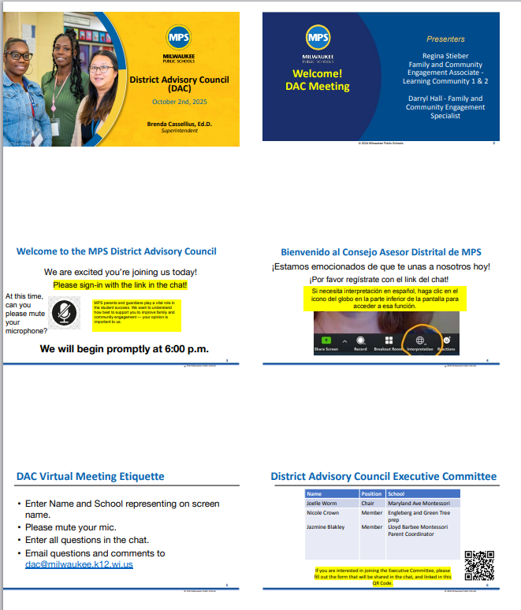

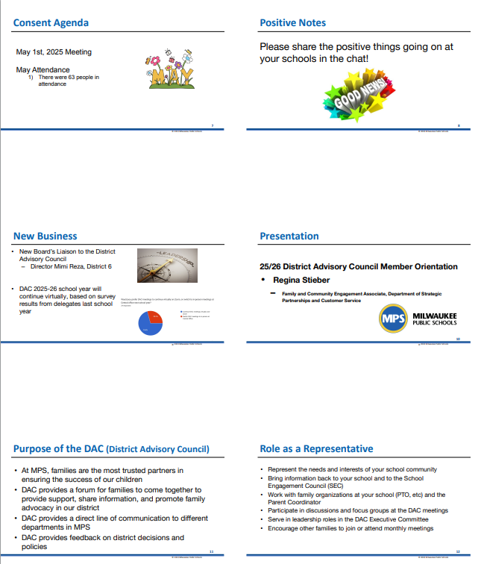

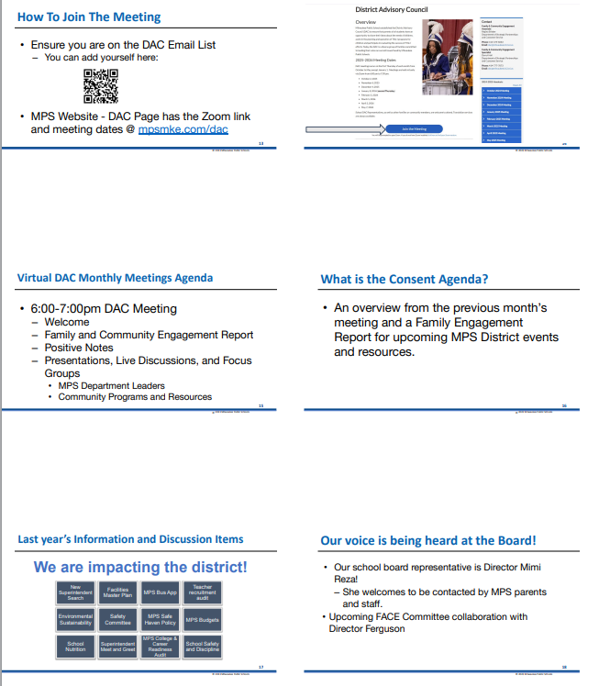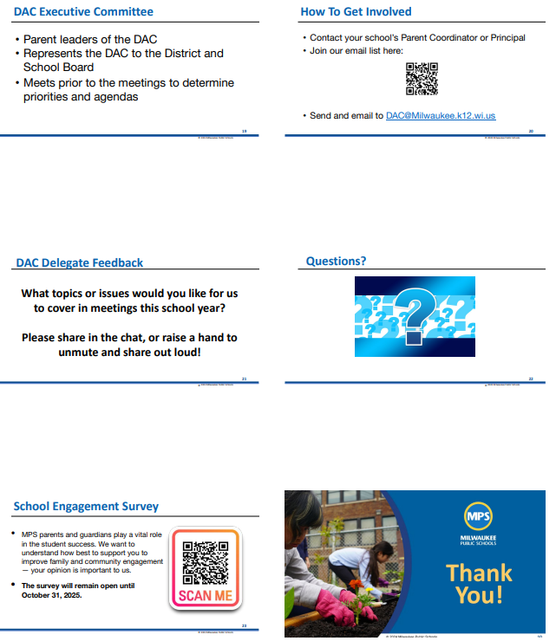

Minutes

Meeting of the Milwaukee Public School District Advisory Council

Thursday, October 2, 2025
6:00 pm – Virtual

- Welcome

- DAC Executive Committee Welcome
- Introductions
- Virtual Etiquette

- Consent Agenda
- Family and Community Engagement Report
- Review the May 2025 Meeting Agenda

- New Business
- New DAC Liaison: District 6: Mimi Reza
- DAC Leadership Opportunities - DAC Executive Committee interest form was shared.
- MPS Board Information

- Positive Notes

- Presentation
- 25/26 Member Orientation - Regina Stieber presented about the DAC, how it runs, parent roles, and DAC history
- Input on Future Meetings - Open discussion was had, parents spoke about issues and wrote in the chat, topics mentioned included:
    - Bus App
    - Students safety
    - I-Pass student data
    - School closures
- Questions

- Evaluation & Adjourn

