Bed Bug Guidelines

What is a bed bug?
Bed bugs are a parasitic insect that feed on human and animal blood. Bed bugs are active at night and bite any areas of exposed skin. Bed bugs can infest a home and hide in crevices or cracks around beds or furniture. Bed bugs have not been known to spread any disease, however, can cause stress, irritation and sleepless nights.
Usually, bed bugs hide during the days and are active at night. Unlike head lice, bed bugs do not live on the human body but may be transported on the body, clothing, shoes, backpack, luggage, books or other items.
What do bed bugs and bites look like?
Bed bugs are small (1/16 to ¼ inch), oval, wingless insects of the family Cimicida. The bugs vary in size and color depending on the where they are in the maturation cycle. Young immature bed bugs are translucent and mature bed bugs are flat with reddish-brown bodies.
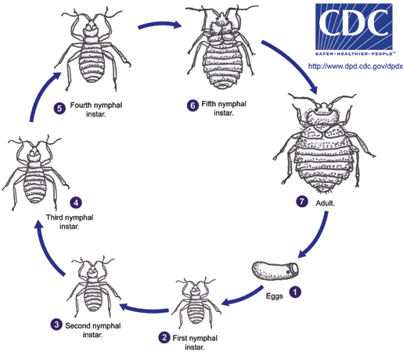
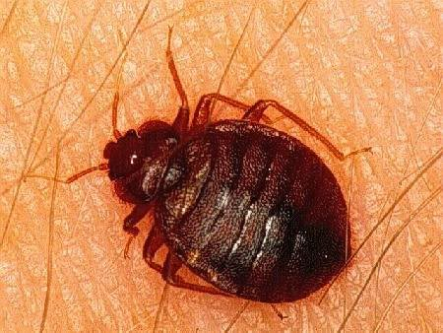

Bed bugs bites are random disperse red, circular macular-papular lesions that are highly pruritic or itchy. Bites vary in size based on the maturity of the bed bug and the inflammatory response of the individual. Consequently, some bites may go unnoticed; bed bug bites may also result in localized swelling and itching,

similar to mosquito bites. The areas may become inflamed or infected when scratched. Bed bugs are not believed to transmit diseases to humans.
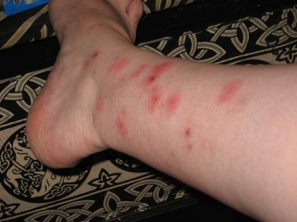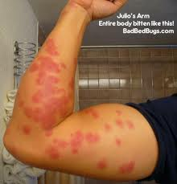

What is the prevalence of bedbugs?
Prevalence is difficult to estimate, however, the Milwaukee Health Department has indicated an increase in calls concerning bed bugs over the last 10 years. Bed bugs have begun making a comeback across the U.S. Several reasons for this resurgence have been suggested including: increase in international travel and commerce, high tenant turnover, changes in pesticide use, and insecticide resistance. Similar to head lice, bedbugs are an equal opportunity infestation without preference for hygiene, race or socioeconomic factors.

Where would I find bed bugs in a house?
Bed bugs can be elusive since they are active at night and are adept at squeezing into seams, folds, creases and cracks. Places were you might see dead bed bugs are on mattress, carpet and couches. Also, you may want to look on mattress, pillow and couch cushions for the spots of black fecal matter of bed bugs or the small maroon spots from the bites. Although, bed bugs need a human or animal blood to survive, they will reside in mattress, pillows, fabric-covered furniture, and cardboard in picture frames.

How do bed bugs migrate to different locations?
Bed bugs are transferred from one location to another by the transfer of a bed bug or egg on furniture, mattresses, pillows, luggage, purses and fabric bags. Unlike head lice, bed bugs do not live on the human or animal body. However, bed bugs may also be transferred by riding on the clothing or shoes of humans which has had contact with an infested location.

What is the treatment for bed bugs?
Once home is infested with bed bugs, it can be difficult to eradicate. Bed bugs hide so well and can live for months without eating. Professional exterminators use a combination of pesticides and nonchemical treatments. If families are using the pesticides themselves, it is important to following all the directives on the product label.

Non-chemical interventions include:
- Vacuuming. A thorough vacuuming of cracks and crevices can physically remove bedbugs from an area. But vacuum cleaners can't reach all hiding places. Used vacuum cleaner bags need to be carefully disposed.
- Hot water. Washing clothes and other items in water at least 120 F (49 C) can kill bedbugs.
- Clothes dryer. Placing wet or dry items in clothes dryer set at medium to high heat (114-118ºF) for 30 minutes will kill bedbugs and their eggs.
- Freezing. Bedbugs are also vulnerable to temperatures below 32 F (0 C), but you'd need to leave the items outdoors or in the freezer for at least 5 days.
- Pillow and mattress protectors. Protectors that are labeled “allergen resistant” will assist in the movement of bed bugs by restricting movement. These protectors need to be completely occlusive. Seal any opening with duct tape.
Some professional exterminators use portable devices to raise the temperature of a room to a lethal temperature. All stages of bedbugs can be killed at air temperature at 122 F (50 C) for 1 hour. In some cases, you may have to throw out heavily infested items such as mattresses or couches.

Suggested Prevention Measures for School Buildings
- Elimination of fabric covered furniture, pillows in school buildings.
- Minimum rugs in the classroom whenever possible.
- Frequent vacuuming of necessary rugs.
- Minimize the amount of materials going home and back to school.
- Place personnel items such as coats and purse in bin or large sealable bag or plastic bin upon entering the school.
- Place contaminated clothing into dryer on high heat for 30 minutes. If the item has many creases such as a backpack place in dryer for 40 minutes.
- Minimize the items you bring back and forth into the school.
- Keep the classroom, especially coat and backpack closets, as clean and free of clutter as possible.
- Initiate a policy of keeping all “Lost and Found” clothing, backpacks, etc. in closeable plastic storage bins (rather than in cardboard boxes) preferably in a central location.

Suggested Prevention Measures for School Staff going into Student’s Homes.
- Bring only the supplies that are necessary into the home.
- Keep all supplies, purses and backpacks off the floor or fabric-covered surfaces in the home.
- Wear protective disposable booties over shoes or boots. Have a designated pair of shoes in your car trunk or zip lock back for use on all home visits.
- Whenever possible complete home visits at the end of the day. Upon your return home, remove clothing on a non-carpeted or rugged floor, place clothing in plastic bag, and transfer to clothing to laundry facilities and wash in hot water and dry in clothes dryer set to the hottest setting.
Typically, the Bureau of Child Protective Services will not open a case due to neglect solely for a family with a persistent bed bug infestation.

Measures if a bug is visualized in school:
- Using a tweezers or an index card, capture the bug and place the bug in a sealable plastic bag or bottle. Immediately, report the incident to the school engineer. Identify the exact location where the bug was found include surface and room number and write this on the bag or labeled bottle.
- Student should not be excluded from school. The parents or guardian should be notified. A nonjudgmental attitude is important. It is difficult to determine the exact source of the infestations once children are in a school building.
- The school engineer will notify the Facilities and Maintenance Supervisor for guidance as appropriate. Only the school engineer or the Building Operations Pest Control team is authorized to use pesticides in MPS schools.
Resources for families:
- Milwaukee Public Health Department - 414-286-8620
- Milwaukee Health Department Bed Bug Fact Sheet: http://city.milwaukee.gov/ImageLibrary/User/tweile/pdf/broc/DNS-311_BedbugBroc_V1wb.pdf
Websites:
Mayo Clinic, Bed bugs, available at: http://www.mayoclinic.com/health/bedbugs/DS00663.
Center for Disease Control and Prevention, Bed Bugs, available at: http://www.cdc.gov/nceh/ehs/topics/bedbugs.htm and http://www.cdc.gov/parasites/bedbugs/.
U.S. Environmental Protection Agency, Bed Bugs, available at: http://www.epa.gov/bedbugs/.
University of Minnesota, Let’s get rid of bed bugs, available at: http://bedbugs.umn.edu/Resources/index.htm.
Medline Plus (English and Spanish) available at: http://www.nlm.nih.gov/medlineplus/bedbugs.html.

