Topic: Self-Care
Learning Intention:
- We are learning that Self-Care is specific to our individual needs
- We are learning that incorporating Self-Care strategies in our daily routine increases individual well-being
- We are learning that there is a relationship between Self-Care and attending school
Success Criteria:
- We know we are successful when students develop a plan to take care of themselves to improve their daily attendance at school.
Materials for Activity:
- Paper Plates (1 for each participant)
- Handouts for each participant
- Markers/Chalk
- Attendance Report Week Prior
Standard Circle Set-Up:
- Chairs in a circle (preferably without desk attached)
- Center piece in center of circle
- 3-4 talking pieces around the center piece
- 2-4 copies of Shared Agreements
Group Procedure
Welcome
Greet students, get in circle. If needed, seat students strategically. Notice how the group is doing today (e.g. high or low energy, high or low motivation). If needed, remind students of the shared agreements. You can ask a student to volunteer to read them or read them yourself.

Icebreaker
Fun Activity to Set Tone: "Full-Plate". Have each participant write "what is on their plate" on their plate. (Hold onto them for closing). Have each participant share something that surprised them when filling their plate (if anything). If nothing surprised them, have them share the most important piece of their plate.

Prior Week Reflection
Pass out the prior week attendance data. Have students reflect on their performance by stating: Let’s take some time to review our attendance for the week.
- Facilitator, take time to explain the attendance report provided. Elaborate on the codes (ANOX, TAUN, ABEX, TAEX, LATE, A, etc.).
- Facilitator, you may use IC reports or student profile report in Dashboard to approximate attendance percentage.
- On average, if you miss 2 days a month (in high school that may be 14 class periods) every month, your attendance is 90% which is considered chronically absent.
After group understands attendance report ask: In the last week what prevented you from getting to school?

Topic of the Week
Self-Care

Inspiring Word
"Your mind will answer most questions if you learn to relax and wait for the answer." - William S Burroughs

"Self-care is not selfish or self-indulgent. We cannot nurture others from a dry well. We need to take care of our own needs first, then we can give from our surplus, our abundance." - Jennifer Louden

Lesson
As we saw from our "Full-Plates", we all live fast-paced, busy, stressful lives, and when we don't take care of ourselves, it makes it very difficult to do our daily activities well. It is important to take time for ourselves to be able to do our best in all areas of our lives. Self-Care is the intentional act of taking care of yourself (physical, mental, and emotional health). Establishing self-care habits is an important part of living a healthy and happy life. Self-care is a personal preference, and it is important to consider what works for you.

- Physical Health
  - Food
    - Eat regularly, nutritional items
  - Exercise
    - Recommended 30 minutes of exercise 5 times a week
    - Walk to or home from school, can combat feelings of sadness/depression and prevent health problems
  - Sleep
    - 6-10 hours of sleep (appropriate bed times)
  - Medical Care
    - Taking prescriptions, seeing the doctor/dentist
- Emotional Health
  - Counseling
    - In school or in community
  - Keeping a Journal
  - Being around positive people
    - Laughing, smiling, etc.
  - Hobbies
  - Meditation/Relaxation
    - Practice deep breathing
    - Take a hot bath/shower
- Mental Health
  - Take Prescriptions
  - Talk to Friends
  - Read! Learn!
*Other important things to consider...
- ALL 3 realms are connected and impact our overall well being
- We all are full time students, may have jobs, volunteer and support our families in different capacities. Finding time to do activities that we enjoy is an important aspect of self-care.
- Be AWARE of things you may be doing that take up a lot of your time but don't support your self-care such as too much time on the internet, watching TV, even sleeping. These can be relaxing, enjoyable activities in moderation.
- Get involved in a sport or hobby that you LOVE! Find other people who are doing the same thing! Knowing that people are counting on you to show up can help motivate you.
- Turn off your cell phones.

Activity to Practice Skill
Review Handout "50 Ways to Take a Break"

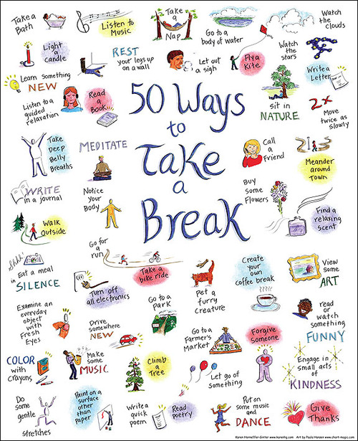

Review Handout "My Self Care Plan (sample)"
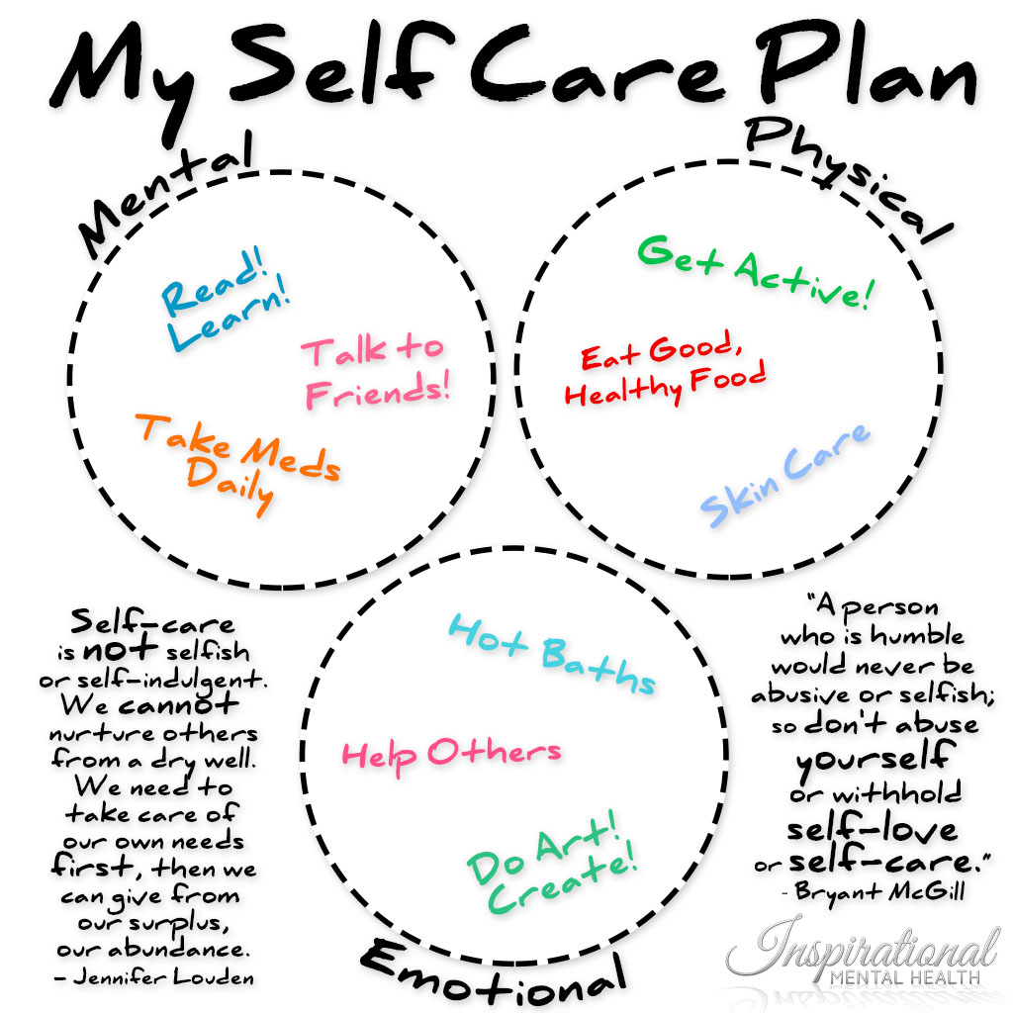

Have each Participant complete their "My Self Care Plan" Handout (page 8)
Closing Circle Question
Have each student retrieve their "Full-Plate" from the icebreaker. Have each student flip their plate over, and have them re-draw how they HOPE their plate would look incorporating their Self-Care strategies. Send the talking piece around to share one Self-Care strategy they plan to use in the next week and how it will help them get to school every day and be able to stay all day.

Student Agenda
Topic: Self Care
Welcome
Icebreaker
Fun Activity to Set Tone: "Full-Plate". Have each participant write "what is on their plate" on their plate. (Hold onto them for closing). Have each participant share something that surprised them when filling their plate (if anything). If nothing surprised them, have them share the most important piece of their plate.
Topic of the Week
Self-Care
Inspiring Word
"Your mind will answer most questions if you learn to relax and wait for the answer." - William S Burroughs
"Self-care is not selfish or self-indulgent. We cannot nurture others from a dry well. We need to take care of our own needs first, then we can give from our surplus, our abundance." - Jennifer Louden
Lesson
Self-Care is the intentional act of taking care of yourself (physical, mental, and emotional health). Establishing self-care habits is an important part of living a healthy and happy life. Self-care is a personal preference, and it is important to consider what works for you.

- Physical Health
  - Food
    - Eat regularly, nutritional items
  - Exercise
    - Recommended 30 minutes of exercise 5 times a week
    - Walk to or home from school, can combat feelings of sadness/depression and prevent health problems
  - Sleep
    - 6-10 hours of sleep (appropriate bed times)
  - Medical Care
    - Taking prescriptions, seeing the doctor/dentist
- Emotional Health
  - Counseling
    - In school or in community
  - Keeping a Journal
  - Being around positive people
    - Laughing, smiling, etc.
  - Hobbies
  - Meditation/Relaxation
    - Practice deep breathing
    - Take a hot bath/shower
- Mental Health
  - Take Prescriptions
  - Talk to Friends
  - Read! Learn!
*Other important things to consider...
- ALL 3 realms are connected and impact our overall well being
- We all are full time students, may have jobs, volunteer and support our families in different capacities. Finding time to do activities that we enjoy is an important aspect of self-care.
- Be AWARE of things you may be doing that take up a lot of your time but don't support your self-care such as too much time on the internet, watching TV, even sleeping. These can be relaxing, enjoyable activities in moderation.
- Get involved in a sport or hobby that you LOVE! Find other people who are doing the same thing! Knowing that people are counting on you to show up can help motivate you.
- Turn off your cell phones.

Activity to Practice
Review Handout "50 Ways to Take a Break"
Review Handout "My Self Care Plan (sample)"
Have each Participant complete their "My Self Care Plan" Handout
Closing
Flip plate over, and re-draw how you HOPE your plate would look incorporating Self-Care strategies. What self-care strategy do you hope to use in the nest week; How will it help you get to school every day and be able to stay all day?

All are related…

EMOTIONAL
PHYSICAL
MENTAL

