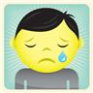SAD | MAD/ANGRY  
SCARED/Afraid   | 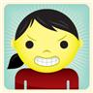JEALOUS
WORRIED | CONFUSED
EMBARRASSED | HAPPY

