
Classroom Survival Skills Grades 6–8

Topic: Refocusing After Distraction
Learning Intentions: We will be able to:
- Recognize our common distractors
- Establish a cue for recognizing that we are distracted
- Say to ourselves, “I am distracted and I need to get back to work”
- Re-engage in the expected task
Success Criteria: We know we’re successful when we can recognize our common distractors, establish a cue for recognizing that we are distracted, say to ourselves, “I am distracted and I need to get back to work,” and re-engage in the expected task.
Materials for Activity: None
Standard Circle Setup:
- Chairs in a circle
- Center piece
- 2–3 talking pieces (to allow selection)
- Shared agreements (refer to your school PBIS expectations)
Teaching Procedure:
- Welcome and names
- Reminder: shared agreements (refer to your school PBIS expectations)
- Begin with a mindful practice (see “Menu of Mindful Practices”).
- Identify topic: IGNORING DISTRACTIONS
Today we are going to learn an important classroom skill—recognizing distractions and refocusing.
- Opening circle question/prompt: Last week we asked, “What is one thing that distracts you that you will try ignoring this week?” How did that go, and what did you notice?
- Explain need for skill (connect with PBIS when appropriate):
  - You probably noticed that you were not always able to ignore the distraction. Some distractions are hard to ignore, so we need to be able to recognize that we are distracted and get back on task. Refocusing allows us to be responsible in getting our work done.
- Teach learning intentions:
  - Recognize our common distractors.
  - Establish a cue for recognizing that we are distracted.

  - Say to ourselves, “I am distracted and I need to get back to work.”
  - Re-engage in the expected task.
- Success Criteria: We know we’re successful when we can recognize our common distractors, establish a cue for recognizing that we are distracted, say to ourselves, “I am distracted and I need to get back to work,” and re-engage in the expected task.

- Explain internal and external distractors:
  - Say to students: There are two types of distractors: external, which come from outside of us, and internal, which comes from our thoughts and feelings. Some people get more easily distracted by what is going on around them, while others are more easily distracted by things going on in their own mind. Some people find both types equally distracting. Here are some examples of both:
  - External—a conversation, students talking, radiators/fans making noise, a friend who is arguing with you right now
  - Internal—being upset about something from this morning still, being excited about what is happening after school, thinking about something over and over and not being able to forget it.
  - Have students individually create a list of internal and external distractors they have experienced this week. Ask the students what they notice about their lists. Are they more easily distracted by internal, external, or both? Do they find one type of distractor harder to ignore than the other?

- Explain the importance of quickly recognizing when you are distracted:
  - Ask the students: How do you know when you are distracted or are getting distracted? What tells you or cues you that you are off-task? How much time do you think passes between when you get distracted and when you recognize you are distracted?
  - Say: An important part of working efficiently is noticing more quickly when you are distracted. Once you notice, you can then refocus on the activity. The key is that you cannot refocus on an activity unless you have first noticed you are distracted.
  - Once you notice you are distracted, say to yourself, “I am distracted and need to get back to work.” Then refocus on the activity you were working on.

Activity to Practice: Brain teasers (see attached links) or visual analogies (see attached), or choose something similar like I Spy, Where’s Waldo, or mazes
Play beep tape. http://www.interventioncentral.org/sites/default/files/audio_files/audio_monitoring_tapes/FI_15_Secs_30_Min_Tape_Final.mp3

Have students work on task. Instruct students that when they hear the beep, they should ask themselves, “Am I on task?” If they are on task, they should continue working; if not, they should use steps to refocus. Allow students to engage in this activity for 2–3 minutes (or as long as they are engaged).
BRAIN TEASERS: https://www.dropbox.com/s/7qdyboapyyskbq5/Hidden%20Meaning%20Brain%20Teaser%20by%20Kandy%20Kreations.pdf
ANSWERS: https://2.bp.blogspot.com/-SfNl8k3zKmU/UxOxoo-i5eI/AAAAAAAAJcc/M3178hKrM90/s600/Hidden+Meaning+Brain+Teaser+answers.jpg

Closing Circle Question: Did the beep help you notice when you were off task? You won’t have this beep in your classroom. For the distractor you focused on last week, what could be a cue, like the beep, to remind you to notice whether you are distracted or not?

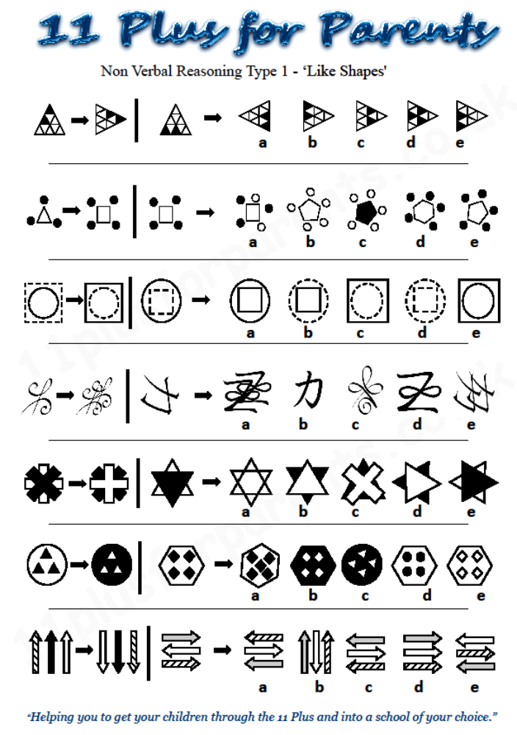
From 11 Plus for Parents: http://www.11plusforparents.co.uk/

