

Anti-Bullying Policy Bilton School
Date Ratified by Local Governing Body: 20 November 2025 Next Review Date: November 2026
Chair of Governor’s signature: 

Person responsible in school to implement: Jayne Delves

Stowe Valley Multi Academy Trust
Registered Office: Southam College, Welsh Road West, Southam, Warwickshire, CV47 0JW Registered in England No: 10445759. A Company Limited by Guarantee Telephone 01926 812560

CONTENTS PAGE

- Statement of Intent

- Aim

- Objectives

- Definition of Bullying

- Identifying and reporting concerns about bullying

- Responding to reports about bullying

- Preventative measures

- Bullying recording

- Support websites

Statement of Intent:
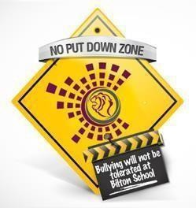
Bilton School has and will maintain a zero-tolerance approach to Bullying. We strive to create a culture based on building positive relationships and one of our values of compassion.

Bilton School sets high standards for our students it is important that we create an atmosphere in which bullying cannot thrive. No student needs to suffer from harassment of any kind.

Bilton School operates a ‘No Put Down Zone’ philosophy creating an ethos where everyone should feel safe from criticism. Effort and progress should be celebrated and staff vigilant about negativity (e.g. Swot, Geek, Boffin). Mistakes
are part of the learning process and students should never be ridiculed in our supportive learning environment.

We also operate a ‘No hands On’ policy so that students do not physically engage with one another in any way, rather they learn to talk and communicate as young adults.

We recognise that bullying takes place at all levels in society and, therefore, Bilton aims to educate students about the impacts of bullying and teach them strategies that enable them to stand up for themselves without resorting to retaliation in any form. We work with parents and/or carers when dealing with incidents of bullying so that all parties are able to distinguish between what is classed as bullying and what is not.

Aim:
The aim of the anti-bullying policy is to ensure that students learn in a supportive, caring and safe environment without fear of being bullied, and that staff are free from fear of bullying by students. Bullying is anti-social behaviour and affects everyone; it is unacceptable and will not be tolerated. Only when all issues of bullying are addressed will students be able to fully benefit from the opportunities available at school.

Objectives:
  - Make sure that all students and adults mean the same thing when they are talking about bullying
  - Help students to understand how bullying feels for the person being bullied and create a supportive climate where bullying is not tolerated
  - Make sure that all students feel able to tell an adult when they know that bullying is going on
  - Make sure that students know exactly what they need to do if they are being bullied, and to feel confident that something will be done to stop it.
  - Help students enjoy, celebrate and respect the ways in which we are all different and to feel good about themselves

Definition of Bullying:
This school has chosen to adopt Warwickshire Anti-bullying Partnership’s definition: “When a person or group of people’s behaviour over a period of time leaves someone feeling one or more of the following:

  - Physically and/or mentally hurt or worried
  - Unsafe and/or frightened
  - Unable to do well and achieve
  - ‘Badly different’, alone, unimportant and/or unvalued
  - Unable to see a happy and exciting future.”

It could be viewed as bullying when a person, or group of people, has been made aware of the negative effects of their behaviour, on another person, and they continue to behave in the same manner. If someone feels they, or someone else, is being bullied, it should be investigated. This should happen straight away as it can take a long time to build up the courage to tell. However, lots of things can make people feel bad, sometimes it depends on the situation we are in, and it is not always bullying – so we think the following definition, adapted from one written by the Anti-bullying Alliance, is also useful:

Bullying is any behaviour by an individual or group that:
  - is meant to hurt – the person or people doing the bullying know what they are doing and mean to do it;
  - when it is repetitive with the intention of hurting a person or people by one person or group, where the relationship involves an imbalance of power;
  - happens more than once – there will be a pattern of behaviour, not just a ‘one- off’ incident;
  - involves an imbalance of power – the person being bullied will usually find it very hard to defend themselves. It can be:
    - Physical, e.g. kicking, hitting, taking and damaging belongings
    - Verbal, e.g. name calling, taunting, threats, offensive remarks
    - Relational, e.g. spreading nasty stories, gossiping, excluding from social groups
    - Racial e.g. using colour or religious differences
    - Homophobic or sexual e.g. making fun of someone’s sexuality or gender reassignment
    - Cyber, e.g. texts, e-mails, picture/video clip bullying, Instant Messaging

Identifying and reporting concerns about bullying
All concerns about bullying will be taken seriously and investigated thoroughly.

Students who are being bullied may not report it. However, there may be changes in their behaviour, such as becoming shy and nervous, feigning illness, taking unusual absences or clinging to adults. There may be evidence of changes in work patterns, lacking concentration or truanting from school. School staff will be alert to the signs of bullying and act promptly and firmly against it in accordance with this policy.

Students who are bullying others also need support to help them understand and change their behaviour.

Students who are aware of bullying (‘bystanders’) can be a powerful force in helping to address it and will be encouraged to do so in a safe way. Assemblies, lessons, posters, and Anti-Bullying Week activities will focus on the responsibility of bystanders to report bullying and certainly not act as ‘reinforcers’.

Why witnesses don’t tell:
- They worry that they will become targets themselves
- It is not cool to be seen as a ‘grass/snake’
- It is hard to go against a crowd

All students will be encouraged to report bullying by:
  - Reassurance that their report will be kept confidential.
  - Highlighting the dangers of bullying
  - Listening and supporting the student

Reporting methods:
  - Talking to a member of staff of their choice (particularly Tutor, Pastoral Leader, Head of Year).
  - Report bullying online by using the ‘Are you worried – need to talk’ anti-bullying icon on the Safeguarding area of the school website. If students wish to report a bullying incident then filling out the online form will notify their Pastoral Leader and Head of Year immediately.
  - Report concerns via the drop box located outside each Head of Year office, or in the school library, using the ‘I’d like to talk …’ reporting form available in the school library, from form tutors or from the school reception. These boxes will be checked at key points throughout the school day.
  - Where bullying outside school is reported to Bilton school staff, it will be investigated and acted on. The Headteacher will also consider whether it is appropriate to notify the police or anti-social behaviour coordinator in Warwickshire of the action taken against any Bilton student. If the misbehaviour could be criminal or poses a serious threat to a member of the public, the police should always be informed.
  - Contacting local and national support agencies for advice/support

Responding to reports about bullying
Bilton school will take the following steps when dealing with concerns about bullying, we set the right ethos by being a “telling school” where students feel supported and know how and where to report bullying:

  - If bullying is suspected or reported, it will be dealt with immediately by the member of staff who has been made aware of it and recorded on CPOMS.
  - A clear account of the concern will be recorded and given to the Pastoral Leader.
  - The Pastoral Leader will interview everyone involved and keep a detailed record, entering the incident on CPOMS and their own bullying log.
  - Form tutors and Heads of Year will be kept informed and, if it persists, the Pastoral Lead will advise the appropriate subject teachers and the Head of Year.
  - As this is such an emotive and dangerous subject, parents and other relevant adults will be kept informed. All communication with home should be recorded. Where the child appears to have been the victim of bullying, it is suggested that a face-to-face meeting is set up, to consider the case and actions recorded.
  - Where bullying occurs outside school, any other relevant schools or agencies (e.g., youth clubs, transport providers, PCSOs) will be informed about the concerns and any actions taken.
  - Sanctions will be used as appropriate and in consultation with all parties involved.

Students who have been bullied will be supported by:
  - offering an immediate opportunity to discuss the experience with a member of staff
  - providing reassurance that the bullying will be addressed
  - offering continuous support
  - providing them with a notebook to record any future incidents and check with them regularly
  - restoring self-esteem and confidence
  - developing anti bullying techniques
  - the use of specialist interventions and/or referrals to other agencies e.g. Mental Health Nurse

Students who have bullied will be helped by:
  - discussing what happened
  - discovering why they became involved
  - establishing the wrongdoing and the need to change
  - looking at the dangers/consequences of bullying
  - informing parents to help change the attitude of the student
  - the use of specialist interventions and/or referrals to other agencies where appropriate

The following disciplinary steps can be taken:
  - official warnings to cease offending
  - detention
  - exclusion from certain areas of school premises
  - loss of social time
  - internal exclusion
  - minor fixed-term exclusion
  - major fixed-term exclusion
  - permanent exclusion

Parents / carers
We see the importance of working with parents/carers for them to understand our approach with regards to bullying and to engage promptly with them when an issue of bullying comes to light. Whether their child is the student being bullied (i.e.. “alleged victim”) or the one doing the bullying (i.e.. “alleged perpetrator”) we will ensure parents/carers are made aware of how to work with us on bullying and how they can seek help if a problem is not resolved.

Some parents/carers may need specific support to help deal with their child’s behaviour. Where Bilton identifies that this is the case, we will initially provide support ourselves or signpost the parent/carers to appropriate channels of help.

Most concerns about bullying will be resolved through discussions between home and School; however, where a parent feels their concerns have not been resolved, they are encouraged to use the Formal Complaints Procedure.

  - Where a student is involved in bullying others outside school, e.g. in the street or through the use of the internet at home, parents will be asked to work with the school in addressing their child’s behaviour, for example, restricting/monitoring their use of the internet or mobile phone.
  - Referral of the family to external support agencies will be made where appropriate.

- Preventative measures
Bilton School will:
  - Raise awareness of the nature of bullying through inclusion in Character and Culture, ICT, tutorial time, assemblies, subject areas and informal discussion, as appropriate, in an attempt to eradicate such behaviour.
  - By developing a common language of power phrases, including (but not limited to): “I don’t like it, please stop” or “I don’t know why you are doing this, but I would like it to stop”, “Please leave me alone now”, “This is a ‘no hands on school’”.
  - Participate in national and local initiatives such as Anti-Bullying Week and the work of Warwickshire’s Anti-Bullying Partnership.
  - Ensure close communication with our primary schools to identify potentially vulnerable students and bullies and share effective strategies.
  - Seek to develop links with the wider community that will support inclusive antibullying education.
  - Consider the use of specific strategies, for example peer mentoring, on a regular basis and implement them if appropriate, subject to available resources.
  - Ensure that social times are well staffed, and that age related social areas are available.
  - Provide ‘safe’ area for vulnerable students such Refocus and Bilton Boost.

Bullying Reviews
  - Pastoral Leaders will maintain the Bullying Spreadsheets and discuss these regularly with their Head of Year, to ensure effective measures have been taken for individual cases and to look for patterns emerging within the statistics concerning vulnerable groups or particular types of bullying.

Process:

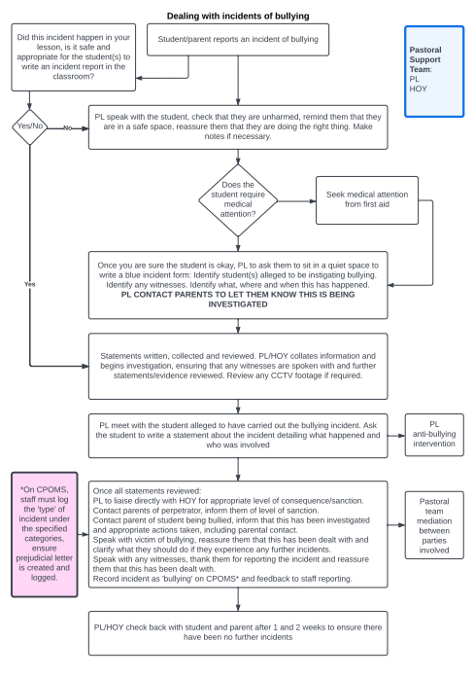

Supporting Organisations and Guidance
- Anti-Bullying Alliance: www.anti-bullyingalliance.org.uk
- Beat Bullying: www.beatbullying.org
- Childline: www.childline.org.uk
- DfE: “Preventing and Tackling Bullying. Advice for headteachers, staff and governing bodies”, and “Supporting children and young people who are bullied: advice for schools” March 2014: https://www.gov.uk/government/publications/preventing-and-tackling- bullying
- DfE: “No health without mental health”: https://www.gov.uk/government/publications/no- healthwithout-mental-health-a-cross- government-outcomes-strategy
- Family Lives: www.familylives.org.uk
- Kidscape: www.kidscape.org.uk
- MindEd: www.minded.org.uk
- NSPCC: www.nspcc.org.uk
- PSHE Association: www.pshe-association.org.uk
- Restorative Justice Council: www.restorativejustice.org.uk
- The Diana Award: www.diana-award.org.uk
- Victim Support: www.victimsupport.org.uk
- Young Minds: www.youngminds.org.uk
- Young Carers: www.youngcarers.net

Cyberbullying
- Childnet International: www.childnet.com
- Digizen: www.digizen.org
- Internet Watch Foundation: www.iwf.org.uk
- Think U Know: www.thinkuknow.co.uk
- UK Safer Internet Centre: www.saferinternet.org.uk

LGBTQ+
- EACH: www.eachaction.org.uk
- Pace: www.pacehealth.org.uk
- Schools Out: www.schools-out.org.uk

Racism and Hate
- Anne Frank Trust: www.annefrank.org.uk
- Kick it Out: www.kickitout.org
- Report it: www.report-it.org.uk
- Stop Hate: www.stophateuk.org

SEND
  - Changing Faces: www.changingfaces.org.uk
  - Mencap: www.mencap.org.uk
  - DfE: SEND code of practice: https://www.gov.uk/government/publications/send-code- of-practice0-to-25

Appendix 1: Student reporting form
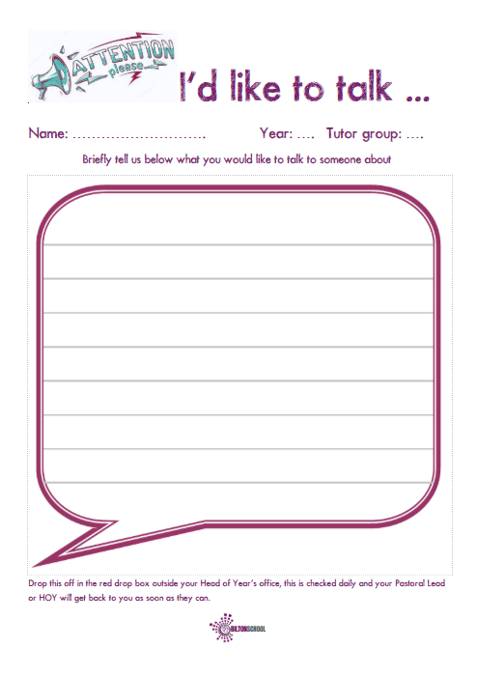

Appendix 2: Anti-bullying charter
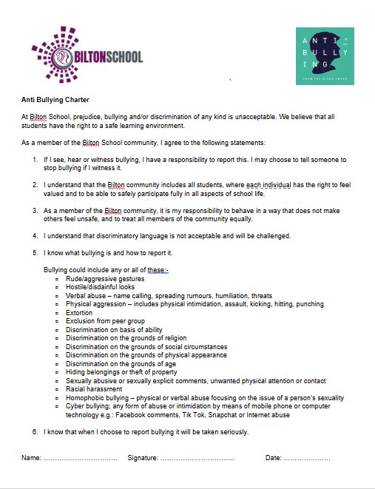

Appendix 3: Roles of involved in bullying incidents

