FY2026

Kyrene Travel Procedure Handbook
Contents
Approval Prior to Travel 2
Travel Status 2
Submit your Claim in a timely manner 2
Mileage Reimbursement 3
Guidelines for Calculating Mileage for Reimbursement: 3
Meal Reimbursement 3
Lodging & Conference Information 5
Conference Lodging 5
Transportation Information 6
Conference Transportation 6
Airport Parking 6
Car Rental 6
Travel FAQs 7
TRAVEL EXPENSE INSTRUCTIONS 8
prior to travel 8
upon your return 8

General Travel Information
The Kyrene School District is committed to continuous learning and encourages on-going professional development as well as opportunities for student competition and learning experiences. At times, this requires travel within or out of state. The Kyrene Elementary School District adheres to the State of Arizona Accounting Manual Travel Policy as set forth by the Arizona Department of Administration, General Accounting Office. Please review this document in its entirety and complete the appropriate forms to submit to your supervisor for approval prior to travel. All employees traveling MUST read the State of Arizona Accounting Manual Traveler Responsibilities document prior to travel. When district travel is approved, the most economical means should be selected.

Approval Prior to Travel
- No travel arrangements or commitments are to be made until appropriate approvals are obtained.
Obtain the Travel Pre-Approval Workbook from the Travel Website . Complete all applicable sections in the Travel Pre-Approval Workbook to its entirety. Print the Travel Pre-Approval Form from workbook, obtain supervisor signature, save in PDF format and submit to bs-travel@kyrene.org. Submit completed Travel Pre-Approval Workbook via email to bs-travel@kyrene.org.
- Prior to submitting the Travel Pre-Approval Workbook, please ensure you have completed all applicable sections in the workbook and attach conference agenda and travel quote (s) to your email. Incomplete forms will be returned to sender.
- Once the Travel Pre-Approval Workbook has been emailed to bs-travel@kyrene.org, one of the Finance team members will review your workbook and notify you by email when it is appropriate for you to proceed with your travel requisitions.
- Confirm your conference registration requisition is submitted and approved prior to travel. Additionally, a requisition for travel reimbursement must also be approved by Finance.

Travel Status
To be in travel status, a traveler must be more than fifty (50) miles from both their residence and regular work site. To be eligible for reimbursement of meals & lodging, employees must be at least 50 miles from their duty post and personal residence and conduct an overnight stay.

Submit your Claim in a timely manner
- Upon return, traveler must complete and submit the Travel Expense Claim Form within two (2) calendar months of travel, including zeroed out receipts for hotel, airfare and transportation (if applicable). Submit to the Finance Dept, Attn: Accounts Payable.
- Please ensure all necessary bookings (flights, accommodation, transportation, registration) are completed as per the approved Travel Pre-Approval Workbook. Only allowable reimbursable amounts will be reimbursed to the employee as authorized by the Finance Department in the Travel Pre-Approval Workbook.
- For employees who are normally reimbursed for in-district travel, claims should be submitted at least monthly, but no later than two (2) calendar months after travel is completed. Please note, travel claims filed beyond the designated filing deadlines may not be eligible for reimbursement. Where receipts are required, please submit the original detailed receipts showing payment in full with your claim. Please keep a copy for your own records.

Mileage Reimbursement

*Refer to the State of Arizona Accounting Manual (SAAM) Topic 50 Section 95 for current mileage rate
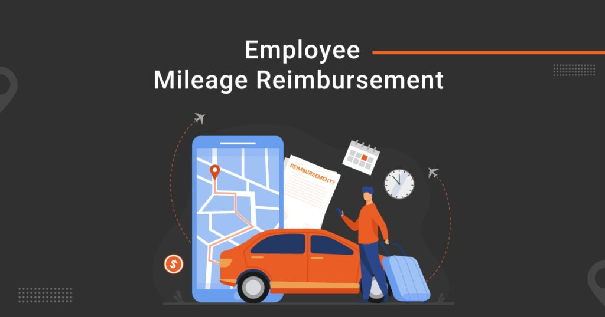

Guidelines for Calculating Mileage for Reimbursement:

- Use the current Mileage Claim Form located on the Travel website and the T:Drive\Business Services\Travel Forms to submit only for mileage reimbursement. This form is not to be used to claim reimbursements for lodging, airfare, meals or other incidentals. This form is for both in-district and out of district mileage
submission. Please use the appropriate tab and follow the instructions included within the spreadsheet.

- When calculating out-of-district mileage, be sure to use Google Maps to verify mileage.

- Traveler is reimbursed for mileage that is lesser of duty workstation or home to event location.

- The mileage reimbursement rate has been calculated to cover all automobile expenses such as fuel and oil, towing charges, repairs, replacements, tires, depreciation and insurance.

- Mileage from event location to obtain meals and back are not reimbursable, as these are considered incidentals and part of the meal reimbursements.

- Commuting miles are not reimbursable -- The cost of commuting between a personal residence and a regular work site is not reimbursable, regardless of the distance.

- When choosing to drive to trainings or conferences more than 20 miles from the employee's worksite, every effort should be made to secure a District fleet vehicle and carpool, if appropriate.

Meal Reimbursement

General Information:
- Meal reimbursement may not exceed the per meal allowable maximum reimbursement rate.

- Meal reimbursement allowance amounts are determined by the State of Arizona (SAAM Topic 50 Section 95)
- When tipping at a restaurant, a normal tip should be from 15% to 20%. If an employee wishes to tip more than 20%, it will be considered a personal non-reimbursable expense. Tips are considered a part of the meal per diem.
- If transportation is needed to obtain a meal, the cost of the transportation and related tip reduce the amount available for meal reimbursement.

- A traveler is only eligible for reimbursement of a meal when it is consumed in travel status, at least 50 miles from their work site and home, and they are in travel status for at least six (6) hours that day.

- No meal is eligible for reimbursement if an overnight stay is not included in travel.

Allowable / Non-Allowable Meal Reimbursement:
- Travelers may only purchase meals for themselves. Reimbursement will not be made for other travelers, friends, family, etc.
- Meals consumed within 50-mile radius of your duty post/home city are not reimbursable.
- Alcohol is not reimbursable.
- When meals are provided to the traveler at no expense, the traveler may not claim reimbursement on those meals. (This includes meals provided by the hotel, conference, or airlines.)
- On departure and return days the traveler is eligible for meal reimbursements up to seventy-five percent (75%) of the full-day rate minus 100% of reimbursement per meal provided. On depart day, the daily rate will be determined by the city/state or county traveling to. Upon returning, the daily rate will be determined by the city of where the traveler last stayed the night.

Lodging & Conference Information

General Information

The actual daily room charge you will be reimbursed is limited to the maximum lodging reimbursement rate according to the city. The maximum lodging amount to be reimbursed includes room charge, and fees charged at the discretion of the facility (i.e., parking, resort fees), up to the allowable Per Diem amount. Service charges that are incurred at the discretion of the traveler are not reimbursed. Business calls, fax and copy charges, as well as internet connect charges - if necessary for District business - are reimbursable. When lodging is arranged at a commercial establishment, the lowest available rate should be sought. Additional room features, special accommodations and personal expenses charged to the room are not reimbursed.

Conference Lodging
The only exception to the per diem lodging rate reimbursement maximum is when an employee is staying at a "conference-designated hotel". Proof that the lodging is indeed "conference-designated" must be attached to your Travel Expense Claim Form or you may be responsible for any charges above the per diem rate.
Conference designated lodging includes lodging at the hotel at which the conference is being held or other hotels listed in the conference brochure. Accommodations at alternate hotels in the immediate vicinity of the conference may be considered as conference-designated lodging when no vacancies exist at the hotels listed in the conference brochure. However, reimbursement for lodging may not exceed the least expensive single room rate plus tax, regardless of availability, as published in the conference brochure. A copy of the conference brochure must be submitted with the travel claim to support the reimbursement.

Transportation Information

Conference Transportation

When more than one employee will be attending the same conference, every effort should be made to carpool or use a District-provided vehicle. Please be aware that the most economical travel option will be reimbursed. District will reimburse actual lowest cost available from destination airport to conference hotel and return to destination. Travelers may choose other methods to get to the airport such as rideshare, Uber, Lyft, cab, etc., however, the district will only reimburse the amount per SAAM Topic 50 Section 95. A google map must be attached for travel both directions.

Airport Parking

Phoenix Airport parking will be reimbursed, with an original receipt, up to $6.50 per day. An employee may park wherever he finds it convenient to do so but will only be reimbursed the lesser of the actual amount incurred or six dollars and fifty cents ($6.50) per day base parking charges.

Car Rental

Use of rented vehicles shall be limited to instances where it is to the advantage of the District, and not for personal convenience of the traveler. Car rental is subject to prior approval. Car rentals must be secured and paid for with the traveler's personal credit card. The traveler must have a valid driver's license and appropriate auto insurance.
The following criteria is used for out-of-state vehicle rental:

Length of Travel | # of Travelers | Size of Rental Vehicle
less than a week | 1 - 2 individuals | compact
less than a week | 3 individuals | intermediate (mid-size)
more than a week | 2 - 3 individuals | intermediate (mid-size)

- Travel should be conducted as economically as circumstances reasonably permit, per the Arizona State Travel Policy, Section 6, Policy 5.

- If you are considering driving, every effort should be made to secure a District fleet vehicle. Please be aware that the most economical travel option will be reimbursed.

Travel FAQs

Q) Who comes up with all these rules, anyway?
A) Arizona School Districts must follow the State of Arizona Travel Policy as established by the Arizona Department of Administration – General Accounting Office.

Q) Besides packing, what else do I need to do before I travel?
A) Complete the Travel Pre-Approval Workbook with your supervisor’s signature, and submit all appropriate travel-related Purchase Orders, including a PO to reimburse the traveler for any travel expenses incurred. A copy of the Travel Pre-Approval Workbook must be attached to all travel-related POs.

Q) Should I keep my receipts for reimbursement?
A) Yes! Original, detailed receipts should be submitted with the claim for reimbursement. Keep personal copies until after you have received your reimbursement. Meal receipts are not required to be submitted if the traveler expended at least the per meal maximum reimbursement rates and the employee attests to this in the travel claim reimbursement form.

Q) Is alcohol a reimbursable expense?
A) No.

Q) Are tips to servers reimbursable?
A) Yes, up to 20% of the meal total, within the allowable meal reimbursement rate. This is already included in the meal reimbursement process.

Q) There are no restaurants near my hotel. Can I be reimbursed for transportation costs to obtain a meal?
A) Yes, however the meal reimbursement rate includes the cost of the meal, tax, tip, and the cost of transportation between places of lodging. Additional transportation is applied to the allowable amount for meal reimbursements.

Q) Is hotel parking a reimbursable expense?
A) Maybe, but it depends on the hotel lodging rate paid versus the allowable rate. Please confer with the Finance Department prior to traveling.

Q) My conference is in Tucson. Can I drive my own vehicle and get reimbursed for mileage?
A) Yes. You may also reserve and drive a district-owned vehicle.

Q) I may need to rent a car when I get to my destination. Is that a reimbursable expense?
A) Yes, however, please call the Finance Department for detailed information.

Q) I find this incredibly fascinating! Where can I get more information?
A) On the Kyrene website, select Departments, then select Finance Department, and select Travel. Enjoy!

TRAVEL EXPENSE INSTRUCTIONS
Travel Reimbursement Claim Form must be signed by the traveler and traveler’s supervisor and must include all proper receipts.

The following must be submitted with travel claim:

- Copy of the signed and approved Pre-Approval Travel Workbook
- Copy of hotel receipt showing payment in full
- Copy of airfare receipt showing payment in full
- Copy of transportation receipts showing payment in full

Copies of all Travel Reimbursement Claim Forms should be submitted to Accounts Payable preferably within 5 – 10 days after return. Claims must be submitted within two (2) calendar months of travel or are considered delinquent.

Please email bs-travel@kyrene.org for assistance.

Additional information may also be found at the Kyrene School District Travel website and Arizona Travel SAAM Topic 50

