Message from the Principal:

Dear Parents, Guardians, and Community Members,

I am thrilled to introduce our new newsletter, “The Warrior Beacon,” designed to illuminate communication between the faculty at Wilton-Lyndeborough Cooperative Middle/High School and you, our invaluable members of the school community. As the proud principal of WLC M/HS, I believe in the power of collaboration and open dialogue. Through this newsletter, we aim to keep you informed about the latest developments, achievements, and important updates within our vibrant school community. Together, we will continue to foster a nurturing environment where every student has the opportunity to thrive, be their best version of self and achieve academic best scores.

Thank you for supporting us and may the light of knowledge guide us on an incredible journey this year.

Warm Regards,

Tom

Safety Training

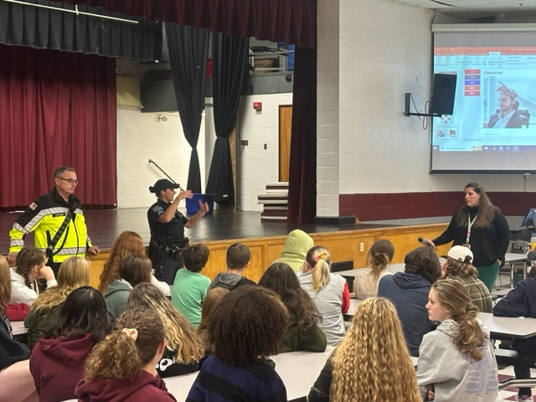
—
We would like to inform you that Thursday, September 28th, we introduced the ALICE) Alert, Lockdown, Inform, Counter, Evacuate) emergency procedure to our students to enhance the safety and security measures at our school. ALICE provides valuable guidance on how to respond effectively to emergency situations, ensuring the well-being of our students and staff. WE are committed to maintaining a safe learning environment, and your awareness and support of these protocols are essential. We ask you to have a conversation with your child(ren) to encourage them to follow the directives of school personnel and ask questions when they come to mind. Through our work together, we can better prepare for any unforeseen circumstances and continue to prioritize the safety of our school community.

ELA 6:
6th grade ELA has wrapped up their first summative grammar assessment and is continuing work with literary devices and figurative language. This week, we are focusing on the Patriot's Pen essay contest. This year's theme is "How Are You Inspired by America?". Students will have the opportunity to enter the Patriot's Pen contest if they choose. Also, please be reminded that the first book report is due on November 10th. Please return any book permission slips that are still missing.

6th Grade Social Studies
Social Studies has been a lot of fun to teach and the students have all shown curiosity and excitement about learning ancient history. On Mondays the students take notes, on Tuesdays the students read a chapter from the textbook, on Wednesdays and Thursdays the students do a larger project and on Fridays students finish any work left undone before the weekend. 6th grade just finished a hands-on project where they simulated ancient river valley kingdoms by collecting water, creating farms out of construction paper and buildings out of cardboard, all while trying to beat the clock. The overwhelming result was that students had fun and learned that by cooperating and working together, not only would they survive but they thrived. 6th grade is now currently learning about the Empires of Mesopotamia and will soon begin studying Ancient Egypt. Later in the year the course will also survey Ancient China, Greece and Rome.
Seventh and Eighth Grade Language Arts
In Seventh and Eighth Grade Language Arts, the students have started the annual essay sponsored by the VFW. The theme for this year is “How are you inspired by America?” In this 300-400 word essay, the students will follow the writing process and write an outline, rough draft and final draft. This program is nationwide and focuses on theme knowledge and development as well as structure and clarity of their writing. The essay is also a contest, and if they want to enter, they can submit their essay to the VFW.

No Nonsense Non Fiction
In the No Nonsense Non Fiction class the seventh graders are learning about hurricanes and other natural disasters through research and hands-on activities. One of the focuses each day is to look at the different types of projections for hurricane activity in the Atlantic and the Pacific on the Smart Board. The students look at what activity has “popped up” and where it may be going as well as what category it is by the Saffir -Simpson Scale. The students are also researching their choice of natural disasters and will present their projects to the class.

Research Methods:7th grade Unified Arts
In this UA we discuss different ways to research different topics. Currently, we finished a project on students discovering the origins of their first, middle and last names. This entailed them to research online what their names mean, as well as asking their parents about why they were given that name. Students created a poster and presented the information they found which allowed me to get to know them more as well as shared interesting facts that their peers did not know about them.

Eighth Grade Language Arts:
8th grade ELA has completed the short story unit. This week, we are focusing on the Patriot's Pen essay contest. This year's theme is "How Are You Inspired by America?". Students will have the opportunity to enter the Patriot's Pen contest if they choose. Afterward, we will proceed to our first novel, "The Little Prince". Also, please be reminded that the first book report is due on November 10th. Please return any book permission slips that are still missing.

Sixth Grade Math
In period 2, 6th grade Math, students are starting to learn about prime factorization, Least Common Multiple (LCM), and Greatest Common Factor (GCF). Students have already mastered exponents and order of operations.

Sixth Grade Science
We are entering a new unit on thermal energy where we are conducting experiments
with cup systems. We just finished a unit on light and matter.

Eighth Grade Science
We are ending a unit on motion and force where we are learning Newton's Laws of motion.

Seventh Grade Social Studies
In the coming days of Ms. Norton's 7th grade Social Studies class, students will be exploring the essential question "how do the geographical features of Earth impact the way humans live?" Through a one-pager expert card project, students will investigate a geographic feature from the chapter that contributes to Earth's physical geography. Students will be using their projects to connect their geographical features or phenomenon to other students' topics and using their projects in small group discussions.

Eighth Grade Social Studies
In Ms. Norton's 8th grade social studies class, students recently participated in a full-class simulation that walked through the effects of the Columbian Exchange during the pre-colonial era of United States history. Students experienced the benefits of voluntary trade, but were also subjected to twists and turns of trading their items as time continued on and goods changed value. Students were able to connect the Columbian Exchange through these phases of consequences and rewards, and in turn, were able to identify the positive and negative impacts that wide-scale trade had on the New World and the Old World through a writing prompt response.

Seventh Grade Math
In Mr. Sullivan’s math class 7th graders are working on an integer timeline project. Students are asked to create a timeline in relation to the year they were born. Students will use the year they were born as the starting point represented with a zero signaling the start of the timeline. Students are asked to come up with 15 events to label on the timeline. Some of the events should be from before they were born, represented with negative integers in relation to their year of birth. The events following their year of birth are represented with positive integers.

Seventh Grade Science
7th-grade science students have been learning about chemical reactions and matter for their first unit of the year. To finish up the unit they will each be building a model of an atom for a particular chemical element.

Eighth Grade Science
8th-grade science students have been learning about motion and contact forces for their first unit of the year. They will soon be conducting a lab where they will be calculating their own speed and acceleration.

School Counseling
This week in advisory, the students of WLC decorated journals that will be sent to patients undergoing chemotherapy. Here are just a few of our many wonderful submissions from students that will surely brighten someone's day. This year we hope to continue participating in activities that will foster community connection.
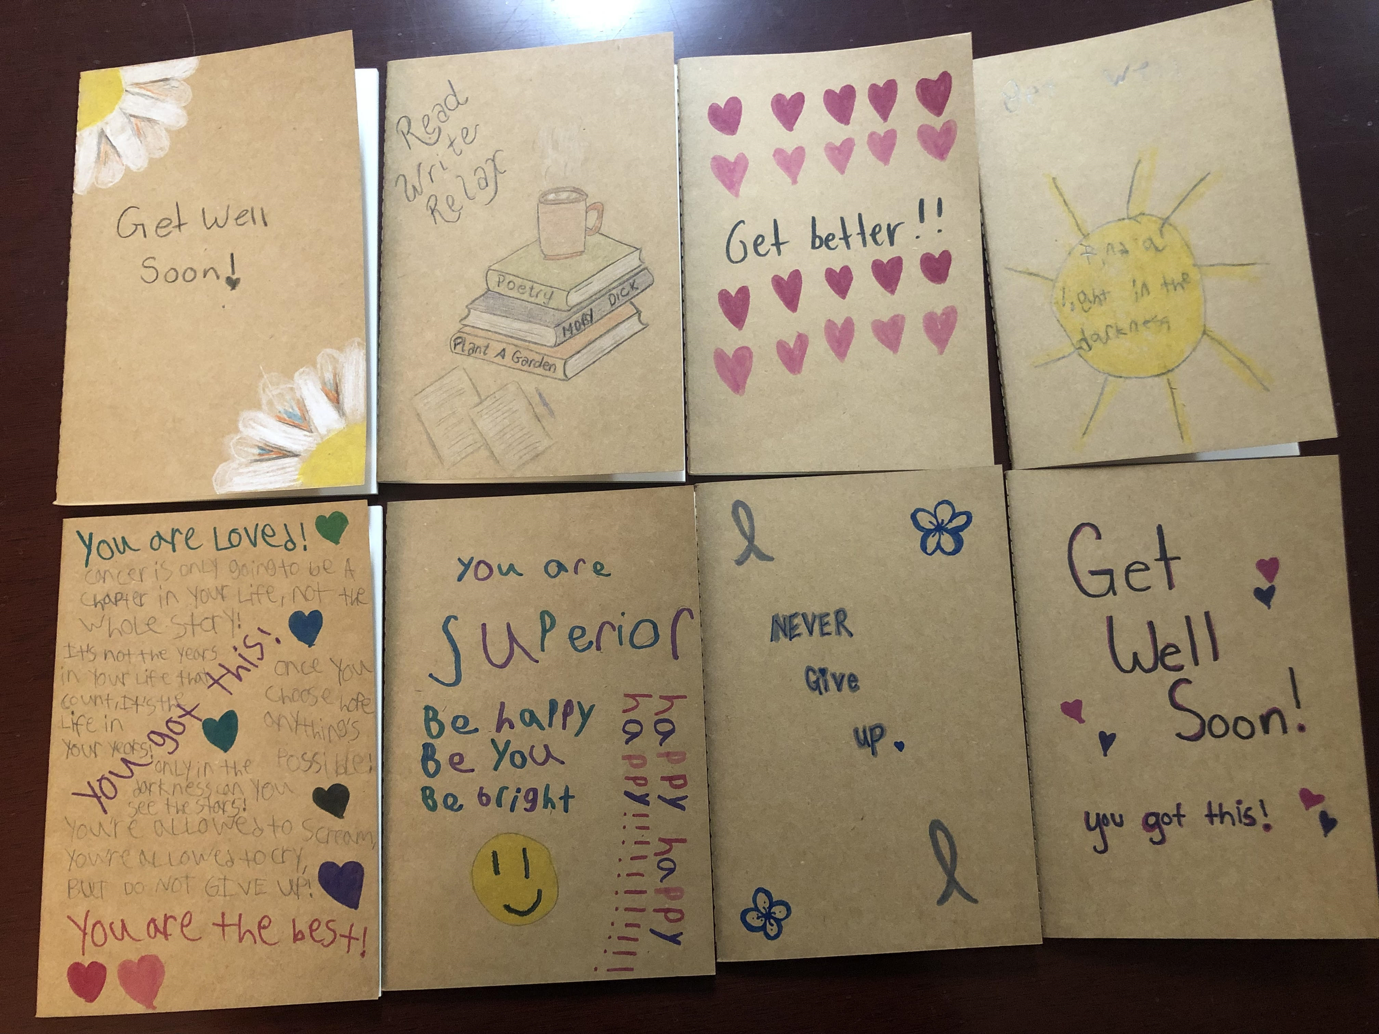

Juniors-- there will be a Common Application demo and help session led by Mrs. Kovaliv on Oct 19th during advisory in the counseling office. Students should bring their computers and any questions they may have!

Virtual College Essay Prep – October 3rd from 5:30-7:30pm
High school seniors, looking to get a jumpstart on your college essay? Register today for NHHEAF’s College Essay Prep! In this interactive workshop, you will hear how the essay is utilized in the admission process, gain insight directly from college admission representatives, learn critical essay writing strategies, participate in essay topic brainstorming activities, and begin drafting your college essay.

This is a FREE live webinar, but registration is required. Please click here to register.

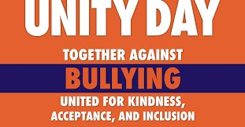

Red Ribbon Week - October 23 - 27, 2023

Red Ribbon Week is a time to educate our students about drug abuse and prevention and to promote awareness surrounding this issue. The Red Ribbon campaign brings millions of people together to raise awareness regarding the need for alcohol, tobacco and other drug and violence prevention, early intervention, and treatment services. It is the largest, most visible prevention awareness campaign observed annually in the United States.

Theme days: ​ We encourage you and your students to participate!!

Monday  10/23 | Tuesday  10/24 | Wednesday  10/25 | Thursday  10/26 | Friday  10/27
“Our Future’s so Bright we have to Wear Shades”  Sunglasses given out!    Wear Red to support a drug free life!  School wide picture in the gym during advisory | Team up Against Drugs  Wear your favorite team jersey  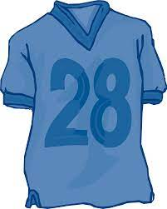 | 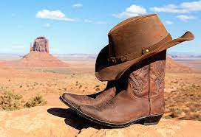  Give Drugs the Boot  Dress in your best Western gear! | Better Together! Drug and Bully Free  Twin Day  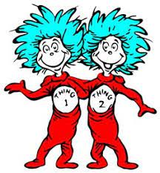  High School Advisory  pumpkin lobotomy  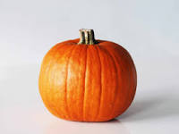 | "This crew is too savvy to do drugs!"  School Pride day  Wear school colors  Guest Speaker for 2 assemblies in Cafe in morning

HIGH SCHOOL

Algebra
We will be starting an in depth unit on equations, going through the many different ways to solve them and understanding the foundations of many mathematical discussions. Geometry is currently learning about mathematical proofs, and how to prove theorems by breaking down a problem and using reasoning to arrive at a conclusion. Statistics is starting data analysis by creating many different visuals to convey information about data. Consumer Math is learning how to build budgets and manage income to set them up for financial success in the future.

9/10 grade Honors Biology/Biology
Students are currently working through the “Marathon Runner” unit.
In this unit students are analyzing data, reading text, creating models and completing labs as they search for the answer to the unit question;

Why would a marathon runner become disoriented during the race, then go into a coma shortly after running the race?

Topics students are investigating include: gas exchange and cellular respiration, thermoregulation, water balance, and homeostasis.

Honors Anatomy and Physiology
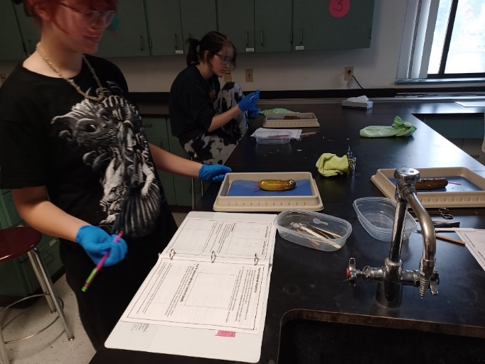
We have completed the first unit: Introduction to Anatomy and Physiology. In this unit students have practiced anatomical directional terms and anatomical planes as they completed a “Pickle Autopsy.”
In our next unit we will be investigating Human Histology- Body Tissues!

9th Grade World Literature
In World Literature, freshmen have been studying the various roles of mythology in the lives of ancient civilizations and cultures, beginning with the ancient Greeks to align with their World History studies in Mrs. Rosana's class. Students are currently working on their first essay, in which they are analyzing a creation myth from a culture we have not studied, and analyzing how their myth reflects the values, beliefs, and collective identity of their chosen culture. Through this assignment, students are practicing critical reading, critical thinking and analysis, and concise writing with strong supporting evidence, as well as a refresher on how to write an essay in MLA format. Students are also preparing a small visual representation of their myth to accompany their essay.

History of Disease and Medicine- Social Studies Elective (Grades 9-12)
*Kids just finished up learning about communicable vs. non-communicable diseases; they completed a project comparing and contrasting the history, symptoms, and treatment of different diseases.
*Also began a weekly infectious disease case study; during each long block, we will be focusing on a historical infectious disease (so far, we have covered smallpox and cholera) by familiarizing ourselves with content-specific vocabulary, the disease throughout history, and where the disease stands today in terms of treatment and eradication.

World History - Grade 9
*Kids just finished a project designed to take a "deep dive" into the history of ancient Greece and Rome; students worked in pairs to compare and contrast the 2 societies. An emphasis was put on the governments, scientific/mathematical achievements, and religious aspects of the 2 empires. The content of this project was designed to align with the 9th grade World Literature class, where they are learning about Greek mythology.

American Literature: Grade 10
We are currently in the middle of our Civil War and Reconstruction unit. We are reading The Narrative of the Life of Frederick Douglass in class, and are simultaneously reading short stories having to do with the romanticism movement in literature. Students have completed a summative looking at different literary devices in short stories written by Edgar Allan Poe, Nathaniel Hawthorne, and Washington Irving. This class is following the same units as American History, where students will be able to apply what they have learned in English to different aspects of their History class and vice versa. In the next coming weeks, we will be finishing up Frederick Douglass with a summative.

Say it and Debate It (ELA elective)
For Say it and Debate it has been focusing on all things speeches so far this year! Students have watched and read a variety of different types of speeches to analyze them for Ethos, Logos, and Pathos. Students have also just finished writing and presenting their own speeches on a topic of their choice. In the near future we will switch to debates and how that looks in different settings.

US History - Grade 10
We are currently in our Civil War and Reconstruction Unit. Students have been learning about the major causes, events and effects of the Civil War on our developing nation. Students have been tasked with analyzing primary sources to help understand the tension caused by expansionism and sectionalism in the Civil War era. In the coming weeks, students will complete a unit test and a research project on a Civil War topic of their choice.

Government and Economics - Grade 11
In Government and Economics students have been learning about the philosophical foundations of government. Students learned about the various “social contract” theories from the Enlightenment that paved the way for the development of modern republics and democracies. Students completed their first test and a project in which they had to design a government to respond to a zombie apocalypse. Currently, students are working on a comparative government project. In the coming weeks, we will begin a deep dive into the development of the US Constitution.

British Literature and Honors British Literature - Grade 11
The Juniors have just finished reading the medieval poem "Beowulf". They read it as a play and the kids really got into the parts with their voices and even roaring. While reading the poem students studied common archetypes in literature; specifically, the hero and the villain. Students created their own heroes and villains in either picture form, resumes, or a creative story. Students then presented their characters and there was a lot of creativity and laughter. Next up is the "Beowulf" essay in which the students will answer if our main hero Beowulf is a good king or a stubborn fool.

College Composition 10
This Running Start course is provided by Nashua Community College and students can earn 4 college credits. We are wrapping up our first unit on writing personal narratives. Students wrote their college admissions essay! It was a nerve wracking process for students but they all supported each other with their ideas. Students wrote rough drafts, had them peer edited, and I will be looking to make more edits to help them with the college admissions process. Students also have their Common Application accounts up and running. They are actually applying to college! Students are thinking about which teachers they will ask for recommendations and exploring colleges that they want to apply to. Working on the Common Application is something we will be doing every so often through November. Our next unit is a Cause and Effect essay. Students are currently working on an assignment on logical fallacies to see how they can poke holes in someone's argument and what to avoid in their own arguments.

Yearbook:
In Yearbook class, seniors have begun to familiarize themselves with the Jostens Yearbook Avenue website after a visit from our Josten's yearbook representative last week, during which students also chose the cover for their yearbook. Students have begun collecting photos from events such as the Senior Field Trip to Mount Monadnock, and also practicing writing letters to local businesses soliciting advertisements, and determining the order in which the pages will appear in preparation for our first submission deadline of November 23rd. Seniors and families of seniors, please be on the lookout for an upcoming email on the senior picture submission deadline and process, as well as families who would like to purchase dedication pages for their senior students.

School Counseling
PSAT/NMSQT Exam will be administered to all Juniors 7:55AM-10:30AM. Students can be dismissed, after testing, as long as they have handed in their dismissal note to Mrs. Kovaliv by Friday, October 6th. No phone calls will be accepted for dismissal.

Senior College Night Program October 12th 5:30PM - 6:30PM - WLC School Counseling Office

Financial Aid Night Program October 12th 6:30PM-7:30PM - WLC School Counseling Office

Band and chorus are already off to a great start! Chorus is working on “Eatnemen Vuelie (Song of the Earth)”, which is a traditional Norwegian song. This song is better known as the opening song at the beginning of the movie “Frozen”. Students are doing very well with the Norwegian pronunciations and are adding in beautiful music notations.

The spring musical this year will be Seussical the Musical written by Lynn Ahers and Stephen Flaherty. Auditions will take place in November. Please see Miss Anderson with any questions.

Ms. Manning’s photography students have been working on designing flyers for the upcoming Harvest Festival. This is a joint project with both the art students who will be displaying their work and student musicians who will be performing at the festival.

Mrs. Wiley’s computer science class will be taking a field trip to the Wilton public library. This has always been a fun trip for the middle school students!

After school weight training club with Mr. Flanagan has had a lot of success with students ages 6th grade to high school.

Miss Smith’s Spanish 3 class is working on a joint project with one of Ms. Clark’s classes. They are making positive Hispanic posters out of fabric with the theme “What are you proud of”. The Spanish 3 class also has an upcoming trip to St. Anselm College.

Ms. Clark’s classes have been helping a lot in the Cafeteria with food prep, safety, and sanitation. Ms. Clark is also working in our school’s kitchen after school. Students have been working on painting murals in the FACS room to help add to the climate and culture. Senior Robert Hannigan has begun planting seeds for the hydraulic units in the FACS classroom for his senior project. Eden Rizzuto has been doing a great job teaching the rest of her class the art of felting which will lead into a lesson of entrepreneurship. Jasper Byrne and Lillian Case, who both attended culinary classes at Milford last year, have given some wonderful presentations of how to make jalapeno poppers wrapped in bacon. Ms. Clark would like to invite parents and administrators to give cooking demonstrations during her classes. Please reach out to Ms. Clark for more information.

AP Environmental Science class has gotten their eco-columns up and running. An ecocolumn is a self-sustaining ecosystem constructed of plastic water bottles. The class will conduct weekly testing on the terrestrial and aquatic chambers until December and observe the systems interactions of the terrestrial and aquatic chambers. Students in the Makerspace course are producing support stands for our eco-columns to help with stability. The class is additionally working on the initial testing and analysis of the raised beds in the courtyards for the collaborative garden project.

Environmental Entrepreneurship class is refining its environmental business plan ideas. Ideas thus far have themes of the creation of bioplastics, gardening problems, materials into new products, and mobile car detailing using a gray water system. Ideas will continue to be refined as the companies form and product research and development begins.

The Chemistry in the Earth System class is exploring the elements, molecules, and compounds that are essential for life on Earth. The class is currently learning about chemical bonding and the properties of elements that allow specific compounds to form.

The Astronomy class has completed its exploration of archeoastronomy sites and their significance on ancient cultures and their societies. The Forensic Science class just started their unit on fingerprints and fingerprinting techniques. Students classified their own prints using the Henry Classification System and learned how prints form in the skin.

PSAT/SAT Prep work has been underway in advisories. Students practice reading/writing and math skills weekly using Khan Academy, tracking scores, and practicing vocabulary through games. 11th graders will take the official PSAT on Wednesday, October 11th from 8 am-1030 am.

High School Math

In Mr. Comerford's classes, we've adopted some of the best practices promoted by teaching specialist Peter Liljedahl. One of the most important includes getting students up and out of their seats as often as possible during the lesson, which has been demonstrated to promote engagement. After the teacher finishes an example, the students then work together on similar problems at the board. Finally, students return to their seats to try a few on their own. 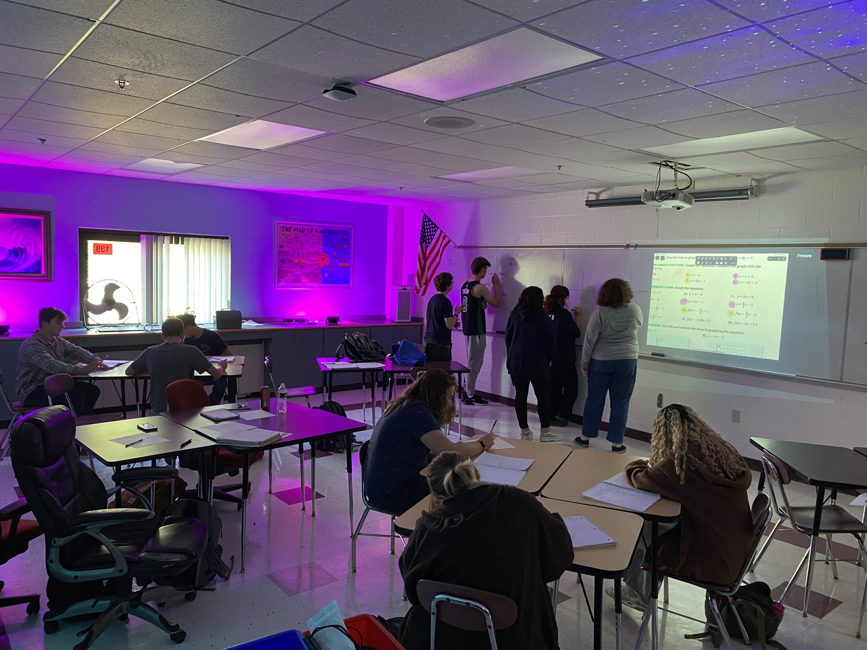 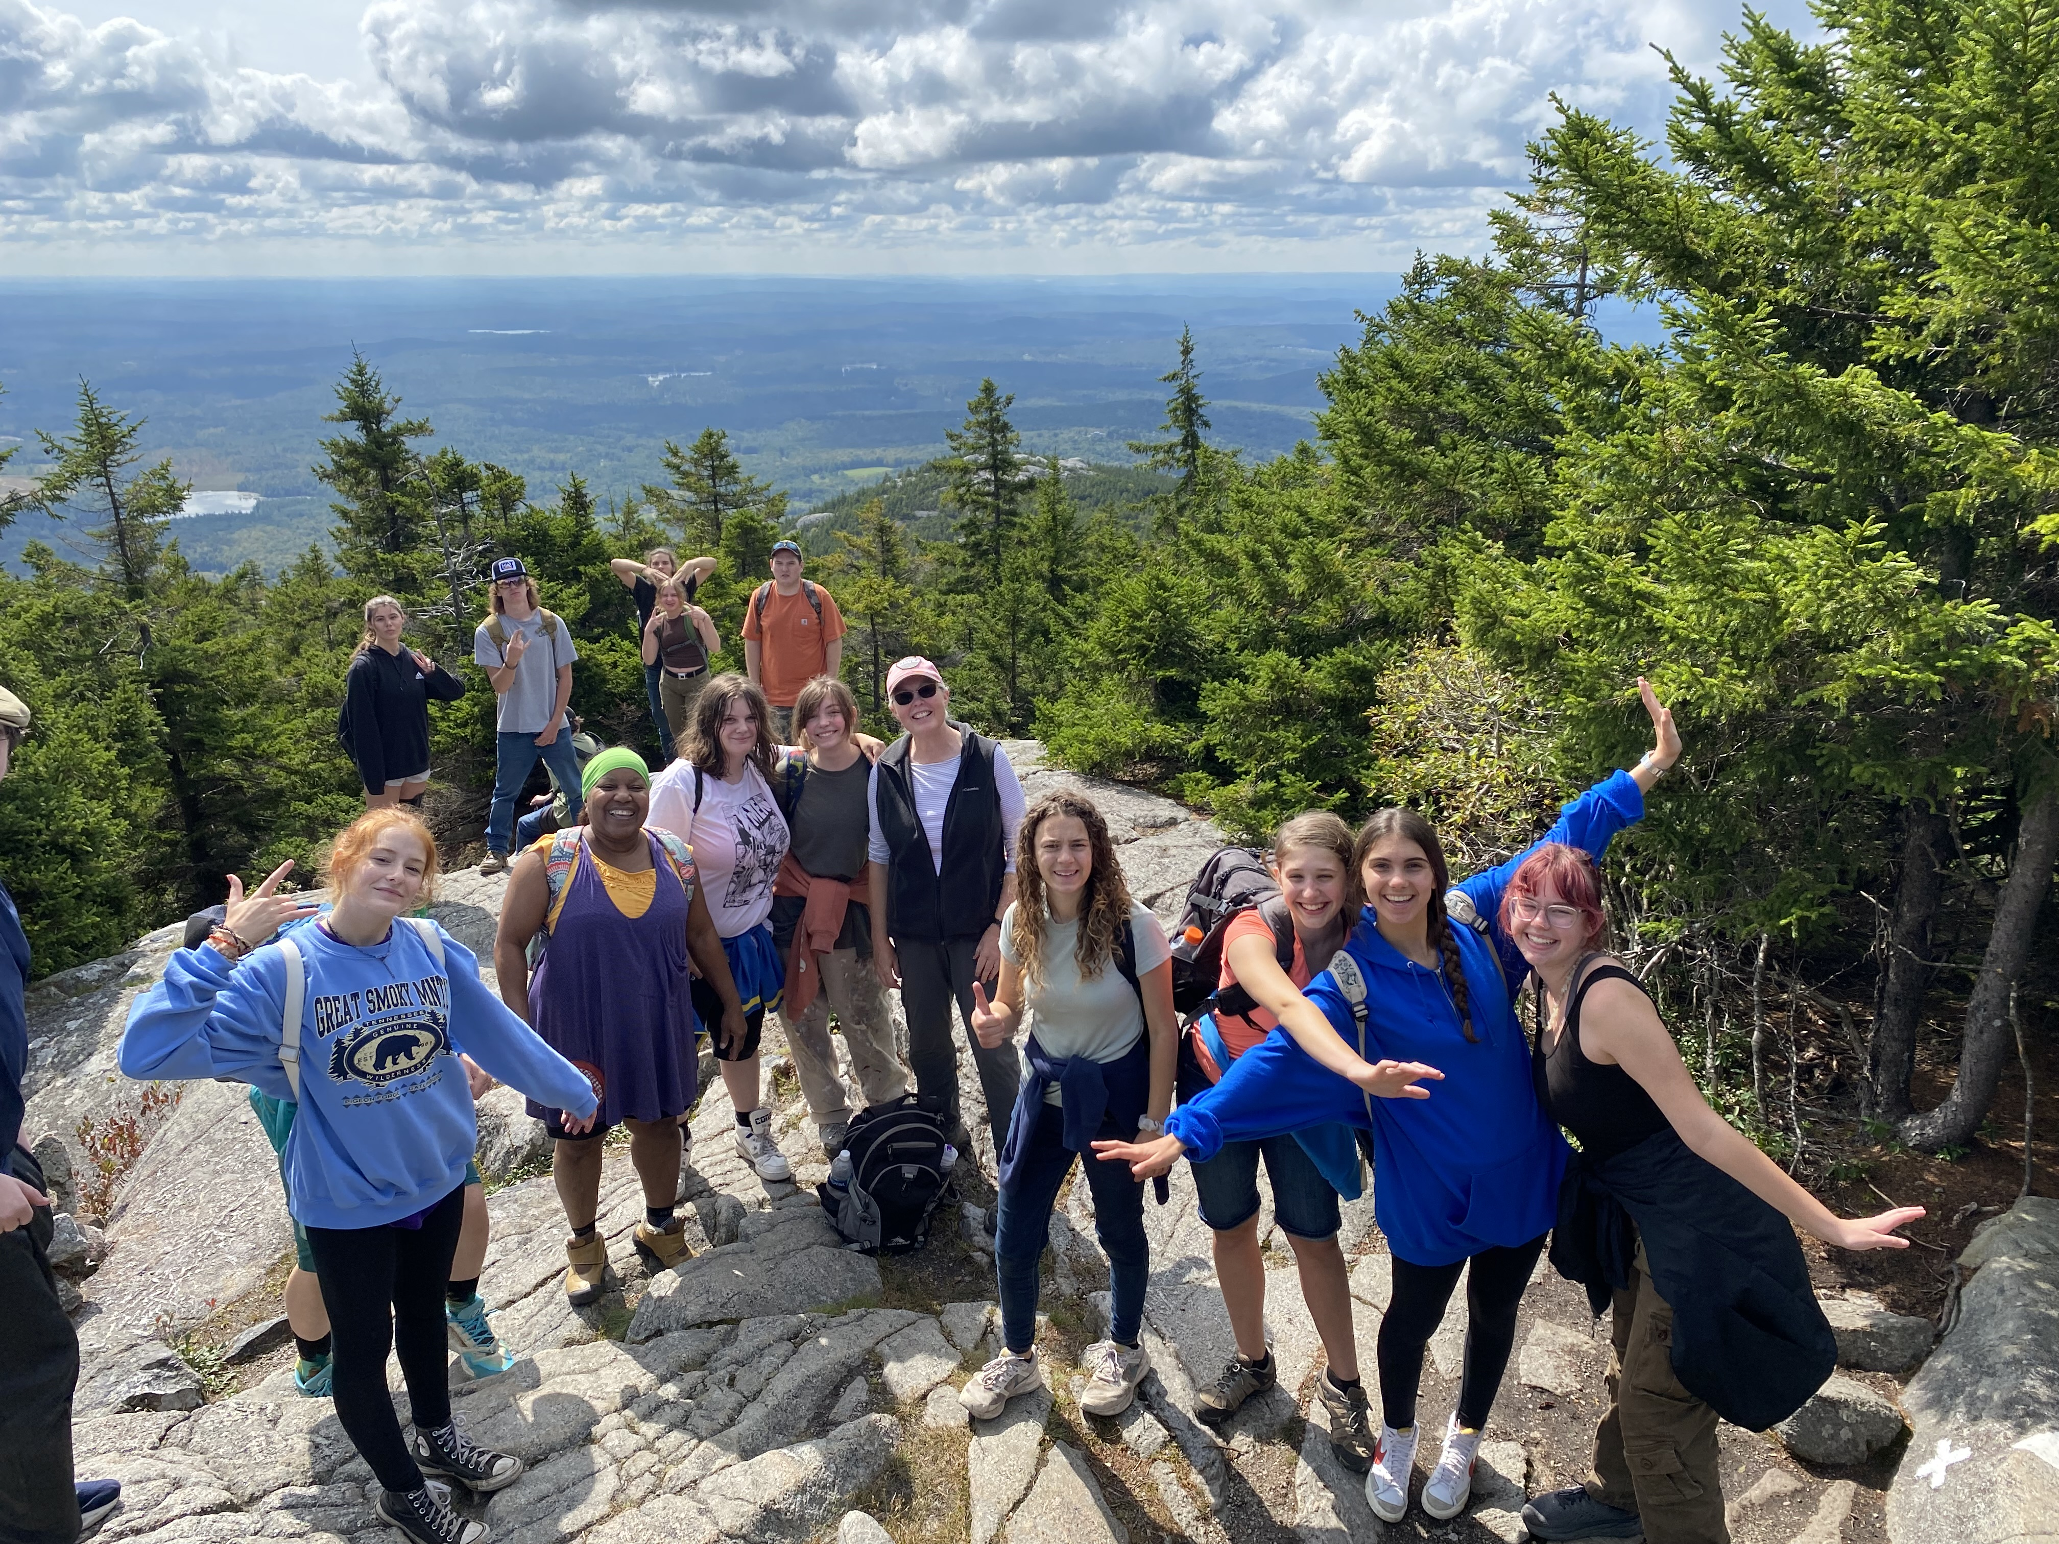

Middle and High School Art
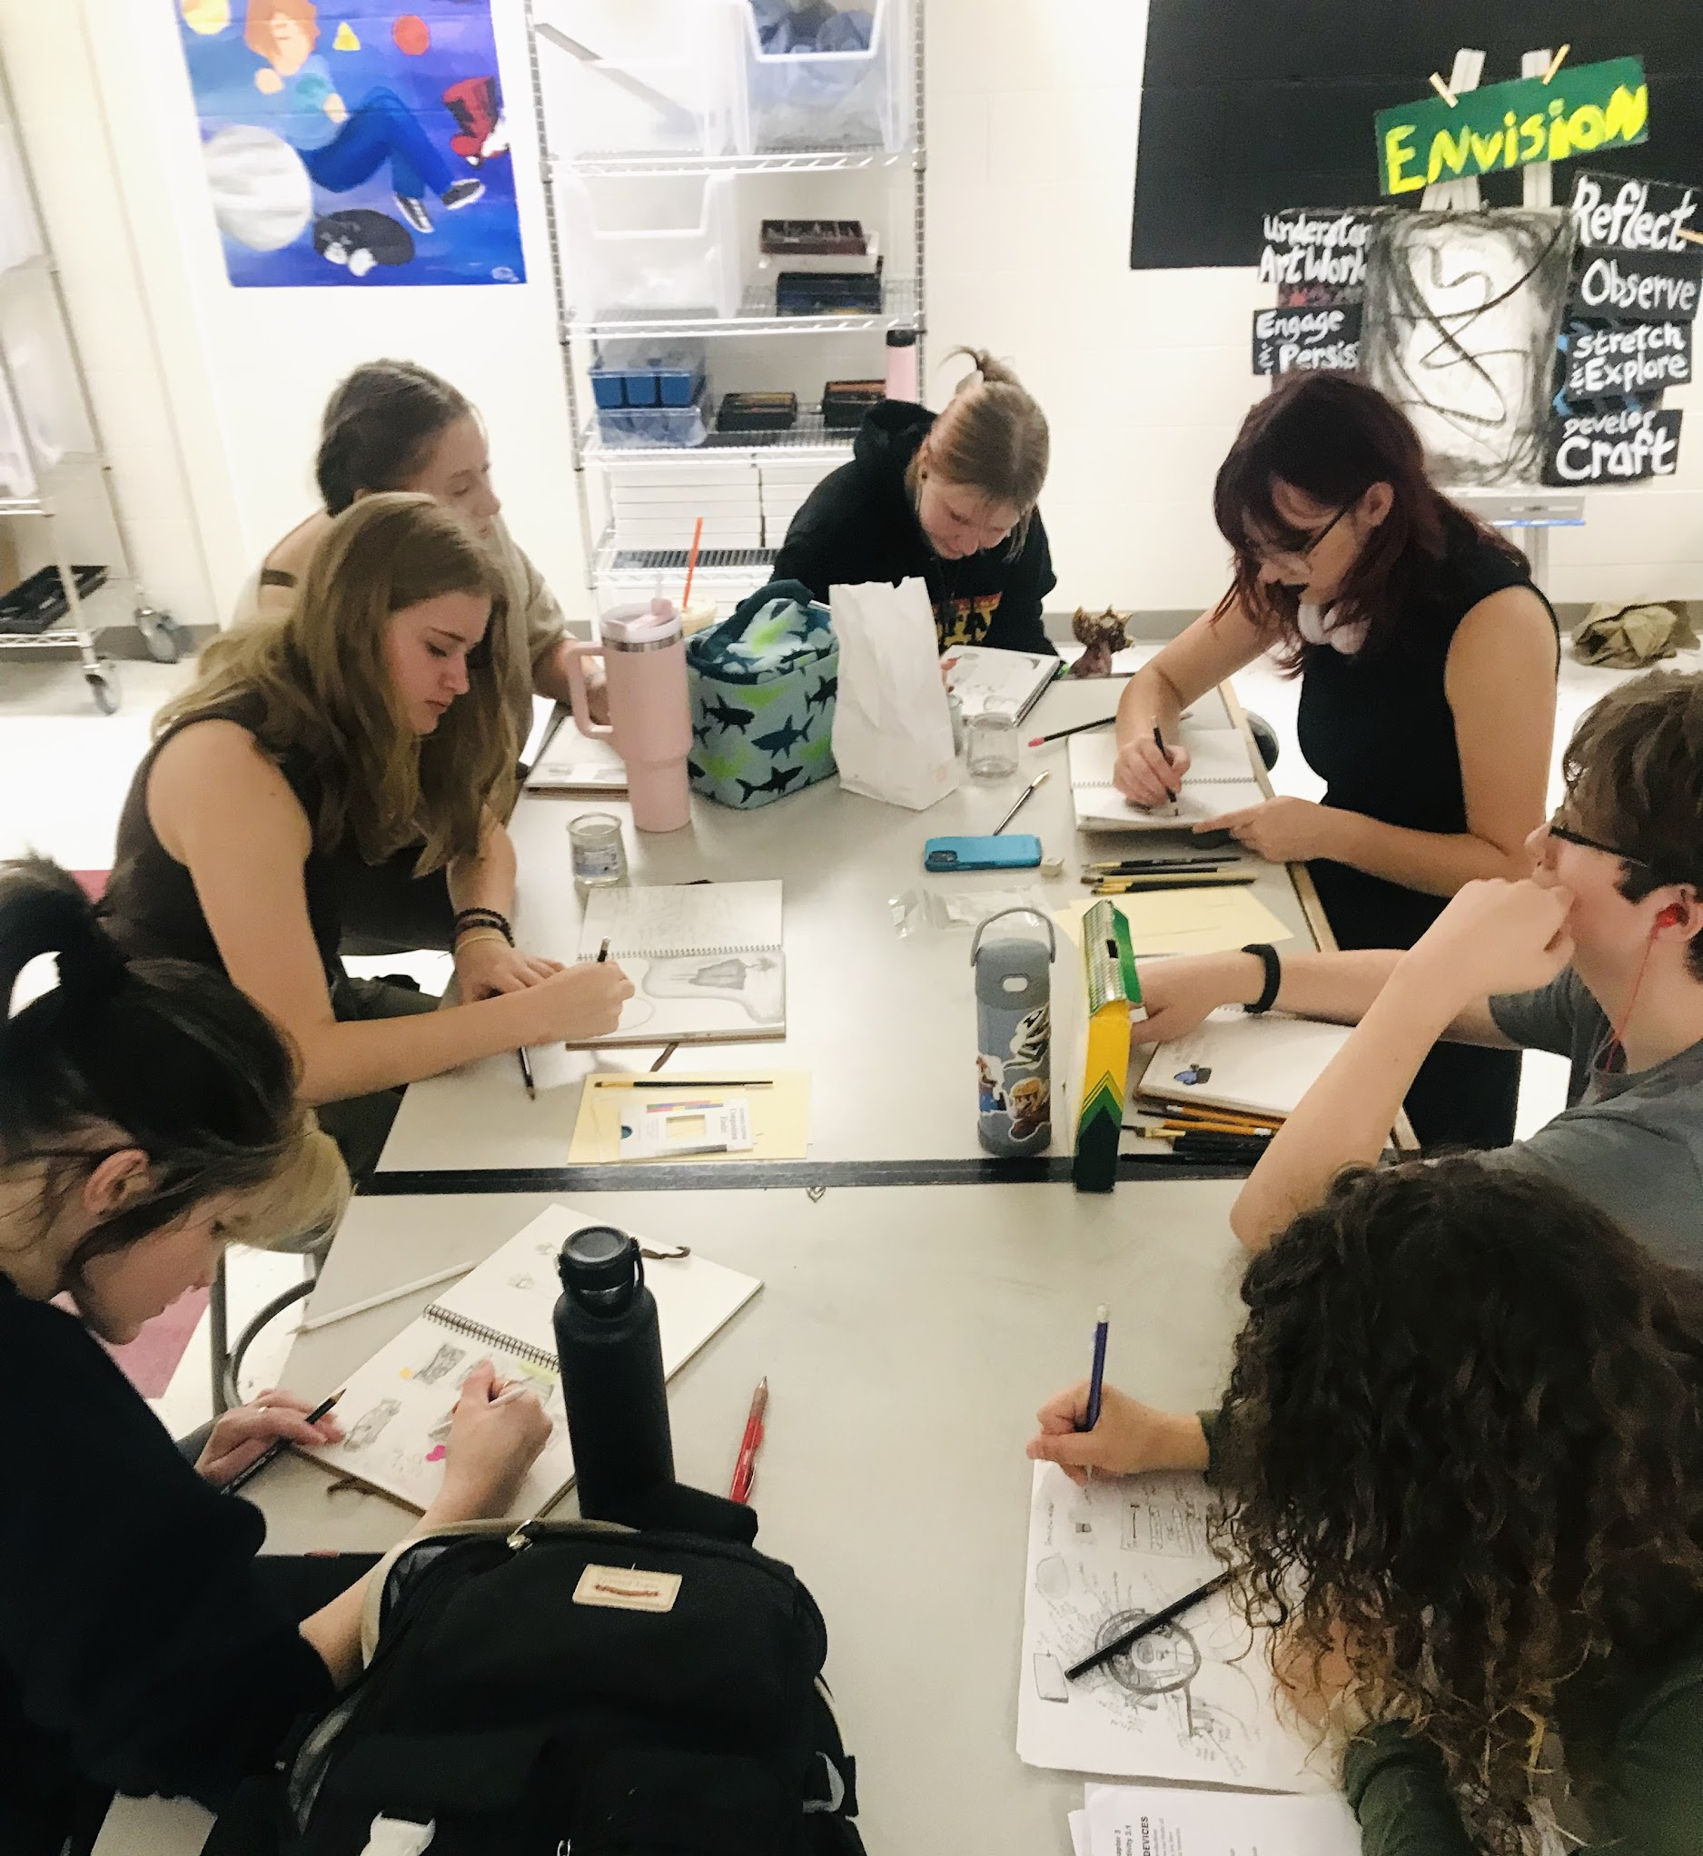
The WLC visual arts program has shown to reach new creative and cultural achievements as of the past few years, including the enrollment of nine talented students in our first AP Art program this fall. Each of these young artists have been in one or more art classes with Ms. Hall over the past four years that she’s been teaching at WLC. They have currently found themselves wading deep in the quest to uncover an essential question for their yearlong art making prompt. This starting point will guide them into a hands-on sustained investigation for their technical, and conceptual, creative development that concludes by April 2024 with a final visual arts portfolio. Stay tuned for exhibits and art shows!

There is another exciting new art class offering at WLC that investigates the intersections of visual and auditory expression. These wonderfully patient high school students in our Painting and Music class have listened to songs on repeat that they’ve selected together in order to refine their observation skills in effort to intuitively translate an auditory composition into a visual landscape. Just recently they began to welcome in even greater nuanced practices of acute analysis to isolate sound effects and visually record them through their subjective perceptions of composed lines, shapes, textures, and colors. Likewise, our introduction to Drawing class is full of many eager 9th and 10th grade students, amidst a few upperclassmen, who are already creating incredible abstract compositions which have helped them better explore their interpretations of the elements and principles of art and design.

The newly primed 6th graders have brushed up on their visual art vocabulary through imaginative peer critiques with the paper puppets they created. Their playful, yet enriched, improv conversations have given them confidence to share objective impressions and subjective interpretations when viewing and talking about art. Our 8th graders are also challenged this year with the investigation into the art of collaboration, and how their collective observations and reflections are creating real-time research into the way that they work together. Through investigating the “art of collaboration” they are laying the foundation for their studies in participatory and socially-engaged art studies, a postmodern art movement of the 21 century!

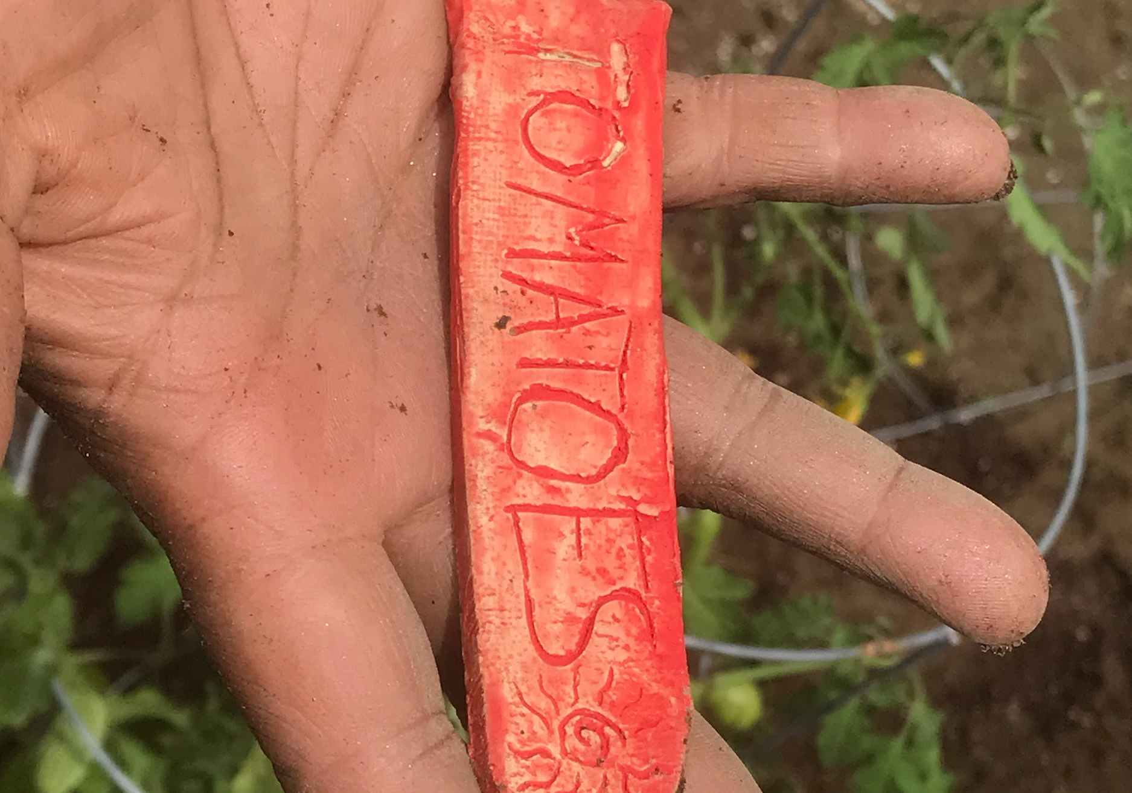
Coming out of the 2022-2023 school year with three successful arts and culture festivals downtown, these events are still in the memories of students and community members alike—and many have asked about the next big event! This fall semester already began with a buzz of ideas amidst interdisciplinary collaborations from WLC teachers who have high aspirations to reinvigorate the school garden as a place for outside teaching and learning. Drum roll please…

Save the date for Friday October 27th, from 4-6pm, for the debut of our first arts and culture festival this year on school grounds! Expect to view the beginning processes of interdisciplinary teaching and learning from the unified arts, sciences, and more. There will be interactive art-making experiences for guests, live music from students and community musicians, and refreshments from the junior class bake sale! Feel free to dress up in joyful autumn or Halloween attire to help celebrate and express your creativity. We hope to see members of the community at this event in order to gather insight and on where the garden may take us in the future of an integrated garden and farming curriculum offering. Come on by to share your ideas, and even interest in becoming a part of this school-to-community initiative!

Updates from Special Education

The Special Education Team is working hard getting to know our new students and welcoming back our previous students. The team has been starting their triennial evaluations and yearly IEP meetings. The RISE program is selling spider plants, jade, neon and marble pothos plants. We welcome the community to purchase these plants for $5.00. All proceeds will go to the RISE program to fund future field trips. Please contact Ashley Ansara to purchase these plants: a.ansara@sau63.org.
