The Warrior Beacon
Newsletter

March 4, 2024 Edition 1, Volume 4



Dear Parents/Guardians:

Students are currently in the process of selecting classes for the 2024-25 school year. I wanted to take a moment to highlight the importance of this and for our students to think about challenging themselves to maximize their intellectual growth. In the past, students were required to complete summer work in order to be considered for higher level classes. Starting this summer, this will not be a requirement. The faculty at WLC are committed to allowing ALL students to challenge themselves by taking higher level classes regardless of whether they do school work over the summer or not. Although all courses are expected to be rigorous, higher level classes such as Honors, Running Start (RS), and Advanced Placement (AP) are designed to challenge our students. With successful completion of RS and AP courses, students may earn college credits.

In a few months, summer break will be upon us. While it is essential for children to have a break from the rigors of school, we encourage parents to consider ways as to how their child(ren) can continue to challenge themselves.

Some ideas:
- Read challenging books: Encouraging students to explore books outside their comfort zone or assigned reading list. They can choose books on topics they are passionate about or select classics and literature from different cultures and time periods.
- Engage in Creative Projects: Encourage students to pursue creative projects success as writing stories or poems, composing music, painting, drawing, or experimenting with photography. Creative expression can be a fulfilling way to challenge themselves intellectually.
- Volunteer: Students can seek out volunteer opportunities in the community.
- Explore Nature and Outdoor Activities: Spending time outdoors and engaging in activities such as hiking and exploring nature.
- Practice Critical Thinking skills: Encourage students to engage in puzzles, brainteasers, or logic games.
- Attend a summer program - such as our math academy - at WLC.

Through advance planning, school breaks may also present a valuable opportunity for students to engage in activities that stimulate their minds and foster a love for learning. Encouraging your child to pursue intellectually challenging endeavors can have a significant impact on their academic and personal development.

The faculty and I understand that every child is unique, and their interests and abilities may vary. Therefore, we encourage you to have open conversations with your child about academic goals and aspirations. Together, you can explore options that align with their interests and challenge them to increase their academic intelligence. As always, if you have any questions or concerns please do not hesitate to reach out to me.

School Counseling

December Students of the Month

6th Grade:

Keira Beam - This student’s manner towards teachers and other students goes unmatched as she consistently shows respect and focus while engaging in classes. She is always getting her work done well and can be seen as one who is doing what is expected. She can be seen outside of school excelling in swimming. She is also extremely polite and kind. The SOM for December is Keira Beam!

Joseph Chumbley - This student takes time to ensure he does his part within the class by setting good examples. He is a focused and determined student who is driven to excel. He’s quiet yet engaged and always seems to know what to be doing. He works hard and is very thorough. He never gives up and is an excellent example of perseverance. The SOM for December is Joseph Chumbley!

7th Grade:

Vivian Boss - This student always has a smile on her face and comes to class every day with an amazing attitude. She is always willing to help out her classmates and teachers and is a pleasure to have in class. She is extremely hard-working and asks for help when she needs it. She loves acting and did an amazing job on her Christmas Carol act in English class. She also plays softball and drank a lot of coffee this morning. Team Awesome is proud to announce Vivian Boss as December’s student of the month.

Connor Allen - This student is always pushing themselves to be successful in the classroom, always trying to improve his grade. His peers look to him as a leader in the classroom as he is consistently setting positive examples. He is always participating in class and treating others with respect. Team Awesome is proud to select Connor Allen as our December Student of the Month.

8th Grade:

Owen Pearsall - This eighth grade student goes up and above the assigned work, always doing his best. He is always participating in class and has a very inquisitive mind. In fact, he enjoys researching and learning new things. He always comes into the room with a big “hello” and is friendly to his peers. Creative writing is a strength of his and he writes great stories and essays. Another one of his strengths is technology. He is very creative with his projects, usually putting some type of technology into them. Team Awesome would like to congratulate Owen Pearsall, as the December Student of the Month.

Ava White - This 8th grade student is a pleasure to have in class. She completes assignments on time and will ask for clarification if needed. She’s determined and always prepared for class. She works well with others and is willing to help. She shows initiative in improving skills and is always well behaved. The SOM for December is Ava White!

(not pictured - Ava White)

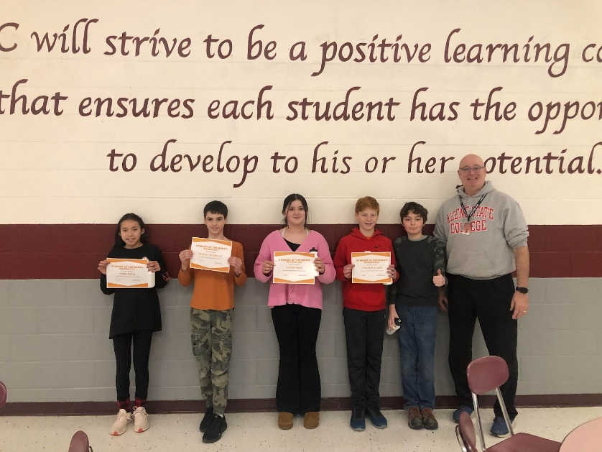
January Students of the Month
6th Grade

Colby Kenney - This student of the month goes to a student who works hard, sets a great example for others, gets along with his classmates, and regularly makes us laugh. He is a responsible student who does the right thing and provides a shining example to his peers in both behavior and academics. He participates in class, both answering questions and providing great comments and feedback. He puts his best effort into his work and encourages his classmates to be their best selves.

Emelia Leach - This student of the month is an incredibly kind 6th grader. Not only has she set an example of model behavior to her fellow students but she has also set an example for one of the most important skills a student can have, determination. This student did not start out with perfect grades, but in the fall she decided to do something about it. She worked hard in all of her classes, used her advisories to check in with all of her teachers when others were playing, and even did work at home. Today she has some of the highest grades in middle school. The dream team is proud to award a student who has set an example for us all to follow, Emelia Leach.

7th Grade
Jameson Benn - This student comes to class with a positive attitude and ready to do his
best every day. He is friendly to his teachers and peers and has been described as “a friend to everyone.” He is always willing to help others. Outside of school he enjoys: robotics, watching hockey with his dad, game night, and video games, especially, “Fortnight.” Team Awesome
would like to congratulate, Jameson Benn as the January Student of the Month.

Colby Allen - This student always comes to class prepared and strives to do his academic best every single day. He is always polite and kind to both teachers and other students. Outside of school, he loves to play soccer and play video games. Team Awesome is proud to announce, Colby Allen as a January student of the month.

8th Grade
Kiana Bigue - This fantastic 8th grade student strives for perfection in everything she sets out to do. She works hard on all of her assignments and shows real grit and determination. She gets along well with her classmates and participates regularly in school activities. She has a great sense of humor and is very creative. The Dream Team is proud to announce and excited to congratulate Kiki Bigue as the February Student of the Month!

Esme Howe - This student is focused and exhibits a strong sense of responsibility. She is a great peer to have on your team as she is patient and fun, while also being serious about her learning and contributing in productive ways. She has a big heart and is kind and respectful towards those around her, and has an admirable sense of self. The Dream Team is excited to have Esme Howe as their student of the month!
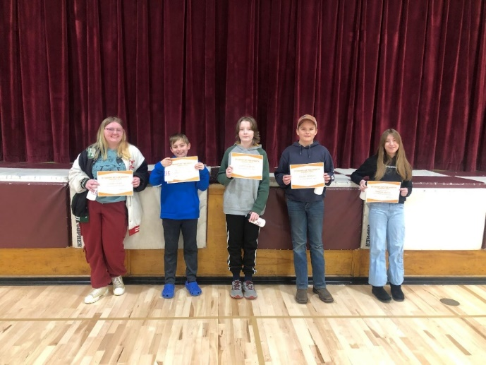(Kiki Bigue missing from pic)
ELA 6:
Hello everyone. Welcome to semester 2! 6th grade has finished our first novel (Tuck Everlasting) and will be moving into narrative and informative writing units. For narrative writing, students will choose a time period to research and write a story about. The research skills gained here will be useful when they move into the informative writing unit and choose a topic they're interested in to learn and present about.

Sixth Grade Social Studies:
In 6th grade Social Studies we have had fun studying the ancient world. In December students studied Ancient Egypt and the role of the pharaohs. During their studies they played with mummifying each other and working cooperatively to build an Egyptian city. As we begin a new semester, the class has shifted focus to studying the roots of democracy by studying Ancient Greece and the Ancient Roman republic. Plenty of engaging and fun learning projects are on the horizon.
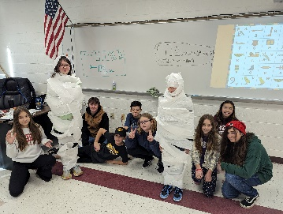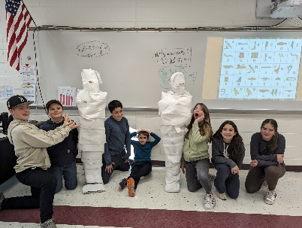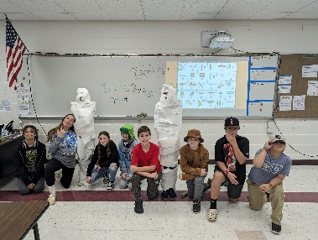
Sixth Grade Math:
4th Period Math: Students are learning how to turn a percent into a fraction. They are learning how to also find the percent of a number and what number is the percent of something. Soon we will be understanding measurements and how to convert measurements.

Sixth Grade Math:
6th Grade Math - Students in 6th grade have been studying how to find the area of rectangles, squares, triangles, parallelograms, and trapezoids. They just completed an end of unit project where each student had to design their dream house, which consisted of rooms of the different shapes they have been studying.

Sixth Grade Science:
Mrs. McGrath’s 6th grade science class just wrapped up their unit on Weather, Climate and the Water Cycle. Next up is the study of the Earth and our solar system!

Sixth Grade STEM:
Mrs. McGrath’s 6th grade STEM class designed and built “egg-catchers” that they tested on the second story! Some of them didn’t crack!

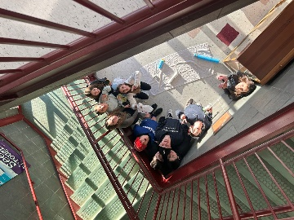
STEM:
In STEM students have been designing a “shake table” which will be used to simulate ground movement during an earthquake. The class will build one of the designs and then use it to design structures that can withstand a simulated earthquake.

Seventh Grade Language Arts:
Seventh Grade Language Arts
The students have started the book, Nory Ryan’s Song about the Irish Potato Famine of 1850. They have done research projects on the setting and are now learning some of the vocabulary and historical facts about those times. The students have also been creating different kinds of writing. They have completed a narrative story, an argumentative essay, and when they return from vacation they will write an informational essay. The students' second book report came in as well and it is a “Literary Elements Food Buffet,” where the students created a replica of some type of food and put all the requirements for the book report on it.
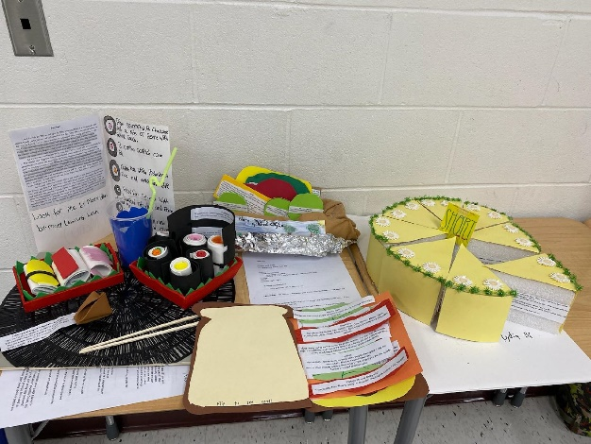

Research Methods:
Students have been learning about various online research methods, such as Boolean Searches and determining source reliability, as well as how to formulate a good research question, using the topic of the Titanic. Students are now in the process of compiling their research into a Google Slideshow, which will be their first summative grade.

No Nonsense Non- Fiction:
The seventh grade students in No Nonsense Non-Fiction have started the National Park Unit. They researched Yellowstone National Park and are now finding out about other parks of their choice. For example, they are researching White Sands National Park, The Grand Canyon, The Everglades and many more. Also, on December 6th a park ranger from Yellowstone National Park met with the students virtually and did a presentation on the park. The students had a lot of questions and it was amazing!

Seventh Grade Math:
7th Grade students are working on a scale drawing project. Students are given $1,000,000 and are asked to use the money designing their dream home. Students must pay attention to the different dimensions of their house and create scale drawings of the home and its landscape. Students have to pay attention to the cost per sq. ft. of the home, the cost of other features like swimming pools, greenhouses, and barns, and the amount of acres they decide to live on to make sure they don't go over their thresholds. Students are able to use their own creativity to design different styles of homes!

Seventh Grade Science:
In 7th grade science, students just finished learning about cells. In this unit, students explored the difference between prokaryotic and eukaryotic organisms, unicellular and multicellular organisms, and the functions of organelles. Students are now beginning to learn about organ systems and the human body.

Eighth Grade Language Arts:
The eighth graders have finished the Poetry Unit. They created beautiful Poetry books with their own creations, researched a classic poet and finished the unit with a performance in our Poetry Cafe’. The students are now reading the novel, Freak the Mighty and finding figurative language and keeping an online journal. Students in eighth grade are also creating different kinds of writing. They have completed a narrative story, an argumentative essay on the Bill of Rights, and when they return from vacation they will write an informational essay.

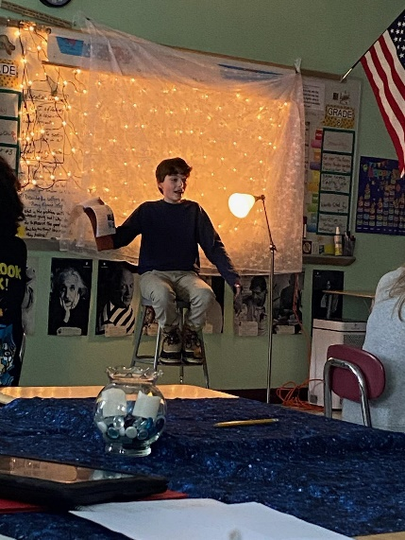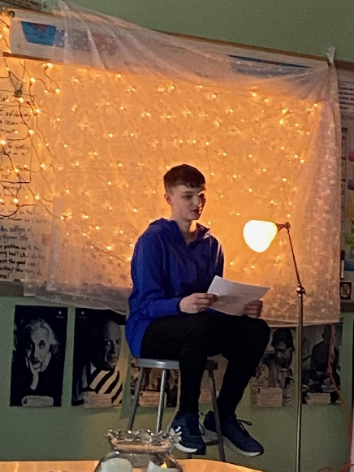

Eighth Grade Math:
8th grade students are using the Pythagorean theorem to determine the distance from one point to another. Students in Mr. Sullivan's and Mr. Chenette's classrooms worked together recently on a scavenger hunt. The scavenger hunt allowed students to go between both rooms and allowed for them to have more of a hands-on experience finding the distances between desks, copiers, projectors, doorways, and other items that might be found in the classroom!

Eighth Grade Math:
8th Grade Math - Students in 8th grade have been working with the Pythagorean Theorem to find the missing length of a right triangle. Students have been measuring the distance between different points in the classroom and then calculating straight-line distance (the hypotenuse) between them.

Eighth Grade Science:
Mrs. McGrath’s 8th grade science class is ready to begin a unit about the Earth as a living planet. They just finished a unit about Forces at a Distance with non-contact forces. Learning about the electromagnet proved to be cool.

Eighth Grade Science:
In 8th grade science, students recently finished learning about gravity, magnets, and electromagnetism. Students are now beginning their unit on space. In this unit, they will explore our solar system, earth-moon-sun systems, lunar phases, and the Big Bang.

Middle School Art:
After almost completing our second full week of middle school art, both 6th and 8th grade students
are creating their preliminary art vocabulary sketchbooks in wondrous ways. They have been working
together to learn about the 8 Studio Habits of Mind from Harvard University’s research program on
how the most effective artists are successful based on healthy, mindful habits in their creative
practices. We are learning about the elements and principles of art and design through various
exercises that allow students to practice them in many different ways. We are learning how to be
more creative with various handwritten lettering techniques, reciting them together out loud, and
using them when we talk about what they mean when we critique a work of art together.

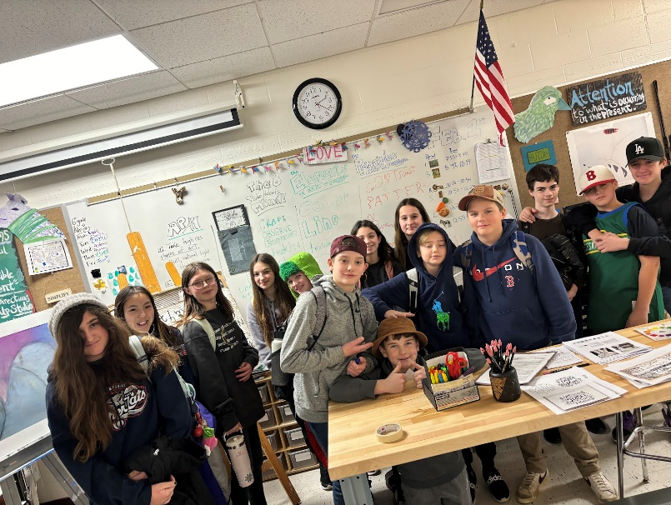

Robotics:
WLC’s two middle school robotics teams did a wonderful job at the Lego League States
Championships. One team scored better than they ever had before! The whole day was filled with
laughter and gracious professionalism. Great job teams!

Drama Club:
Drama Club rehearsals for Seussical the Musical have started! We spent the first few
meetings just playing theatre games and having everyone get to know each other. Bonds are growing
quickly and we are now working on our choreography. We are so excited to present our shows in April!

HIGH SCHOOL

9th Grade World Literature:
We wrapped up our Romeo and Juliet unit with an abridged act re-enactment - students were creative and collaborative, and each group demonstrated a solid understanding of the crucial scenes in their chosen act while having fun with Shakespeare! Students are about to begin their freshman research paper on the Holocaust, in preparation for our reading of Elie Wiesel’s memoir Night. Students are first working on a preliminary vocabulary list of 50 words and terms related to the Holocaust that they will need prior to their research and our next reading unit. They will then write a five paragraph research paper in MLA format in which they explore the perpetrators, bystanders, and victims and/or survivors of the Holocaust from a human experience and human behavior perspective. They will have 4 weeks to work on completing this paper in class. *Please note that this paper will be a significant part of their semester 2 grade, and will be assessed as 2 summative grades (1 for content and 1 for format) and 1 formative grade (ability to meet each deadline).
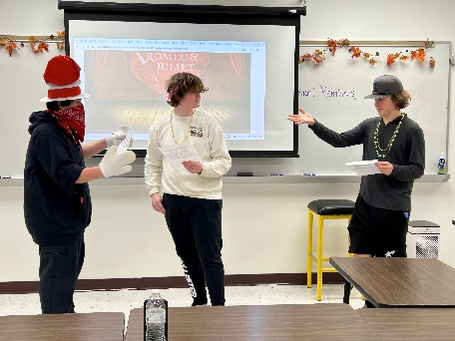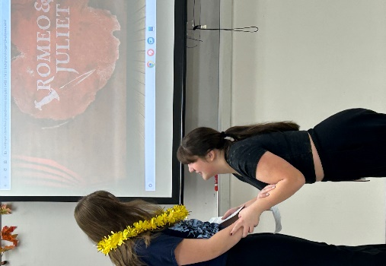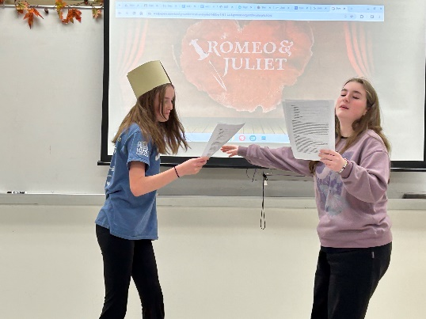
9th Grade Honors World Literature:
We wrapped up our Romeo and Juliet unit with an abridged act re-enactment - students were creative and collaborative, and each group demonstrated a solid understanding of the crucial scenes in their chosen act while having fun with Shakespeare! Students have begun their freshman research paper on the topic of contemporary genocide, through the lens of the 10 stages of genocide (from genocidewatch.org) - they can choose to research genocide in Rwanda, Cambodia, Bosnia, or Darfur. They will then write a five paragraph research paper in MLA format in which they explore the circumstances that gave rise to the genocide, and the experiences of the victims and the perpetrators, and the response from the global community. They will have 4 weeks to work on completing this paper in class. *Please note that this paper will be a significant part of their semester 2 grade, and will be assessed as 2 summative grades (1 for content and 1 for format) and 1 formative grade (ability to meet each deadline). This assignment will lay the groundwork for their analysis of the Holocaust in our reading of Elie Wiesel’s memoir Night.
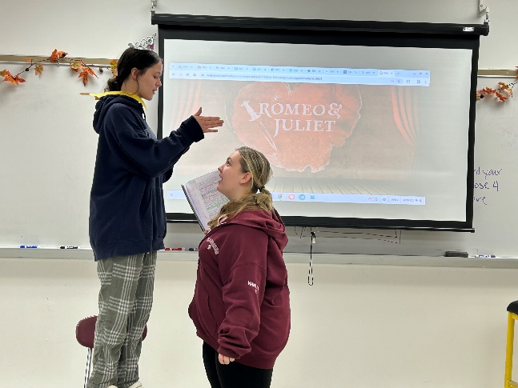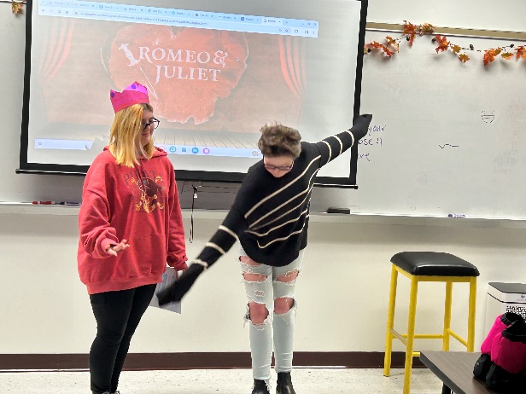

American Literature: Grade 10
Hello parents of American Literature students! Over the past month, we have finished reading Of Mice and Men by John Steinbeck. Students explored how many of the characters interacted with the idea of the “American Dream”. Students also explored the historical events of the Great Depression and the Dust Bowl, and how that affected people across the country. Students are now shifting towards WW2 with the novel Hiroshima, and a project on pro and anti-war songs.

Honors American Literature:
Hello parents of Honors American Literature students! Over the past month, we have finished reading The Great Gatsby by F. Scott Fitzgerald. Students explored how many of the characters interacted with the idea of the “American Dream”. Students also explored the historical events of the Roaring 20’s, Great Depression and the Dust Bowl, and how that affected people across the country. Students are now shifting towards WW2 with the novel Hiroshima, and a project on pro and anti-war songs.

Say it and Debate it!
Hello parents of Say it and Debate it students! We wrapped up the semester with a debate on banned books, and students had such interesting perspectives on the topic. Everyone did well on their Final assessments, which showed that they truly met the expectations of the class.

Horror A-Z:
Why do we love to be scared? This is just one of the questions the Horror A-Z class looks to delve into. Gothic Literature, ghosts in film and literature, monsters in film and literature, Stephen King and local ghost stories are just a few of the topics this class ventures into. Students right now are making a timeline that dates from the 1960s-2010s about the literature and film of that time and how what was happening in the world dictated what went into each story.

Sci Fi and Fantasy:
Hello parents of Science fiction and Fantasy students! This semester is off to a great start- we’re focusing on Science Fiction currently. We’re looking at the history of the genre, common motifs, and different subgenres of Sci-Fi. As the semester goes on, we will look at transitioning to fantasy and comparing how the two genres intersect. We will be looking at a variety of different media, from comic books to movie scenes, and looking at how each piece of media fits each genre.

Yearbook:
Students are finalizing pages for our final yearbook deadline, which is the Monday we return from Winter Break. We will then begin our studies of journalism, beginning with its history, and the elements of good journalism.

British Literature and Honors British Literature - Grade 11:
Semester 1 ended with the Juniors handing in impressive midterms on William Shakespeare’s Macbeth. The higher order thinking skills shown by our students went above and beyond. Shakespeare is very hard to understand and the students read the entire play aloud and answered the analysis questions thoughtfully and with evidence from the play. I am very proud of their hard work in preparing for the midterm and using a difficult text successfully.

Next up to start semester 2 we are reading Mary Shelley’s Frankenstein. This is their first novel! Students will be learning about the Romantic period in England, discussing what science’s role was and is in society, and how literature reflects the historical period in which it is produced. Students will be starting to participate in Socratic seminars which help students share what they have learned from the reading and answer those higher order thinking questions.

College Composition 101:
This semester the English department is running a second Running Start class from Nashua Community College. Students can once again earn college credits for free! This semester the students will be reading literature from many different genres such as class short stories, historical non-fiction, poetry and drama. Students will then practice analyzing the literature and writing about it in various formats. Students will take part in Socratic seminars, write dialectical journals, and research non-fiction pieces.

Students are now creating literary term review lessons so that they can brush up on terms they have already mastered as well as learn some new ones that they will then identify and explain throughout the semester.

Into to Psychology:
This class just wrapped up our first research project on some of the most influential psychologists in history, including but not limited to Sigmund Freud, Abraham Maslow, and Stanley Milgram. Students were tasked with conducting research to become an expert on one psychologist. They then had to create a final product (in a format of their choosing) to present their findings to their peers in small-group discussions. Additionally, the students were asked to apply the content from our previous chapter to their particular psychologist to reinforce and expand their understanding of psychology thus far.

World History (Grade 9):
Students have just wrapped up the era of Napoleon-- they studied how Napoleon Bonaparte rose to power after the French Revolution, how he expanded the French empire to cover most of continental Europe, and how he was defeated. The students then participated in an interactive simulation on the Congress of Vienna, which asked students to assume the roles of European countries after Napoleon. The kids were tasked with solving the problems left in the wake of Napoleon such as how to reallocate territory and how to prevent future wars in Europe; they did so all from the perspective of the countries they were randomly assigned. The week before winter break the class focused on the Industrial Revolution in preparation for our next major unit: The Rise of Nationalism and the Age of Imperialism.

10th Grade US History:
Students in US History have just completed their unit on America’s role in World War I. Students examined major world impacts such as the international alliance systems, submarine warfare and trench warfare. Students also looked at how the war impacted America at home by analyzing war time propaganda posters and primary sources about victory gardens, the draft and wartime economics. Students ended the unit with a simulated debate in which they recreated their own version of the Treaty of Versailles, the peace treaty that ended World War I and then compared their version to the historical one. Students analyzed the strengths and weaknesses of both their document and the real treaty.

11th Grade US Government and Economics:
Students in Economics have just completed their first unit covering the introduction to economics, such as the factors of production, types of economic systems and how businesses operate in various economies. Students completed the unit, first with a summative content test and then with a business proposal project in which they needed to research and pitch a business idea to their class. Student projects included presentations on landscape companies, clothing lines, pizzerias and athletic camps, just to name a few.

Honors Algebra 2:
In Honors Algebra II, the students are wrapping up our unit on Systems of Equations. We've learned how to solve 2-variable systems, 3-variable systems, linear programming problems, systems involving inequalities, and even systems using matrices. We've been administering frequent quick quizzes to make sure the students never fall off track, and the benefit has been immediate. We hope to carry this momentum into our next unit test!

Honors Algebra 1:
In Honors Algebra 1, the 8th graders have just started to explore SLOPE, one of the most important (and challenging) concepts in all of math. Slope allows students to understand rate of change -- how much does changing an input affect an output? -- which is critical not only in all higher level mathematics, from Algebra II to Calculus and beyond, but also in real-world problem solving. From paving roads to building roofs, from forecasting expected revenue to monthly account balances, slope is used.

Algebra 1:
In Algebra we finished up our unit on absolute values and inequalities, and how we can visually see the areas taken up by each inequality. We are now beginning our unit on systems of equations, which is an essential part of algebra and explores the many ways to use equalities to our advantage.

Geometry: We are working on properties of triangles including different measurements of center, using these properties to compare and contrast the different definitions of the center of a triangle. In the honors class, we are beginning similar figures, starting with similar triangles.

Geometry:
Students in Geometry are working on the properties of triangles including different measurements of center. They use these properties to compare and contrast different definitions of the center of a triangle.

Pre-calculus:
In Pre-calculus, the students are about to embark on a journey through the land of Trigonometry. Based on the math of triangles, trigonometry is actually best understood using a circle, and is the best tool to visualize or model waves. How could that be? The students are about to find out.

Consumer Math:
In Consumer Math, the students have just started the Foundations in Personal Finance Course created by Ramsey Education. The students will learn about budgeting, managing credit and debt, consumer awareness, investing and retirement, and more. This course will not only help prepare the students for achieving financial stability in life, but also meets the state graduation requirement for financial literacy.

Quantitative Reasoning:
In Quantitative Reasoning, the students just finished the unit on basic Finances, and are now moving on to learn about Annuities and loans. The class has been steadily improving all year. Their most recent test was the best so far, and we hope to continue the trend!

Stock Market Game:
This semester's edition of the stock market game has begun! We are learning about the basics of the stock market, including companies, stock exchanges, and ticker symbols. We have begun investing, each student is given $100,000 in this game to buy and sell stocks, bonds, and mutual funds. By the end of the year, we will see who has earned the most amount of money.

Senior Project:
For the Senior Project, the students are entering the critical months. It's imperative that the students start compiling quality research and put together a plan to complete their applied piece. The presentations will be in late May -- it seems so far away, but it always arrives sooner than the students expect!

Biology and Honors Biology(9/10):
The biology and honors biology classes ended first semester investigating the following questions: How has evolution shaped how humans and bacteria interact? How can we prevent future outbreaks of bacterial infections?
During this unit students collected and analyzed information on the factors that impact bacterial evolution. Students then created an argument defending the best strategy to use in preventing future infectious disease outbreaks.
Our next unit is - BioTrek! This unit is a project based learning program that introduces students to the world of bio-fabrication. Students working in teams identify a real world problem and conceptualize a tissue-engineered medical product (TEMP) that attempts to solve the problem. The unit culminates with a “Shark Tank” competition where the winners will move forward to the state championship in May.

Honors Anatomy and Physiology:
Students ended the semester studying the functions and structures of the Integumentary system. Currently students are investigating the skeletal system focusing on: The Bone matrix,
the major bones of the skeletal system, bone disorders, and bone fractures. During this unit students will also be completing activities/labs such as; How to determine the height of an individual using femur bone measurements, and using carrots to replicate bone fractures and the motion that causes them.
.
AP Environmental Science
AP Environmental Science students recently completed the Cookie Mining Lab as part of their Impacts of Mining section of the Land Use Unit. Chocolate Chip cookies were mined from overburden material using rented tools. Their individual mining companies needed to track expenses, only mine between certain hours, and deal with environmental alerts and fines. The mined locations needed to be returned to their original states at the culmination of the mining activities.
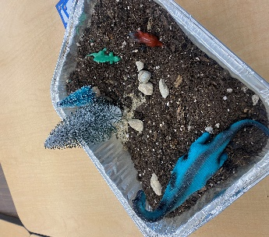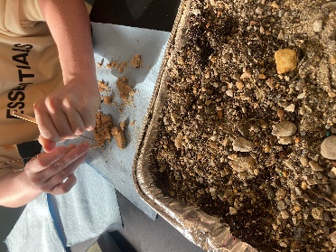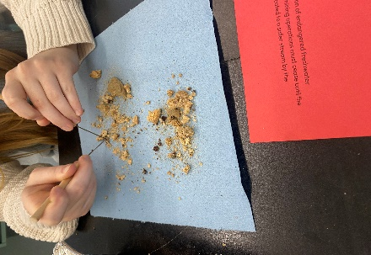

Environmental Entrepreneurship:
Environmental Entrepreneurship has been learning about intellectual property. They investigated trademarks, patents, and copyrights, began to create their own logos for their individual businesses and are presenting on an intellectual property infringement case of their choosing.

Forensic Science
Forensic Science students are exploring Locard's Exchange Principle, the principle that the perpetrator of a crime will bring something into the crime scene and leave with something from it. Students collected trace evidence from themselves and their desks. The evidence was placed in paper bindles that were sealed with evidence tape. A microscopic analysis of the evidence collected was completed during subsequent lab periods.

Chemistry in the Earth System:
Chemistry in the Earth System students are working their way through stoichiometry and rates of reactions. They calculated the amount of sugar in a piece of bubble gum and the amount of chalk used to write their name and then created chalk using a precipitation reaction. The lab practical required students to have their balanced equations correct, and conversions to moles and molar ratios accurate to determine the theoretical yield of the reaction.

Astronomy
Our new astronomers are beginning to explore the celestial sphere and the tools of astronomy. Using the Stellarium web software we investigate celestial objects and how they move in the night sky. Students will begin to build on their navigation skills by plotting out celestial objects using polar graphs and developing an understanding of archeoastronomy and ancient megaliths and geoglyphs.

Family and Consumer Science:
My Creative Cooking Class continues to make wonderful food. One long block we decided to have breakfast together and ate family style. They did a wonderful job. As a part of the Creative Cooking Final Exam, students had to cook a meal for family members. Tyler Gill and Savanah Dubois decided to do it together and cooked a meal for both of their families. The parents enjoyed it so much that they posted it on social media and everyone loved it. This is the way it should be! Great job Savanah and Tyler. Cooking with Mrs. Crotty!!!!! Many thanks for coming in and teaching us about Jewish foods
and traditions. My students loved it. If any other parent would like to come in and cook with my classes, you are more than welcome. We loved having Mrs. Crotty with us and plan on making this a yearly tradition.

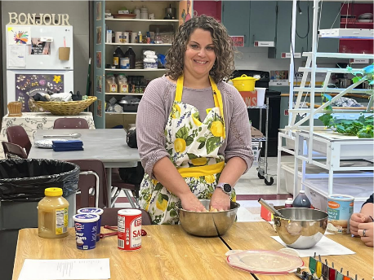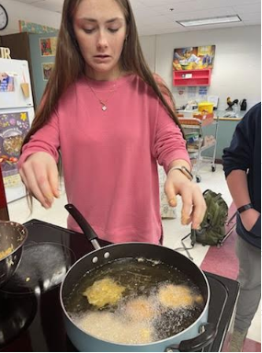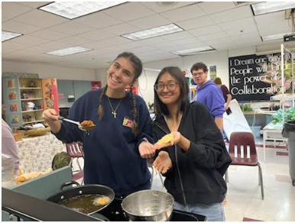

Here are some of our gingerbread houses from our “For the Love of Leftovers Class. They came out great. They turned out to be a lot bigger than we expected. Very creative!
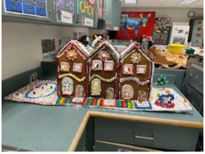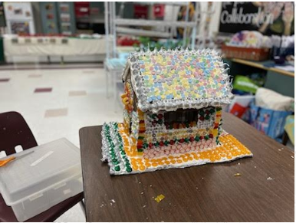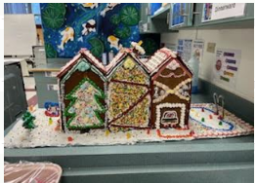

As a part of our “For the Love of Leftovers Class” final, we celebrated part of Emily Hank’s journey and included a few of her special friends. We had a nice luncheon! We are so proud of you Emily!!
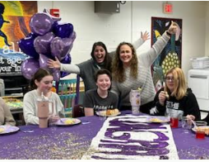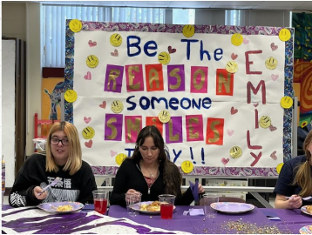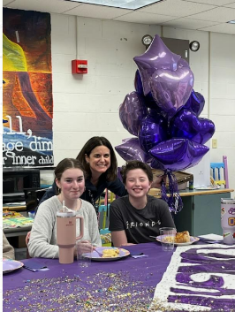 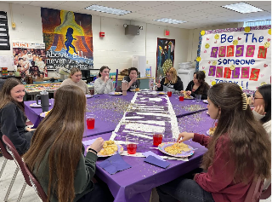
My Creative Arts students, under the tutelage of one of our seniors, Chloe Abbott, finished our classroom mural. It is vibrant and so colorful. Many thanks to everyone that worked on it.
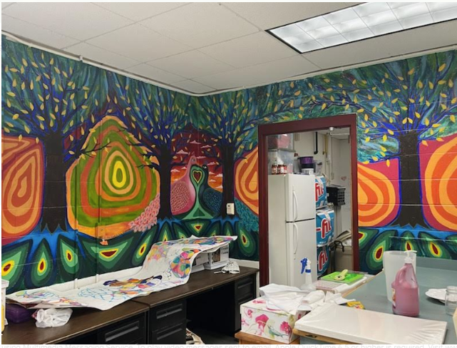

More from Creative Arts………
Here are our Cityscape Color Wheels……… 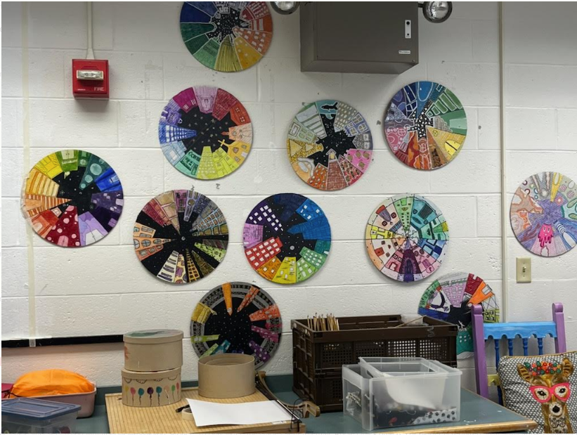
Great job!
News from the Music Department:
Winter Concert: The wonderful musicians in WLC’s Band and Chorus did a fantastic job at the Winter Concert! Soloists included Owen Pearsall, Ben Hamilton, Hannah Hamilton, Jayden Heaphy, Victoria Gilbeau, Logan Rocca, Mackensie Skiff, and Avian Benson. Thank you to all who came to support our students in the music department. Everyone should be very proud of their performances!
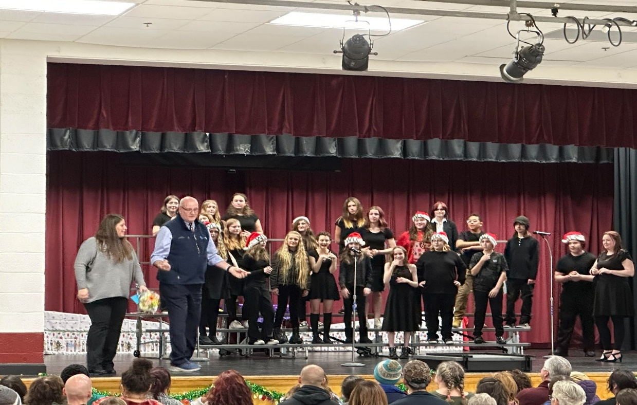

Industrial Arts/Tech Ed:
In an exciting collaboration between Ms. Manning's Photography and Makerspace classes, students are envisioning their futures a decade after graduation through the creation of alumni templates. Guided by their creative instincts and technical skills, students are capturing their dreams of the future through personalized designs. This project not only showcases the artistic talent within our school but also encourages students to think deeply about their future paths. Students will then use their layouts to create an actual alumni wall at the school. We are asking former graduates of WLC to help students bridge the gap between now and the future by sending pictures and a brief bio to Linda Draper at l.draper@sau63.org.

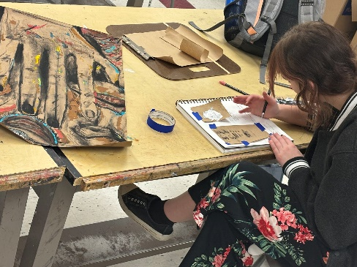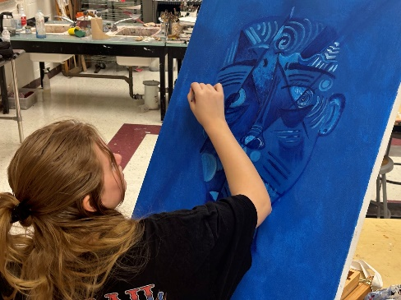

AP Art and Art
These young artists rocked their midterm exams where they were asked to select, review, and
critique the artwork of a featured AP art student’s portfolio from the 2022-2023 curated online show.
They are currently wrapping up their second (and some their third!) work of art for their sustained
investigation.

As the students’ complete works of art they reflect on the objective and subjective qualities of their
visual compositions, as well as their process. This enables them to grow within their investigation
through each work of art as they refine their art technique and intentions of creating meaning in their
work. Junior Brianna Linehan’s sustained investigation question is, “What is nostalgia and where can
you find it?” Her reflection on one of her charcoal drawings is a testament to the powerful impact of
how the visual arts provide a space for rich experiences within a student’s development of their visual
and written language.

“I see a car driving on a road late at night with trees covering the sides of the road. The background
filled with an opaque darkness. When I was making the art and making small adjustments I was
keeping in my nostalgia and how the piece was making me feel. How the materials were affecting the
paper, and how to get my ideas about the art from my mind and onto the paper. The charcoal was my
main chosen material due to the fact that I wanted to achieve a pitch black rather than a dark gray
with graphite. The art needed to be moody and expressive, and the charcoal was what truly brought
that life to the piece.”

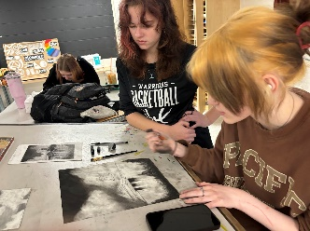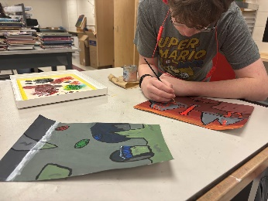
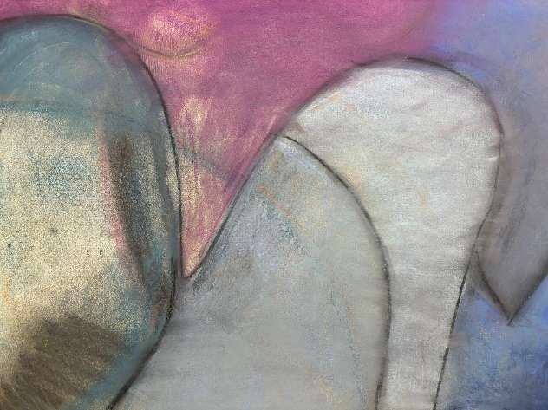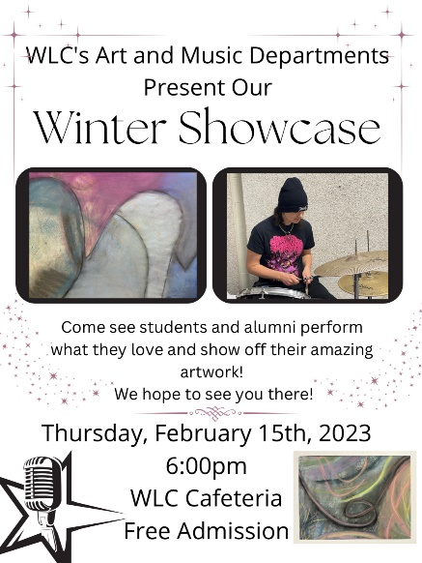
Student Art on Exhibit with Artist Statements during Winter Showcase!
Make sure to try and stop by the Winter Showcase on Thursday, February 15th from 6-8pm to view
some artwork from semester 1, as well as the work by our AP Art students. Featured here is a pastel
drawing from high school student Cailin Swett, accompanied by an excerpt from her artist statement.

“My artwork was a reflection of my breathing; a visual expression and emotion. When I look at my work I see lines that create a sense of movement. Some are bold and others are delicate— dynamic just like the rhythm of my breath. When I look at my work I see blue, pink, and purple colors. I see rhythm and patterns that bleed into texture and shading.

Participating in the art critique helped a lot, not only from my peers sharing their opinions about my art, but also helping me understand and appreciate the piece better. This assisted me to see my art in a new way as I looked at it from a different point of view. I hope when people look at my piece they see their feelings. I want them to imagine, and I want them to feel the emotion they are struggling with and wonder what it is.”

School Counseling:
Congratulations to our December Students of the Month- 9th and 10th grade
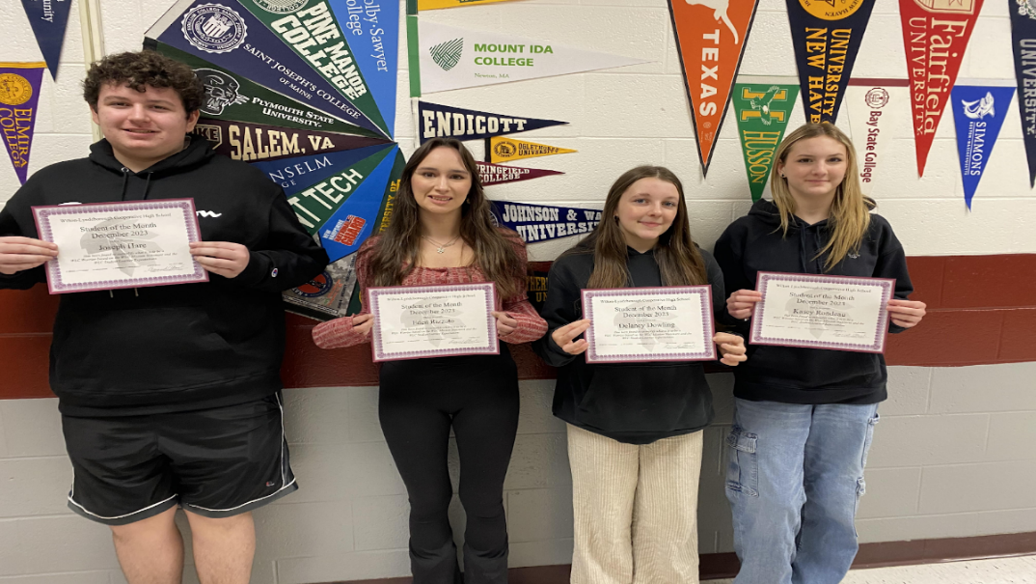
Congratulations goes out to Joey Hare and Eden Rizzuto from the 9th grade and from the 10th grade big congratulations go out to Delaney Dowling and Kasey Rondeau.
Congratulations to our January Students of the Month- 11th and 12th grade
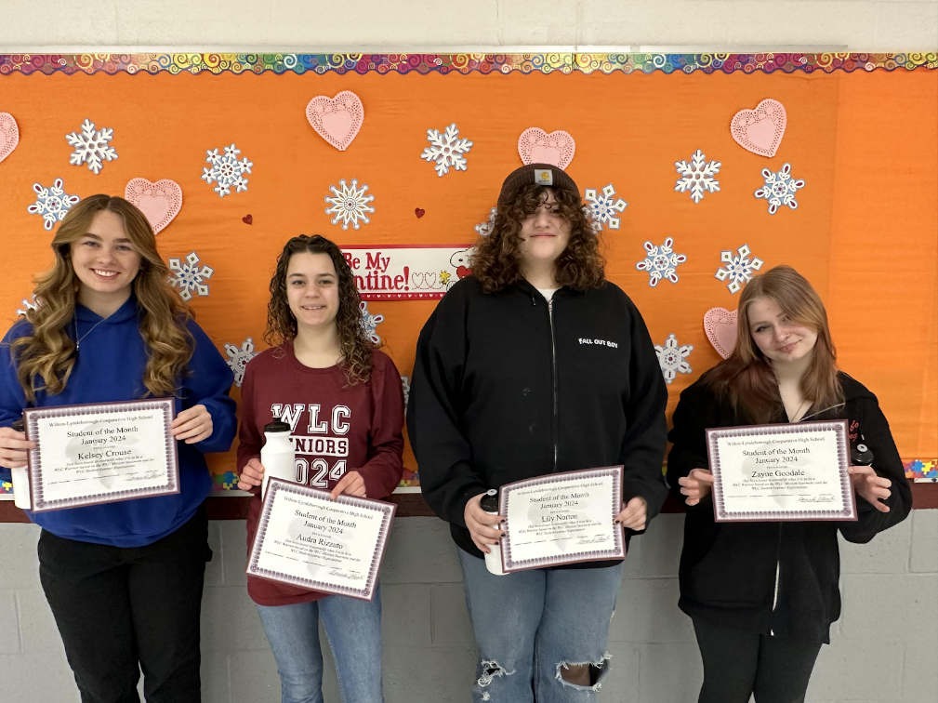

Congratulations goes out to Kelsey Crouse and Lily Norton from the 11th grade and from the 12th grade big congratulations go out to Zayne Goodale and Audra Rizzuto.

We are so proud of all of you!
Also in December, Donald Anselmi of St. Paul’s Summer Program provided a presentation and overview of the Advanced Summer Program at St. Paul’s in Concord, NH that runs each summer.

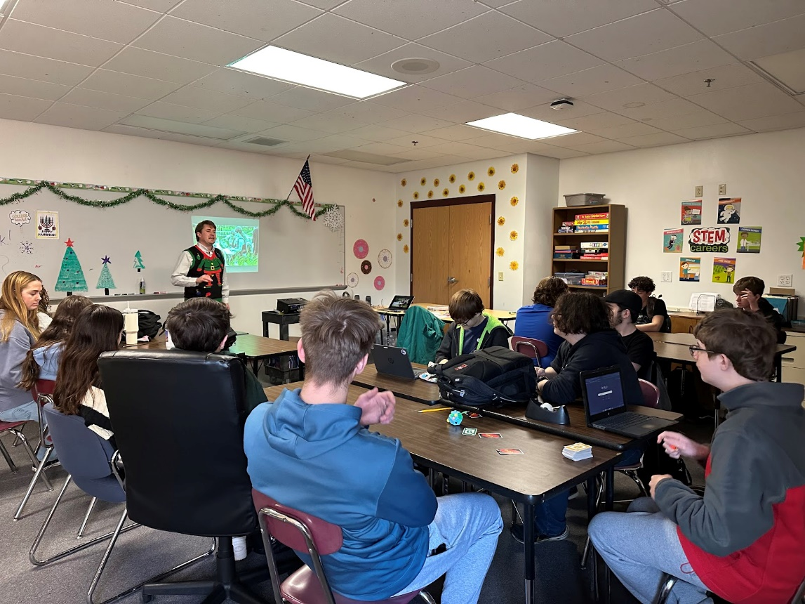
WLC was welcomed at Milford High School Career Technology center – the students had a fantastic time learning about the different CTE programs and we were fortunate to have a wonderful lunch. Thank you to MHS for a great tour of your facilities-

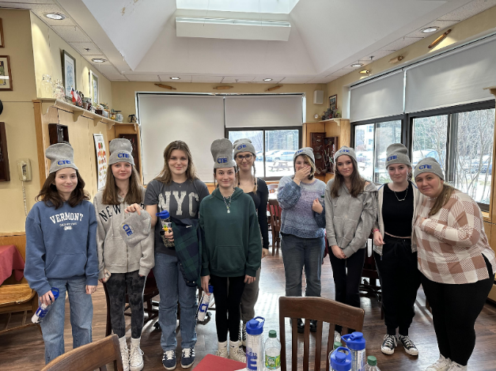
We were so fortunate to have Scott from the NH Mechanical Trade School come to WLC and speak to our students about the many opportunities available at both of their locations in NH. Students were able to ask questions and obtain valuable information to consider towards their future endeavors.
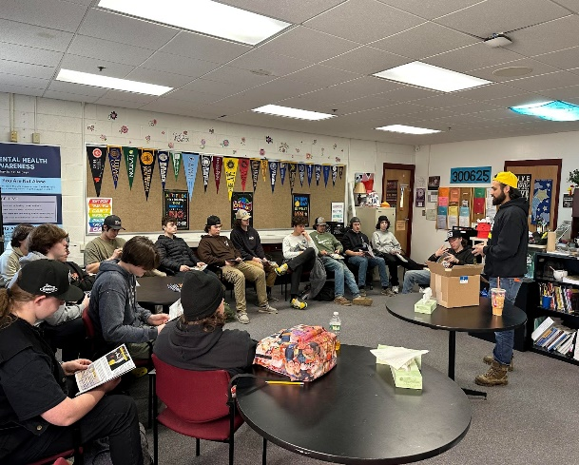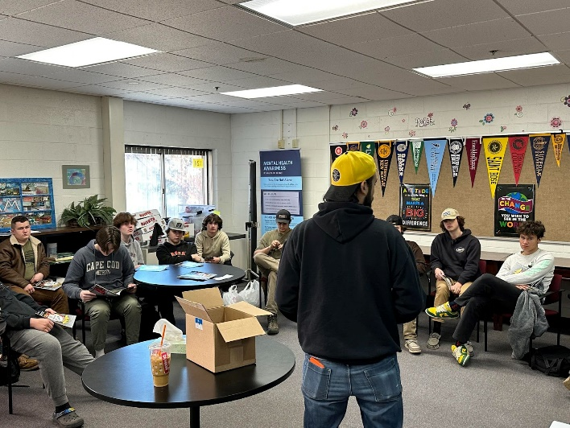

Updates from Special Education:
Special Education students have been working hard at completing midterms in the high school. All students are working with staff to set up appropriate schedules for next year. We have multiple students completing on the job training in preparation for graduation. The RISE program is looking for local businesses for the students to participate in small jobs. Please reach out to Ashley Ansara at a.ansara@sau63.org if you are interested or know someone who may be interested.

Warrior Postcards

The families of the following students have received a postcard in the month of January.

Litchfield, Logan Carson, Colt* Faye, Natalia
Crouse, Devon* Dean, Sophia Rizzuto, Eden
Rondeau, Kasey Hare, Joey Dowling, Delaney*
Beam, Keira Chumbley, Joseph Boss, Vivian*
Allen, Connor Siekman, Caroline* Niquette, Avery
O’Grady, Shawn Pearsall, Owen* White, Ava
Hibbard, Izzy Fish, Leighton Benson, JJ*
Drew-Mochrie, Ebben Anzalone, Vito Hannigan, Robert
White, Vinnie* Jacob, Ben Norton, Lily
Goodale, Zayne* Alley, Henry Rinke-Stanford, Charlee
Crouse, McKenna Stevens, Angel Ouellette, Tyler
Fish, Sam Swett, Cailin Bennett, Jack
Levesque, Zach Litchfield, Logan Parsons, Alea
Hall, Abby Hanks, Madelyn Crotty, Jon
Phillips, Jacob Cole, Taylor Gorman, Mia
Javier, Alexa Krug, Harry Balusek, Christian
Collins, Colby Clark, Jaryd Sanchez, Sandy
Benn, Jason Labreque, Madison Lord, Josh
Kimball, Evan Bickerton, Sean Peckens, Saige
O’Brien, Julie Straw, Jack Crouse, Kelsey
Newton, Ellyanna Barber, Evan
*Received more than one Warrior Postcard

National Honor Society and National Junior Honor Society
The induction date for both the NHS and the NJHS is February 22nd at 6pm. We are proud to be welcoming some fantastic students to our chapters of these honor societies. All are welcome to attend. Refreshments will be served following the ceremony.

Athletic News:
As the winter season comes to a close, both Varsity basketball teams look to make a playoff push! The Lady Warriors ended the regular season in a 3-way tie for 5th place in Division IV and are looking to secure home court advantage throughout the playoffs. We are hopeful to host a home prelim game on Tuesday, February 20th.

Physical Education News:
With the recent start of the 2nd semester and the availability of the gym our HS PE class
is starting with a Basketball / Volleyball Unit to provide options for students to stay active,
practice skills, and work on their fitness. Weight Training has been learning new exercises and
tracking their fitness via logs which are incorporated as part of how they are assessed. Racquet
and Net Sports is in a Volleyball Unit and has made significant progress in skill development in
the early weeks of the semester. Lifetime Sports is also in a Volleyball Unit which has been very
competitive and is an emphasis of the class. MS PE is also in a Basketball / Volleyball Unit
where students have been learning and practicing fundamental skills of both sports.

